
CS673 Software Engineering
Team 2 - MBTA
Software Design Document

Team Member | Role(s) | Signature | Date
The Anh Tran | Design & Implementation Leader | The Anh Tran | 10/26/2026
Wenbo Fan | Team Leader  Security Leader | Wenbo Fan | 10/26/2026
Yuexian Feng | Requirement Leader | Yuexian Feng | 10/26/2026
Yuchen Bao | Configuration leader | Yuchen Bao | 10/26/2026
Zhiao Chu | QA Leader | Zhiao Chu | 10/26/2026

Revision history
Version | Author | Date | Change
0 | The Anh Tran | 10/26/2026 | Initial Documentation

● Introduction
● Software Architecture
● Class Diagram
● UI Design (if applicable)
● Database Design (if applicable)
● Security Design
● Business Logic and/or Key Algorithms
● Design Patterns
● Rest APIs
● Any Additional Topics you would like to include.
● AI usage Log
● References
● Glossary

(In your submitted document, please delete all instructions)

Introduction

This document describes the proposed design of the MBTA Tracker, a web application that helps passengers plan direct journeys along the Green Line B branch between Boston College and Government Center. Users will select a starting station and destination, view the route and stops, and check upcoming departures, estimated arrival times and relevant service alerts.
The design goals are to make journey information easy to understand, reduce unnecessary user interaction, keep information updated automatically, and avoid excessive requests to the MBTA API. The initial scope focuses on one branch rather than a complete journey planner with transfers across the transit network.

Software Architecture

The system will use a browser-based frontend and a server backend. Next.js and React will support the application, with JavaScript, CSS and SVG used for interface behavior, styling and the map.
The frontend will contain station selection controls, a route map, train cards and an alerts panel. It will communicate with the backend through HTTP requests and JSON responses. Journey-processing modules will determine the travel direction, match suitable trips and prepare the information shown to users.
The backend will obtain transit data through an MBTA API adapter and maintain a shared data pool. A refresh coordinator will update this pool at controlled intervals, with different intervals for frequently changing predictions and more stable route information. User refresh requests will retrieve the latest available server data rather than independently forcing another MBTA API call.
Separating the interface, journey logic and external data access will make the system easier to test and maintain.
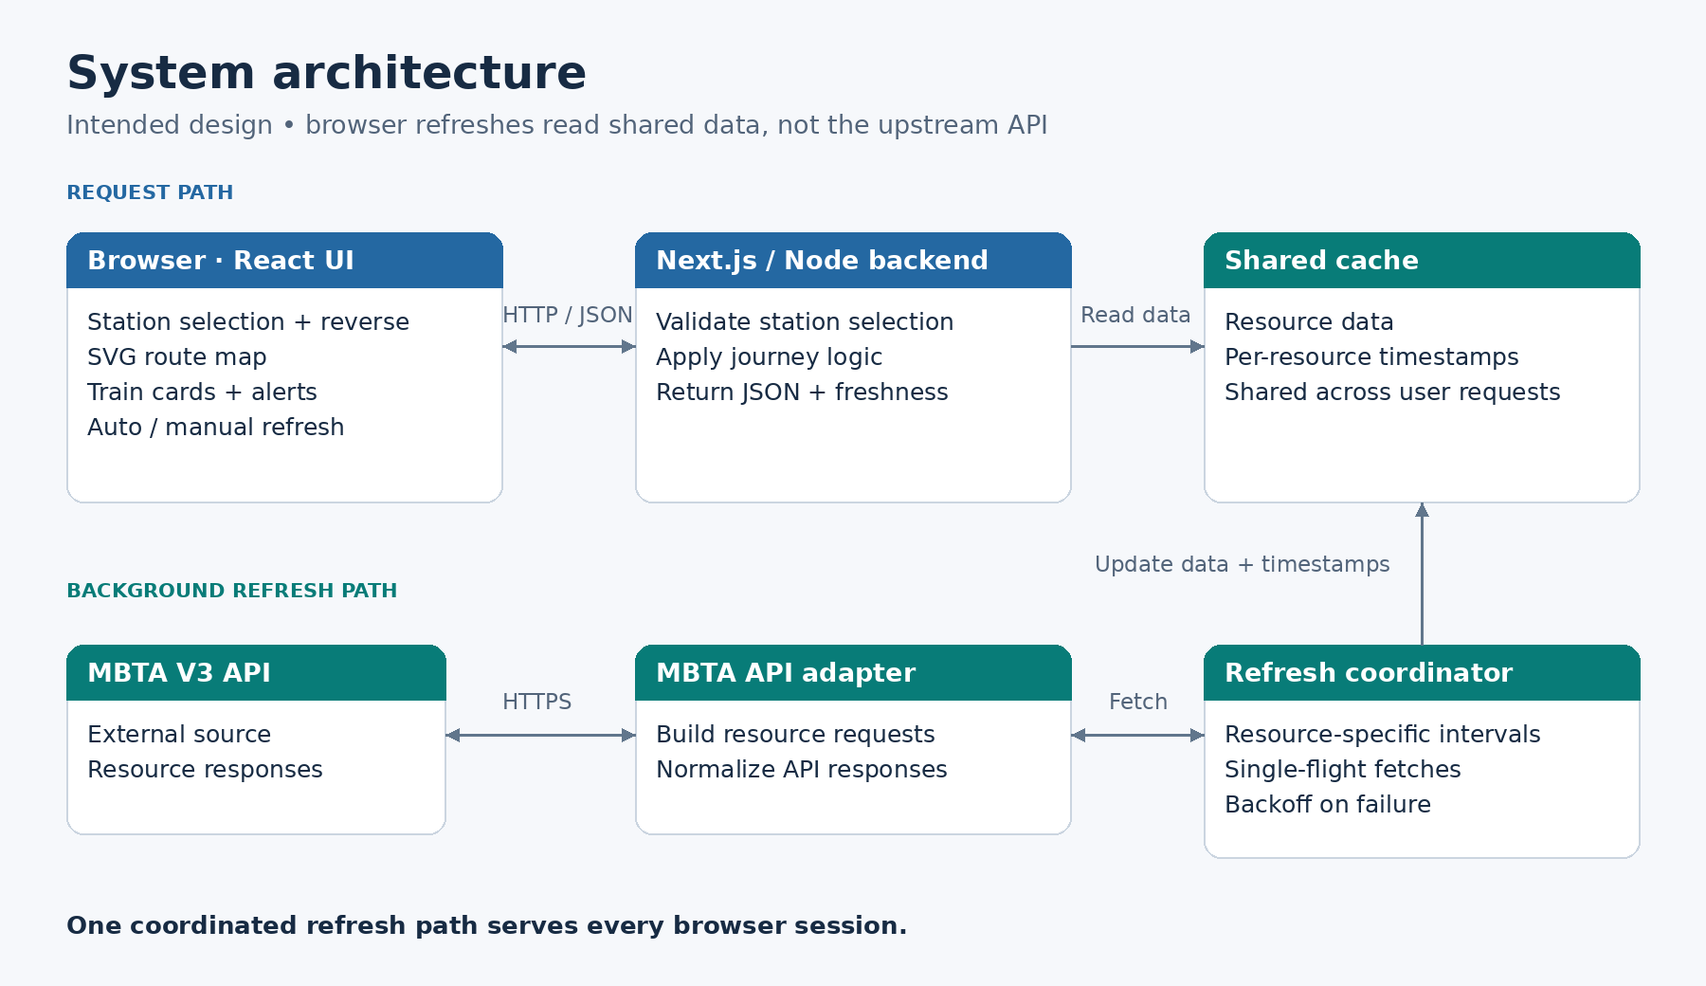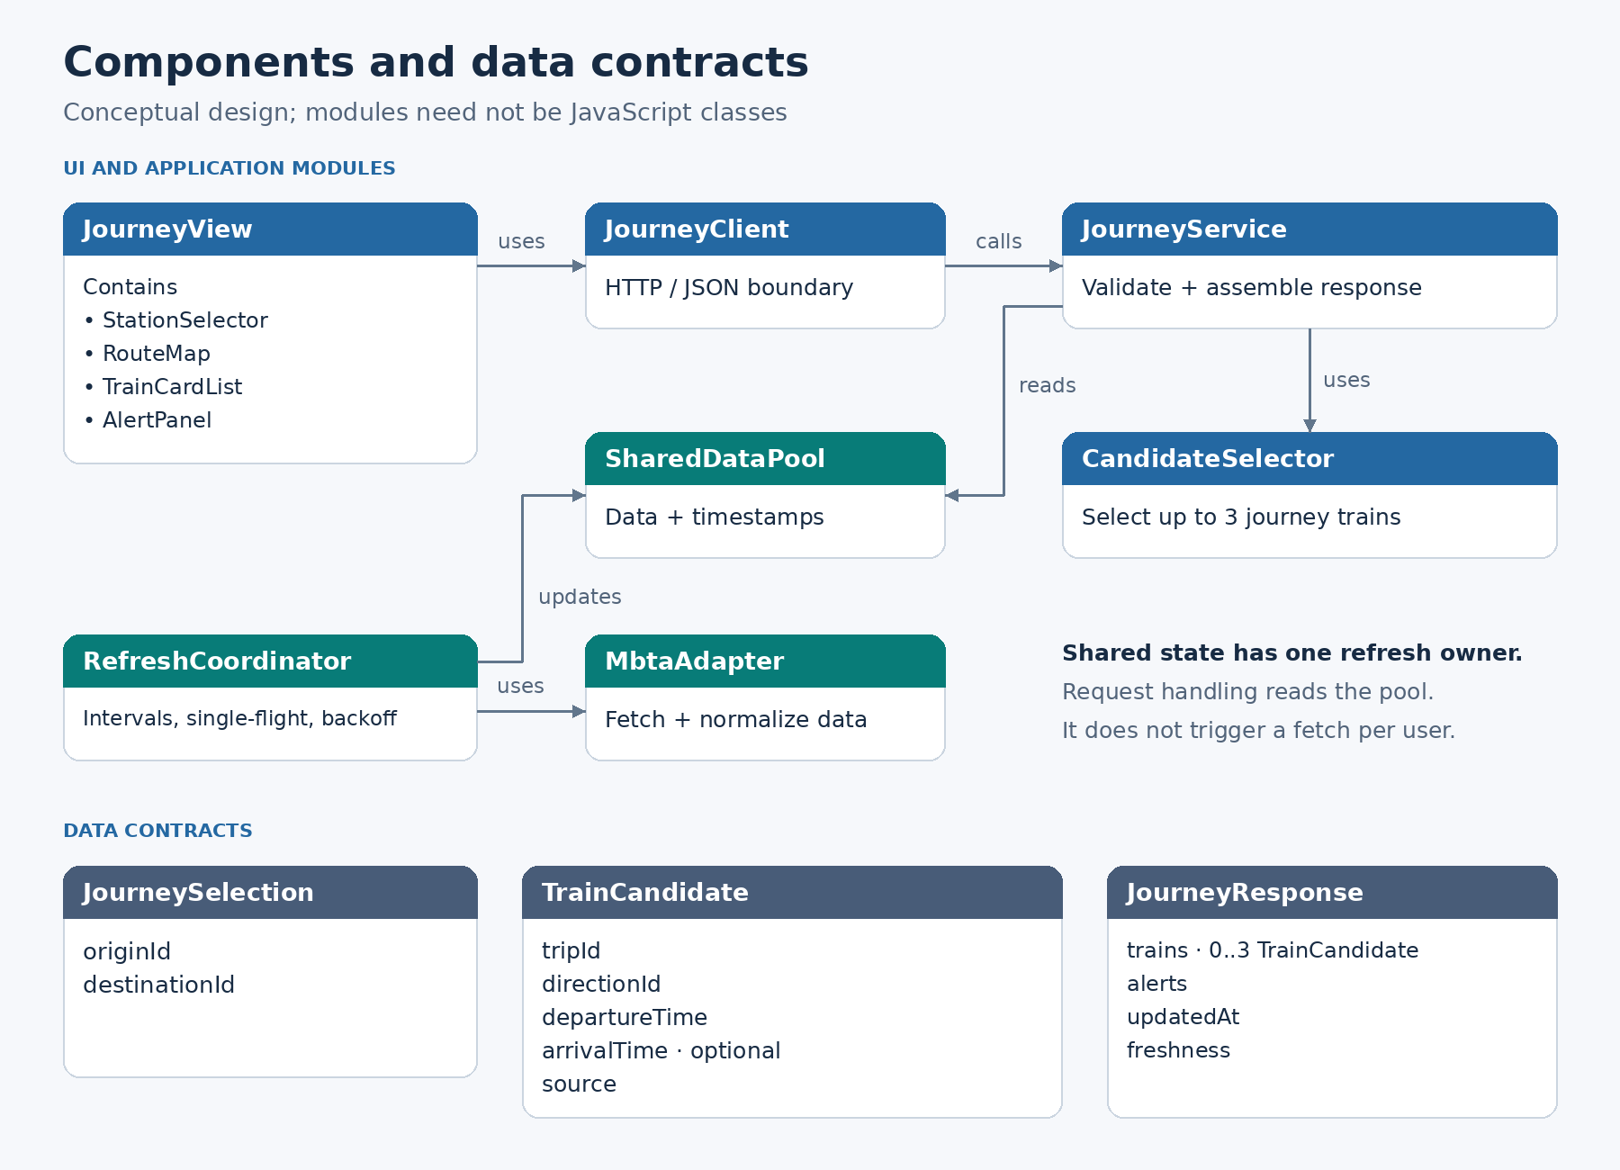

Class Diagram

The design is organized around components and functional modules rather than requiring an object-oriented class hierarchy. The diagram represents their intended responsibilities and relationships; it does not imply that every element must be implemented as a JavaScript class.
The main view contains the station selector, route map, train-card list and alerts panel. A journey client connects the view to the backend. The journey service reads the shared data pool and uses journey-selection rules to prepare a response. The refresh coordinator updates the pool through the MBTA API adapter.
The main data objects are JourneySelection, TrainCandidate and JourneyResponse. They describe the selected stations, a possible train for the journey, and the information returned for display.
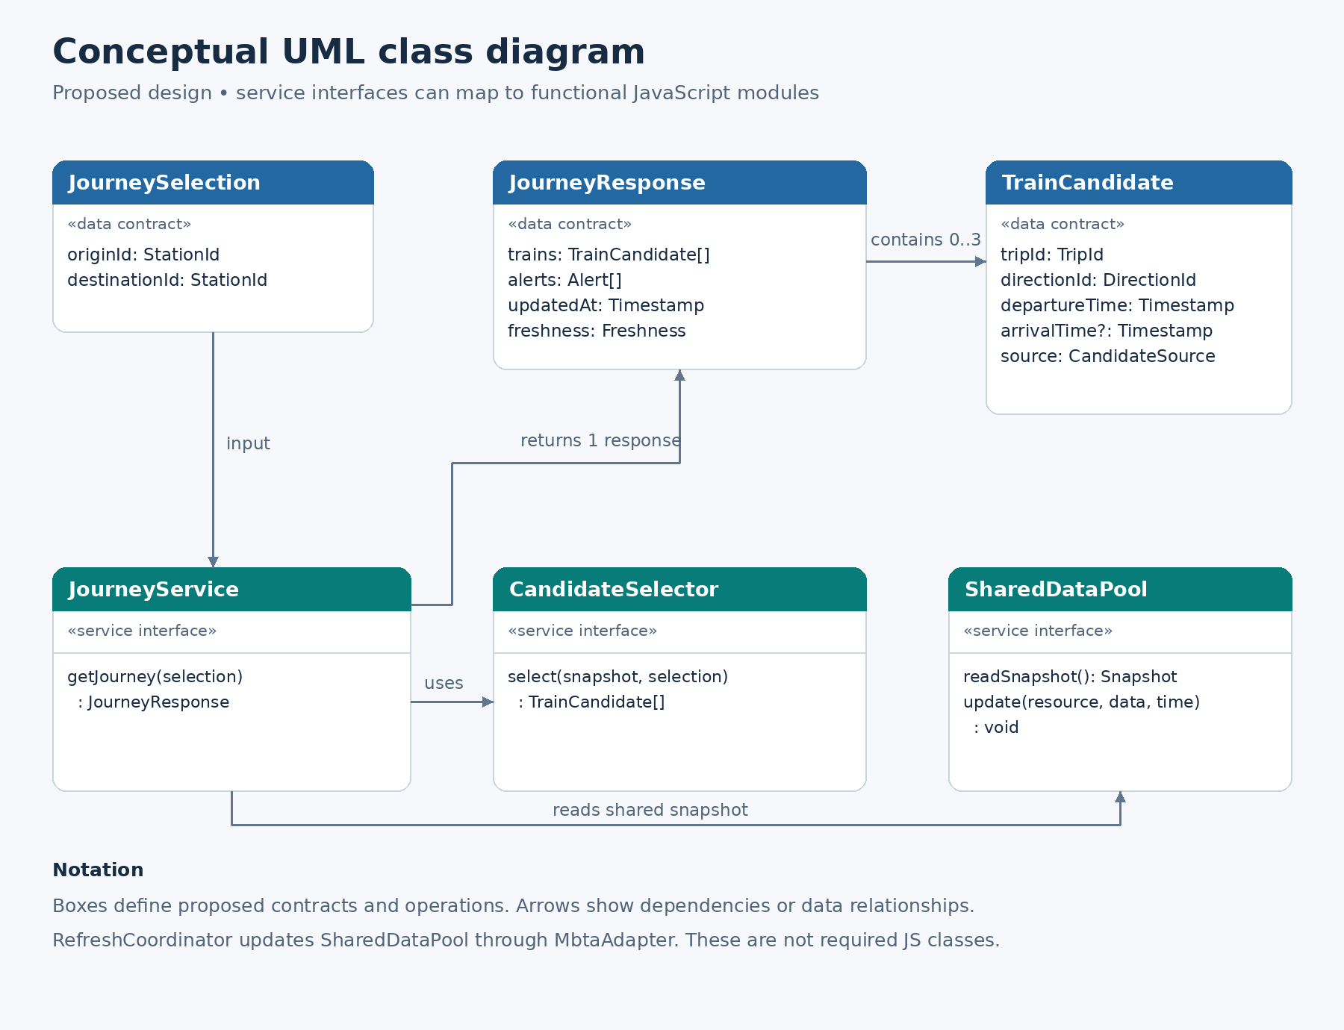

UI Design (if applicable)

The user interface will be clean, simple and easy to navigate. A minimalist layout and a consistent, limited color palette will keep the screen uncluttered and make important information easy to read. Frequently needed information will be displayed directly, reducing unnecessary clicks and navigation through menus.
Users will select their starting station and destination, with a reverse control to swap them quickly. The map will highlight the selected journey, while train cards will show upcoming departures and available destination estimates. The interface will display up to three eligible trains and replace expired cards with the next available candidates. Live predictions, scheduled times and last-known offline estimates will be clearly distinguished.
Automatic updates will handle routine refreshes. A manual refresh button will remain available without being necessary for normal use.

Database Design (if applicable)

The system will maintain a shared server-side data pool to reduce repeated requests to the MBTA API. Each resource will include its data, last successful update time and freshness information. Users will receive information from this shared pool instead of making separate upstream requests.
A persistent database has not yet been selected. The initial design mainly requires temporary caching, which can be held in server memory. If the application later runs across multiple servers, a shared external cache may be needed to coordinate updates. Long-term storage would be considered only if additional requirements justify it.

Security Design

The backend will keep the MBTA API key in server-side configuration rather than exposing it in browser code. Requests will be restricted to supported API resources, and user inputs such as station identifiers and travel direction will be validated before processing. HTTPS will protect communication in the deployed system.
Shared caching, request limits and retry delays will help control excessive traffic. External alert content will be displayed safely as text. Error responses will explain the problem without exposing credentials or internal system details. User accounts are not required for the initial journey-planning scope.

Business Logic and/or Key Algorithms

Journey selection begins by validating the selected stations and determining the required direction. The system will identify trips that serve the selected journey, filter out unsuitable or expired candidates, remove duplicates, and sort the remaining trains by departure time. The first three eligible candidates will be displayed. Destination estimates will be matched to the same trip when available; missing estimates will not be invented.
Reversing a journey will swap the origin and destination and recalculate the direction and matching trips. The system should not assume that service is always symmetrical or that every train serves the entire branch.
When live predictions are unavailable, the system will attempt to display suitable scheduled departures, clearly labeled as timetable information. Mixing live and scheduled results in one list remains a design decision to refine.
The backend refresh process will update shared resources at controlled intervals and prevent simultaneous requests from starting duplicate refreshes. Failed requests will use retry delays, and upstream rate-limit instructions will be respected. Manual refreshes will not bypass these controls.
If connectivity is lost, the interface may continue counting down from previously received timestamps. These cards will be labeled as offline estimates and will expire under defined freshness rules. The application will not invent new trains or claim that a train has actually departed based only on its local clock.
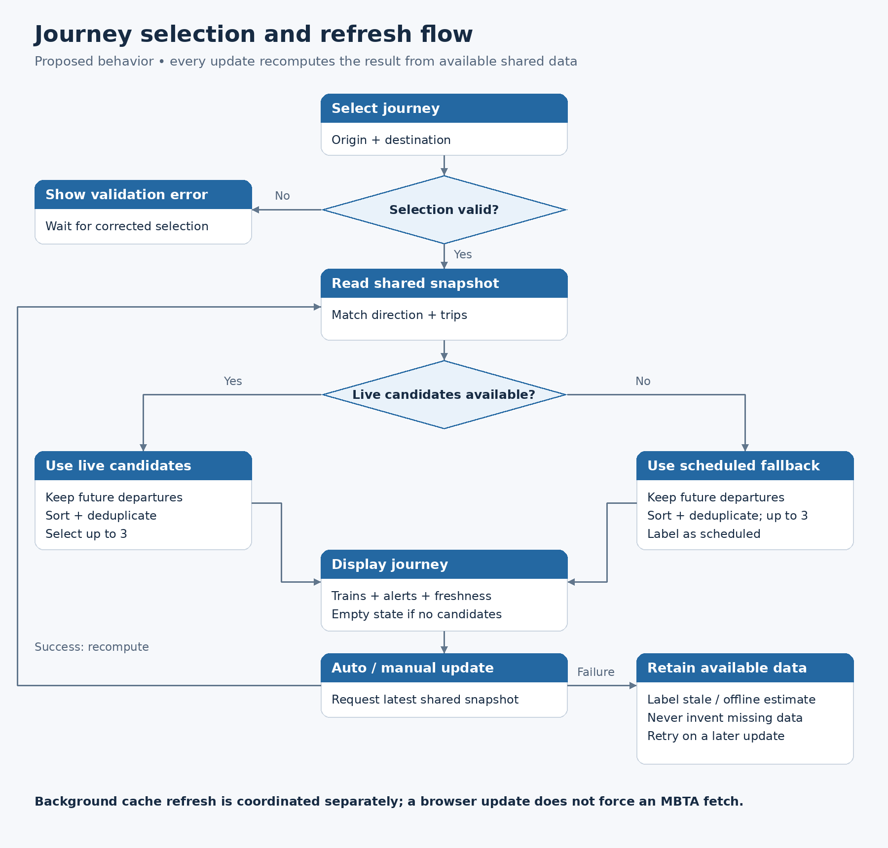

Design Patterns

The design uses a layered structure separating presentation, journey-processing logic and external data access. React component composition will divide the interface into smaller parts with clear responsibilities.
An adapter will isolate MBTA-specific request and response handling from the rest of the application. A shared cache will allow multiple users to reuse the same data. Request coalescing will ensure that concurrent refresh requests share one upstream operation. Separating data transformation from network operations will make the journey rules easier to test independently.

Rest APIs

The application will use the MBTA V3 API to retrieve route patterns, predictions, vehicle information, alerts and schedules. Requests will be filtered to obtain information relevant to the supported journey.
The application's own backend API will provide the browser with normalized transit data. The main snapshot interface, GET /api/b-snapshot, will supply the shared resources together with timestamps and error information. Supporting interfaces can provide station information and journey-specific results.
Responses will distinguish invalid selections, unavailable data, outdated information and temporary upstream failures. The browser will use these states to show meaningful messages rather than treating every empty response as proof that no service exists.

Any Additional Topics you would like to include.
Transit predictions can change, so the application will present them as estimates rather than guarantees. Failures affecting one resource should not unnecessarily hide other usable information. Every displayed estimate should retain enough timing information to explain how current it is.
Testing will cover both travel directions, invalid station selections, partial service, missing predictions, scheduled fallback, duplicate trips, automatic card replacement and recovery after connection loss. Cache tests will check simultaneous requests and repeated manual refreshes. Deployment testing will also account for whether the application runs in one server process or across multiple instances.

AI usage Log
(This table summarizes AI contribution in this document)
Section | Who | AI contribution (%) | Description | Verified by
1-13 | The Anh Tran | 80% | Ask ChatGPT to generate a better worded writing for each section | Wenbo Fan

References
- MBTA V3 API documentation: https://api-v3.mbta.com/docs/swagger/index.html
- Next.js documentation: https://nextjs.org/docs
- React documentation: https://react.dev/learn
- The team’s project repository and approved requirements/design materials.

Glossary
- Prediction: a live forecast of a train’s arrival or departure.
- Schedule: a planned timetable, not a live prediction.
- Trip: one scheduled or operating vehicle journey.
- Cache: temporarily stored data reused across requests.
- Shared data pool: server-held transit information distributed to multiple users.
- Freshness interval: the period during which cached data is considered current enough to reuse.
- Request coalescing: combining simultaneous requests into one shared upstream operation.
- Backoff: delaying retries after a failed or rate-limited request.
- Offline estimate: a local calculation based on previously received information.

