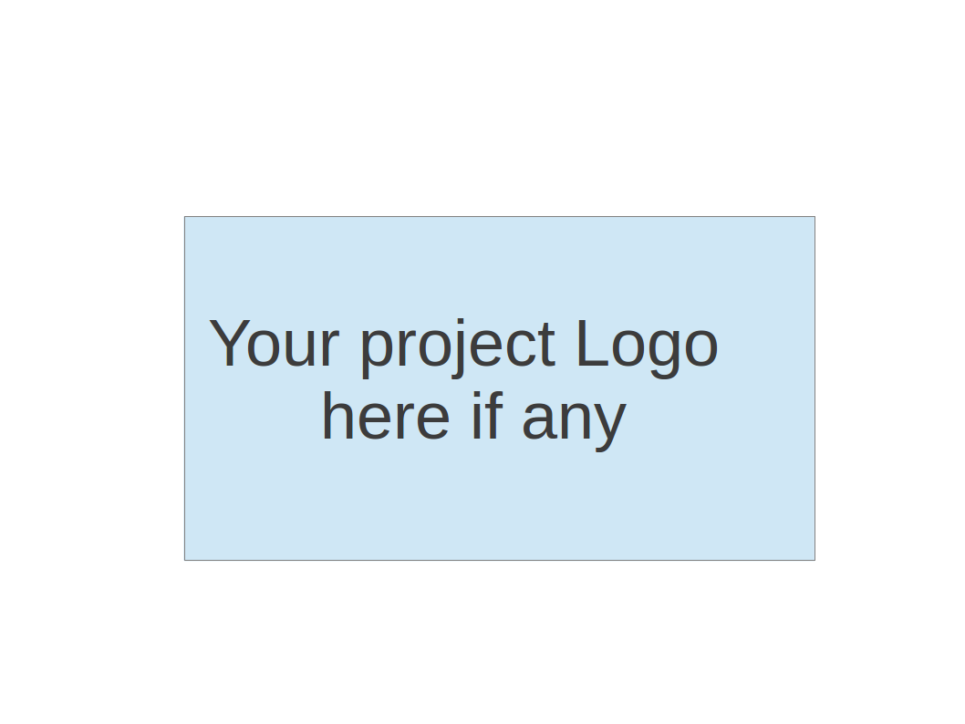
CS673 Software Engineering
Team 2 - Massachusetts Bay Transportation Authority (MBTA) tracker
Project Proposal and Planning

Team Member | Role(s) | Signature | Date
Wenbo Fan | Team Leader  Security Leader | Wenbo Fan | 2026/09/27
Yuexian Feng (Luna) | Requirement Leader | Yuexian Feng | 09/27/2026
The Anh Tran (Bill) | Design and Implementation Leader
Yuchen Bao | Configuration leader | Yuchen Bao | 2026/09/27
Zhiao Chu | QA Leader | Zhiao Chu | 2026/09/27

Revision history
Version | Author | Date | Change
0 | Wenbo Fan  Yuchen Bao | 09/27/2026 | Initial project proposal and planning document

1. Overview
2. Related Work
3. Proposed High level Requirements
4. Management Plan
a. Objectives and Priorities
b. Risk Management (need to be updated constantly)
c. Timeline (this section should be filled in iteration 0 and updated at the end of each later iteration)
5. Configuration Management Plan
a. Tools
c. CI/CD Plan
6. Quality Assurance Plan
a. Metrics
c. Code Review Process
d. Testing
e. Defect Management
7. AI usage Log
8. Project Links
9. References
10. Glossary

(In your submitted document, please delete all instructions)

Overview
(Please give an overview of your project. It should include the motivation, the purpose and the potential users of the proposed software system, the basic functionality of the proposed software system and the possible technology stack to be used. )

Team 2 proposes a responsive MBTA tracker for commuters, students and visitors who need to select a route and stop, check upcoming arrivals and understand service disruptions. The goal is to make routine departure checks quick and transparent about missing or stale information.

Related Work
(Please describe any similar software systems that you have found through the online research, and the differences between your software and those software systems.)

Transit offers nearby departures, route tracking, trip planning and pinned lines . Its schedule view distinguishes real-time and scheduled departures. Team 2’s proposed difference is a smaller MBTA-only browser workflow centered on route/stop selection, readable freshness states and testable failure handling. This is a scope and learning distinction, not a claim of better prediction accuracy or unique features.

Proposed High level Requirements
  - Functional Requirements
(For each functional requirement, please give a feature title and a brief description using the following format: As (a role), I want to (action), so that (value).)
    - Essential Features (the core features that you definitely need to finish):
      - Route and stop discovery. As a rider, I want to search and select a supported route, direction and stop, so that I can check the correct service. Accept when names and identifiers resolve correctly, directions are labeled, and empty/invalid searches have useful messages.
      - Upcoming arrivals. As a rider, I want the next available arrivals at my selected stop, so that I can decide when to leave. Show up to three predictions in time order, destination, time/countdown and source label. Handle absent predictions, canceled/unavailable service and time-zone boundaries using fixtures; never invent an arrival.
      - Relevant service alerts. As a rider, I want alerts affecting my selected route or stop, so that I can adjust my travel. Show applicable active alert text and available effective periods, distinguish no alerts from an alert-fetch failure, and test unrelated/expired alert filtering.
      - Refresh and failure transparency. As a rider, I want visible refresh and stale-data status, so that I know whether arrivals are current. Propose a 30-second foreground refresh, manual refresh and a stale label after 90 seconds without a successful fetch. Show last successful fetch time, pause background polling and offer retry after errors. Fetch time does not guarantee upstream observation freshness.
      - Accessible mobile workflow. As a rider on a phone or using a keyboard, I want a readable, operable search-to-arrival flow, so that I can use the tracker without relying on a map. Accept the core flow at 360-pixel width and on desktop, with visible focus, labeled controls and text status cues that do not rely on color.

    - Desirable Features (the nice features that you really want to have too):
      - Favorites. As a returning rider, I want to save and remove route/stop/direction choices locally, so that I can reopen frequent trips
      - Vehicle map. As a rider, I want available vehicle locations for my route, so that I can view service movement. Accept route filtering, timestamp/stale labels and an equivalent text view; unavailable positions must not appear live. Map provider, attribution and quota suitability are [TBD].
    - Optional Features (additional cool features that you want to have if there is time):
      - Nearby stops. As a rider, I want nearby stops with optional location permission, so that I can find service around me. Accept denial handling and manual search fallback; do not retain precise location.
      - Shareable stop view. As a rider, I want a link to a route/stop/direction selection, so that another person can open the same view. Validate link parameters and handle unavailable routes gracefully.
    - Existing Features (delete this item if your project starts from scratch)
  - Nonfunctional Requirements
(including security requirements, and other nonfunctional requirements such as compatibility, scalability, reliability etc)
    - Security requirements

Management Plan

Objectives and Priorities
(Please describe your project objectives with highest priority first. Project Goals can include but not limited to complete all proposed (essential) features, deploy the software successfully, the software has no known bugs, maintain high quality, etc )
- Complete the software with all essential features and as many desirable features as possible.
- Fix all known bugs along the development.
- Maintain a clean github repository.

Risk Management (need to be updated constantly)
(Please write a summary paragraph about the main risks your group identified and how you plan to manage these risks. Then use the separate google sheet for detailed risk management. The template is provided in the same folder with this file. Please provide the link to the sheet.)

Risk Management Sheet Link:
https://docs.google.com/spreadsheets/d/19Ud8ZKOAHr60J9ZxlKItetXT4bnNECfi/edit?gid=1939224981#gid=1939224981

Timeline (this section should be filled in iteration 0 and updated at the end of each later iteration)
(The estimated hours should be realistic)
Iteration | Functional Requirements(Essential/Desirable/Optional) | Tasks (Cross requirements tasks) | Estimated/real total person hours
1 | Essential feature 1-3 finished, the application can be fully functional with the basic features. | Set up dev environment for everyone, set up the basic user interface, connect the MBTA API and clean the input into into usable data and set up a generally functional basic application | 30hrs
2 | Essential feature 4-5 with some chosen desirable features. | Adding more features to the application. Adjust the UI to a mobile usable size. | 30hrs
3 | Complete more desirable features. Testing and refine the application | Testing all parts of the application. Security review, debug, and improvement. And final deployment | 30hrs

Configuration Management Plan

Tools
(In this project, we will use Git and Github as the version control tools. Please also specify any other tools to be used, e.g. IDE tools, CI/CD tools, container tools, SAST or DAST tools, and any other DevOps tools and AI tools)

- IDE tools: Visual Studio Code
- CI/CD tools: Github
- SAST or DAST tools:
- DevOps tools & AI tools: GitHub Copilot, ChatGPT, Google Gemini

  - Code Commit Guideline and Git Branching Strategy
(Please briefly describe criteria for the code commitment and the branching strategy used, e.g. what are the branches to be used, how the pull request will be used etc. Here is an article to give you some basic knowledge about different git branching strategies: https://www.flagship.io/git-branching-strategies/

Proposed guideline: use Git and GitHub to manage source code. Keep the main branch stable and create separate branches for features, bug fixes and documentation changes. Make small, focused commits with clear messages that explain the change, and reference related issues when applicable.
Before submitting a pull request, check that the code builds, follows the coding standard and passes relevant tests. Include a brief description of the changes and any necessary documentation updates. Merge into main only after peer review, resolution of blocking feedback and successful automated checks. Avoid direct changes to main and remove branches after merging.
Keep source code, tests, dependency files and project documentation under version control. Do not commit passwords, API keys, local environment files or generated build output. Use release tags to identify stable versions, and review and test AI-assisted contributions before including them.

CI/CD Plan
(Briefly describe how you plan to continuously integrate and deploy your application).

Proposed plan: use an automated CI/CD workflow, such as GitHub Actions, to check changes consistently and support reliable releases. On pull requests, run code-quality checks, automated tests, security scans and an application build. Address failed required checks before merging.
After changes are merged, deploy the tested build to a staging environment and verify that the main application functions work as expected. Use controlled test data for repeatable tests and check live MBTA integration separately. Release to the demo environment after team review and confirmation that the agreed quality criteria are met.
Store deployment credentials securely and keep environment settings separate from source code. Record release versions and deployment results, verify the application after deployment, and retain a previous stable version for rollback if problems occur. Hosting and deployment details remain [TBD].

Quality Assurance Plan

Metrics
(Describe the metrics to be used in the project to measure the quality of your software. Each metric should be measurable and quantifiable. Examples of metrics include product complexity (LOC, # of files, # of classes, # methods, cyclomatic complexity, etc.) , defect rate (# of defect per KLOC), # of test cases, test case pass rate, cost (# of person hours used), # of user stories completed, etc. The result of these metrics should be reported in the progress report/ iteration summary sheet.)

The team plans to use several measurable metrics to monitor software quality and project progress. The specific metrics may be adjusted as the project develops.
Metric Name | Description
Number of Test Cases | Number of unit, integration, or other test cases created for the project.
Test Pass Rate | Percentage of executed test cases that pass successfully.
Defect Count | Number of defects identified and resolved during each iteration.
Code Coverage | Percentage of the code covered by automated tests, where applicable.
User Stories Completed | Number of planned user stories completed during each iteration.

  - Coding Standard
(Describe any coding standard to be used)

The team will follow general coding conventions appropriate for the programming languages and frameworks used in the project.

Code should use clear and meaningful names, consistent formatting, and reasonable organization. Team members should avoid unnecessary duplication and keep functions, classes, and components understandable and maintainable.

Formatting or linting tools may also be used to help maintain consistency across the codebase.

Code Review Process
(Everyone should review all documents to be submitted. Here you will mainly describe how the code review will be done. Who will review the code, e.g. design or implementation leader will review all code or team members review each other’s code. Do you use pull requests for the code review? Is there a checklist to help review? What feedback should the reviewer provide?)

GitHub Pull Requests are expected to be used for reviewing significant code changes before they are merged into the main branch.

Team members will review each other's code when appropriate. Reviews may consider implementation correctness, readability, coding style, possible defects, and whether the code is consistent with the project requirements and design.

Feedback can be provided through Pull Request comments or team discussion. Project documents will also be reviewed by the team before submission.

Testing
(Both manual testing and automated testing should be considered. Both unit testing and integration testing should be considered. Briefly describe the testing tools/framework to be used, the personnel involved (e.g. the QA leader will focus on the integration testing and each developer will unit test their own code), when and what types of testing will be performed, the testing objectives, etc)

The project will consider both manual and automated testing, including unit and integration testing.

Developers will generally test the components they implement. Unit testing may be used for individual functions, components, or services, while integration testing will be used to verify communication between different parts of the system.

For components involving MBTA data, sample or mocked API responses may be used during testing when appropriate.

Manual testing will also be performed for user-facing features such as displaying MBTA information, map interactions, and other application functionality.

Testing frameworks and tools will be selected based on the final technology stack. Automated testing may also be incorporated into the project's continuous integration workflow.

Defect Management
(Describe the tool to be used to manage the defect (e.g github issues). The types of defects to look at. The actions or personnel for defect management. )

GitHub Issues is expected to be used to track defects discovered during development and testing.

Defects may include functional problems, user interface issues, data or API integration problems, backend problems, and integration issues between different components.

Team members may create issues when defects are found and assign them to the appropriate developer. Defects will be reviewed, fixed, and retested as part of the normal development process.

AI usage Log
(This table summarizes AI contribution in this document)
Section | Who | AI contribution (%) | Description | Verified by
Configuration Management Plan | Wenbo Fan | 80% | Ask Chatgpt to make up a proper guideline for commit and CI/CD plan | Yuchen Bao
Quality Assurance Plan | Yuchen Bao | 60% | Based on the MBTA Tracker and the basic features needed, ask ChatGPT the proper way to make a clear testing plan specifically for the project. | Wenbo Fan

Project Links
Github link: https://github.com/BUMETCS673/CS673A1F26P2
Project management tool link (e.g. Jira): None

References
(Any references/citations that you have used)

Open API Provided by Massachusetts Bay Transportation Authority:
Website: https://www.mbta.com/developers/v3-api
Documentation: https://api-v3.mbta.com/docs/swagger/index.html

Glossary
(Any acronym used in the document should be explained here)
MBTA: Massachusetts Bay Transportation Authority

