CS673 Software Engineering
Team 1 - Bluejay
Software Design Document

Team Member | Role(s) | Signature | Date
Kimleng Lim | Design & Implementation Leader | Kimleng Lim | 09/20/2026
Sara Orion | Team & Security Leader | Sara Orion | 09/20/2026
Krizma Nagi | Requirements Leader | Krizma Nagi | 9/21/2026
Italia Tran | QA Lead | Italia Tran | 09/21/2026
Andy Chang | Configuration Lead | Andy Chang | 09/22/2026

Revision history
Version | Author | Date | Change
1.0 | Kimleng Lim | 09/20/2026 | Introduction, Software Architecture, Rest APIs, Database Design, UI Design
1.1 | Sara Orion | 9/20/2026 | Security, Design Patterns, file formatting
1.2 | Kimleng | 10/05/2026 | UI Design, API, and Database usage
1.3 | Sara Orion | 10/05/2026 | Inventory functionality update

1. Introduction
2. Software Architecture
2.1. Architecture Foundations
2.2. Component Dependency & REST Flow Diagram
3. Class Diagram
3.1 Auth Package Class Diagram
3.2 Product Package Class Diagram
3.3 Inventory Package Class Diagram
3.4 Report Package Class Diagram
3.5 Sales Package Class Diagram
4. UI Design
4.1. Framework Architecture
4.2. Core Design Pillars
4.3. Login Screen
4.4. Application Main Layout
4.5. Product Catalog Screen
4.6. Inventory Report Screen
4.7. Inventory Health & Stock Entry Screen
4.8. User Management Screen
5. Database Design
5.1. Database Architecture Overview
5.2.Entity Relationship Diagram (ERD)
6. Security Design
6.1. Security Architecture Overview
6.2. Key Security Components & Class Responsibilities
6.3. Token-Based Authentication Flow
6.4. Role-Based Access Control (RBAC) & Fine-Grained Authorization
7. Business Logic and/or Key Algorithms
8. Design Patterns
8.1. Authentication & Security Patterns
8.2. Core System & Architectural Patterns
9. Rest APIs
9.1. Authentication Endpoints
10. Any Additional Topics you would like to include.
11. AI usage Log
12. References
13. Glossary

Introduction
This document provides a comprehensive high-level architectural overview of Bluejay, a web-based Point of Sale (POS) system. It serves as the primary technical blueprint for development teams, system architectures, and stakeholders to ensure consistent design patterns, clear layer boundaries, and standardized development practices across the codebase.

Software Architecture

2.1. Architecture Foundations
The backend of Bluejay is engineered as a single, cohesive Java Spring Boot application (monolithic) organized strictly by packages. It functions purely as a stateless backend engine, exposing a decoupled, secure REST API to an independent, modern Angular frontend. The structural design of Bluejay builds directly upon the foundation of traditional Layered Architecture. However, to prevent the historical pitfalls of tight coupling where business logic becomes permanently entangled with database frameworks and web technologies, Bluejay implements Clean Architecture (also known as Onion or Hexagonal Architecture). Below is the comparison diagram:
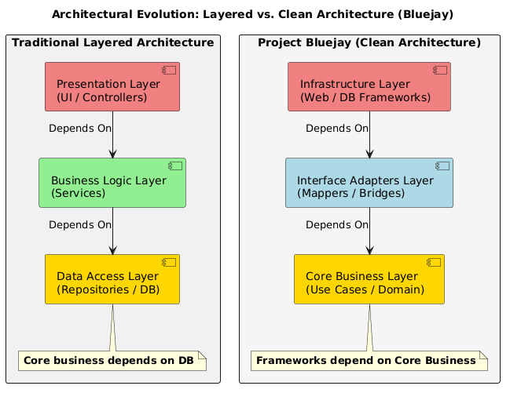
By evolving our layered architecture approach into a Clean Architecture model, we achieve the following architectural goals:
- Framework Independence: The core POS business rules do not depend on Spring Boot, Hibernate, or any external library. The frameworks are treated as pluggable utilities.
- Database Independence: The business logic does not know or care whether data is stored in MySQL, MongoDB, or an in-memory mock during testing.
- Maintainability via Dependency Inversion: Unlike old layered styles where the business layer pointed “down” to the data access layer, Bluejay forces all source code dependencies to point inward toward the core domain.

2.2. Component Dependency & REST Flow Diagram

The Bluejay architecture establishes a strict unidirectional dependency. The client app (Bluejay Web UI) communicates solely through the exposed REST boundary, possibly extended to websocket when dealing with real-time communication or notification in specific modules including inventory and sale. Below is the whole system architecture diagram:
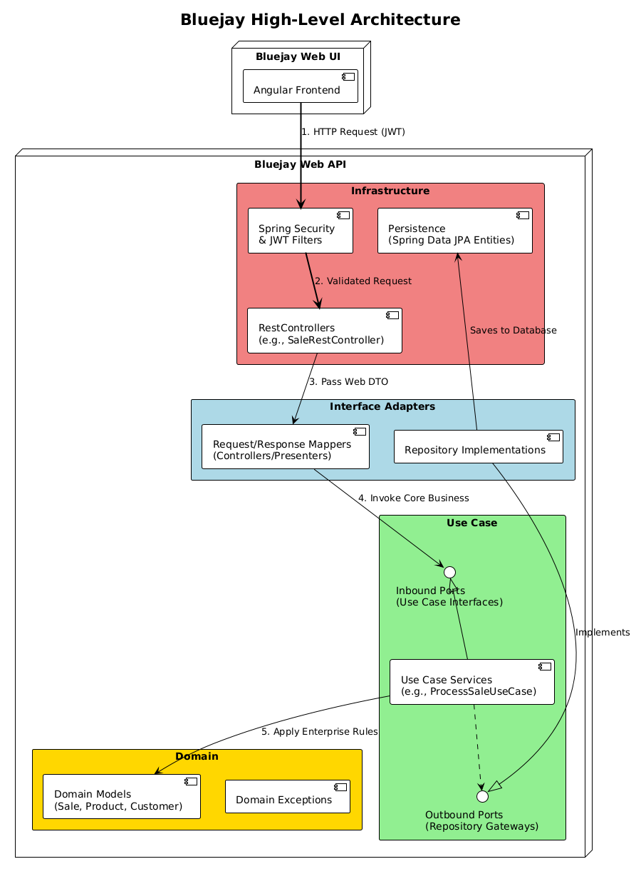

2.2.1. Domain Layer
- Responsibility: Contains core rules governing the business logic. For example, a Sale entity that knows how to calculate its own tax and total without touching a database.
- Dependencies: None. No Spring, no Jackson, no JPA annotations.

2.2.2. Use Case Layer
- Responsibility: Orchestrates application logic. Translate business intent into executable flows.
- Dependencies: Relies only on the Domain layer.

2.2.3. Interface Adapters Layer
- Responsibility: Acts as an insulating buffer. It ensures that if changing JSON mapping tools or database tables, the core engines including use case and domain remain entirely untouched.
- Dependencies: Depends heavily on use case and domain.

2.2.4. Infrastructure Layer
- Responsibility: Implements technical plumbing. Since the application serves an Angular frontend, CORS configuration and JSON/JWT Handlers belong exactly here.
- Dependencies: Accesses all inner layers to tie them together through Spring dependency injection.

Class Diagram
Each domain will include its own class diagram. Currently the authentication package has been implemented. All PlantUML diagrams are stored in the GitHub repository at code/api/docs/plantuml.

3.1 Auth Package Class Diagram
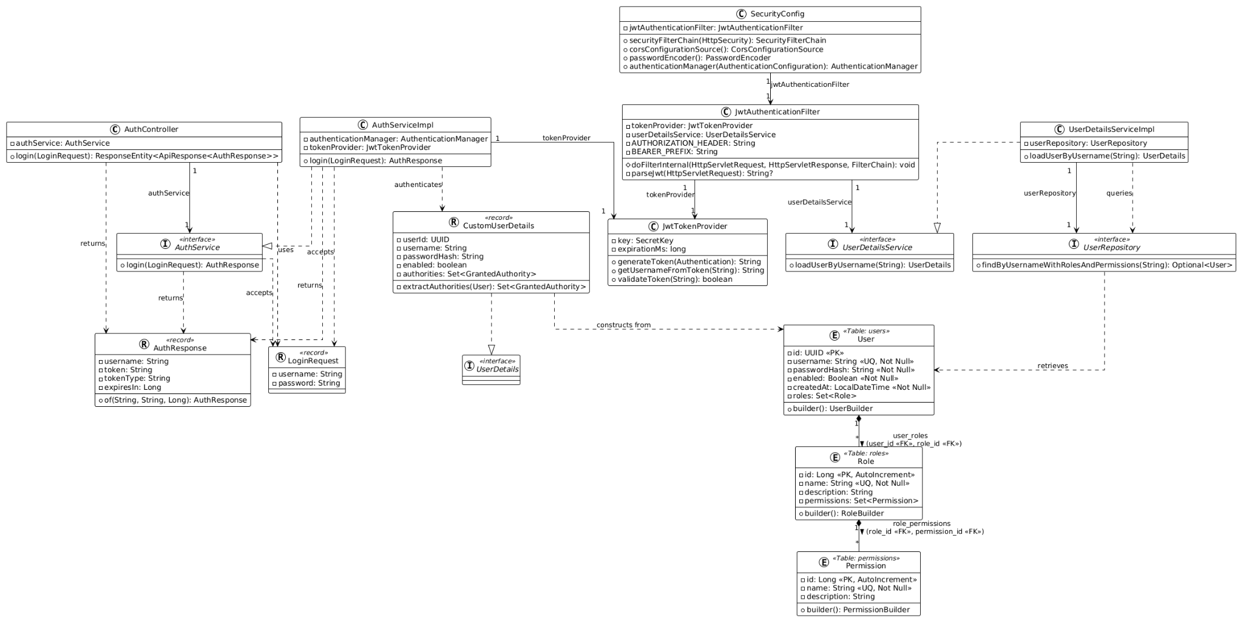
The following package diagrams will be added with the final version of the project

3.2 Product Package Class Diagram

3.3 Inventory Package Class Diagram

3.4 Report Package Class Diagram

3.5 Sales Package Class Diagram

UI Design

4.1. Framework Architecture
The frontend infrastructure for the Bluejay Web UI is engineered around Angular, an enterprise-grade, component-driven framework. Angular’s strict architectural pattern ensures high-speed data bindings, modular code maintainability, and clean separation of concerns across our Point of Sale (POS) and inventory workflows.
To deliver a highly cohesive, accessible, and responsive user experience, Bluejay natively adopts the Google Material Design principles. This design system is programmatically implemented utilizing Angular Material, the official suite of first-party UI components built specifically for the Angular ecosystem.

4.2. Core Design Pillars
By anchoring the interface in Material Design via Angular Material, the Bluejay platform guarantees three operational pillars:
- Visual Hierarchy: Use deliberate depth, lighting, and typography to streamline high-velocity checkout and inventory actions.
- Predictable Behaviors: Standardizes interactive elements (like data tables, form fields, and confirmation dialogs) to eliminate user learning curves.
- Universal Accessibility: Employes built-in ARIA compliance, fluid keyboard navigation, and responsive grids for seamless desktop and touchscreen operation.

4.3. Login Screen
The authentication screen utilizes a single, centered Material Card container to provide an internal visual focus and a clean, elevated surface against the application background.

Visual & Workflow Implementation
- Users navigate to web URL, then get redirected to the login page if they haven't signed in yet.
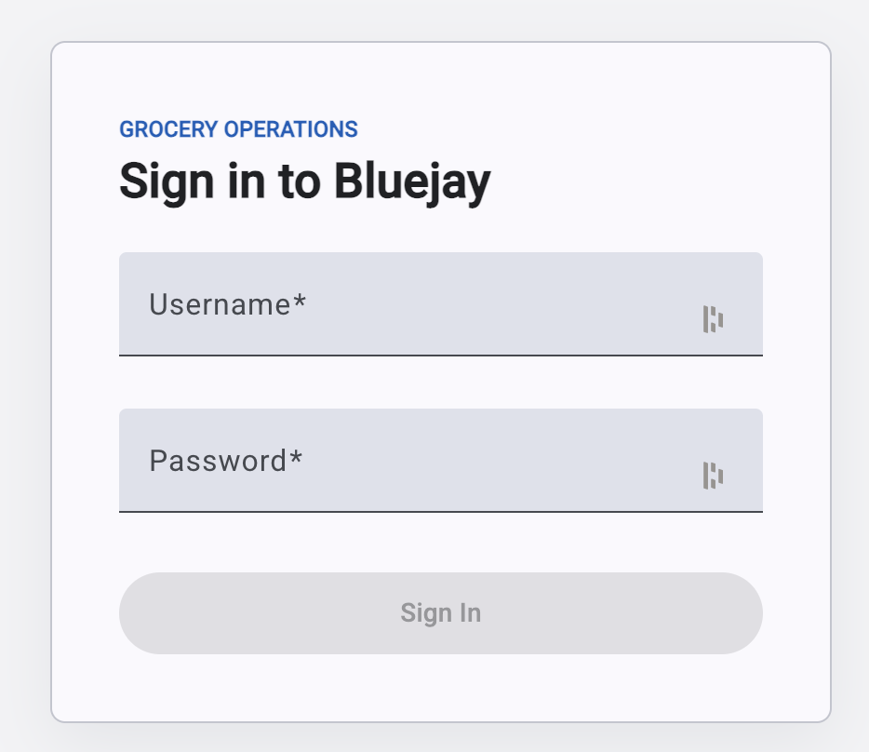

- When invalid login credential, an error message is thrown in the form.
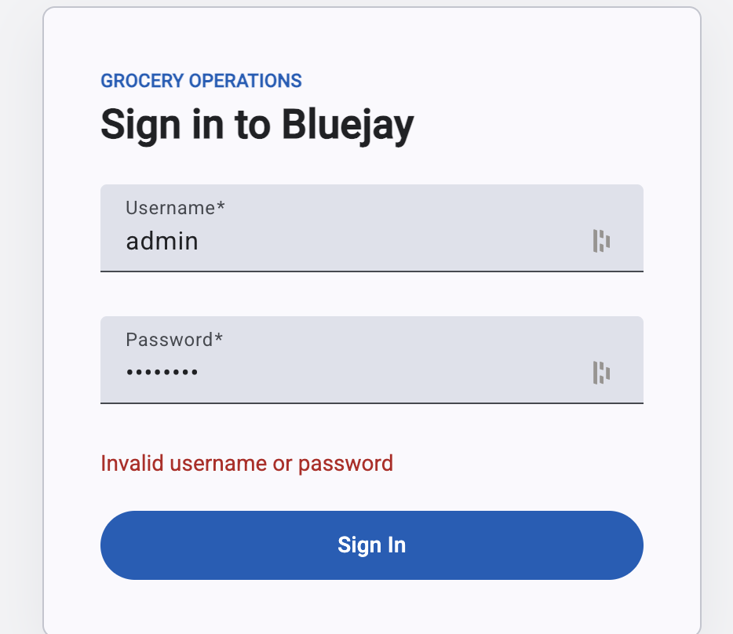
- When login successfully, the system redirects to the dashboard.

4.4. Application Main Layout
The application’s main layout provides a consistent navigation structure across all screens. The primary menu includes Dashboard, Products, Inventory, Sales, Reports, and Users, allowing users to access the system’s core functions. A header bar at the top displays the application name, while the upper-right area shows the signed-in user’s name and provides a Log Out button for securely ending the session.

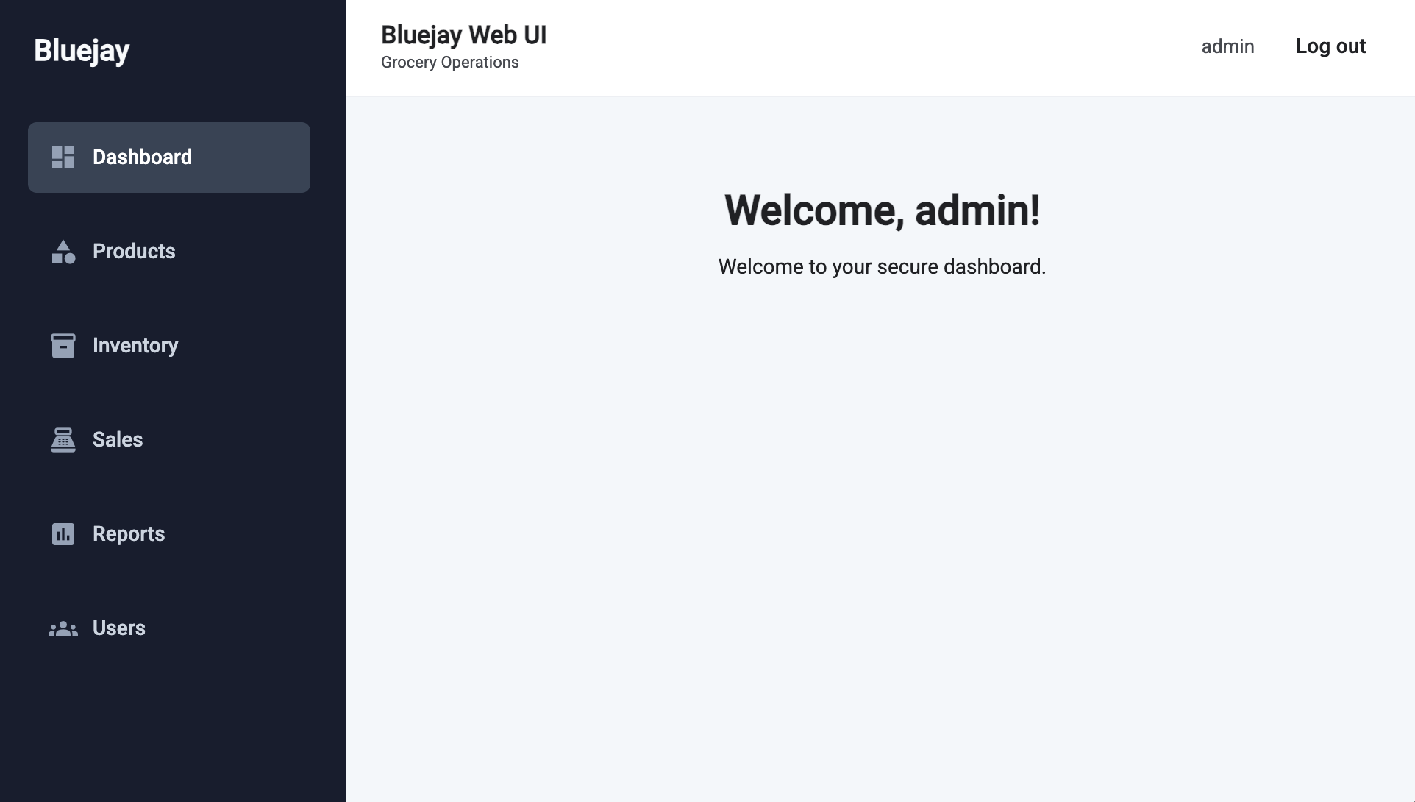

4.5. Product Catalog Screen
The Product Catalog screen provides a centralized interface for managing and locating product records. It contains three main components: the Product Form, Product Search, and Product List.

Visual & Workflow Implementation
- Product Form: Allows users to create and maintain product information, including the associated category.

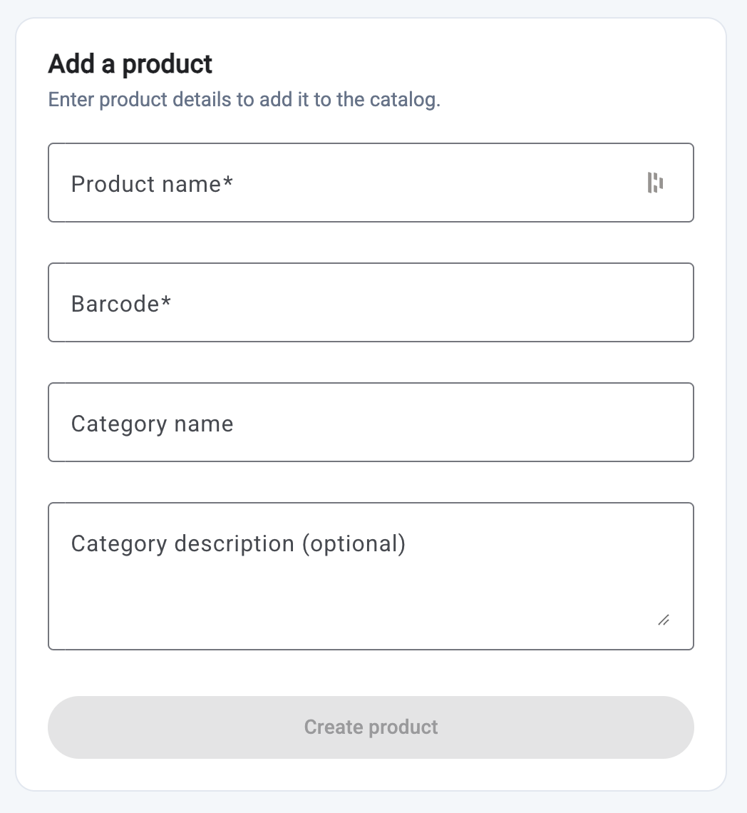

- Product Search: Enables users to locate products by name or category.

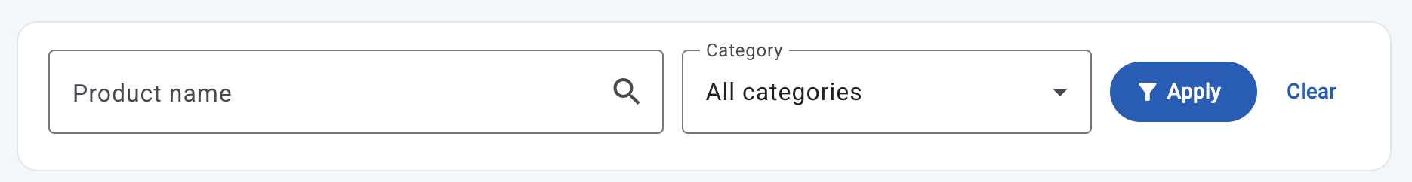

- Product List: Displays matching products in a paginated table for quick review.
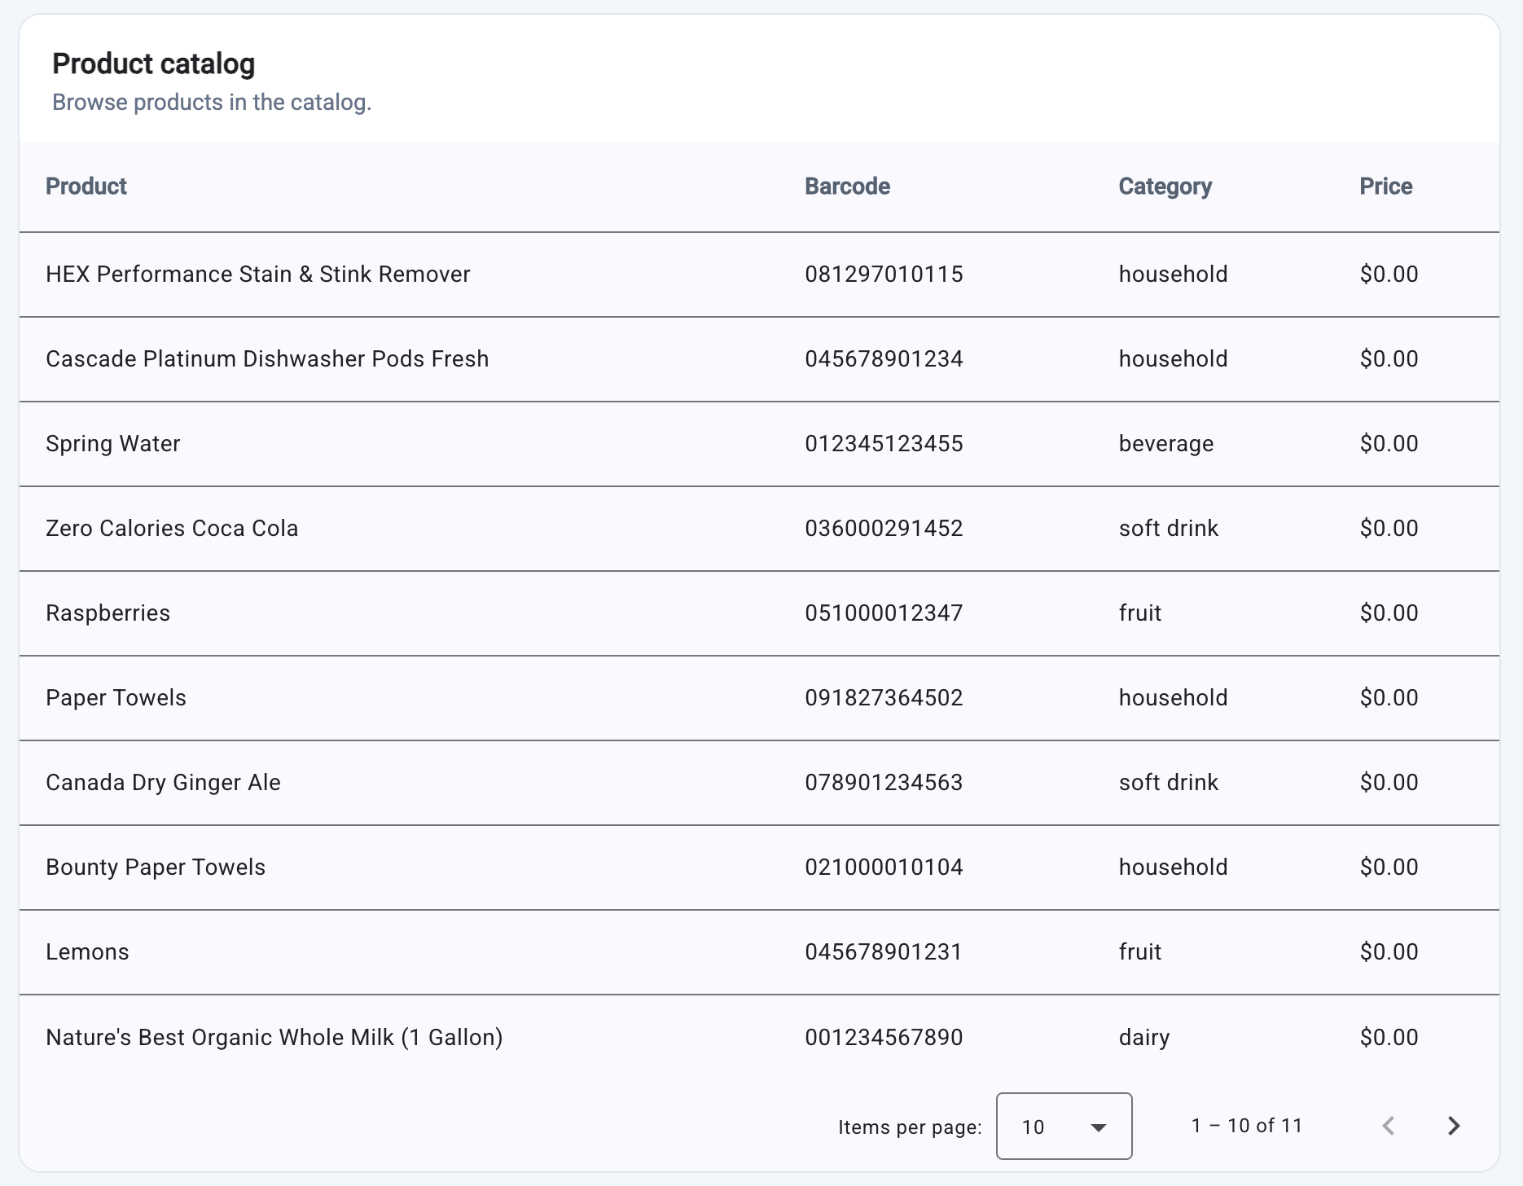

4.6. Inventory Report Screen
The Inventory Report screen provides a high-level view of each product’s current stock balance and latest cost, enabling users to quickly monitor inventory levels and product valuation. The system calculates these values by aggregating all inbound and outbound stock entries for each product. Inbound entries increase the stock-on-hand balance, while outbound entries reduce it, and the latest recorded cost is displayed for reference. Because the stock-entry feature is currently under development, no inventory transactions have been recorded; therefore, the report currently displays zero values.

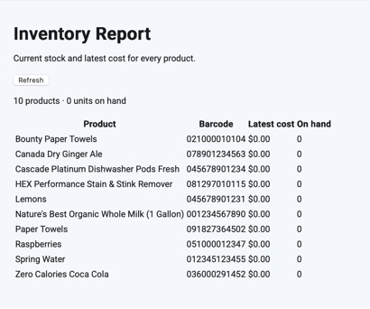

4.7. Inventory Health & Stock Entry Screen
The Inventory Health & Stock Entry screen provides a centralized interface for tracking and entering stock into the inventory. It contains three main components: the Stock Entry Form, Inventory Health, and Inventory List.

Visual & Workflow Implementation
- Stock Entry Form: Allows users to update the stock amount in the inventory.
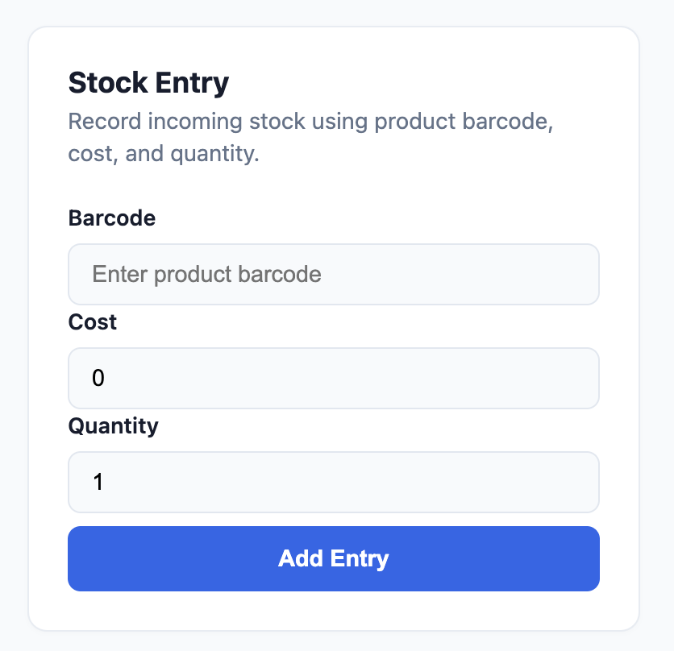
- Inventory Health: Provides a graphical chart of the products that have low stock.
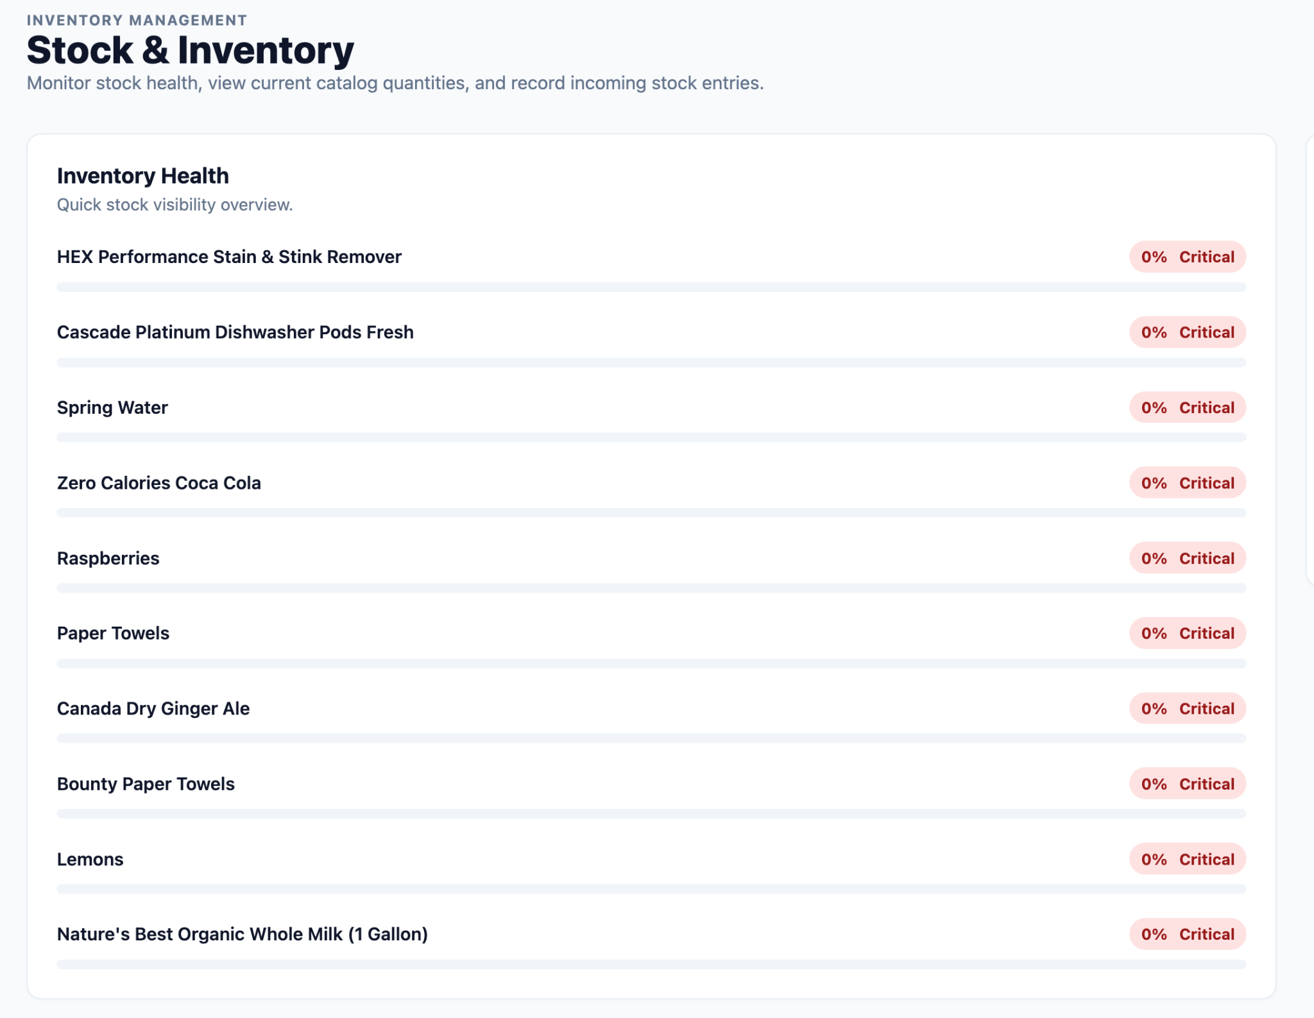
- Inventory List: Displays a complete list of the inventory items.
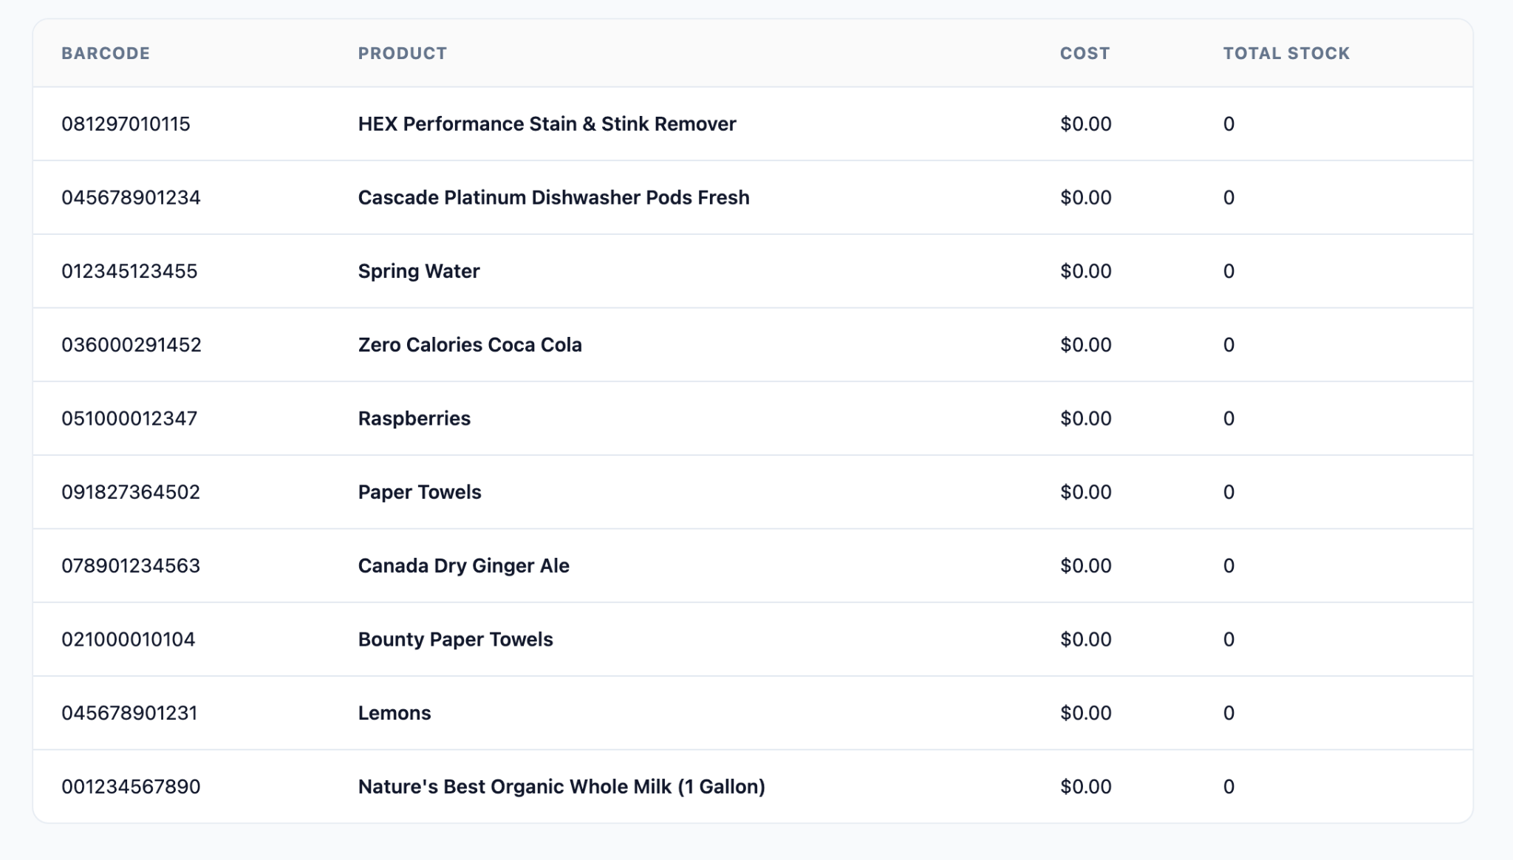

4.8. User Management Screen
The User Management screen provides administrators with a centralized interface for creating, monitoring, and maintaining user accounts. It supports role-based account setup, account-status control, summary metrics, and quick access to user records.

Visual & Workflow Implementation
- Account Creation: An administrator creates a user account, assigns a temporary password, and associates the account with an appropriate user role.
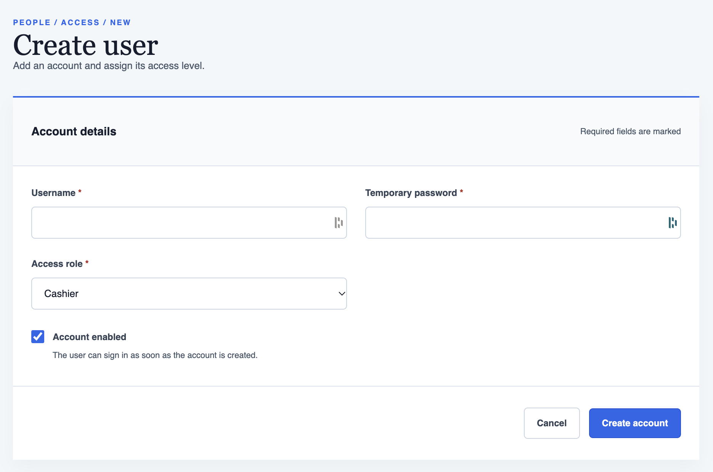
- Account Status Management: An administrator can activate or deactivate an account as needed. Deactivated accounts remain in the system but cannot be used to access the application.
- Account Summary: A summary component displays the total number of user accounts and the number of currently enabled accounts.

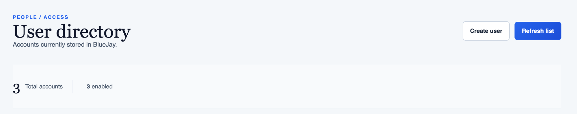

- User List and Search: A table displays all user accounts, while the quick-search feature helps administrators locate specific users efficiently.

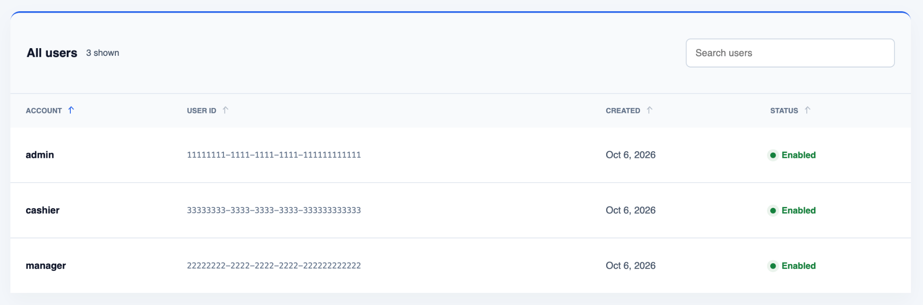

Database Design
This document outlines the relational database architecture for the Bluejay application. The database is optimized for transactional consistency, role-based access control, inventory accuracy, and explicit auditability.

5.1. Database Architecture Overview
- Database Paradigm: Relational Database Management System (RDBMS)
- Database Engine: MySQL
- Primary Key Strategy:
  - UUID (VARCHAR(36)): Applied to high-velocity, globally referenceable entities (users, products, sale_transactions) to decouple unique identifiers from sequential guessing vulnerabilities and optimize parallel muti-region writes.
  - Auto-Increment (BIGINT): Applied to sequential metadata, configurations, and junction routing tables for compact indexing performance.

5.2.Entity Relationship Diagram (ERD)
To ensure agile engineering velocity, the Bluejay database architecture is designed as a unified, complete system but is delivered incrementally across distinct feature iterations. Below is the initial whole database system design:

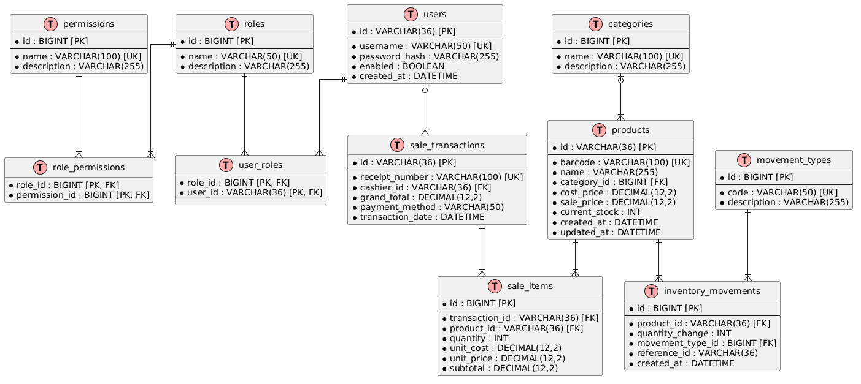

5.2.1. Iteration 1: User Authentication & RBAC
This foundational milestone is fully delivered and currently operational in the codebase. This layer secures the system and establishes structural user profiles before transactional modules are attached.
- Active Tables: users, roles, permissions, user_roles, role_permissions.
- Capabilities: Secure login, generate dynamic authorization token, and return role to client-side.

5.2.2. Iteration 2: Product Catalog & Core Inventory Management
This feature-intensive milestone is fully implemented and operational. The system supports product creation with associated categories, product searches by name or category, paginated table results, and reporting of on-hand inventory and current stock levels.
● Active Tables: products, category, inventory_movement, movement_type
● Capabilities: Persists the product catalog and inventory stock updates and returns a well-defined JSON structure to the client.

5.2.3. Iteration 2: User Management
This milestone is fully implemented and operational. It provides administrators with centralized user-account management, including account creation with temporary passwords, role assignment, account-status control, summary metrics, and searchable user records.
● Active Tables: users, roles, and user_roles.
● Capabilities: Creates user accounts with temporary passwords, assigns roles, activates or deactivates accounts, reports total and enabled account counts, and returns searchable user data to the client.

Security Design
The Bluejay Point of Sale (POS) system employs a stateless, token-based authentication and authorization architecture powered by Spring Security and JSON Web Tokens (JWT). The architecture enforces Role-Based Access Control (RBAC) and follows Clean Architecture principles by isolating core security logic within dedicated infrastructure, adapter, and domain components.

6.1. Security Architecture Overview
Spring Security manages incoming REST API requests through a filter chain. Authentication is stateless, meaning no session state is maintained on the server. Subsequent requests authenticate using an Authorization: Bearer <JWT_TOKEN> header.
The authentication flow handles two primary workflows:
- User Authentication (Login): Users submit credentials to /api/v1/auth/login. The AuthenticationManager delegates to DaoAuthenticationProvider, which verifies credentials using CustomUserDetailsService and PasswordEncoder (BCrypt). Upon success, JwtTokenProvider creates a signed JWT token containing user identity and role claims.
- Stateless Request Authorization: For secured endpoints, JwtAuthenticationFilter intercepts the request, extracts the JWT, and validates it via JwtUtils. If valid, user details are loaded from UserDetailsServiceImpl, converted into a UsernamePasswordAuthenticationToken, and set in Spring's SecurityContextHolder.

6.2. Key Security Components & Class Responsibilities
Based on the authentication package class architecture, the security responsibilities are distributed as follows:

Component / Class | Layer | Core Responsibility
SecurityConfig | Infrastructure | Configures SecurityFilterChain, stateless session management, CORS, public route matching, and registers custom security filters.
JwtAuthFilter | Infrastructure | Intercepts HTTP requests, extracts and validates Bearer tokens, and populates the SecurityContextHolder.
JwtUtils | Infrastructure | Handles token lifecycle: cryptographic signing, parsing claims, checking expiration, and signature validation.
CustomUserDetailsService | Infrastructure / Adapter | Implements Spring's UserDetailsService to fetch user security profiles from the repository by username.
CustomUserDetails | Domain / Adapter | Wraps the core User entity and translates domain roles/permissions into Spring Security GrantedAuthority objects.
AuthController | Interface Adapters | Exposes public REST endpoints (e.g., POST /api/v1/auth/login) and delegates execution to use case services.
AuthService | Use Case | Orchestrates credential authentication via AuthenticationManager, invokes JwtUtils, and formats authentication response DTOs.
TokenBlacklistService | Infrastructure | Tracks tokens revoked at logout so they are rejected before they expire.

6.3. Token-Based Authentication Flow
- Client Request: The client sends a POST /api/v1/auth/login request with JSON payload containing username and password.
- Authentication Verification: AuthController passes data to AuthServiceImpl, which invokes AuthenticationManager.authenticate(...).
- Database Identity Load: DaoAuthenticationProvider delegates to CustomUserDetailsService.loadUserByUsername() to retrieve user credentials and authorities.
- Password Matching: PasswordEncoder verifies the raw password against the hashed database password.
- Token Generation & Response: Upon successful verification, JwtUtils.generateToken() generates a signed JWT string containing subject, issuance, expiration, and authority claims . The token is returned in the response payload and Authorization header.
- Protected Request Validation: For subsequent API requests, JwtAuthFilter intercepts the request, calls JwtUtils.validateToken(), builds an Authentication object, and injects it into SecurityContextHolder.getContext().setAuthentication(...).

6.4. Role-Based Access Control (RBAC) & Fine-Grained Authorization
The system leverages Spring Security's authority mapping to enforce access control across endpoints and domain services :
- Role Mapping: Database roles (e.g., ROLE_ADMIN, ROLE_CASHIER, ROLE_MANAGER) and granular permissions (e.g., inventory:read, sale:create) are retrieved via CustomUserDetailsService.
- GrantedAuthorities: CustomUserDetails maps these roles and permissions into Spring Security GrantedAuthority collections.
- Method & Endpoint Security: API endpoints enforce restrictions using Spring Security annotations (such as @PreAuthorize("hasRole('ADMIN')") or @PreAuthorize("hasAuthority('sale:create')")) as well as filter chain route rules configured in SecurityConfig.

Business Logic and/or Key Algorithms
This section will be populated as business functionality is implemented.

Design Patterns
This section outlines the primary structural, behavioral, and creational design patterns utilized within the Bluejay system, with a specific focus on the authentication and security package.

8.1. Authentication & Security Patterns

8.1.1. Chain of Responsibility Pattern (Spring Security Filter Chain)
- Where: SecurityConfig, JwtAuthFilter, UsernamePasswordAuthenticationFilter.
- Description: Spring Security passes incoming HTTP requests through a chain of filters. Each filter handles a specific concern (e.g., CORS checking, JWT parsing/validation, security context setup) before passing the request to the next filter in the chain or aborting early with an error

8.1.2. Adapter Pattern (UserDetails Wrapper)
- Where: CustomUserDetails wrapping the domain User entity.
- Description: Adapts Bluejay’s internal User domain model into Spring Security’s required UserDetails interface. This allows Spring Security to evaluate roles and authorities without forcing the core User domain entity to depend directly on Spring Security classes.

8.1.3. Strategy Pattern (Authentication Providers & Password Encoders)
- Where: AuthenticationManager, DaoAuthenticationProvider, PasswordEncoder.
- Description: Spring Security defines interchangeable strategy interfaces for authentication and password hashing. Bluejay plugs in the DaoAuthenticationProvider strategy for database-backed logins and the BCryptPasswordEncoder strategy for hashing passwords.

8.1.4. Data Transfer Object (DTO) Pattern
- Where: LoginRequest, AuthResponse.
- Description: Encapsulates incoming login payload data (username, password) and outgoing authentication details (token, tokenType, expiresIn, roles) to decouple API transport contracts from internal domain models.

8.2. Core System & Architectural Patterns

8.2.1. Clean Architecture (Architectural Pattern)
- Where: Backend project package structure.
- Description: Enforces Dependency Inversion so that core business rules remain completely independent of external frameworks, UI components, and database drivers.

8.2.2. Dependency Injection / Inversion of Control (IoC)
- Where: Spring Framework Core
- Description: Spring manages component lifecycles and injects collaborators (e.g., injecting JwtUtils into JwtAuthFilter) at runtime, promoting loose coupling and testability.

8.2.3. Repository Pattern
- Where: Spring Data JPA Repositories (e.g., UserRepository).
- Description: Abstracts data persistence behind an interface, allowing the application to execute queries without tightly coupling business logic to database-specific access code.

Rest APIs
Because Bluejay is undergoing rapid development and continuous iteration, tracking every single evolving route within this static document is impractical. To maintain agility without sacrificing clarity, our primary technical source of truth for backend endpoints is dynamically generated via Scalar UI and structured interactively within our team’s shared Postman collection.
The specifications listed in the subsections below are foundational endpoint examples from each business domain such as authentication and checkout systems that are highly stable, structurally locked, or least likely to change. For up-to-date query parameters, edge-case payload schemas, and minor feature endpoints, developers should always consult the live Scalar UI/ Postman dashboards.

9.1. Authentication Endpoints
Endpoint: POST /api/v1/auth/login
Authenticates a user against system credentials and issues a stateless JSON Web Token (JWT).
- Authentication Required: No (Public Endpoint)
- Headers:
  - Content-Type: application/json

Request Body Payload

{
“username”: “admin”,
“password”: “Password123!”
}

Success Response
- Code: 200 OK
- Headers:
  - Authorization: Bearer <JWT_TOKEN>
- Response Body:

{ “data”: {
“token”: “eyJhbGciOiJIUzI1NiIsInR5cCI6IkpXVCJ9...”,
“tokenType”: “Bearer”,
“expiresIn”: 86400,
“username”: “admin”
“role”: “ROLE_ADMIN”
.. ..
}
}

Error Response
- 401 Unauthorized (Invalid credentials)

{
“timestamp”: “2026-09-20T14:19:00Z”,
“status”: 401,
“error”: “Unauthorized”,
“message”: “Bad credentials supplied.”,
“path”: “/api/v1/auth/login”
}

9.2. User Management Endpoints
Endpoint: POST /api/v1/users
Creates a new user account with a temporary password and assigns the account to the specified user role. This private administrative endpoint validates the submitted account information, securely stores the password, and returns the newly created user record.
● Authentication Required: Yes (Private Endpoint)
● Headers:
○ Content-Type: application/json
○ Authorization: Bearer <JWT_TOKEN>

Request Body Payload

{
“password”: “string”,
“username”: “string”,
“enabled”: true,
“role”: “2026-10-05T16:25:21.274Z”
}

Success Response
● Code: 200 OK
● Headers:
○ Authorization: Bearer <JWT_TOKEN>
● Response Body:

{
“data”: {
“id”: “123e4567-e89b-12d3-a456-426614174000”,
“username”: “string”,
“enabled”: true,
“createdAt”: “2026-10-05T16:25:21.274Z”
.. ..
}
}

Error Response
● 401 Unauthorized (Invalid credentials)

Any Additional Topics you would like to include.

AI usage Log
(This table summarizes AI contribution in this document)
Section | Who | AI contribution (%) | Description | Verified by
Software Architecture | Kimleng Lim | 60% | AI execution mainly focuses on technical heavy lifting by generating the pattern frameworks, writing the technical copy. While I provided the vital strategic direction by establishing the monolith scope, injecting the branding, and enforcing a simplified, readable layout. | x
REST APIs | Kimleng | 65% | Write introduction for this section and how to format | x
Database Design | Kimleng | 45% | Translate raw engineering data into a polished SDD layout and wrestle with the PlantUML compiler to ensure it is rendered on the screen without class diagram errors while I take the heavy lifting of mapped out the entire relational system, the constraints, and table relationships for Bluejay platform. | x
UI Design | Kimleng | 50% | Initial idea and provide screenshot and let Microsoft Copilot format and rewrite description in a concise and correct grammar. | x
Security & Design Patterns | Sara Orion | 80% | Evaluated existing authentication code in order to summarize and outline the security framework and design pattern usage. | x

References

Glossary

