CS673 Software Engineering
Team 1 - BlueJay
Software Test Document

Team Member | Role(s) | Signature | Date
Sara Orion | Team & Security Lead | Sara Orion | 09/21/2026
Kimleng Lim | Design & Implementation Lead | Kimleng Lim | 09/20/2026
Krizma Nagi | Requirement Lead | Krizma Nagi | 09/20/2026
Andy Chang | Configuration Lead | Andy Chang | 09/22/2026
Italia Tran | QA Lead | Italia Tran | 09/20/2026

Revision history
Version | Author | Date | Change
1.0.0 | Italia Tran | 09/20/2026 | - Testing Summary  - Manual Testing Report  - Automated Testing Report  - Testing Metrics
1.0.1 | Italia Tran | 10/06/2026 | - Updated manual testing report  - Updated automated testing report  - Updated testing metrics

1. Testing Summary
2. Manual Testing Report
3. Automated Testing Report
4. Testing Metrics
5. AI usage Log
6. References
7. Glossary

Testing Summary
For our web application BlueJay, each person is responsible for their own unit testing. Any user story, features, tasks that are assigned to the individual, that individual is responsible for doing their own unit testing on both the back and front end of their code. Each unit test needs to have at least two test scenarios: a pass and fail scenario.

Any feature/user story shall have a system test assigned to it. The person implementing the feature/user story is also responsible for writing the system test case. The first pass of each test will be tested by the implementer. A second pass shall be done and verified by the QA Lead.

Manual Testing Report
As all features and user stories need to have a system test associated with it, this will be done manually. As the project grows and expands, this list will also be amended.

Iteration 2
User Story | System Test Link
#18 [STORY] Cashier Session Expiration and Lockout Enforcement | #111 [TEST] Cashier Session Expiration and Lockout Enforcement
#60 [STORY] Admin System Initialization & Preloaded Account | #116 [TEST] Admin System Initialization & Preloaded Account
#14 [STORY] Cashier users should be able to login and get into checkout page | #117 [TEST] Cashier users should be able to login and get into checkout page
#15 [STORY] Cashier users should not get into the management page | #118 [TEST] Cashier users should not get into the management page
#22 [STORY] Add New Product | #119 [TEST] Add New Product
#32 [STORY] User Creation and View | #81 [TEST] User Creation and View
#23 [STORY] View Product Catalog | #122 [TEST] View Product Catalog
#24 [STORY] Stock Entry | #120 [TEST] Stock Entry
#57 [STORY] Core Inventory Report | #121 [TEST] Core Inventory Report

Automated Testing Report
Back-end
Back-end testing will use the JUnit/Mockito framework.Code coverage will be done using JaCoC and the resulting summary will be posted in the Java CI with Maven workflow run for every accepted pull request.

The API testing directory is found as follows:
code/
├── docker-compose.yml
├── api/
│ ├── README.md
│ ├── Dockerfile
│ ├── pom.xml
│ ├── docs/
│ └── src/
│ ├── main
│ ├── test
Iteration 2 Back-end Summary
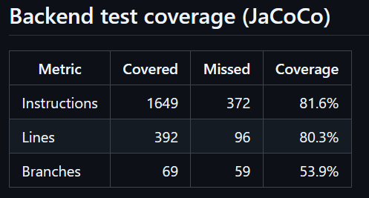

Front-end
Front-end testing will use Vitest as part of the testing framework as the project is Angular based. Each feature that is created should have its own *spec.ts file where the unit tests will be implemented.

Code coverage will be done through the default Angular framework and the resulting summary will be posted in the Frontend CI Test workflow run for every accepted pull request.

Iteration 2 Front-end Summary
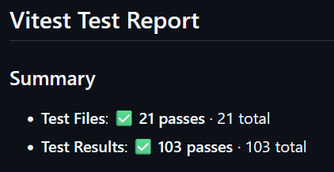

Testing Metrics
These are the testing metrics that we are currently using. However, as the scope and the project expands, there might be additional metrics added.

Metric Name
Total Number of Test Cases | - Front-end: 103 tests  - Back-end: 74 tests
Unit Test Suite Passing | Both front-end and back-end unit tests must pass 100%
Unit Test Per Method | At least 2 unit tests per API and
Total Number of Feature Test Cases | - Iteration 2: 9 System tests

AI usage Log

Section | Who | AI contribution (%) | Description | Verified by
Manual Testing Report | Italia Tran | 90% | Used AI to pull all the current user stories from the project and render them as a table | Italia Tran
Manual Testing Report | Italia Tran | 90% | Used AI to render user stories and the associated system test as a table specific to iteration 2 | Italia Tran

References
  - AI Usage Log - Manual Testing Report Chat
  - AI Usage Log - Manual Testing Report Iteration 2

Glossary

