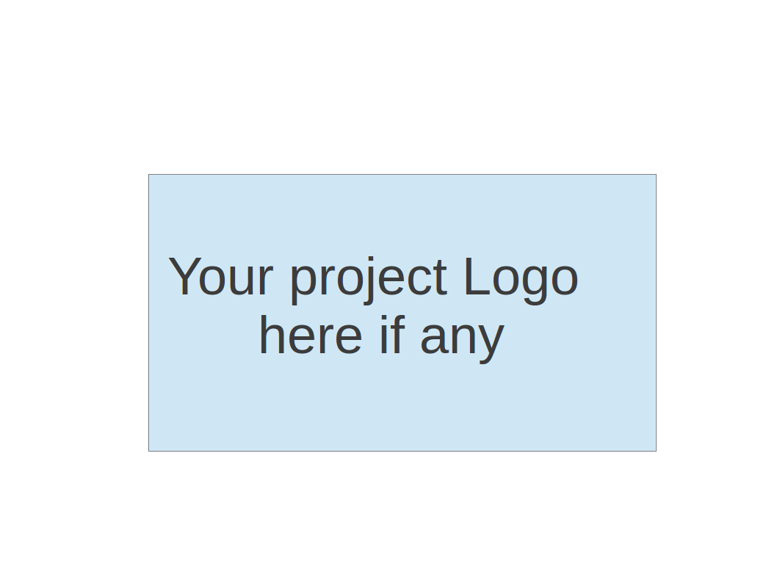
CS673 Software Engineering
Team 1 - BlueJay
Project Proposal and Planning

Team Member | Role(s) | Signature | Date
Sara Orion | Team & Security Lead | Sara Orion | 09/09/2026
Kimleng Lim | Design & Implementation Lead | KimlengLim | 09/09/2026
Krizma Nagi | Requirement Lead | KrizmaNagi | 09/09/2026
Andy Chang | Configuration Lead | Andy Chang | 09/09/2026
Italia Tran | QA Lead | Italia Tran | 09/09/2026

Revision history
Version | Author | Date | Change
1.0.0 | Kimleng Lim | 09/09/2026 | Add Related Work section  Add Functional Requirement Section
1.0.1 | Krizma Nagi | 09/09/2026 | Added information to section 3b
1.0.2 | Italia Tran | 09/09/2026 | Added section 6
1.0.3 | Sara Orion | 09/09/2026 | Added sections 1, 4, 5

1. Overview
2. Related Work
3. Proposed High level Requirements
4. Management Plan
a. Objectives and Priorities
b. Risk Management (need to be updated constantly)
c. Timeline (this section should be filled in iteration 0 and updated at the end of each later iteration)
5. Configuration Management Plan
a. Tools
c. CI/CD Plan
6. Quality Assurance Plan
a. Metrics
c. Code Review Process
d. Testing
e. Defect Management
7. AI usage Log
8. Project Links
9. References
10. Glossary

Overview

Motivation
Small-to-medium grocery and retail store owners often struggle with fragmented management tools—relying on terminal-based legacy software, manual invoice processing, or paper-based stock tracking. Existing Point of Sale (POS) solutions are either expensive enterprise applications or desktop-locked scripts that lack modern web accessibility, multi-user concurrency, and automated data entry.

Purpose
BlueJay transforms a legacy Java console POS application into a secure, multi-tenant web platform designed specifically for small grocery store operations. The application streamlines daily store workflows by providing a responsive web interface for cashiers and store managers, automated low-stock warnings during checkout, robust role-based access control, and modern AI-driven receipt scanning and inventory forecasting to eliminate manual data entry.

Target Users
- Store Administrators: Require high-level oversight of user management, sales reporting across custom date ranges, macro-financial health tracking, and system configuration.
- Stock Managers: Require tools to manage product catalogs, record incoming supplier inventory batches, view real-time stock levels, and upload supplier delivery invoices for automated AI parsing.
- Cashiers: Require a fast, reliable web-based checkout counter interface to process customer transactions, verify product pricing, receive low-stock alerts, and print or generate receipts.

Basic Functionality
- Role-Based Authentication & Session Control: Secure server-side access control separating Admin, Stock Manager, and Cashier capabilities with automated session timeouts on shared counter terminals.
- Point-of-Sale Web Checkout: Digital sales execution, product price lookups, real-time stock updates upon purchase completion, and live low-stock alerts on the counter display.
- Inventory & Catalog Management: Product catalog creation, barcode mapping, stock batch entry validation, and comprehensive date-range inventory valuation reports.
- AI-Driven Automation: Automated supplier invoice/receipt scanning (OCR parsing) to automatically populate incoming stock batches and costs, alongside predictive time-series machine learning models for demand forecasting and reorder recommendations.
- Relational Database Backend: Migration from legacy single-user SQLite to RDB which supports multi-user concurrency without data collisions.

Technology Stack
- Frontend: Angular, TypeScript, HTML5/SCSS, Responsive Web Layout (optimized for counter displays and tablets).
- Backend: Java 17+, Spring Boot (REST API, Spring Security, Spring Data JPA).
- AI Integration: Spring AI / OpenAI / Ollama API (for invoice OCR parsing and demand forecasting).
- Database: TBD
- Testing & Tools: JUnit 6, JaCoCo, Git/GitHub, GitHub Actions (CI/CD).

Related Work
BlueJay is a lightweight, web-based Point of Sale (POS) system migrated from a legacy JPOS console application. It is designed for small grocery store owners to streamline product catalogs, track inventory, execute customer sales and sale reports. Additionally, the web platform introduces modern AI-driven features to automate manual workflows, reduce human error, and help store owners make data-backed purchasing decisions.

Proposed High Level Requirements

Functional Requirements
    - Essential Features
- Real-Time Low-Stock Checkout Alerts: As a Cashier, I want to see immediate visual warnings on the checkout screen if an item’s stock is low, so that I can notify the team to restock the shelf.
- Relational Database Infrastructure Migration: The system should migrate legacy SQLite data into a secure, multi-user relational database (e.g., PostgreSQL), so that the system handles concurrent cashier and manager requests without data collisions.
- Responsive Frontend Layout: The system should provide an adaptive web layout optimized for desktop screens, so that the interface remains functional on different hardware setup at the counter.

    - Desirable Features
- AI Supplier/Restock Receipt Scanner: As a Stock Manager, I want to upload a photo of a physical supplier delivery invoice and have the system parse it using AI (OCR), so that stock items, quantities, and cost prices are automatically populated without manual data entry.
- AI Smart Restock & Demand Forecasting: As an Admin or Stock Manager, I want the system to apply a predictive time-series machine learning model to historical sales records, so that it can forecast future product demand and generate optimized reorder quantities automatically.

    - Existing Features
- Admin Preloading: The system shall have exactly one preloaded Admin user when the application is initialized.
- Create Users: As an Admin, I want to create new user profiles specifically assigned to the Stock Manager, or Cashier roles, so that I can onboard store staff.
- View Users: As an Admin, I want to view a comprehensive list of all users registered in the system, so that I can audit who has system access.
- Access Authorization: The system should dynamically grant or restrict feature access based on the assigned roles, so that unauthorized actions are prevented.
- Multi-User Session Management: The system should safely log in and out of the shared computer, so that multiple users can operate the system securely across different shifts.
- Add New Product: As an Admin or Stock Manager, I want to add new products to the catalog by inputting their barcode, name, and category, so that they become available for inventory management.
- View Product Catalog: As an Admin or Stock Manager, I want to view the entire product catalog, so that I can verify existing product details and configurations.
- Stock Entry: As an Admin or Stock Manager, I want to record new batches of incoming stock items, so that our on-hand inventory levels are kept up to date.
- Stock Entry Validation: As an Admin or Stock Manager, I want the system to validate that a product already exists in the catalog before allowing a stock entry for it, so that database consistency is preserved.
- Core Inventory Report: As an Admin or Stock Manager, I want to view an inventory report showing each product, its latest cost, and its total on-hand stock quantity, so that I can see current warehouse levels at a glance.
- Execute Sale: As a Cashier, I want to perform a web-based checkout for customers, so that I can process retail sales digitally at the counter.
- Price Lookup: As a Cashier, I want to search and check the latest price of a specific product, so that I can quickly answer customer pricing inquiries.
- Print Receipt: As a Cashier, I want to view or print a structured receipt at the end of a transaction, so that I can provide proof of purchase to the customer.
- Sale Report by Date Range: As an Admin, I want to view a consolidated sales report for a selected period detailing total revenue, cost, and net profit, so that I can monitor the store’s macro-financial health.
- Product-Level Sale Analysis: As an Admin, I want to view the quantity sold, total cost, and profit calculated for each individual product within a selected timeframe, so that I can identify high-performing and low-performing inventory.
- Inventory Update After Sale: The system should automatically decrease a product’s inventory count immediately following a successful sale, so that inventory reflections remain accurate in real time.
- Inventory Report by Date Range: As a Stock Manager, I want to view a historical inventory report for a selected period showing total inventory value, product count, and item status, so that I can make data-driven stocking decisions over time.
    - Optional Features (additional cool features that you want to have if there is time):
- Sales/Inventory Report Export (CSV/Excel): As an admin, I want to export sales and inventory reports to a CSV or Excel file, so that I can analyze the data further or share it out of the system
- Barcode Scanner Hardware Integration: As a cashier, I want to scan a product barcode using a USB or camera-based scanner instead of typing it manually, so that checkout is faster and less error prone
- Email Receipt Option: As a cashier, I want to send a digital receipt to a customer’s email instead of printing one, so that we reduce paper use and give customers a saved copy
- Multi-Location Inventory View: As an admin, I want to view inventory levels across multiple store location (if applicable), so that I can make transfer for reorder decisions across the business

Nonfunctional Requirements
    - Security requirements
      - User passwords must be securely hashed and never stored or logged in plaintext
      - Role based access control must be enforced server-side on every request, not only hidden/disabled in the UI, so that a cashier cannot access admin or stock manager functionality by directly calling an endpoint
      - User sessions must automatically time out after a period of inactivity on the shared checkout terminal, so that an unattended session cannot be misused by another user
      - All data in transit (including login credentials and uploaded receipt images) must be encrypted via HTTPS/TLS
      - Uploaded supplier invoice images (for the AI receipt scanner) must be handled securely and retained only as long as needed for processing, given they may contain sensitive supplier/pricing information
      - Database access must be parameterized queries/prepared statements throughout to prevent SQL injection
    - Performance
      - Checkout (execute sale) transactions should complete and confirm to the cashier within two seconds under normal load
      - Report generation (sale report, inventory report) should return results within 5 seconds for a typical single store dataset
    - Scalability
      - The system must support multiple concurrent cashier and manager sessions against the same database without data collisions or lost updates (directly motivating the postgreSQL migration)
      - The architecture should allow additional store terminals or locations to be added without major redesign
    - Reliability & Availability
      - The system should degrade gracefully if the AI/OCR or forecasting service is temporarily unavailable — e.g., falling back to manual stock entry rather than blocking the workflow entirely.
      - Core POS functions (checkout, price lookup, inventory lookup) should remain available during store operating hours with minimal planned downtime.
    - Compatibility
      - The web application must function correctly on the latest two major versions of Chrome, Firefox, and Edge.
      - The responsive layout must remain usable across common desktop and tablet screen resolutions used at checkout counters.
    - Maintainability
      - The codebase should preserve the existing modular architecture (model/repository/service/facade layering) so new features can be added without disrupting existing modules.
      - Automated test coverage should be maintained above the project's established threshold (consistent with existing JaCoCo coverage targets) for all new and modified modules.
    - Usability
      - The interface should be usable by non-technical store staff with minimal training, given high staff turnover common in retail/grocery settings.

Management Plan

Objectives and Priorities
The primary goal of the BlueJay POS web migration project is to deliver a secure, production-ready, multi-tenant web application while maintaining high software engineering quality and test coverage across three iterations.
    - High Priority (Core Success Criteria):
      - Complete Migration & Multi-User Concurrency: Successfully migrate domain logic from single-user SQLite to a multi-user relational database backend (e.g., PostgreSQL, MySQL) to eliminate database locking during concurrent cashier transactions.
      - Security & Role-Based Access Control: Implement secure server-side session management and strict role-based access control (Admin, Stock Manager, Cashier) with password hashing.
      - Web POS Checkout & Inventory Management: Deliver responsive Angular web interfaces for real-time checkout, low-stock counter alerts, catalog creation, and sales reporting.
      - High Software Quality: Maintain high unit test coverage (using JUnit and Mockito) and zero high-severity defects across core service modules.
    - Medium Priority:
      - AI-Driven Automated Restock: Integrate Spring AI to parse supplier receipt images/PDFs via OCR and automatically populate incoming stock batches and costs.
      - CI/CD Automation: Establish GitHub Actions automation for automated test execution, code coverage reporting (JaCoCo), and release builds.
    - Low Priority / Optional:
      - Advanced Analytics & AI Forecasting: Implement demand forecasting models for restock suggestions, report export functionality (CSV/Excel), and digital email receipt options.

Risk Management
The project risk management strategy focuses on early identification, continuous monitoring, and proactive mitigation across key engineering categories. High-priority risks and mitigation protocols identified in the project risk matrix include:
- Design & Architecture Risks (Improper Design / Tech Stack):
  - Risk: Inappropriate architectural choices or stack selection could lead to system complexity, maintainability issues, or performance bottlenecks during multi-user web migration.
  - Mitigation: Architecture reviews conducted by the Design & Implementation Lead prior to major feature additions; keeping component boundaries modular and simple.
- Requirements & Scope Control (Unclear Requirements / Scope Creep):
  - Risk: Frequent changes or underspecified user stories can lead to unnecessary rework and missed release deadlines.
  - Mitigation: Backlog items require explicit acceptance criteria before work begins; new feature requests are triaged in GitHub Projects and deferred if capacity is constrained.
- Testing & Quality Assurance (Insufficient Coverage):
  - Risk: Inadequate unit testing coverage leading to late-stage integration defects.
  - Mitigation: Automated CI/CD test gates via GitHub Actions enforce agreed coverage thresholds (monitored via JaCoCo), blocking pull request merges if coverage drops.
- Personnel & Coordination (Lack of Motivation / Misaligned Tasks):
  - Risk: Missed individual deadlines or improper task distribution based on member bandwidth.
  - Mitigation: Work is broken into granular sub-tasks with assigned owners and hard due dates, tracked asynchronously and during regular standups.
The complete risk breakdown, priority scores, and detailed mitigation plans are maintained in the team sheet: CS673_SPPP_RiskManagement_team1

Timeline
(The estimated hours should be realistic)
Iteration | Functional Requirements (Essential/ Desirable/ Optional) | Tasks (Cross requirements tasks) | Estimated/real total person hours
1 | Essential Features: Relational Database Infrastructure Migration (PostgreSQL), Core User Authentication & Session Management, Web Checkout Interface Baseline, Product Catalog API. | Set up team GitHub repo, establish GitHub Actions CI/CD pipeline, define DTO contracts, establish JUnit/Mockito unit test suites, configure JPA entity mappings. | 120
2 | Essential Features: Real-Time Low-Stock Checkout Alerts.  Desirable Features: AI Supplier/Restock Receipt Scanner (Spring AI OCR Integration). | Frontend-backend REST API integration, complete role-based authorization security filters, implement JaCoCo test coverage reporting, execute system testing. | 120
3 | Desirable Features: AI Smart Restock & Demand Forecasting.  Optional Features: Sales/Inventory Report Exporting (CSV/Excel), Digital Email Receipts. | End-to-end integration testing, defect remediation, production deployment configuration, demo video production, final SPPP document update. | 100

Configuration Management Plan

Tools
    - Integrated Development Environments (IDEs): Developers may select their tool of choice based on preference:
      - IntelliJ IDEA: Recommended for Java / Spring Boot backend service development, Maven management, and database tooling.
      - Visual Studio Code: Recommended for Angular / TypeScript frontend development, featuring native Angular Language Service integration and linting plugins.
    - Version Control: GitHub (git) will serve as the single source of truth for all source code, documentation, database scripts, and assets.
    - Project Tracking: GitHub Projects (Kanban board) will be used for agile task management, backlog prioritization, iteration planning, and assigning task ownership.
    - Continuous Integration & Delivery: GitHub Actions will manage automated workflow pipelines for code compilation, execution of unit test suites, code coverage generation, and release packaging.

Code Commit Guideline and Git Branching Strategy
    - Branching Model:
      - main: Production-ready code. Protected branch requiring pull request reviews before merging.
      - develop: Integration branch for active iteration development.
      - feature/<GH Issue #>-<feature-name>: Short-lived topic branches for individual user stories or task implementations.
      - bugfix/<GH Issue #>-<issue-name>: Branches dedicated to defect remediation.
    - Code Review & Merge Policy: All feature branches must submit a Pull Request (PR) to develop. Merges require at least one peer approval (managed by QA Lead) and passing automated CI build/test gates.

CI/CD Plan
    - Automated Builds: Every commit or PR pushed to develop or main automatically triggers a GitHub Actions workflow that executes Maven clean compile targets for the Spring Boot backend and NPM builds for the Angular frontend.
    - Automated Testing: Automated execution of JUnit/Mockito test suites and JaCoCo coverage reporting occurs on every pull request. PRs will fail if test suites fail or code coverage drops below agreed team thresholds.

Quality Assurance Plan

Metrics

Metric Name | Description
Unit Test Suite Passing | Each unit test created for each iteration should pass, giving 100% passing rate for the suite
Unit Test Per Method | Each method should have at least 2 unit tests: one happy path and one bad path
Logging For All Methods | Each method should have a logger to know when something is triggered during success or failure

  - Coding Standard
As this is a Boston University class, we will be adhering to the coding standard set by CS112 as noted here: https://www.cs.bu.edu/courses/cs112/problem_sets/coding_standards.html

Any additional standards that are agreed upon as a group will be updated here as well.

Code Review Process
Any update to the repository will be done via PR and merge into the main branch. However, the reviews will depend on the type of update:
- Code Changes: Review should be done as a team with a minimum approval for the code change to be merged into a selected branch be set at two different team members. This should ensure that all code changes be viewed by everyone, and allows at least 60% (including owner of PR) approval before merging.
- Adding documentation: No review will be necessary, as adding documentation does not affect the application build or status.

Testing
The framework that will be used for unit testing will be JUnit 6 as that is the current version for the framework. However, this is subject to change based on the Java version that we will be using due to dependencies.

As JUnit does not have a mocking system built in. Any mocks will use Mockito 5 to build mock objects for unit testing. Again, this is subject to change based on dependency issues.

There will be two types of testing:
- Unit Testing
  - Each individual method that is created for the project shall have their own unit test. All unit tests must pass before the iteration can be considered complete.
- System Testing
  - This testing will be done per iteration and will be testing the entire application/system as a whole.

Defect Management
Any new defects should be logged in GitHub as a new issue with the owner of the issue being the person who wrote the code as that person is the best fit to understand how to fix it. The issue should try to have the failure log and identifying objects to try and replicate so that the root cause can be easily identified and fixed.

AI usage Log
(This table summarizes AI contribution in this document)
Section | Who | AI contribution (%) | Description | Verified by
1, 4.a-c, 5 | Sara Orion | 75% | Assisted with drafting Overview, Management Plan, and Configuration Management sections | Sara Orion

Project Links
Github link: https://github.com/BUMETCS673/CS673OLF26P1
Project management tool link (GitHub Projects): https://github.com/orgs/BUMETCS673/projects/32

References
(Any references/citations that you have used)

Glossary
(Any acronym used in the document should be explained here)

