CS673 Software Engineering
Team 2 - Cadence
Software Design Document

Team Member | Role(s) | Signature | Date
Miles Cameron | Team Leader, Security Leader | Miles Cameron | 9/21/26
Nurzat Mukhamedali | Requirements Leader | Nurzat Mukhamedali | 9/21/26
Duc Anh Nguyen | DevOps Leader | Duc Anh Nguyen | 9/21/26
Osasenaga Von Okunbor | QA Leader | Osasenaga Von Okunbor | 9/21/26

Revision history
Version | Author | Date | Change
1 | Duc Anh Nguyen | 9/22/26 | Initial draft for all sections (Iteration 1)
2 | Miles Cameron | 10/5/26 | Iteration 2: added architecture, class, and sequence diagrams; described the system as built (scheduler, study endpoints, schema, routes, REST API, design patterns); marked AI generation as planned for Iteration 3; updated the security design (CSRF, cookies, HTTPS) and deployment status.

● Introduction
● Software Architecture
● Class Diagram
● UI Design (if applicable)
● Database Design (if applicable)
● Security Design
● Business Logic and/or Key Algorithms
● Design Patterns
● Rest APIs
● Any Additional Topics you would like to include.
● AI usage Log
● References
● Glossary

Introduction

This document describes the design of Cadence, a web-based spaced-repetition learning platform that uses generative AI to author flashcards. It covers the system architecture, main classes, user interface, database schema, security design, key algorithms, design patterns, and REST API. It is updated at the end of every iteration.
Cadence keeps Anki's proven scheduling model and addresses two of its limitations: the effort of building decks by hand, and the rigid reveal-and-self-grade review format. Users sign in, manage personal decks and cards, generate candidate cards from a prompt with an LLM, review and edit those candidates before saving, and study with a scheduler that shows each card when reinforcement is most valuable.

Design goals
Separation of concerns: a React single-page frontend and a Flask REST backend that communicate only through a documented JSON contract, so both sides can be developed and tested in parallel.
Per-user data isolation: every deck, card, and review belongs to exactly one user and is only reachable by that user.
Isolated, testable business logic: the scheduler is a pure module that imports nothing from Flask or the database and never reads the clock, so it can be unit tested without HTTP, a database, or waiting. AI generation will follow the same rule.
Safe AI integration (Iteration 3): LLM output is treated as untrusted input, validated against a schema, and never saved without the user's review.
Reproducible delivery: the same Docker images are built and scanned in CI and published for deployment, and Docker Compose runs the whole stack locally.
Secure by default: hashed passwords, hardened session cookies, ownership checks on every operation, and no secrets in source code.
Status at Iteration 2: accounts, deck and card management, and study mode are built and tested. AI card generation is designed but not yet built. It is planned for Iteration 3 and is marked as planned wherever it appears below.

Software Architecture

Cadence uses a three-tier, client-server architecture deployed as a monolithic backend (the team chose a monolith for simplicity; services are separated by module, not by process).
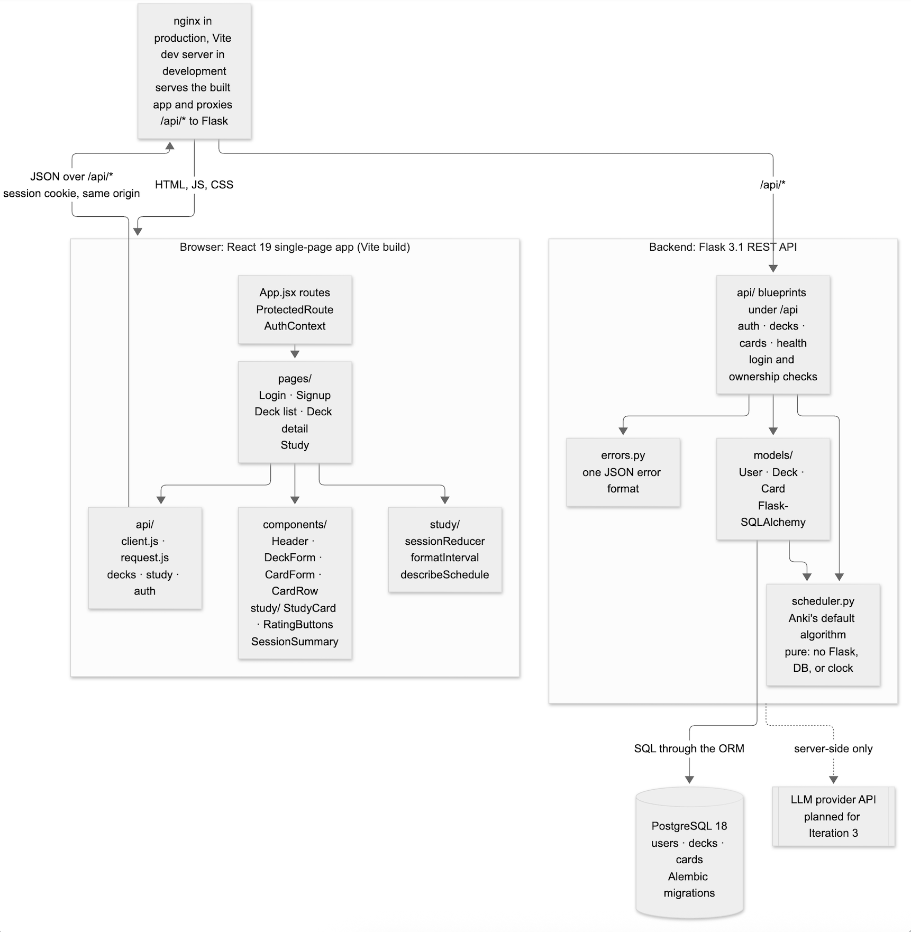
Component | Location | Responsibility | Framework / technology
Frontend | code/frontend/src | Screens, forms, client-side routing, signed-in state, study-session state, API calls | React 19, React Router 7, Vite 7; nginx serves the production build
API layer | code/backend/app/api | HTTP routes, request validation, authentication and ownership checks, JSON responses | Flask 3.1 blueprints, Flask-Login
Scheduler | code/backend/app/scheduler.py | Anki’s default scheduling algorithm and the interval previews on study cards. Pure: no Flask, database, or clock | Python standard library
Data layer | code/backend/app/models, migrations | ORM models, relationships, schema migrations | Flask-SQLAlchemy, Alembic (Flask-Migrate)
Error handling | code/backend/app/errors.py | One JSON error format and HTTP status mapping for the whole API | Flask error handlers
Database | PostgreSQL service | Persistent storage of users, decks, cards, and review history | PostgreSQL 18
Third-party API (planned, Iteration 3) | Third-party API | Will generate candidate flashcards from a user prompt | LLM provider configured by environment variable
Demo data | code/backend/app/seed.py | flask seed [--reset] loads a demo user and two decks with cards in every state; flask time-travel moves due dates for demos | Flask CLI

Interfaces and dependencies
- The frontend depends only on the REST API under /api. In development the Vite dev server proxies /api to Flask; in production nginx serves the built files and proxies /api to Flask, so the browser sees a single origin
- The API layer depends on the models and the scheduler. The models use the scheduler to compute interval previews. The scheduler depends on nothing else in the application.
- Only the backend talks to the database and the LLM API. API keys never reach the browser.
- The frontend and backend share a contract of paths, JSON field names, and error codes ({"error": {"code", "message", "field"}}).

Deployment
Both tiers are packaged as Docker images (multi-stage Dockerfiles with a prod target) and run locally with Docker Compose. GitHub Actions runs CI on every push and pull request. After CI passes on develop or main, the CD workflow publishes both images to GitHub Container Registry, tagged with the commit SHA. render.yaml and the CD workflow define a Render staging environment (from develop) and production (from main), where Render runs flask db upgrade on each deploy and CD waits for /api/health. The Render deploy hooks are not configured yet, so the deploy step is skipped and the application is demonstrated locally.

Class Diagram

Figure 2 shows the backend’s classes and their relationships. Figure 3 shows the frontend’s main modules.
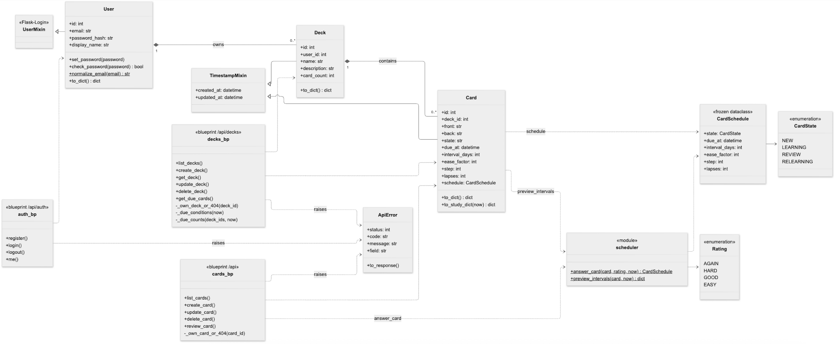

Figure 2. Backend classes.

Backend: models (code/backend/app/models)
- TimestampMixin – adds created_at and updated_at.
- User (Flask-Login UserMixin) – email (stored trimmed and lowercased), password_hash, display_name; set_password(), check_password(), to_dict(). Owns many Decks, which are deleted with the user.
- Deck – name, description, and card_count, which is counted in SQL rather than by loading the cards. Owns many Cards, which are deleted with the deck.
- Card – front and back, plus Anki’s scheduling fields: state, due_at (null while new), interval_days, ease_factor (in thousandths: 2500 = 250%), step, and lapses. The schedule property converts these to and from a CardSchedule. to_study_dict(now) adds the interval previews, which only the study endpoints send.
Backend: scheduler (code/backend/app/scheduler.py)
- CardState (new, learning, review, relearning) and Rating (again, hard, good, easy).
- CardSchedule – a frozen dataclass holding a card’s scheduling fields.
- answer_card(card, rating, now) – the card’s next schedule (section 7.1).
- preview_intervals(card, now) – how long until the card would be due for each rating, found by calling answer_card() once per rating.
Backend: api (code/backend/app/api)
- auth – register, login, logout, me.
- decks – deck CRUD; get_due_cards() for a study session; due_counts on every deck, computed by _due_counts() from the same _due_conditions() the session uses; _own_deck_or_404().
- cards – card CRUD; review_card() saves a rating; _own_card_or_404().
- errors.py – ApiError and the helpers (not_found(), validation_error(), conflict()) that produce the one JSON error format.
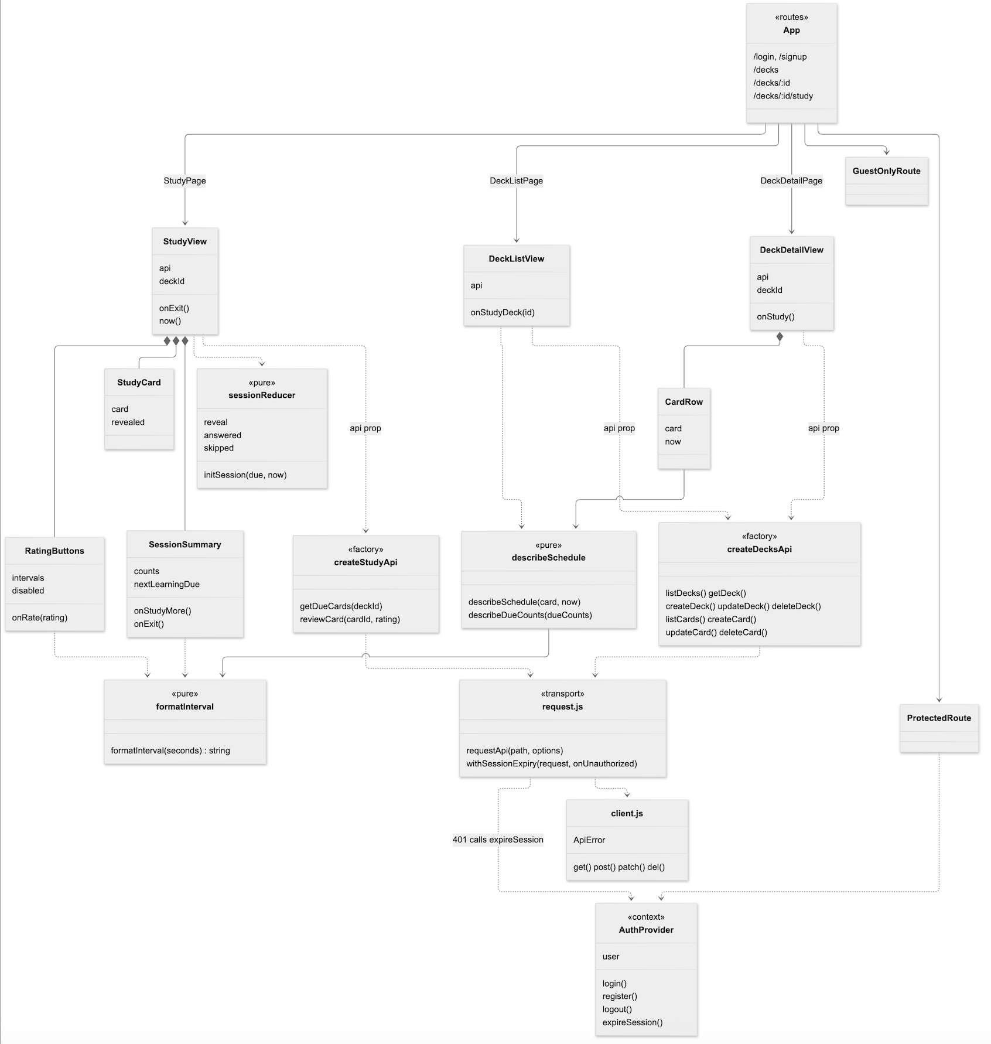
Figure 3. Frontend Modules

Frontend (code/frontend/src)
- pages – each route is a thin page that reads the router and hooks, and renders a view that takes api as a prop: DeckListView, DeckDetailView, and StudyView, plus LoginPage and SignupPage.
- components – Header, DeckForm, CardForm, CardRow (with a schedule badge), and study/StudyCard, study/RatingButtons, and study/SessionSummary.
- study – sessionReducer (card order, reveal, answered, skipped), formatInterval() (seconds to labels like 10m, 25d, 1.5mo), and describeSchedule() (badges like “Review · in 25d”). All pure.
- api – client.js (the fetch wrapper and ApiError), request.js (transport and 401 handling), createDecksApi and createStudyApi (one function per endpoint), useDecksApi and useStudyApi (hooks that sign the user out on a 401), and auth.js.
- auth – AuthContext (signed-in user state), ProtectedRoute and GuestOnlyRoute, and form validation.
Planned for Iteration 3: a generation module (prompt building, provider client, output validation) and its blueprint, added to Figure 2 when built.

UI Design (if applicable)

The UI is a single-page application with client-side routing. Signed-out users can only reach Login and Signup; all other routes are wrapped in ProtectedRoute, which redirects to Login when /api/auth/me returns 401.

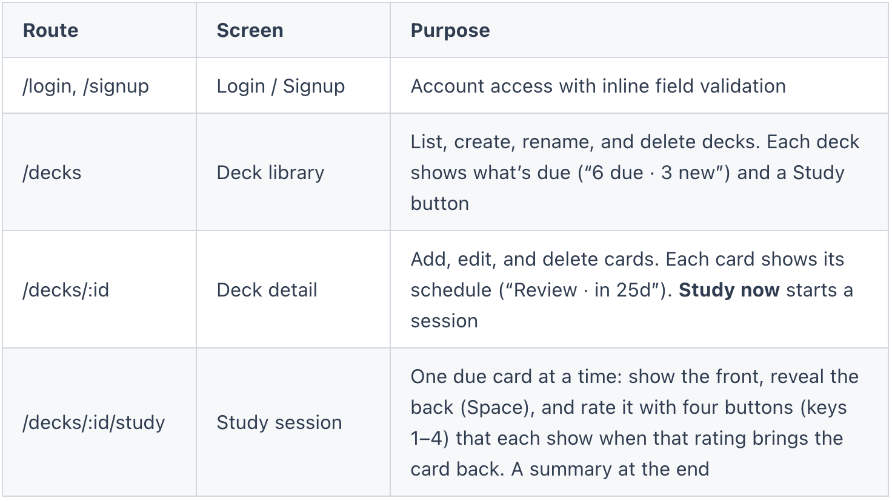

Every page uses one design system, defined in styles.css: Inter for text and Plus Jakarta Sans for headings, navy text, blue for anything clickable, and gold as an accent, with shared classes for buttons, fields, panels, badges, alerts, and empty, loading, and error states. Every text color meets WCAG AA contrast, and every interactive element has a visible focus ring. AI generation (/decks/:id/generate) is planned for Iteration 3.

Database Design (if applicable)

PostgreSQL 18, accessed through SQLAlchemy and versioned with Alembic migrations: 0001 created the three tables and 0002 added the scheduling columns. CI applies the migrations to an empty database, checks that they match the models, and runs each downgrade.

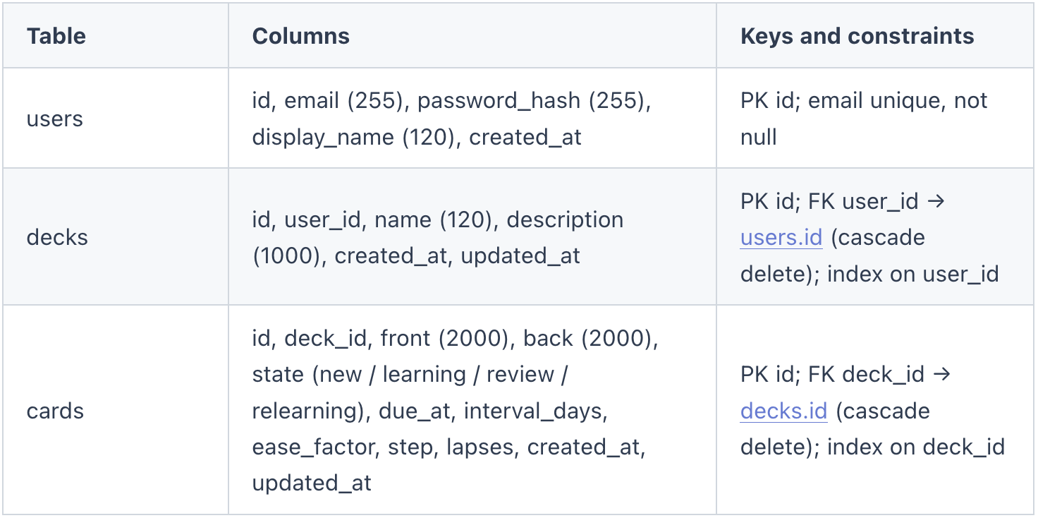
A new card has state = new, due_at = null, ease_factor = 2500 (250%), and interval_days, step, and lapses = 0. It enters a study session through the new-card queue, not by due date. There is no review-history table yet; one would be needed for per-day limits and statistics.

Security Design
(In this section, you shall describe any security design in your software system.)

- Authentication: session-based login with Flask-Login. Passwords are hashed with Werkzeug (salted, never stored or logged in plain text).
- Session cookies and HTTPS: cookies are always HttpOnly and SameSite=Lax. Secure is set by SESSION_COOKIE_SECURE, which render.yaml sets to 1 because Render terminates TLS, so a deployed session cookie is only ever sent over HTTPS. Local Docker Compose runs over plain HTTP with Secure off. No hosted deployment is live yet (section 2).
- Account enumeration protection: login returns the same generic error for an unknown email or a wrong password, and checks a dummy hash so response time does not reveal which emails exist. Emails are trimmed and lowercased.
- Cross-site request forgery: the app doesn’t use CSRF tokens. It relies on four things instead. SameSite=Lax stops the browser from sending the session cookie on cross-site POST, PATCH, and DELETE requests. Every endpoint that takes a body accepts only JSON (Content-Type: application/json), which an HTML form on another site cannot send. Another site’s script can only send JSON after a CORS preflight, and the backend sends no CORS headers, so the preflight fails. GET requests never change data. The frontend and API share one origin, so none of this restricts the app itself.
- Authorization: every deck, card, and study route requires login and loads records through _own_deck_or_404() or _own_card_or_404(). Another user’s record returns 404, so its existence isn’t revealed. Tests check this on every route, including that reviewing another user’s card changes nothing.
- Input validation: field types and lengths are checked on every request, and ratings against the four allowed values. Request bodies are limited to 1 MB, and a malformed or non-JSON body gets a 400 in the standard error format.
- Review integrity: a card that isn’t due yet can’t be reviewed (409), and the study page sends one review per card shown, so a double click can’t push a card’s interval out twice.
- SQL injection prevention: all queries go through the SQLAlchemy ORM with bound parameters; no raw SQL string building.
- AI safety (planned, Iteration 3): the LLM API key is stored only in backend environment variables. LLM output is validated against a Pydantic schema, length-limited, and rendered as plain text (never as HTML). Generation requests are rate-limited per user to control cost and abuse.
- Secrets: SECRET_KEY and DATABASE_URL come from the environment, and Render generates SECRET_KEY on first deploy. .env is git-ignored, and .env.example documents the variables.
- Tooling: CodeQL static analysis on every push and pull request; Trivy scans both Docker images on every CI run and fails on any fixable HIGH or CRITICAL vulnerability; Dependabot security alerts are on; .github/SECURITY.md explains how to report a vulnerability privately.

Business Logic and/or Key Algorithms

7.1 Spaced-repetition scheduling (Anki’s default algorithm)
The scheduler implements Anki’s default scheduler with Anki’s default settings. It leaves out the random “fuzz” Anki adds to review intervals, so every result is testable. It was written from Anki’s documented rules, not copied from Anki’s AGPL source. Settings: learning steps 1m and 10m; graduating interval 1 day; easy interval 4 days; relearning step 10m; starting ease 250%; minimum ease 130%; easy bonus 1.3; hard interval 1.2; maximum interval 36,500 days.
answer_card(card, rating, now):
if card.state == REVIEW: return answer_review(card, rating, now)
return answer_in_steps(card, rating, now) # new, learning, relearning

answer_in_steps(card, rating, now):
steps = [10m] if card.state == RELEARNING else [1m, 10m]
AGAIN: step = 0; due = now + steps[0]
HARD: stay on this step; due = now + (this step, or on step 0 the average
of the first two steps, or 1.5 x the only step)
GOOD: if another step remains: step += 1; due = now + steps[step]
else graduate
EASY: graduate
graduate: state = REVIEW
new or learning card: interval = 1 day (GOOD) or 4 days (EASY); ease = 250%
relearning card: interval = interval set at the lapse (+1 day on EASY)
due = now + interval

answer_review(card, rating, now):
AGAIN: state = RELEARNING; step = 0; due = now + 10m
lapses += 1; ease = max(130%, ease - 20%); interval to return to = 1 day
late = days since due_at
hard = max(round(interval x 1.2), interval + 1)
good = max(round((interval + late / 2) x ease), hard + 1)
easy = max(round((interval + late) x ease x 1.3), good + 1)
HARD: ease = max(130%, ease - 15%); interval = hard
GOOD: interval = good
EASY: ease = ease + 15%; interval = easy
due = now + min(interval, 36500) days

Example: a review card with a 10-day interval and 250% ease, answered 4 days late, gives Again 10m, Hard 12d, Good 30d, and Easy 46d. It is one of the unit tests’ reference cases. A review before the card is due is refused with 409, because Anki’s early-review formula isn’t implemented.
7.2 Study session
GET /api/decks/{id}/due returns three lists, all computed at one moment: learning (learning and relearning cards due within the next 20 minutes, the learn-ahead window), review (review cards due now, at most 200), and new (at most 20). Each card carries intervals, the seconds until it would be due for each rating, from preview_intervals(). The frontend only formats these numbers; it never computes an interval.
The study page keeps the session in sessionReducer, which shows due learning cards first, then reviews, then new cards. Space reveals the answer, and a click or keys 1–4 rate it. Each rating sends POST /api/cards/{id}/review. The response is the rescheduled card, which the reducer puts back into the session if it is a learning card due within the learn-ahead window. A 409 or 404 skips the card. When nothing is left, SessionSummary shows the count for each rating. Every answer is saved as it happens, so a refresh loses only the session’s counts.
The due_counts on each deck come from the same conditions and caps as these lists, so the number on the Study button is the number of cards the session serves.
7.3 Reviewing a card
Figure 4 shows one rating, from the key press to the next card.
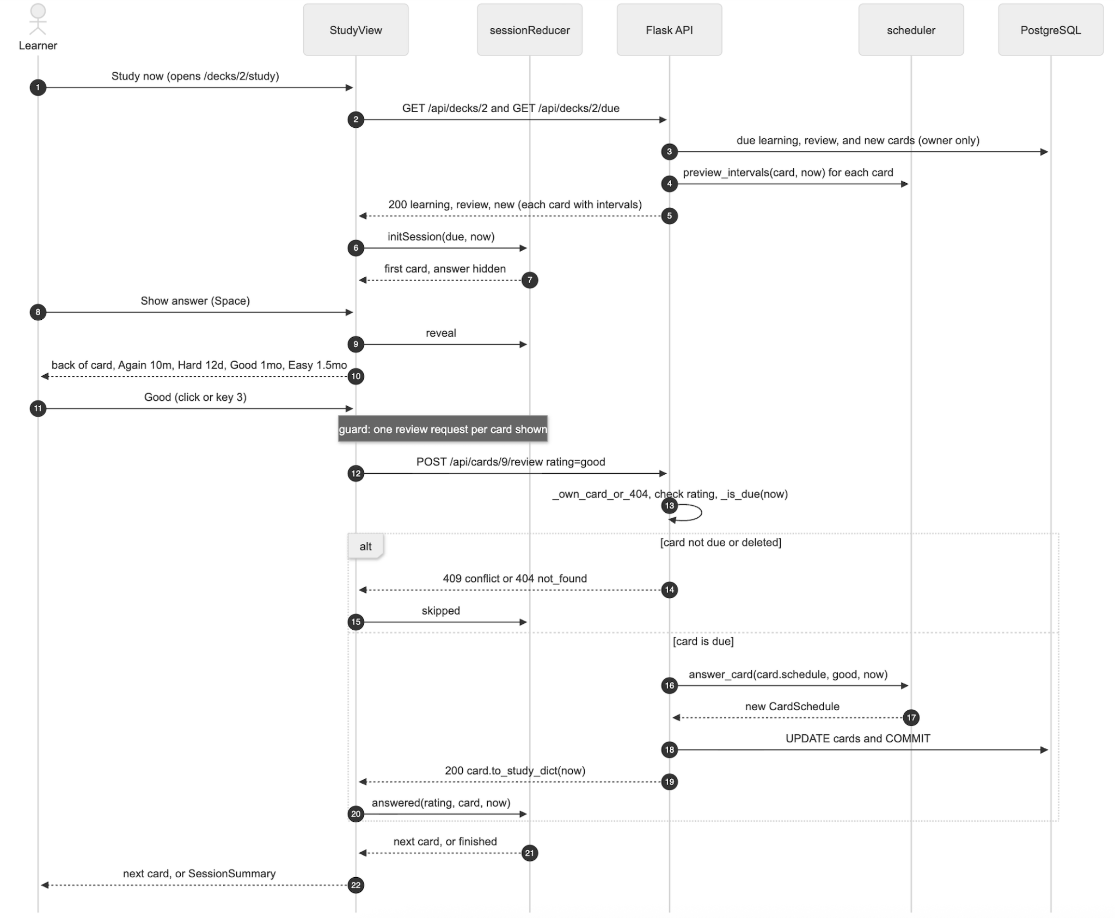

7.4 AI deck generation
- The user enters a topic or prompt and a number of cards.
- CardGenerator builds a structured prompt that asks for JSON matching the GeneratedDeck schema (front, back, card_type, choices).
- The response is parsed and validated with Pydantic. Invalid items are dropped; if nothing is valid, the request is retried once and then fails with a clear error.
- DuplicateDetector normalizes text and compares each candidate with the deck's existing cards and the other candidates, flagging likely duplicates.
- Candidates are returned to the browser but not saved. The user edits, accepts, or discards each one, and only accepted cards are saved.

Design Patterns

- Application Factory – create_app(config) builds the Flask app, so tests, CLI, and production each get an app with their own configuration.
- Blueprint (modular routing) – auth, decks, and cards routes are separate blueprints registered under /api.
- Active Record / ORM – SQLAlchemy models map directly to tables and carry their own persistence and serialization (to_dict()).
- Mixin – TimestampMixin reuses the timestamp columns across models.
- Decorator – @login_required adds authentication to routes without changing their code.
- Provider / Context – React AuthContext shares the signed-in user across components.
- Factory Method – error helpers (not_found(), validation_error(), etc.) create consistent ApiError objects.
- Functional core, imperative shell – the scheduler is pure functions over an immutable CardSchedule (a value object). The route does the I/O: it reads the card and the clock, calls the scheduler, and saves the result.
- Reducer (state machine) – the study session is a pure reducer with three actions (reveal, answered, skipped), used through React’s useReducer.
- Dependency injection / Strategy – views take api as a prop, and StudyView takes a now clock, so tests pass fakes instead of mocking fetch or time. createDecksApi(request) and createStudyApi(request) take the request function as a strategy: real HTTP, or in-browser demo storage.
- Adapter (planned, Iteration 3) – the LLM client will hide the provider’s API behind one method.

Rest APIs
All endpoints are under /api, accept and return JSON, and use the session cookie for authentication. Errors use {"error": {"code", "message", "field"}} with status 400, 401, 404, 409, or 422.
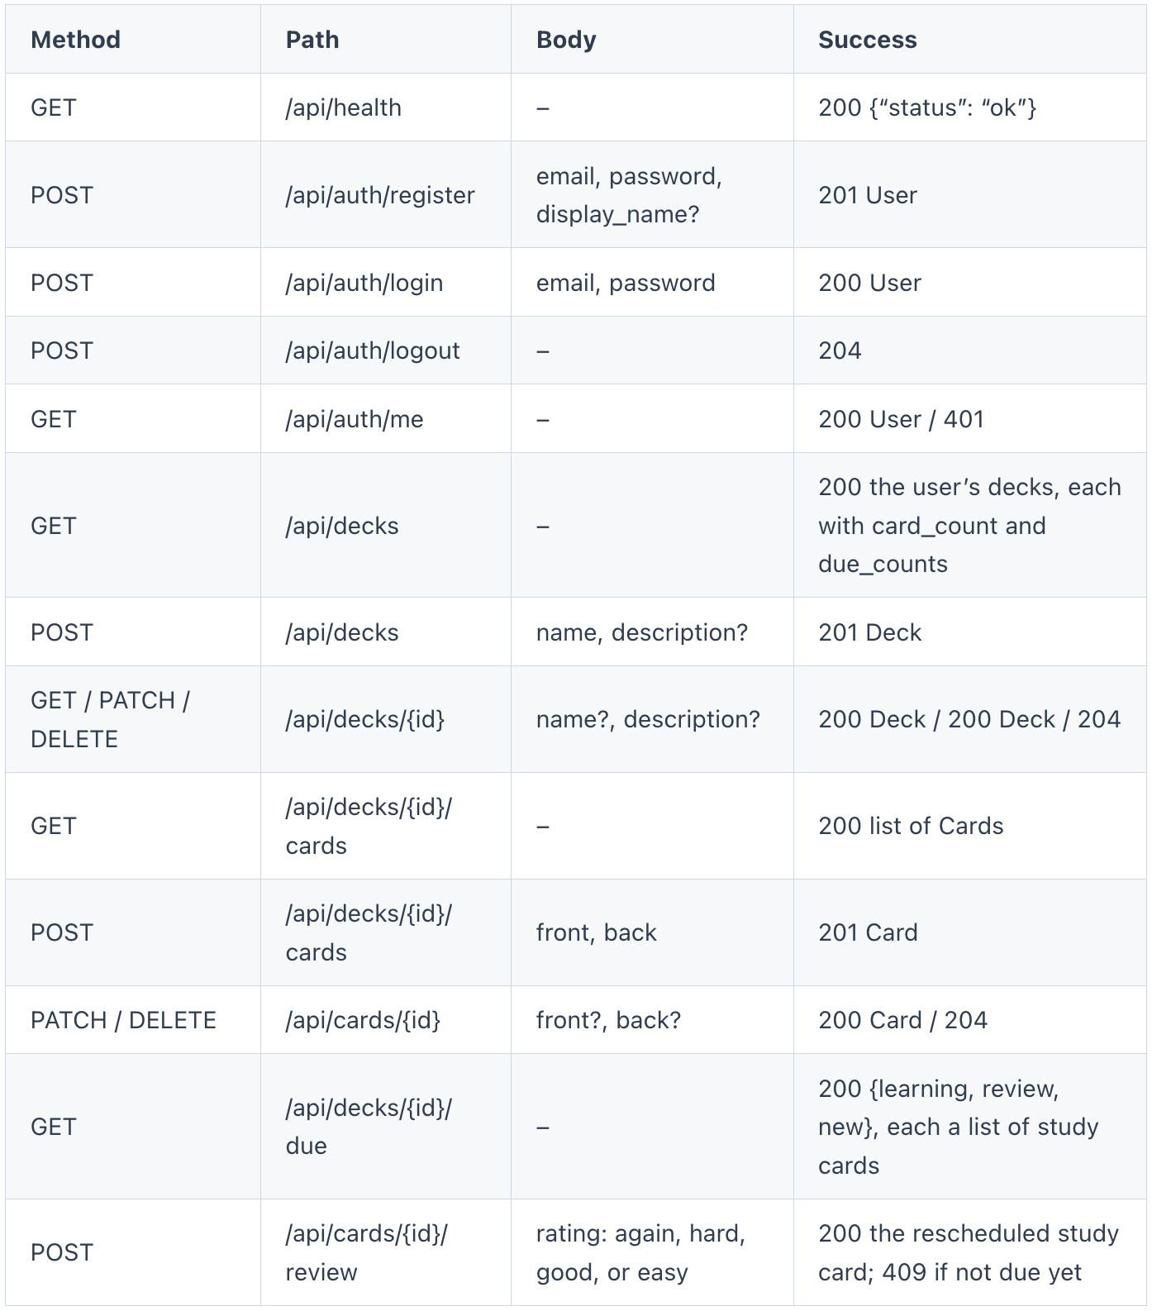

Deck: id, name, description, card_count, due_counts {learning, review, new}, created_at, updated_at. Card: id, deck_id, front, back, state, due_at, created_at, updated_at. A study card adds intervals {again, hard, good, easy}, in seconds.
Planned for Iteration 3: POST /api/decks/{id}/generate (returns candidate cards without saving them) and POST /api/decks/{id}/cards/bulk (saves accepted cards). The LLM provider’s API will be called only from the backend.

Any Additional Topics you would like to include.

Configuration and environments: development (Docker Compose); CI (GitHub Actions, with SQLite and PostgreSQL test jobs); staging (from develop) and production (from main) on Render, defined in render.yaml but not yet deployed. Configuration is read from environment variables in config.py.

Ethical considerations for AI content: generated cards may be inaccurate or biased, so every card is reviewed by the user before it is saved, AI-generated cards are marked with source = ai, and user prompts are not used for any purpose other than generating that user's cards.

AI usage Log
(This table summarizes AI contribution in this document)

Section | Who | AI contribution (%) | Description | Verified by
All sections | Duc Anh Nguyen | 80% | Claude Code drafted the document from the repository code, CI results, SPPP, meeting minutes, and Iteration 1 presentation. Content was reviewed and edited against the code and team decisions. | Duc
Iteration 2 revision (figures 1–4, sections 1–9) | Miles | 80% | Claude Code read the code, CI workflows, and Iteration 2 plan, listed where the SDD no longer matched the code, drafted replacement sections, and drew Figures 1–4 as Mermaid diagrams (sources in doc/diagrams). | Miles

References

- Anki Manual – Deck options and scheduling. https://docs.ankiweb.net/
- Wozniak, P. A. SuperMemo 2 (SM-2) algorithm. https://super-memory.com/english/ol/sm2.htm
- Flask documentation. https://flask.palletsprojects.com/
- SQLAlchemy documentation. https://docs.sqlalchemy.org/
- React documentation. https://react.dev/
- Pydantic documentation. https://docs.pydantic.dev/
- Render documentation – Deploy hooks. https://render.com/docs/deploy-hooks
- OWASP Top 10. https://owasp.org/www-project-top-ten/
- Team 2 SPPP (CS673_SPPP_team2).

Glossary
- Card – one flashcard: a prompt (front), an answer (back), a format, and scheduling state.
- Deck – a user's collection of cards on one topic.
- Due card – a card whose next review time has passed.
- Ease factor – per-card multiplier that controls how fast intervals grow.
- Interval – number of days until a card's next review.
- LLM – Large Language Model, used to generate candidate cards.
- ORM – Object-Relational Mapping (SQLAlchemy).
- SM-2 – SuperMemo 2, the scheduling algorithm Anki is based on.
- SPA – Single-Page Application.
- SRS – Spaced Repetition System.
- Render – cloud platform hosting the staging and production deployments.
- GHCR – GitHub Container Registry.

