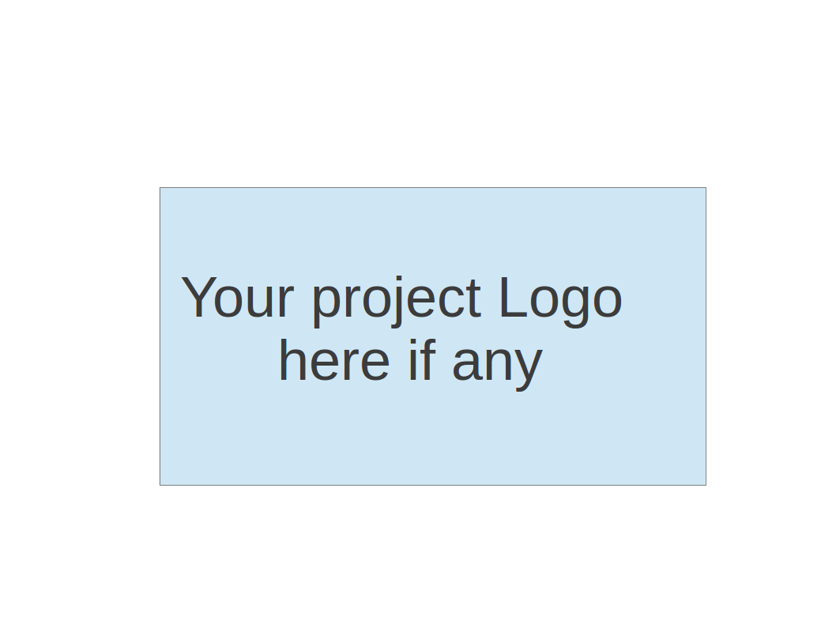
CS673 Software Engineering
Team 2 - “Cadence” Learning/Study Application
Project Proposal and Planning

Team Member | Role(s) | Signature | Date
Miles | Team Leader | Miles Cameron | 9/8/26
Nurzat | Requirements Leader | Nurzat Mukhamedali | 9/8/26
Paul | Frontend Implementation Leader | Paul Probst | 9/8/26
Victor | Backend Implementation Leader
Duc | Config/DevOps Leader | Duc Anh Nguyen | 9/8/26
Osasenaga | QA Leader

Revision history
Version | Author | Date | Change
1 | Team collaboration | 9/9

1. Overview
2. Related Work
3. Proposed High level Requirements
4. Management Plan
a. Objectives and Priorities
b. Risk Management (need to be updated constantly)
c. Timeline (this section should be filled in iteration 0 and updated at the end of each later iteration)
5. Configuration Management Plan
a. Tools
c. CI/CD Plan
6. Quality Assurance Plan
a. Metrics
c. Code Review Process
d. Testing
e. Defect Management
7. AI usage Log
8. Project Links
9. References
10. Glossary

Overview
This project is proposed as a web-based spaced-repetition learning platform that uses generative AI to author flashcards and supports multiple review formats. The spaced-repetition functionality is based in concept on the open source app Anki, and we plan to preserve Anki's basic scheduling model while addressing two limitations that keep learners from getting value out of it.
The first is the hurdle of building decks of digital flashcards. Building a deck in Anki typically means writing cards individually by hand or sourcing an existing deck from an online source like Reddit or other forums, which may not exactly suit the user’s needs. While the spaced repetition model is highly effective, the hurdle of sourcing your own learning content is prohibitive for some users. The second main limitation is review format. Anki offers rigid manually configured interaction types, the default being reveal-and-self-grade, which suits some material poorly and puts the burden of honest assessment on the learner. Our proposed system would solve both of these issues: First by generating custom content based on user prompts, then by providing that content to the user with multiple interaction types that would make for a varied and challenging experience with assisted grading.

The potential users are learners who need to retain a large volume of discrete facts: students in fact-dense fields such as medicine, law, and the sciences; language learners; and professionals preparing for certification exams.

The proposed functionality covers these areas:
- AI-assisted deck generation: The user supplies source material or basic prompts, and the system produces candidate cards to accept, edit, or discard.
- Deck management: Users can manually create, organize, edit, and delete content from their decks at any time.
- Review interface: Users can enter a review session and study their material, guided by the application.
- Spaced repetition scheduling: The system tracks per-card performance and schedules reviews at the interval where reinforcement is most valuable (drawn most directly from Anki).
- Multiple interaction formats: Beyond reveal-and-grade recall, the system supports free-text entry and multiple-choice questions.

The team chose a web application over a native mobile application to reduce implementation complexity and concentrate effort on core functionality within the project schedule. Whether to build on Anki's open-source codebase or implement the scheduling logic independently will be decided during design. The proposed stack is a React frontend, a Python backend, and a PostgreSQL database, to be finalized in upcoming team meetings.

Related Work

RemNote
  - Description: RemNote is a note-taking application that turns your notes into flashcards, either manually with keyboard shortcuts or automatically with AI. It offers content summaries, quizzes, an AI tutor chat, and spaced repetition practice.
  - Differences to our proposed product: RemNote is designed to digest notes first and foremost. This likely works well for many academic course applications where lectures and slides are available, but it serves a narrower use case than our product will strive to offer. An independent learner seeking guidance on what to learn next within a topic, a language being the clearest example, would benefit from the open-ended, prompt-based content generation of our proposed product.
Quizlet
  - Description: Quizlet is a widely used flashcard study and sharing web app. It offers a variety of learn and test modes, with premium features offered for AI "Magic Notes" generation and scheduling-based study modes.
  - Differences to our proposed product: Quizlet offers scheduling and generative capabilities as add-ons on the periphery of its manual deck creation and sharing functionality, where our app's core functionality is the evidence-based approach of spaced repetition to cement knowledge, paired with the ability to continuously generate added cards from a user's prompt or source material.
Knowt
  - Description: Knowt markets itself as a direct competitor to Quizlet, generating a variety of types of content such as summaries, notes, and flashcards from user input via AI. It integrates directly with classroom management applications like Canvas which has made it popular in schools.
  - Differences to our proposed product: Knowt is built around the course-material workflow, where a student uploads a document they have already been given and receives study material derived from it. Our product is built for the learner who does not have that document, generating a deck from an open-ended prompt and then exercising it through configurable interaction formats, with the spaced-repetition schedule as the center of the product rather than one output type among many.

Proposed High level Requirements
  - Functional Requirements
    - Essential Features:
- Deck & Card Management
As a learner, I want to create, view, edit, and delete flashcard decks and individual cards, so that I can organize my study topics effectively.
Estimation: 15–20 person-hours
- Interactive Study Interface
As a learner, I want to view flashcards one at a time, reveal answers, and rate my performance, so that I can review material actively.
Estimation: 10–15 person-hours
- Spaced Repetition System (SRS)
As a learner, I want the system to schedule card reviews based on my previous performance, so that I can optimize my retention and study efficiency.
Estimation: 20–25 person-hours
- Data Persistence
As a user, I want my decks, cards, and study progress saved to a database, so that my learning history remains intact across sessions.
Estimation: 12–18 person-hours
- AI Deck Generation
As a learner, I want to input a topic and prompt to automatically generate a deck using an LLM, so that I can save time creating study materials manually.
Estimation: 15–20 person-hours
- AI Deck Review & Editing
As a learner, I want to preview and edit AI-generated cards before saving them, so that I can fix inaccuracies or adjust phrasing.
Estimation: 8–12 person-hours

    - Desirable Features:
- Typed-Answer Study Mode & Basic Evaluation
As a learner, I want to type out my answer and have the app evaluate simple exact or near-exact matches, so that I can test my precise recall.
- Duplicate Card Detection
As a user, I want the system to flag potential duplicate cards during AI generation, so that my decks stay concise and non-redundant.

    - Optional Features:
- Document / Source File Upload
As a student, I want to upload text files or notes so the AI can extract key concepts into cards tailored directly to my course material.
- Voice Support / Text-to-Speech
User Story: As a learner, I want the option to listen to card audio and speak my answers using voice recognition, so that I can practice listening comprehension and pronunciation hands-free.

  - Nonfunctional Requirements
(including security requirements, and other nonfunctional requirements such as compatibility, scalability, reliability etc)
    - Security requirements
- Data Privacy
User data and generated flashcards must be isolated per user account.

Management Plan

Objectives and Priorities

- Complete all essential features. Successfully implement and integrate all features classified as essential requirements, resulting in a functional AI-powered spaced repetition flashcard application.
- Deliver a reliable and usable application. Ensure that the completed essential features work together as a cohesive application and that no known critical or high-impact defects remain in the final release.
- Maintain high software quality. Use appropriate coding standards, code reviews, testing, and defect management throughout development to maintain the quality and reliability of the application.
- Complete desirable features as project capacity allows. After the essential functionality is stable, implement as many desirable features as reasonably possible within the available schedule and resources.
- Maintain an effective and reproducible development process. Use version control, Docker, CI/CD practices, and project-management processes to support consistent development, testing, and integration among team members.
- Ensure meaningful team participation and learning. Distribute project responsibilities across the team so that all members contribute to development and gain practical experience with the software engineering processes and technologies used in the project.
- Complete optional features if time permits. Implement optional enhancements only after higher-priority objectives have been adequately completed.

Risk Management

The main risks identified include scope creep, inadequate planning or design, insufficient testing, integration and deployment delays, AI-generated content quality, and team coordination or availability issues. The team will manage these risks by prioritizing essential features, monitoring workload and progress each iteration, defining requirements and system interfaces early, integrating and testing components throughout development, and using code reviews and version-control practices to reduce integration problems. AI-specific risks will be mitigated through structured prompts, output validation, user review of generated cards, and safeguards for LLM API availability, rate limits, and cost.

Risk Management Sheet Link: CS673_SPPP_RiskManagement_team2

Timeline
Iteration | Functional Requirements(Essential/Desirable/Optional) | Tasks (Cross requirements tasks) | Estimated/real total person hours
1 | Essential: Basic deck/card management; study interface; core spaced repetition scheduling; persistent deck, card, and review data | Finalize architecture and technology stack; design database schema and generic card/deck/review model; establish frontend/backend project skeleton; define API contracts; configure GitHub workflow; establish Docker development environment; set up initial testing framework | 80
2 | Essential: AI-generated decks from natural-language prompts; review/edit generated cards; duplicate detection/prevention; complete end-to-end AI/SRS workflow | IIntegrate LLM service with backend; implement structured AI output validation; integrate frontend/backend/AI components; expand unit and integration testing; configure CI; address integration defects | 65
3 | Essential: Complete or correct any unfinished essential requirements. Desirable/Optional: Implement additional features as time permits, such as typed answers, answer tolerance, or broader subject support | System-wide testing; bug fixing; regression testing; UI/UX cleanup; Docker/deployment validation; documentation; final integration; code cleanup; final release preparation | 40

Configuration Management Plan

Tools

Version Control:
- Git – Distributed version control system used to track source-code changes, manage branches, and support collaborative development.
- GitHub – Used for remote repository hosting, Pull Requests, code reviews, issue tracking, project management, and collaboration.

Development Tools:
- Visual Studio Code (VS Code) / PyCharm – Primary IDEs for writing, debugging, and maintaining application code. The choice will depend on the programming language and developer preference.
- Postman – Used for developing, testing, and debugging REST APIs and validating API requests and responses.
- Code formatting and linting tools – Used to maintain consistent coding standards and identify potential code-quality issues before changes are merged.

CI/CD Tools:
- GitHub Actions – Primary CI platform used to automatically build the application, run unit/integration tests, perform code-quality and security checks, and create deployment artifacts.
- Jenkins – May be used where additional or legacy CI/CD automation is required, particularly for more complex build or deployment workflows.
- Argo CD – Used for continuous delivery in a Kubernetes environment following a GitOps approach. Argo CD will monitor the desired application configuration stored in Git and synchronize approved changes to the Kubernetes environment.

Container and Orchestration Tools:
- Docker – Used to package the application and its dependencies into portable containers, ensuring consistency between development, testing, and production environments.
- Kubernetes – Used to orchestrate and manage containers in environments where container orchestration is required, including deployment, scaling, service discovery, and application availability.
- Container Registry – Used to securely store and distribute Docker container images for deployment.

Security and Code Quality Tools:
- GitHub CodeQL – Used for Static Application Security Testing (SAST) to identify potential security vulnerabilities in the source code.
- Dependabot – Used to monitor project dependencies for known vulnerabilities and recommend or automatically create dependency updates.
- OWASP ZAP – Used for Dynamic Application Security Testing (DAST) against the running application to identify potential security vulnerabilities.
- Automated testing tools – Unit, integration, and API tests will be incorporated into the CI pipeline to detect defects before deployment.

AI-Assisted Development Tools:
- GitHub Copilot – Used for AI-assisted code completion, code generation, refactoring, and developer productivity.
- ChatGPT / Codex – Used as an AI development assistant for design discussions, troubleshooting, documentation, test generation, code explanation, and development support.
- Claude Code – Used as an AI coding assistant for code analysis, implementation, refactoring, debugging, and working with larger codebases.

Project Management and Collaboration:
- GitHub Issues – Used to track bugs, tasks, requirements, and enhancements.
- GitHub Projects – Used to organize and monitor development work and project progress.
- GitHub Pull Requests – Used for code review, discussion, automated validation, and controlled integration of changes.

  - Code Commit Guideline and Git Branching Strategy

main branch – Represents the production-ready code. Changes to this branch will only be made through an approved Pull Request from the develop branch after testing and review have been completed.

develop branch – Represents the latest integrated development version. It will be used for integration testing before changes are promoted to production.

feature/* branches – New features or significant changes will be developed in separate branches created from develop (e.g., feature/user-login). Developers will commit their work to these branches rather than directly to develop or main.

Pull Requests (PRs) – When a feature is complete, a Pull Request will be opened from the feature branch into develop. The PR will require code review and successful automated tests/CI checks before it can be merged.

Commit criteria – Commits should be small, focused, and related to a single logical change. Commit messages should clearly describe the change. Developers should ensure that code builds successfully and relevant tests pass before committing and submitting a Pull Request.

CI/CD Plan

The project will use GitHub Actions to implement the CI/CD pipeline. Whenever code is pushed to a feature branch or a Pull Request is created, the pipeline will automatically build the application, run automated tests, perform code-quality checks, and run security scans.

After a feature is reviewed and merged into the develop branch, the application will be deployed to the development/test environment for further integration and acceptance testing.

Once the changes in develop have been tested and approved, a Pull Request will be created to merge them into the main branch. After the PR is approved and all required CI checks pass, the application will be automatically deployed to the production environment.

This process ensures that code is automatically tested and validated before deployment, reducing the risk of introducing errors or security vulnerabilities into the production environment.

Quality Assurance Plan

Metrics

Metric Name | Description
Automated Test Case Pass Rate (%) | The percentage of automated unit and integration tests that execute successfully without failure  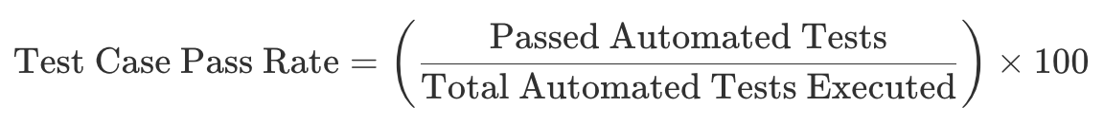  Target: 100% on the main/production branch. No pull request can be merged if any automated test fails.
Automated Test Code Coverage (%) | The percentage of application source code executed when running the automated test suite  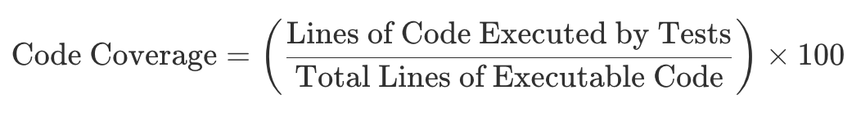  Target (Conservative): More than 70% overall statement coverage
User Story Acceptance Rate (%) | The percentage of planned user stories for a given iteration that successfully pass the acceptance testing and are completed according to their Definition of Done  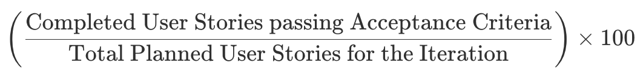

  - Coding Standard
Language-Specific Style:
- For Python we will use PEP8
- For The front end, we will use ESLint

Aside from those, a couple of specific rules to follow are:

Explicit Naming Conventions:
    - Variables & Functions: Use descriptive, full-word names in snake_case for Python or camelCase for JavaScript. (e.g., calculate_next_review_interval or isAnswerValid instead of srs_calc or chkAns).
    - Classes: Use PascalCase (e.g., FlashcardDeckManager).
    - Constants: Use UPPER_SNAKE_CASE

Type Safety & Type Hints:
    - If using Python , all function signatures must include type hints (e.g., def schedule_card(card_id: int, rating: int) -> dict:).
    - If using JavaScript, TypeScript is highly recommended to enforce type safety across the frontend/backend bridge.

Code Review Process

Code Review Model & Roles
We will adopt a Peer-to-Peer with Lead Oversight Model:
- Peer Review: Every developer must act as a reviewer. Any Pull Request (PR) must be reviewed and approved by at least one other team member before it can be merged.
- Lead Oversight: The Design or Implementation Leader must perform a final sign-off or review for PRs that go into the production branch.
Pull Request (PR) Workflow
Branch Off: Create a feature branch (e.g., feature/feature_xyz) from develop.
- Commit Code: Commit logic incrementally using conventional commits.
- Open a PR: Once the user story is complete, open a Pull Request targeting the develop branch.
- Automated CI Run: GitHub Actions automatically triggers a CI pipeline to run:
  - Code formatting and linting (Ruff/ESLint).
  - Automated unit and integration test suites.
  - Code coverage report generation.
- Peer Review: A reviewer cannot start a manual review until the automated CI status is green. This ensures reviewers spend their time evaluating logic and architecture rather than formatting or syntax errors.
- Approval & Merge: Once peer approved and CI-checked, the PR can be safely merged into develop

Review Checklist
A proposed template to evaluate the code is the following one. Every item in the following list should be marked yes/no

Correctness & Requirements
- [ ] Acceptance Criteria Met: Does the implementation fulfill all defined acceptance criteria for the user story?
- [ ] Edge Cases Handled: Are boundary conditions handled (e.g., rating a card at the maximum review intervals, handling null ratings)?
Architecture & Style
- [ ] Standards Compliant: Does the code follow our designated Python (PEP 8) or JavaScript conventions?
- [ ] Modular Unit Size: Are methods/functions kept under 30 lines? Is business logic clearly separated and encapsulated? Is the code open to be extended or when changes are needed, huge modifications need to be made?
- [ ] Security: No API keys, credentials, or secrets are hardcoded (they must be loaded via .env).
Test Coverage & Documentation
- [ ] New Unit Tests Added: Are there new unit tests validating the feature’s code paths?
- [ ] Coverage Target Met: Does the file meet our overall 70% coverage target
- [ ] Comments & Docs: Are complex algorithmic sections clearly commented?
Reviewer Feedback Guidelines
Reviewers will use the Conventional Comments syntax to categorize feedback:
- [blocking] Critical Issues: Functional bugs, schema violations, missing error handling, or security risks. These must be resolved before approval.
  - Example: [blocking] The LLM JSON schema parser doesn't catch empty card fields. If the API returns an empty term, our DB save will throw a constraint error.
- [suggestion] Refactoring / Improvements: Tips on performance, readability, or cleaner patterns. Non-blocking unless code complexity is high.
  - Example: [suggestion] We could decouple the scheduling calculations from the route controller and place it in an isolated service utility to make it easier to unit test.
- [nit] Minor Items: Small style improvements or typos. Non-blocking.
  - Example: [nit] Typo in user message: 'repetition' is spelled 'repetiton' in line 42.

Testing

Testing Personnel & Responsibilities (Self-QA Model)
Our team faces distinct personnel and technical risks, including having no dedicated QA engineer and a potential lack of advanced automated testing experience among developers. To mitigate these risks, we will utilize a Self-QA and Collaborative testing model:
- Individual Developers (White-Box Focus): Each developer is directly responsible for unit-testing their own code. Developers must write automated unit tests for every class, utility, and helper function they introduce, ensuring high code coverage on critical logic before submitting code for peer review.
- Configuration/DevOps Leader: Coordinates the overall testing strategy. This role focuses on orchestrating automated integration testing, setting up the continuous integration (CI) pipeline, validating internal API payloads, and executing regression test suites to ensure subsystem connections do not break.
- The Team (as the "Customer"): Performs manual User Acceptance Testing (UAT) on the deployment environment at the end of every iteration. No user story can be considered completed or accepted unless it passes a live walkthrough of its defined acceptance criteria.
Testing Types, Methods, & Levels

We will implement a structured testing pyramid where the vast majority of our automated checks occur at the unit level, supplemented by robust API integration checks and manual user testing as shown in the following figure:
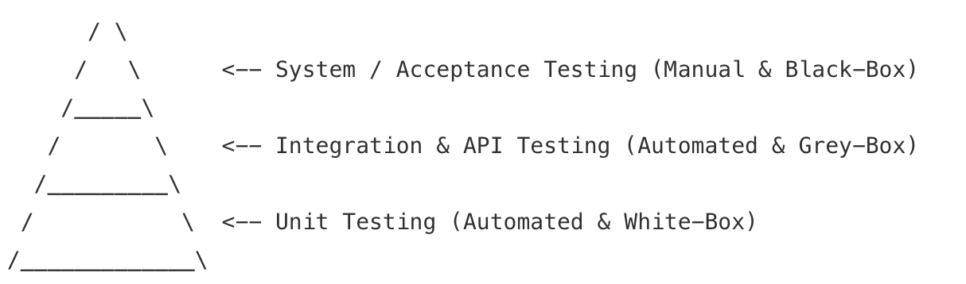
A. Unit Testing (Automated & White-Box)
- Focus: Testing individual classes, helper utilities, and backend methods in isolation.
- Objective: To confirm that isolated algorithms—specifically the mathematical formulas calculating SRS card intervals and multipliers—behave correctly under all input conditions.
- Execution: Executed automatically inside the developer's local environment and within the CI pipeline on every code commit.
B. Integration Testing (Automated & Grey-Box)
- Focus: Testing the interfaces and interactions between independent subsystems (e.g., the frontend client communicating with the backend API database models, and the backend coordinating with the LLM API).
- Objective: To ensure that data persists correctly across the backend and PostgreSQL database, and that structured LLM output schemas are properly verified.
- Execution: Executed via automated integration test scripts that mimic actual client requests.
C. System & Acceptance Testing (Manual & Black-Box)
- Focus: Validating the external behavior of the entire application without analyzing the internal code structure.
- Objective: To confirm that end-to-end features, such as studying a deck or triggering an AI-generated deck, are functional and user-friendly on a simulated browser.
- Execution: Performed manually by team members during end-of-iteration reviews to formally accept user stories.
D. Regression Testing (Automated)
- Focus: Re-running the entire suite of unit and integration tests after any code modification or bug fix.
- Objective: To guarantee that new features (such as Iteration 3's duplicate card prevention) do not break existing, stable functionalities (such as Iteration 1's SRS card reviews)

Testing Tools & Frameworks
- Backend Test Execution: PyTest (or Python's unittest library) to write, structure, and automatically run our unit and integration test suites.
- Frontend Test Execution: Jest (coupled with React Testing Library) to test component rendering, local state changes, and simulated client interface events.
- Automated Testing Oracle & Schema Validator: Pydantic (or JSON Schema validation models) to serve as our data validation oracle. This tool will parse non-deterministic LLM response schemas and immediately catch malformed AI payloads before database insertion.
- Environment Parity: Docker will house both the application runtime and testing frameworks, aligning the development and testing environments to eliminate errors caused by local operating system configurations.
- Continuous Integration Engine: GitHub Actions CI will automatically run linter checks, run our unit/integration test suites, and generate a code coverage report on every pull request
Iteration-by-Iteration Testing Timeline

Timeline | Milestone Focus | Specific Testing Activities
Iteration 1  (Weeks 1–2) | Test Framework & Core Unit Models | - Define and establish the automated unit testing framework (PyTest/Jest).  - Write white-box unit tests covering the initial SRS scheduling mathematical algorithm.  - Log team development hours to establish the baseline effort variance.
Iteration 2  (Weeks 3–4) | CI Integration & API Schema Verification | - Configure the automated GitHub Actions CI pipeline.  - Write API-level integration tests to verify successful backend-to-database communication.  - Implement validation tests using Pydantic/JSON Schema to test mock response payloads.
Iteration 3  (Weeks 5–6) | Full End-to-End System Integration & Release | - Run complete automated and manual integration testing across frontend, backend database, and AI integrations.  - Test the duplicate-card detection algorithm with edge-case card comparisons.  - Perform full regression sweeps and final release testing.

Defect Management

Tooling: GitHub Issues integrated with a 5-stage GitHub Kanban board (Backlog →To Do →In Progress →In Review →Closed).
Severity Levels:
- P1 (Critical): App crash or database failure → Halts feature work; immediate fix required29.
- P2 (High): Major story malfunction or broken AI schema validation → Resolve within active iteration26.
- P3 (Medium): Minor functional or UI glitch → Scheduled into current or next backlog.
- P4 (Low): Cosmetic issue or typo → Addressed during cleanup tasks.

AI usage Log - All
(This table summarizes AI contribution in this document)
Section | Who | AI contribution (%) | Description | Verified by
Quality Assurance Plan | Victor | 70% | AI Assisted with drafting the sections related to the testing, providing options for metrics, templates, tools, etc… I had to refine it for the timeline we have and experience of our team.
Management Plan | Paul | 60% | AI assisted with drafting and refining project objectives and priorities, identifying and evaluating project risks and mitigation plans, and developing the initial iteration timeline and person-hour estimates.
Configuration Management Plan | Duc | 50% | AI assisted with refining and rephrasing the sentences and wording from my input with the list of tools and the plan that I provide to make it more detailed
Summary | Miles | 60% | AI took dictated key points and structure and created a rough draft. After thorough manual review, AI checked for errors or mistakes like typos.
Related Work | Miles | 60% | AI helped in researching related products and giving a jumping-off point for manual research. I drafted the section and AI edited and filled gaps.
Proposed High level Requirements | Nurzat | 50% | AI helped with brainstorming the ideas for the different kinds of requirements for our project. I drafted the section and AI helped me to refine it and make it more clear and understandable.

Project Links - All
Github link: https://github.com/BUMETCS673/CS673OLF26P2
Project management tool link (Github issues page): https://github.com/BUMETCS673/CS673OLF26P2/issues

References

Products Reviewed (Section 2)

Anki. Powerful, intelligent flashcards. https://apps.ankiweb.net/
Knowt. https://knowt.com/
Quizlet. https://quizlet.com/
RemNote. https://www.remnote.com/

Learning Science

Cepeda, N. J., Pashler, H., Vul, E., Wixted, J. T., & Rohrer, D. (2006).
Distributed practice in verbal recall tasks: A review and quantitative
synthesis. Psychological Bulletin, 132(3), 354-380.
https://doi.org/10.1037/0033-2909.132.3.354

Roediger, H. L., III, & Karpicke, J. D. (2006). Test-enhanced learning:
Taking memory tests improves long-term retention. Psychological
Science, 17(3), 249-255.
https://doi.org/10.1111/j.1467-9280.2006.01693.x

Standards and Conventions

Conventional Comments. https://conventionalcomments.org/
Conventional Commits. https://www.conventionalcommits.org/
van Rossum, G., Warsaw, B., & Coghlan, N. PEP 8 - Style Guide for Python
Code. https://peps.python.org/pep-0008/
OWASP Foundation. OWASP Top 10. https://owasp.org/www-project-top-ten/

Glossary

Acronyms and Abbreviations

API — Application Programming Interface. The defined interface through which the frontend, backend, and LLM service exchange data.
CI/CD — Continuous Integration / Continuous Delivery. Automated building, testing, and deployment of code changes.
DAST — Dynamic Application Security Testing. Security testing performed against a running application.
DevOps — Development and Operations. Practices that combine software development with IT operations to shorten and automate the delivery cycle.
GitOps — An operational model in which the desired system state is stored in Git and automatically synchronized to the runtime environment.
IDE — Integrated Development Environment. An application providing code editing, debugging, and build tooling in one interface.
JSON — JavaScript Object Notation. The data-interchange format used for API payloads and structured LLM output.
LLM — Large Language Model. The generative AI model used to author flashcard content.
OWASP — Open Worldwide Application Security Project. A nonprofit producing widely used application security resources.
PEP 8 — Python Enhancement Proposal 8. The official Python style guide, adopted as our Python coding standard.
PR — Pull Request. A proposed set of changes submitted for review before merging.
REST — Representational State Transfer. The architectural style used for the backend API.
SAST — Static Application Security Testing. Security analysis of source code without executing it.
SPPP — Software Project Proposal and Planning. This document.
SRS — Spaced Repetition System. The scheduling engine that determines when each card is next reviewed.
UAT — User Acceptance Testing. Manual validation that delivered features meet their acceptance criteria.
UI / UX — User Interface / User Experience.
ZAP — Zed Attack Proxy. The OWASP DAST tool used to scan the running application.

Terms

Anki — An open-source spaced-repetition flashcard application whose scheduling model informs our own.
Card — A single flashcard: a prompt, its answer, and the review history used to schedule it.
Deck — A user-defined collection of cards grouped by topic.
Spaced repetition — A learning technique that schedules review of material at increasing intervals timed to reinforce memory just before it decays.

