

CS673 Software Engineering
Team 2 - My Magical Bedtime
Software Design Document

Team Member | Role(s) | Signature | Date
Iqra Chaudhary | Team Lead | IC | 5/24/2025
Tetiana Korchynska | Design and Implementation Lead, Requirement Lead | TK | 5/19/2025
Thomas Iliev | QA Lead | TI | 5/26/2025
Grant Hovey | Configuration Lead | GH | 5/26/2025
Hongjie Zhang | Design and Implementation Lead, Security Lead | HJZ | 5/10/2025
Xuelin Min | Security Lead | XLM | 5/25/2025

Revision history
Version | Author | Date | Change
1 | Hongjie Zhang | 05/21/2025 | Filled sections: Introduction, Software Architecture, Class Diagram, Database Design, insert images/ diagrams
2 | Tetiana Korchynska | 05/26/2025 | Filled sections: UI Design, References & Glossary; formatted the whole document
3 | Iqra Chaudhary | 5/26/2025 | Filled Sections: Business Logic and Design Patterns
4 | Tetiana Korchynska | 06/05/2025 | Updated AI Usage Log
5 | Grant Hovey | 06/14/2025 | Added section for CI

Introduction
Software Architecture
Class Diagram
UI Design (if applicable)
Database Design (if applicable)
Security Design
Business Logic and/or Key Algorithms
Design Patterns
Any Additional Topics you would like to include.
References
Glossary

Introduction

In this section, give an overview of this document, and also address the design goals of your software system.
This document presents the software requirements specification for "My Magical Bedtime," a bedtime story generation application designed specifically for preschool children aged 3-5 years.
The specification provides a comprehensive blueprint for developing a platform that creates engaging bedtime content while supporting early childhood development. This document outlines functional and non-functional requirements, system architecture, user interface design, and technical implementation guidelines, serving as the primary reference for developers, designers, stakeholders, and quality assurance teams throughout the software development lifecycle.
The My Magical Bedtime application focuses on key design goals including child-friendly interface design with simple navigation for preschoolers, educational content integration that supports language development and emotional intelligence, personalized story generation based on individual children's interests and developmental needs, parental controls that allow caregivers to manage content and monitor progress, reliable technical infrastructure with content moderation and secure data handling.
These design goals ensure that My Magical Bedtime functions as both an effective bedtime routine tool and a valuable educational resource that adapts to each child's developmental journey while maintaining high standards of safety, engagement, and educational value.

Software Architecture

In this section, you will describe the decomposition of your software system, which includes each component (which may be in terms of package or folder) and the relationship between components. You shall have at least one diagram to show the whole architecture of. The interface of each component and dependency between components should also be described. If any framework is used, it shall be defined here too.

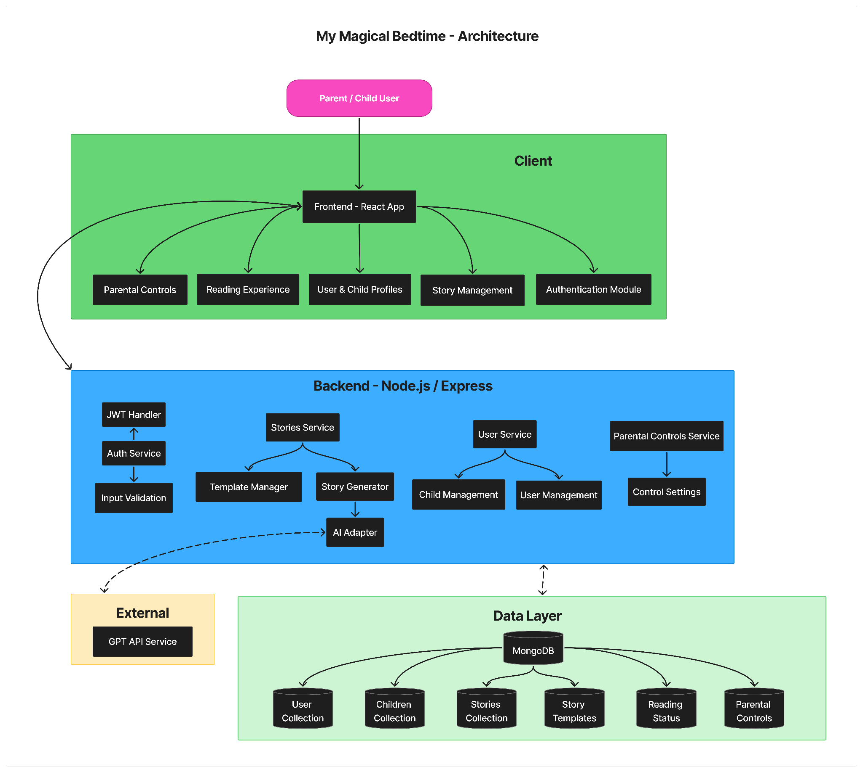
The My Magical Bedtime application follows a three-tier architecture pattern with clear separation of concerns between the presentation layer (frontend), business logic layer (backend), and data persistence layer (database). This modular approach ensures maintainability, scalability, and testability of the system.

System Overview
The architecture consists of four primary layers: Client (Frontend), Backend Services, External Services, and Data Layer, each handling distinct system responsibilities.

Frontend Architecture
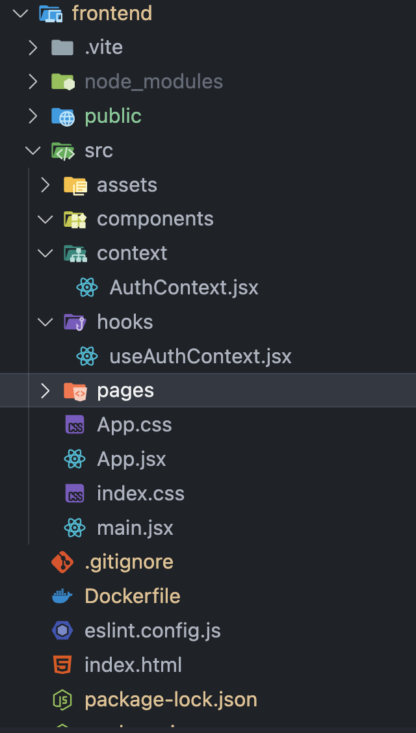
Built with React and organized in the frontend folder:
- src/components/ - Contains five main modules: Authentication, User & Child Profiles, Story Management, Reading Experience, and Parental Controls
- src/context/ - React Context for state management (AuthContext.jsx)
- src/hooks/ - Custom React hooks (useAuthContext.jsx)
- src/pages/ - Application views and navigation screens
- public/ - Static assets and HTML templates

Backend Architecture
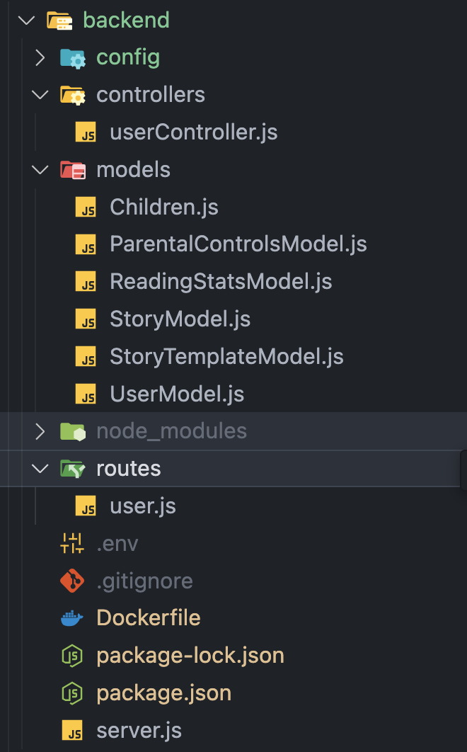
Node.js with Express using MVC pattern in the backend folder:
- Controllers: userController.js handles HTTP requests
- Models: Six data models (UserModel, Children, StoryModel, StoryTemplateModel, ParentalControlsModel, ReadingStatsModel)
- Routes: user.js defines API endpoints
- Services: Auth Service (JWT handling), Stories Service (Template Manager + Story Generator), User Service (Child/User Management), Parental Controls Service, and AI Adapter

External Services
GPT API Service integrates through the AI Adapter component for dynamic story generation with secure API calls and rate limiting.

Data Layer
MongoDB with six collections: User, Children, Stories, Story Templates, Reading Status, and Parental Controls, corresponding to the business models.

Component Dependencies
Frontend communicates with backend via RESTful APIs using JWT authentication. Backend services interact through defined interfaces: Stories Service depends on Template Manager and AI Adapter, Auth Service secures all services, and all services connect to MongoDB through model interfaces.

Technology Stack
Frontend: React, Vite (build tool), CSS Modules
Backend: Node.js, Express.js, JWT, Mongoose (MongoDB ODM), OpenAI GPT API

Class Diagram

In this section, you will provide a detailed description of each component (or package) and use one or multiple class diagrams to show the main classes and their relationships in each component.
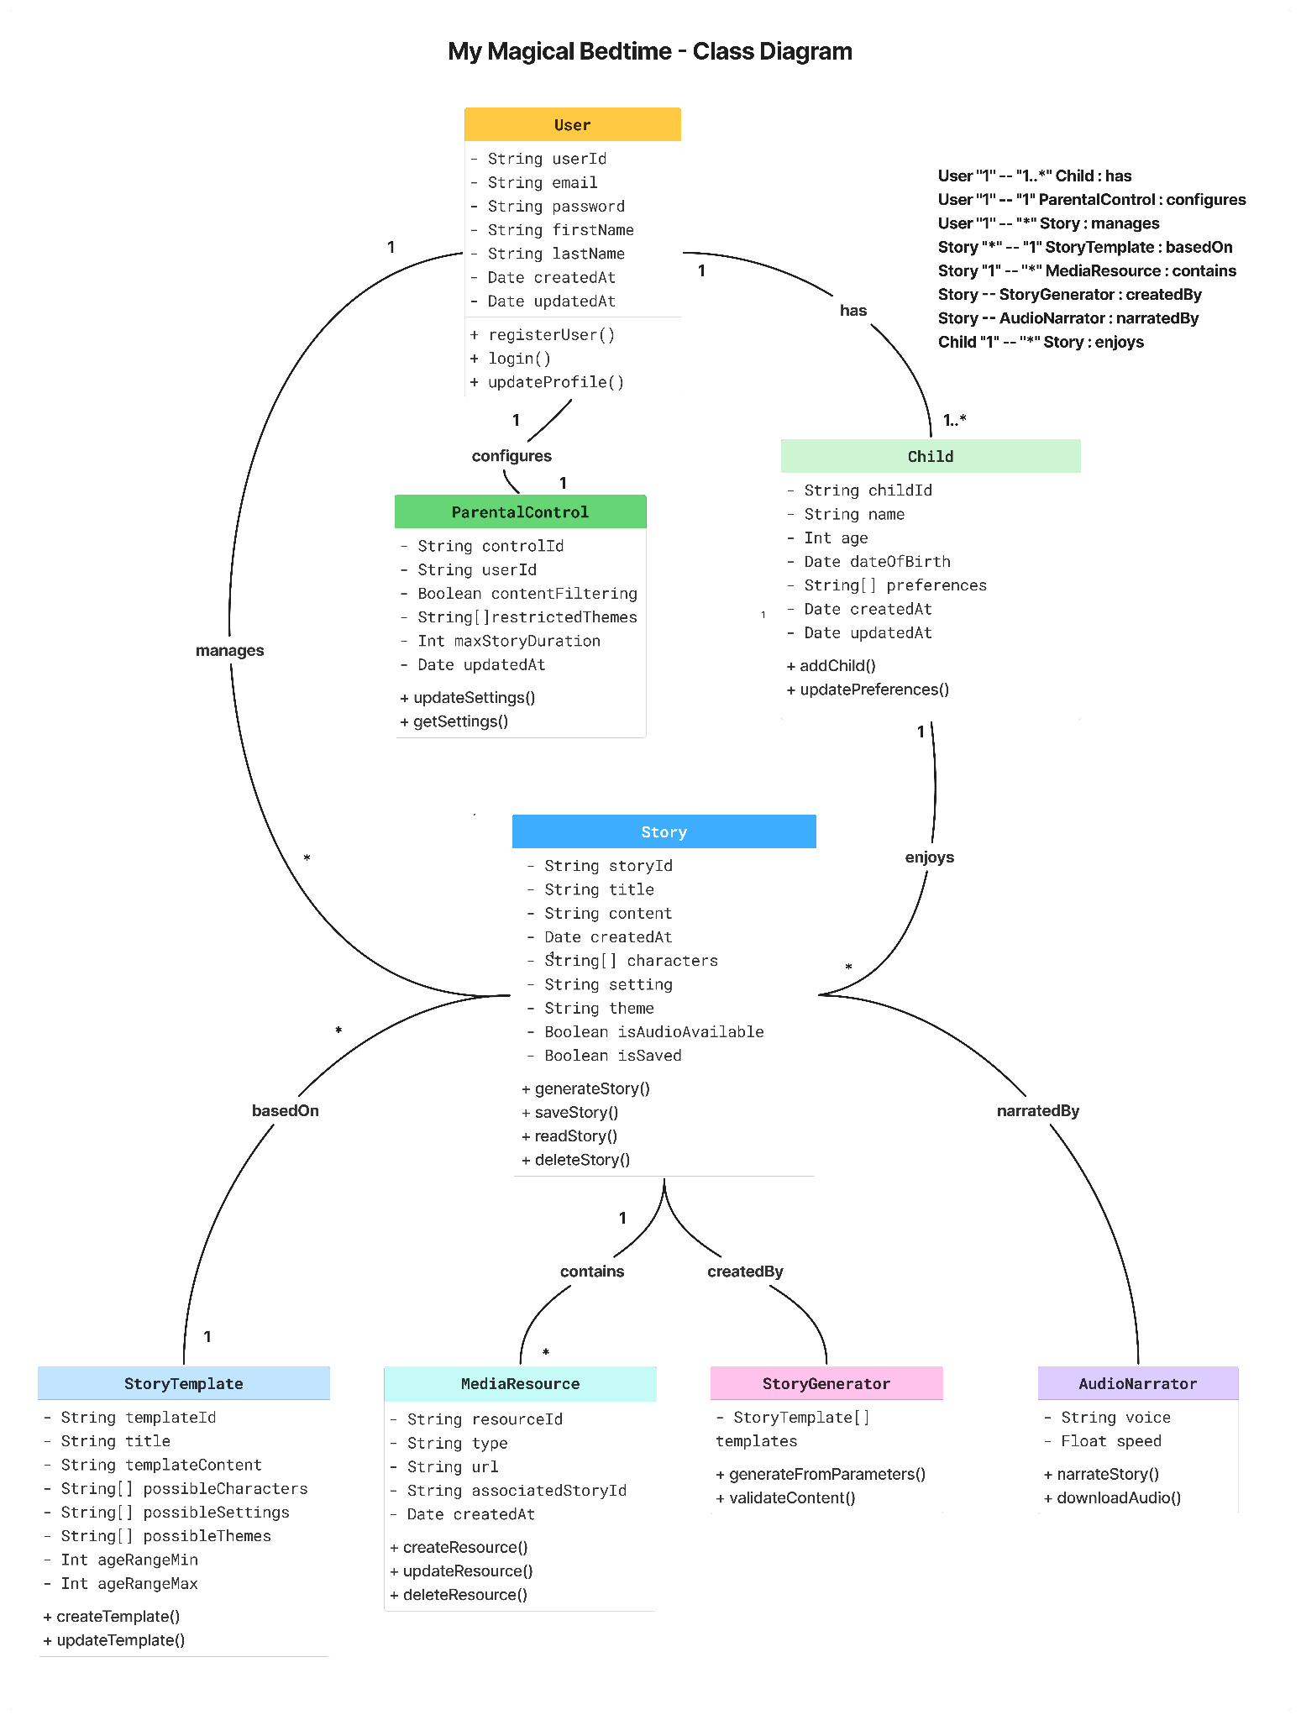
The My Magical Bedtime application's class structure follows object-oriented design with clear relationships between core entities in the MERN stack architecture.

Core Classes

User Class
Represents parents/caregivers with attributes: userId, email, password, firstName, lastName, createdAt, updatedAt. Methods include registerUser(), login(), updateProfile(). Has a one-to-many relationship with Child and a one-to-one with ParentalControl.

Child Class
Represents preschool users with childId, name, age, dateOfBirth, preferences array, createdAt, updatedAt. Methods: addChild(), updatePreferences(). Has a one-to-many relationship with Story.

Story Class
Central content entity with storyId, title, content, createdAt, characters array, setting, theme, isAudioAvailable, isSaved. Methods: generateStory(), saveStory(), readStory(), deleteStory(). Connected to StoryTemplate, MediaResource, StoryGenerator, and AudioNarrator.

StoryTemplate Class
Foundation for story generation with templateId, title, templateContent, possibleCharacters, possibleSettings, possibleThemes, ageRangeMin, ageRangeMax. Methods: createTemplate(), updateTemplate(). Has a one-to-many relationship with Story.

ParentalControl Class
Manages content safety with controlId, userId, contentFiltering, restrictedThemes, maxStoryDuration, updatedAt. Methods: updateSettings(), getSettings().

Service Classes

StoryGenerator Class
Handles AI content creation with StoryTemplate array. Methods: generateFromParameters(), validateContent().

MediaResource Class
Manages multimedia content with resourceId, type, url, associatedStoryId, createdAt. Methods: createResource(), updateResource(), deleteResource().

AudioNarrator Class
Handles audio delivery with voice, quality attributes. Methods: narrateStory(), downloadAudio().

Key Relationships
- User manages multiple Children and configures ParentalControl
- Children enjoy multiple Stories
- Stories are based on StoryTemplates and contain MediaResources
- StoryGenerator creates Stories, AudioNarrator provides narration

UI Design
In this section, you can describe your UI design



The user interface of My Magical Bedtime is designed to be clear and easy to use, especially for children. The goal was to create a calm, bedtime-friendly atmosphere with a fun and magical feel. The design uses warm colors, big buttons, simple text, and illustrations that work well on both small and large screens.

Before designing, we looked at several similar apps to understand what works well for bedtime story platforms. These included:
Bedtime Stories for Kids | 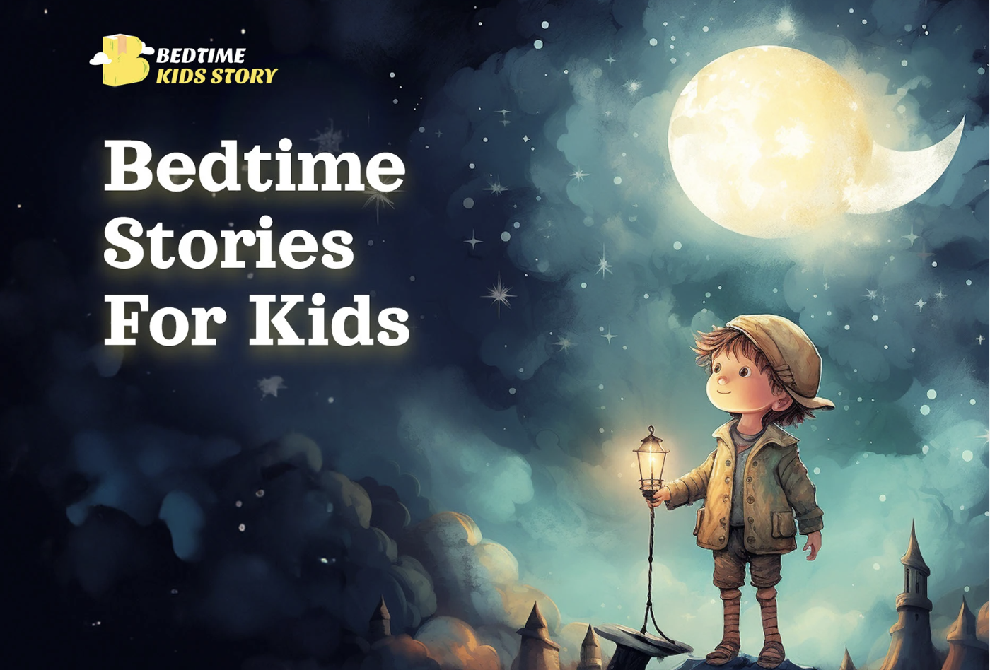
Lullaby – Magical Bedtime Stories | 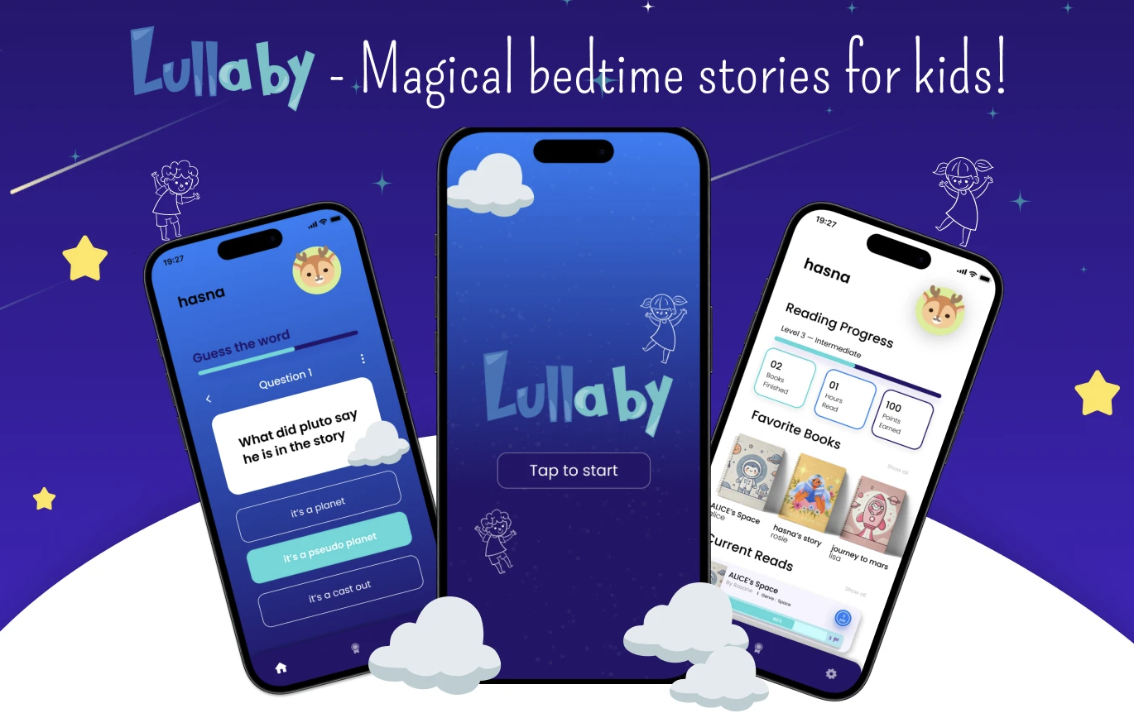
Znichka Bedtime Story App | 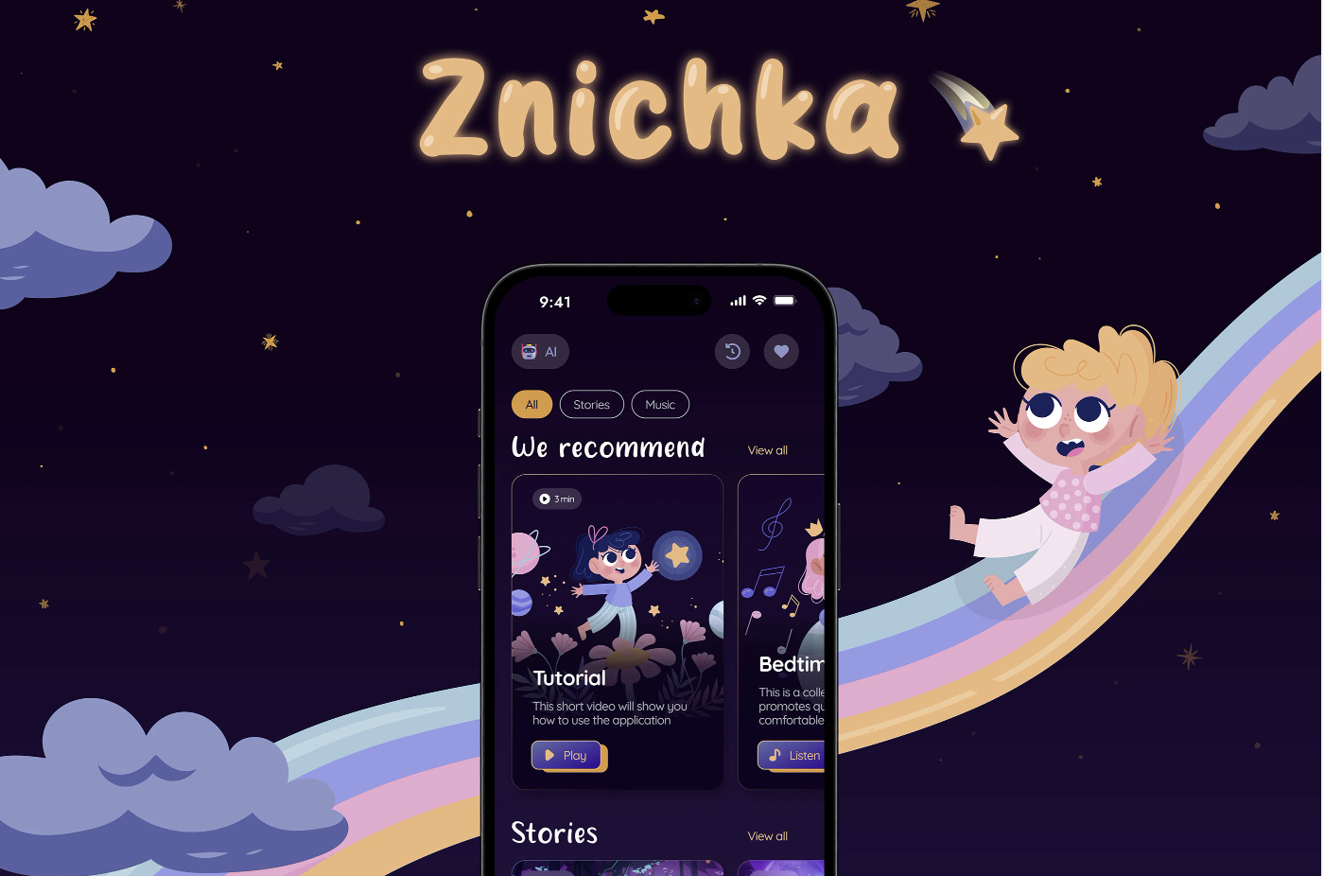

These examples helped us see how other apps combine colors, pictures, buttons, and text to guide users in a simple and friendly way. Bedtime Stories for Kids became our primary inspiration.

Our Figma prototype is here.

Style and Visual Design

The main theme uses dark blue as the background (like the night sky), with orange and light blue as accent colors. This makes the screens feel cozy and bedtime-appropriate. The fonts include:

Love Ya Like A Sister – used for titles, gives a playful, hand-drawn look

Montserrat – used for smaller text and form inputs, easy to read

Large AI-generated illustrations of children reading and/or imagining magical places are used in the background to give the feeling of full immersion into the story.

The screens are made to work on desktops, tablets, and mobile devices. The layout adjusts depending on screen size.

Buttons and Forms

All buttons are big enough to tap easily and have different looks when hovered over. Forms include clear labels, and the password field has a show/hide icon.

There is also an error state design (with red outlines) for cases when users enter something incorrectly.

Accessibility

We kept things simple so both kids and adults could use the app without confusion. Some key points:

Large fonts

No extra clutter or unnecessary text

Clear labels and instructions

Big tap areas for buttons and form fields

Overall, the UI is simple, clear, and designed with young users in mind. At the same time, it is catchy and interesting. We avoided small text or busy layouts. Everything works on phones, tablets, and desktops. The colors, images, and text work together to give a cozy and magical feel that fits the idea of bedtime stories.

Database Design

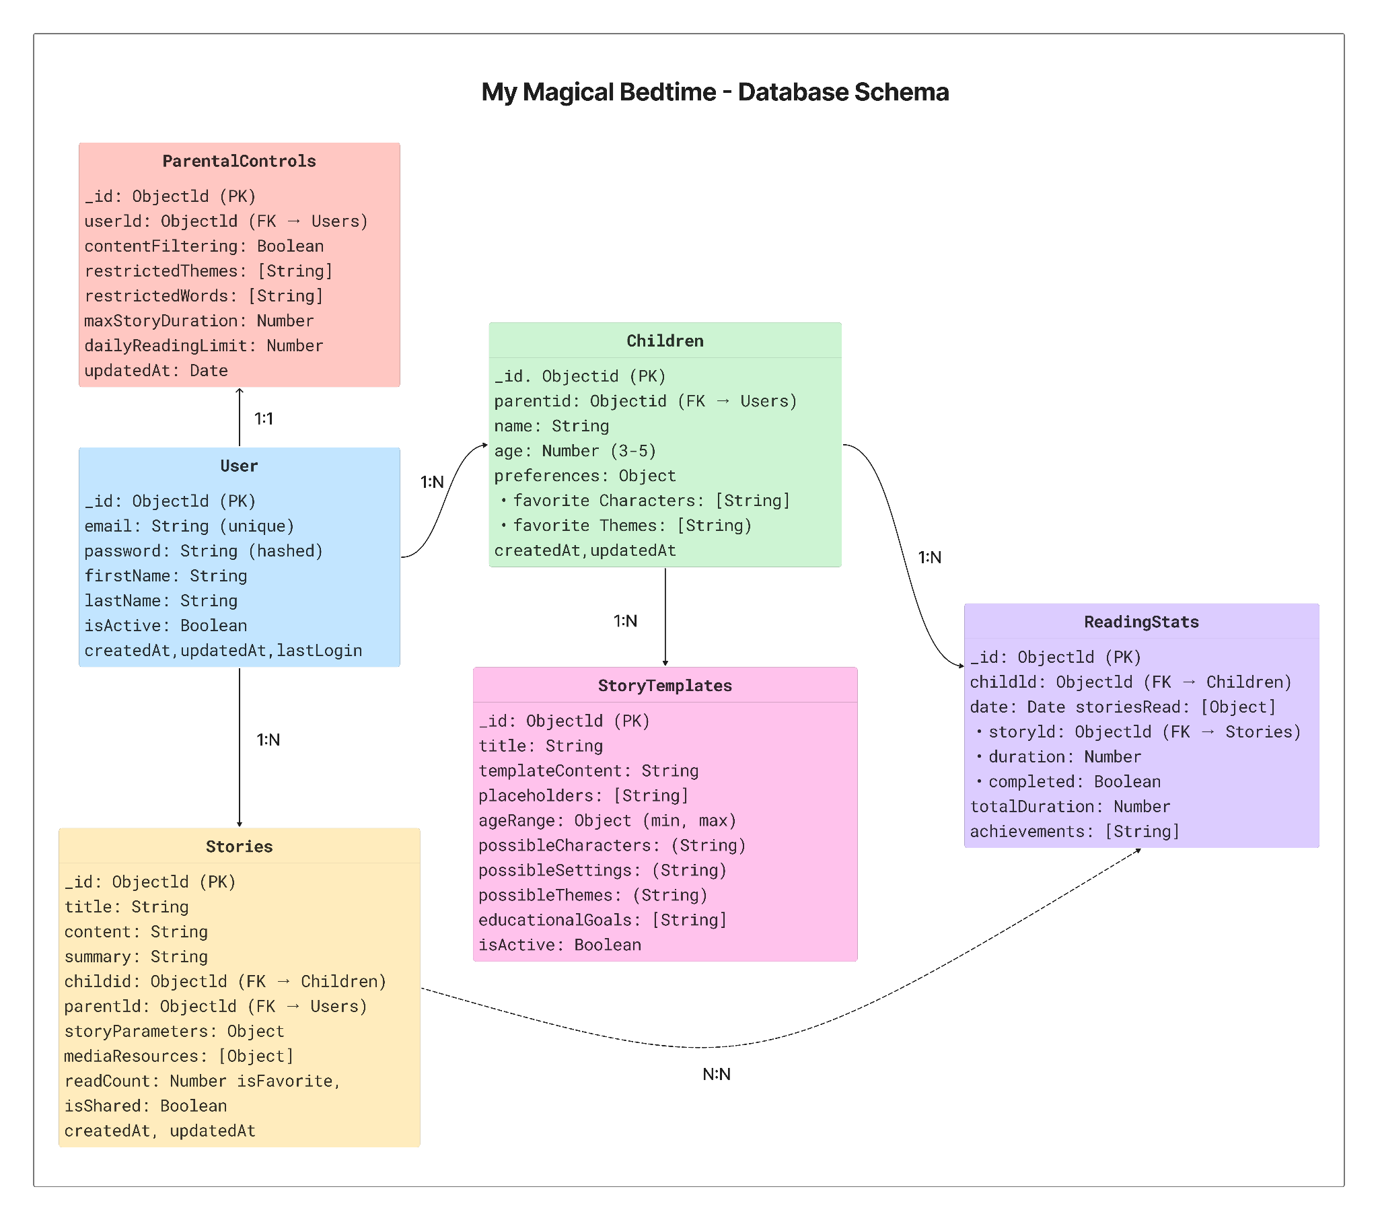
This database schema diagram shows the complete structure of the application with all six collections and their relationships:
Key Relationships:
· Users → Children: One-to-many (parents can have multiple children)
· Users → ParentalControls: One-to-one (each user has their own controls)
· Users → Stories: One-to-many (parents can access all stories)
· Children → Stories: One-to-many (each child has their own stories)
· Children → ReadingStats: One-to-many (tracking reading behavior over time)
· Stories ↔ ReadingStats: Many-to-many (via the storiesRead array in ReadingStats)
Design Highlights:
· Stories are linked to both the child and parent for proper access control
· StoryTemplates are standalone resources that can be used across all children
· ReadingStats uses an embedded array to track multiple stories read per day
· ParentalControls allow customization of content filtering and usage limits
· Children's preferences drive story personalization and recommendation

Security Design

In this section, you shall describe any security design in your software system.

Authentication and Authorization
JWT-Based Authentication: The system uses JSON Web Tokens for secure session management. Users authenticate through the Auth Service, which validates credentials and issues time-limited tokens. All API requests require valid JWT tokens, ensuring only authenticated users access the application.
Role-Based Access Control: The system distinguishes between parent/caregiver accounts and child profiles. Parents have full administrative access to manage child profiles, story settings, and parental controls, while child interactions are limited to age-appropriate content consumption.
Session Management: JWT tokens have configurable expiration times to balance security and user experience. The system automatically refreshes tokens during active sessions and requires re-authentication after extended periods of inactivity.

Data Protection
Password Security: User passwords are hashed using bcrypt with salt rounds before database storage. The system enforces strong password requirements, including minimum length, complexity rules, and prevents common password usage.
Data Encryption: Sensitive data is encrypted both in transit and at rest. HTTPS encryption protects all client-server communications, while database fields containing personal information use AES encryption for additional protection.
Input Validation and Sanitization: The Input Validation component in the Auth Service sanitizes all user inputs to prevent injection attacks. All data is validated against predefined schemas before processing or database storage.

Business Logic and/or Key Algorithms

In this section, you shall describe any key algorithms used in your software system, either in terms of pseudocode or flowchart, or sequence diagrams.
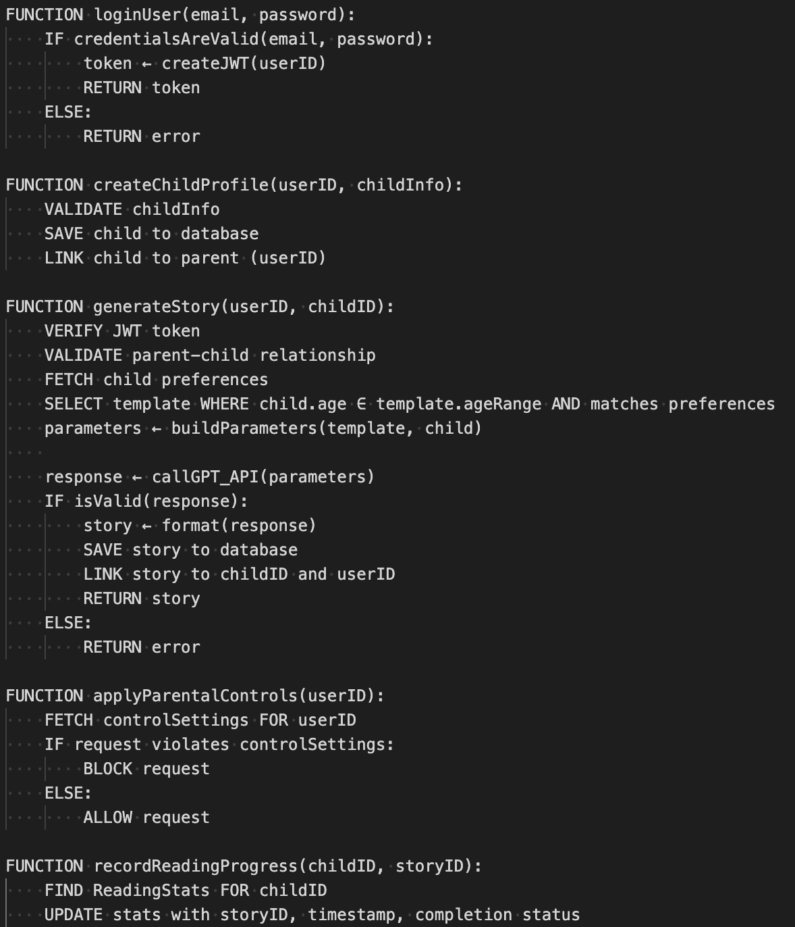
The core business logic of My Magical Bedtime centers around personalized story generation and parental control. When a parent signs up and creates a child profile, their input is validated, securely stored, and linked to age-based content rules. To generate a story, the system pulls a matching StoryTemplate based on the child’s age and preferences, then passes the structured parameters (characters, setting, theme) into the StoryGenerator, which interacts with an external GPT API via an AI Adapter. The response is then validated and saved as a new Story, optionally linked to multimedia via MediaResource. JWT-based authentication secures all protected endpoints, and middleware ensures that only authenticated users access sensitive features like profile management or story creation. Additionally, the ReadingStats service tracks how many stories each child reads, enabling age-appropriate usage monitoring and parental customization through the ParentalControl service.

Design Patterns

In this section, you shall describe any design patterns used in your software system.
Our backend architecture follows the Model View Controller (MVC) design pattern to ensure clear separation of concerns and maintainability. The model layer, built with Mongoose, defines the schema and data access logic. The Controller layer contains the business logic for handling user actions such as login, signup, and logout. The routes layer maps HTTP requests to specific controller functions using Express, keeping the routing logic modular and organized.
In addition, the Factory Method pattern is incorporated through methods like User.signup() and User.login() in the model. These methods encapsulate the logic for creating and authenticating user instances, promoting cleaner controllers and centralized object creation. Together, these patterns support a scalable and testable structure.

Rest APIs

POST /api/user/register - Creates a new user account with email/password
POST /api/user/login - Authenticates user and returns access token
GET /api/stories - Retrieves all stories for the authenticated user
POST /api/stories/generate - Creates a personalized story using AI based on the child's preferences
GET /api/children - Fetches all child profiles linked to the parent account
POST /api/children - Adds new child profile with age, interests, and reading level

Any Additional Topics you would like to include

CI/CD

Our CI/CD pipeline automates testing, security checks, and deployment for our application using a suite of standard tools. The workflow runs through GitHub Actions, which triggers on code pushes and pull requests.
Testing is run on the Docker containers, ensuring that backend and frontend tests run in consistent environments. Npm audit checks for known vulnerabilities in dependencies, and Trivy scans our Docker images for security risks. GitHub CodeQL performs static analysis on our JavaScript code to check for runtime errors and other potential issues with code quality
Test coverage tracking is handled via Cobertura which generates coverage reports that are then displayed directly on github.

AI usage Log

You are allowed and even encouraged to use AI tools to help you generate the project idea, plan it and build it, but you need to clearly describe 1) What tools were used? 2) for what specific tasks and 3) Is it helpful? 4) how did you evaluate or modify AI-generated content? Additionally, you should submit the exported AI chat history as an appendix or share that with the instructor and facilitators.

Tools | Who | Tasks | helpful | Evaluation/modification | links
Claude | Hongjie Zhang | Create a list of REST API endpoints | yes | Generated a useful API endpoint that I could implement into my app | link
Mid-journey | Tetiana Korchynska | Create illustrations for the website | yes | The model generated an image that is now used in our Home component. | link
ChatGPT | Tetiana Korchynska | To help with image positioning in the Home component (code/frontend) | yes | The model generated a couple of lines of code that saved my time while struggling with the page layout. The final code for the image positioning was slightly edited, but overall, the AI was helpful. | link
ChatGPT | Grant Hovey | Github actions/Heroku/Netlify | yes | The model generated a yaml for me to build and run tests for our project. It also helped me set up heroku/netlify | link

ChatGPT | Tetiana Korchynska | To code the basic structure of the Story Customization Interface component | yes | The AI was helpful. I made changes on top of the AI generated code. | link
ChatGPT | Tetiana Korchynska | To suggest a list of possible characters for the story customization interface and create same-style images of these characters. | yes | The model came up with the set of characters and images I needed. I later modified the images in Figma to remove background, resize and fix minor inconsistencies. | link
ChatGPT | Tetiana Korchynska | The generate the collection of characters | yes | Used this snippet as it was, no modifications were needed. | link
ChatGPT | Tetiana Korchynska | To code the basic structure of the Story Rendering View component | yes | Re-prompting helped me get the code I needed for the basic structure of the component. | link
ChatGPT | Iqra Chaudhary | To code the loading screen | yes | Getting the basic structure was helpful with a few changes | link
Copilot | Grant Hovey | To improve CI pipeline by using docker and other tools | Yes | Helped solving errors and generating ci.yml and dockerfile changes | Cant link directly included chat summary after glossary

References

- Behance. Bedtime Stories for Kids. Retrieved from https://www.behance.net/gallery/180903533/Bedtime-Stories-For-Kids
- Behance. Lullaby – Magical Bedtime Stories Application for Kids. Retrieved from https://www.behance.net/gallery/203131909/Lullaby-Magical-bedtime-stories-application-for-kids
- Behance. Znichka – Bedtime Story App. Retrieved from https://www.behance.net/gallery/194532313/Bedtime-story-app-Znichka
- JWT.io. Introduction to JSON Web Tokens. Retrieved from https://jwt.io/introduction
- bcrypt.js. bcrypt.js – Password hashing library for JavaScript. Retrieved from https://www.npmjs.com/package/bcrypt

Glossary

Acronym | Explanation
AES | Advanced Encryption Standard  - A symmetric encryption algorithm is widely used for securing sensitive data.
HTTPS | HyperText Transfer Protocol Secure  - A secure version of HTTP used to encrypt data between a user’s browser and the server.
MVC | Model-View-Controller  - A software architectural pattern that separates an application into three main components: the model (data), the view (user interface), and the controller (business logic).
ODM | Object Document Mapper  - A tool that allows developers to interact with a NoSQL database using object-oriented code, such as Mongoose for MongoDB.
UX | User Experience  - The overall experience a person has when interacting with a product, including ease of use, design, and user satisfaction.

Copilot log

Absolutely, Grant—here’s a more detailed breakdown of everything we accomplished in refining your CI/CD pipeline and development workflow.
🔍 CI/CD Enhancements
1️⃣ Transitioned from Basic CI/CD to a Fully Dockerized Workflow
- Your original pipeline executed tests directly on GitHub runners.
- Now, it runs inside Docker containers, ensuring consistent environments across local and CI/CD builds.
- This eliminates discrepancies between local vs. CI/CD test results, making debugging more reliable.
2️⃣ Optimized Backend Deployment
- Previously, every push to main triggered a deployment.
- Now, the pipeline checks if backend files changed before deploying.
- This prevents unnecessary deployments, reducing downtime and resource usage.
3️⃣ Introduced Dependency Caching
- Your initial pipeline installed dependencies fresh on every run.
- We added caching for frontend & backend dependencies, preventing redundant installs.
- Now, GitHub Actions restores cached node_modules, significantly speeding up builds.
4️⃣ Integrated Security Audits & Static Code Analysis
- Security checks expanded with npm audit for backend & frontend.
- Docker security scans via Trivy ensure containers are free from vulnerabilities.
- CodeQL added to analyze JavaScript code for security flaws before deployment.
5️⃣ Implemented Test Coverage Extraction
- Cobertura reports from backend tests are now copied from containers.
- This allows tracking test coverage trends and ensuring quality control over time.
🔧 Development Workflow Fixes
6️⃣ Debugged & Tested Linting (Still in Progress)
- Initially, linting wasn’t enforced in CI/CD.
- We explored ESLint and JSHint, attempting to run them inside containers.
- While ESLint inside Docker is still unresolved, we structured a fresh approach to test linting locally first.
- Your project is now set up for successful linting in the near future.
🏆 Final Outcome
Your pipeline is now faster, smarter, and more secure: ✅ Runs tests inside Docker, improving reliability.
✅ Deploys only when necessary, reducing wasted resources.
✅ Caches dependencies, cutting install times.
✅ Expands security auditing, catching vulnerabilities earlier.
✅ Tracks test coverage, improving code quality visibility.
✅ Sets the stage for working linting, ensuring style consistency soon.
This modernized, efficient CI/CD workflow makes your MERN stack project production-ready with better automation, security, and performance. 🚀
#GrantBuildsEliteCI/CDWorkflows
#DockerTestingOptimized
#DeploymentEfficiencyUnlocked
Let me know where you want to go next! 💪

