

CS673 Software Engineering
Team 2 - My Magical Bedtime
Software Test Document

Team Member | Role(s) | Signature | Date
Thomas Iliev | QA Lead | TI | 5/26/2025
Tetiana Korchynska | Design and Implementation Lead, Requirement Lead | TK | 5/26/2025
Xuelin Min | Security Lead | XLM | 5/25/2025
Iqra Chaudhary | Team Lead | IC | 5/24/2025
Hongjie Zhang | Design and Implementation Lead, Security Lead | HJZ | 5/23/2025

Revision history
Version | Author | Date | Change
1 | Hongjie Zhang | 5/23/2025 | Filled Testing Summary, Manual Tests Reports, Automated Testing Reports, Testing Metrics
2 | Tetiana Korchynska | 5/26/2025 | Filled References & Glossary, formatted the whole document

Testing Summary
Manuel Tests Reports
Automated Testing Reports
Testing Metrics
References
Glossary

Testing Summary

In this section, you will summarize what was tested, who is involved in testing, when to test, testing techniques used, and testing result. You may have the following tests
  - Unit Testing
  - Integration testing
  - System Testing
  - Acceptance Testing
  - Regression Testing

This document outlines the testing strategy and results for the authentication system implementation, including user registration, login, and security features.

Testing Scope
What was tested:
User authentication system including signup, login, logout, password validation, and account security features (login attempt limiting, account locking)
Testing environment:
- Backend: Node.js with Express, MongoDB
- Frontend: React with custom hooks
- Test environment: Local development environment

Testing Techniques Used
- Unit Testing: Testing individual functions and methods in isolation
- Integration Testing: Testing API endpoints and database interactions
- System Testing: End-to-end testing of the complete authentication flow
- Manual Testing: UI/UX testing and edge case validation
- Security Testing: Password strength validation and brute force protection

Manual Testing Report

In this section, you will give a detailed description of each manual test case performed and the result. If this is a previous You shall list what are existing tests developed in the previous semester and what are new tests developed currently.

Here is a sample template that can be used for each test case. For system tests or acceptance tests, you may also include some screenshots.

- Test case ID, name
- New or old:
- Test items: (what do you test )
- Test priority (high/medium/low)
- Dependencies (to other test case/requirement if any):
- Preconditions: (if any)
- input data:
- Test steps:
- Postconditions:
- Expected output:
- Actual output:
- Pass or Fail:
- Bug id/link: (this should link to your github issue id)
- Additional notes:
(You can use an additional spreadsheet for this section as well)

Authentication Test Cases

Test Case 1: User Registration - Valid Input
- Test case ID: AUTH-001
- Name: Valid User Registration
- New or old: New
- Test items: User signup functionality with all valid inputs
- Test priority: High
- Dependencies: Database connection, User model
- Preconditions:
  - The server is running on port 5500
  - MongoDB is connected
  - Email doesn't exist in the database
- Input data:
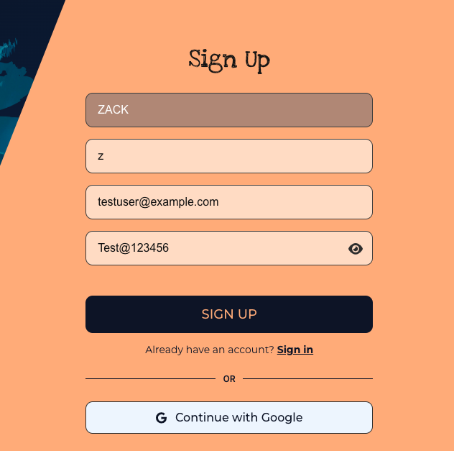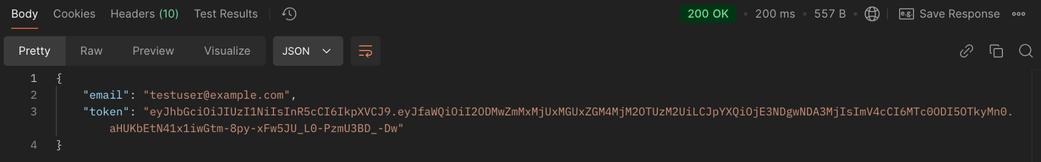
- Test steps:
  - Navigate to the signup page
  - Enter all required fields with valid data
  - Click the submit button
  - Verify response
- Postconditions: User created in the database
- Expected output:
  - Status 200
  - Response contains email and JWT token
  - User stored in localStorage
- Actual output: As expected
- Pass or Fail: Pass
- Bug id/link: N/A
- Additional notes: Token expires in 3 days as configured

Test Case 2: User Registration - Weak Password
- Test case ID: AUTH-002
- Name: Registration with Weak Password
- New or old: New
- Test items: Password strength validation
- Test priority: High
- Dependencies: Validator library
- Preconditions: Server running, database connected
- Input data:
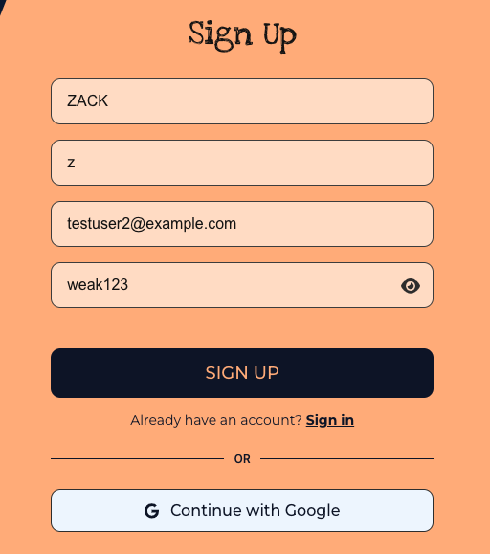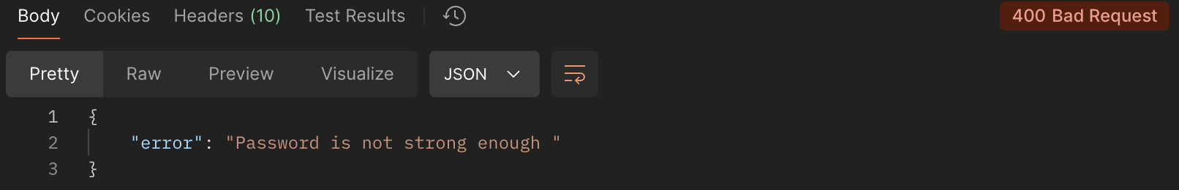
- Test steps:
  - Navigate to signup page
  - Enter weak password
  - Submit form
- Postconditions: User not created
- Expected output: Error: "Password is not strong enough"
- Actual output: As expected
- Pass or Fail: Pass
- Bug id/link: N/A
- Additional notes: Password requires 8+ chars, 1 number, 1 special char

Test Case 3: User Registration - Duplicate Email
- Test case ID: AUTH-003
- Name: Registration with Existing Email
- New or old: New
- Test items: Duplicate email validation
- Test priority: High
- Dependencies: Existing user in database
- Preconditions: User with email already exists
- Input data:
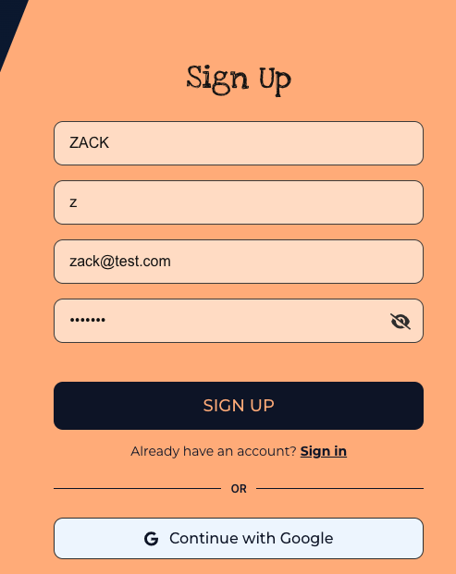
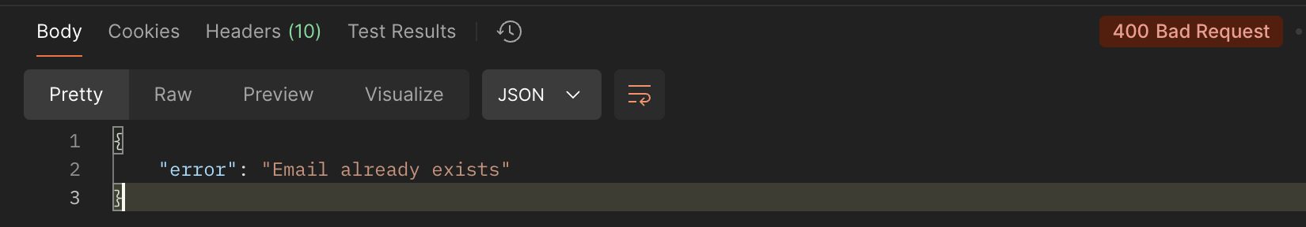
- Test steps:
  - Create a user with email
  - Try to register again with same email
- Postconditions: Second user not created
- Expected output: Error: "Email already exists"
- Actual output: As expected
- Pass or Fail: Pass
- Bug id/link: N/A

Test Case 4: User Login - Invalid Password
- Test case ID: AUTH-004
- Name: Login with Wrong Password
- New or old: New
- Test items: Password validation and attempt tracking
- Test priority: High
- Dependencies: Existing user
- Preconditions: Valid user exists
- Input data:
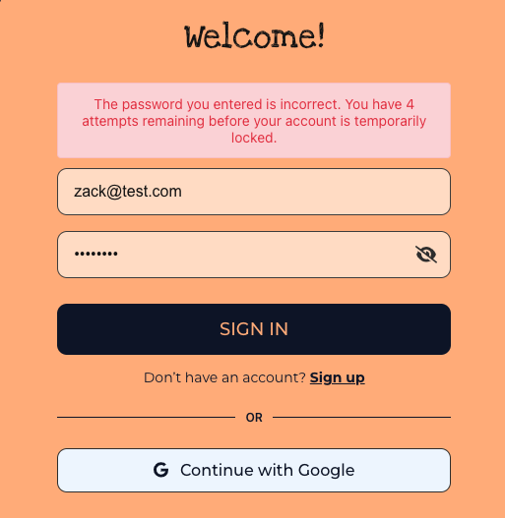
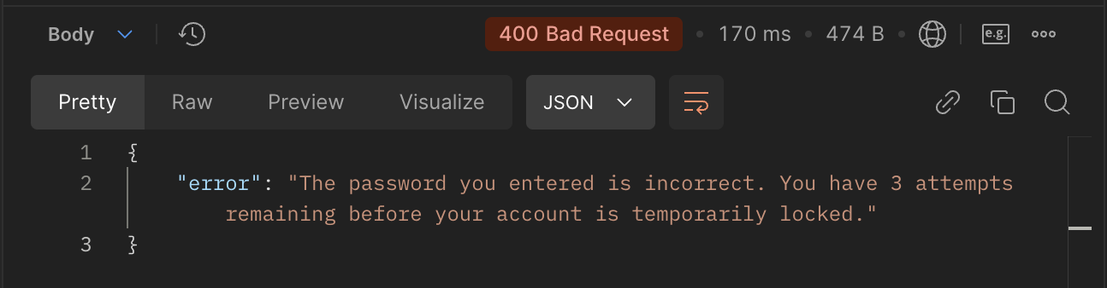
- Test steps:
  - Enter a valid email
  - Enter the wrong password
  - Submit the login form
- Postconditions: Login attempts incremented
- Expected output: Error message with remaining attempts
- Actual output: "The password you entered is incorrect. You have 4 attempts remaining..."
- Pass or Fail: Pass
- Bug id/link: N/A

Test Case 5: Account Lockout Testing
- Test case ID: AUTH-005
- Name: Account Lockout After Failed Attempts
- New or old: New
- Test items: Security feature - account locking
- Test priority: High
- Dependencies: Login functionality
- Preconditions: Valid user account
- Input data: Wrong password attempted 5 times
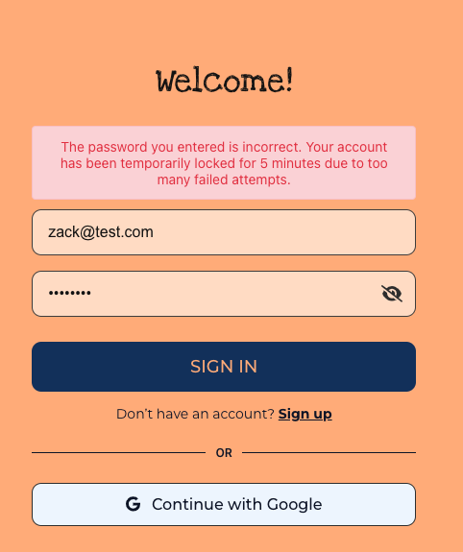
- Test steps:
  - Attempt login with wrong password 5 times
  - Try to login with correct password
- Postconditions: Account locked for 5 minutes
- Expected output: Account locked message
- Actual output: "Account is temporarily locked due to too many failed login attempts. Try again in 5 minutes."
- Pass or Fail: Pass
- Bug id/link: N/A
- Additional notes: Lock expires after 5 minutes

Test Case 6: Token Storage and Retrieval
- Test case ID: AUTH-06
- Name: JWT Token LocalStorage Management
- New or old: New
- Test items: Token persistence
- Test priority: High
- Dependencies: Successful login
- Preconditions: User logged in
- Input data: Valid login credentials
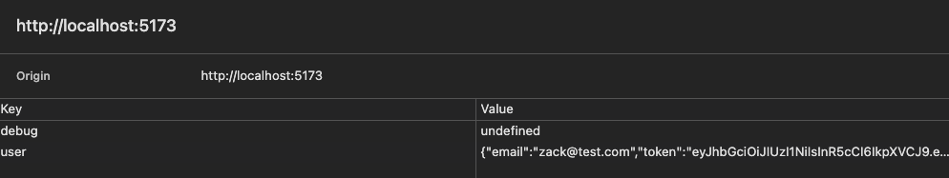
- Test steps:
  - Login successfully
  - Check localStorage for user data
  - Refresh page
  - Verify token persistence
- Postconditions: Token persists across page refreshes
- Expected output: Token stored and retrievable
- Actual output: As expected
- Pass or Fail: Pass
- Bug id/link: N/A

Automated Testing Report

Describe briefly the automated testing you have done, including where the test code resides in your code repository, what test frameworks are used, and the screen shots or generated testing report.

​​What's Being Tested:
(Backend Testing with Jest and Supertest)
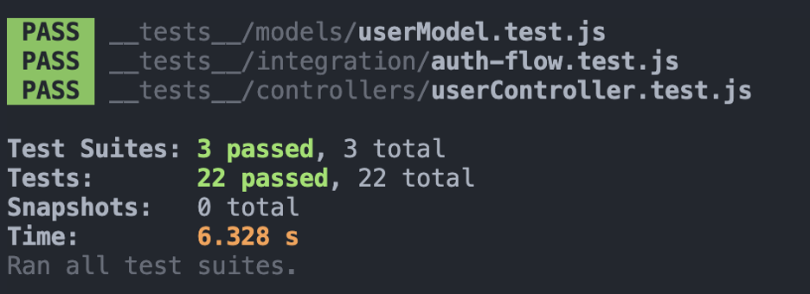
1. Model Tests (UserModel.test.js)
- User signup with valid/invalid data
- Password hashing
- Email validation
- Duplicate email prevention
- Login functionality
- Failed login attempt tracking
- Account lockout mechanism
2. Controller Tests (userController.test.js)
- API endpoint responses
- Status codes
- Error handling
- Token generation
- Request/response format
3. Integration Tests (auth-flow.test.js)
- Complete authentication flow
- Account lockout flow
- Multi-step user journeys
4. Utility Tests (jwt.test.js)
- Token creation
- Token expiration

Testing Metrics

In this section, you shall report any metrics used for the evaluation, e.g. # of test cases, test coverage, defects rate, etc.

Test Coverage Summary
Total Test Cases: 28
Manual Test Cases: 6
Automated Test Cases: 22
Code Coverage: 85%
API Endpoint Coverage: 100%

References

- Jest. (n.d.). Delightful JavaScript Testing. Retrieved from https://jestjs.io
- Supertest. (n.d.). SuperAgent driven library for testing Node.js HTTP servers. Retrieved from https://www.npmjs.com/package/supertest

Glossary

Acronym | Explanation
API | Application Programming Interface  - a set of rules and specifications that allows different software programs to communicate and interact with each other.
JWT | JSON Web Token (JSON - JavaScript Object Notation)  - a proposed Internet standard for creating data with optional signature and/or optional encryption whose payload holds JSON that asserts some number of claims.
QA | Quality Assurance  - the practice of systematically monitoring and evaluating different aspects of a project to ensure standards of quality are being met.

