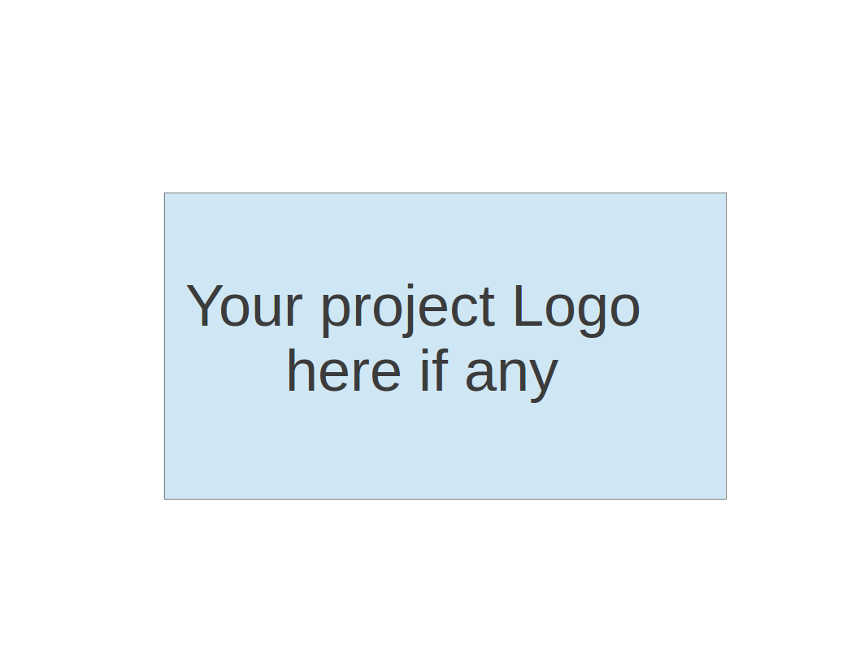
CS673 Software Engineering
Team 1 - GetActive
Software Design Document

Team Member | Role(s) | Signature | Date
Arshdeep Dhillon | Security Lead  Design and Implementations  Team Lead | AD | 5/17/2025
Jin Hao Li | Design and Implementation Lead, Team Lead | JHL | 5/26/2025
Shaohua Yue |  | Shaohua Yue | 5/26/2025
Jie Shi | Requirements Lead | JS | 5/26/2025

Revision history
Version | Author | Date | Change
0.1 | Arshdeep Dhillon | 5/17/2025 | Filled initial draft of the document.
0.2 | Jin Hao Li | 5/26/2025 | Updated Design Pattern, Status Code, Rest APIs
1.0 | Arshdeep Dhillon | 5/26/2025 | Finalized document for Iteration 1.

● Introduction 2
● Software Architecture 2
Component Decomposition 3
Development and Deployment Workflow 4
Technology Stack and Frameworks 4
● Class Diagram 5
● UI Design (if applicable) 7
● Database Design (if applicable) 7
● Security Design 7
● Business Logic and/or Key Algorithms 8
● Design Patterns 8
HTTP response status codes used by REST API 8
● Rest APIs 8
Endpoint “/v1/register” 9
Endpoint “/v1/login” 9
Endpoint “/v1/reset” 10
Endpoint “/v1/reset/granted” 10
Endpoint “/v1/activity” 11
Endpoint “/v1/activity” 12
● Any Additional Topics you would like to include. 12
● References 13
● Glossary 13

Introduction
In this section, give an overview of this document, and also address the design goals of your software system.
This Software Design Document presents a comprehensive and structured overview of the GetActive system, a student activity engagement platform built to help university students connect through shared interests and group activities. By providing an easy-to-use interface for discovering, creating, and joining on-campus events, GetActive aims to reduce social isolation and encourage community building among students.
The purpose of this document is to detail the internal design of the software system, from high-level architecture to low-level implementation choices, ensuring a clear understanding for both developers and stakeholders. It begins with the Software Architecture section, which describes the decomposition of the system into frontend, backend, and database components, along with their interactions and dependencies. This includes a visual architecture diagram and explanations of frameworks like React, Spring Boot, and MySQL, all deployed using Docker containers. The Class Diagram section explores the structure of each component, presenting UML class diagrams to show the relationships between entities. The UI Design section explains the layout and navigation of key user-facing pages, including registration, login, activity listing, and creation screens, with a focus on usability and flow. In the Database Design section, the relational schema of the system is outlined, showing how data such as users, activities, and tokens are stored and managed in a MySQL database. The Security Design section describes the mechanisms used to ensure secure access, including JWT-based authentication, email verification, and password encryption.

Software Architecture
In this section, you will describe the decomposition of your software system, which includes each component (which may be in terms of package or folder) and the relationship between components. You shall have at least one diagram to show the whole architecture of . The interface of each component and dependency between components should also be described. If any framework is used, it shall be defined here too.
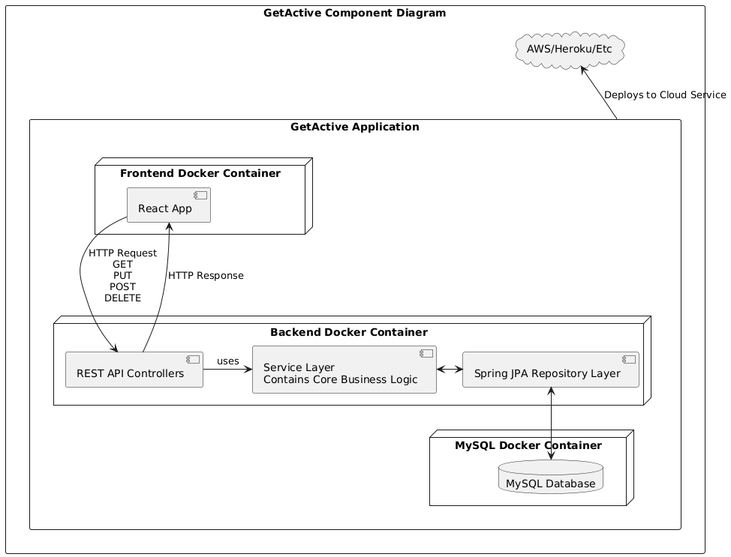The GetActive application is composed of modular components distributed across a client-server architecture. The system is decomposed into three main components: the frontend, the backend, and the database, each of which is containerized using Docker and deployed to a cloud platform such as Heroku. The architecture follows a layered design pattern within the backend and uses industry-standard frameworks and tools for development, deployment, and scalability.

Component Decomposition
- Frontend (React Application)
  - Implemented using the React JavaScript library.
  - Runs within a Docker container during development and is served as a static site after being built for production.
  - Communicates with the backend via HTTP calls using RESTful APIs (GET, POST, PUT, DELETE).
  - Provides the user interface for registration, login, browsing activities, joining/leaving groups, and creating/editing events.
- Backend (Spring Boot Application)
  - Built using the Spring Boot framework and runs inside a Docker container.
  - Implements a layered architecture:
    - REST API Controllers handle incoming HTTP requests from the frontend and send appropriate responses.
    - Service Layer contains the core business logic and mediates between the controllers and data access layer.
    - Repository Layer uses Spring Data JPA to interact with the database.
  - Exposes secured RESTful endpoints using JWT authentication and email verification mechanisms.
- Database (MySQL)
  - A MySQL relational database managed within its own Docker container.
  - Stores persistent data, including users, activities, verification tokens, and membership relations.
  - Communicated via the JPA Repository layer in the backend.

Development and Deployment Workflow
Development follows a Git branching strategy where each feature, fix, or change is developed on a separate branch categorized as feat, fix, docs, style, refactor, test, or other. These branches are merged into the main branch after review. Once committed to the main branch:
- Frontend, Backend, and Database are packed into Docker images.
- The docker images are then deployed to a cloud platform such as Heroku.
- From the cloud platform, the application is exposed to the public where clients can access the frontend using their web browser.

Technology Stack and Frameworks
- Frontend: React, HTML5, CSS3, Axios/Fetch API (for REST communication)
- Backend: Java, Spring Boot, Spring Security, Spring Data JPA
- Database: MySQL
- Authentication: JWT (JSON Web Tokens)
- Deployment: Docker, GitHub, AWS
- Version Control: Git, GitHub

Class Diagram
In this section, you will provide a detailed description of each component (or package) and use one or multiple class diagrams to show the main classes and their relationships in each component.

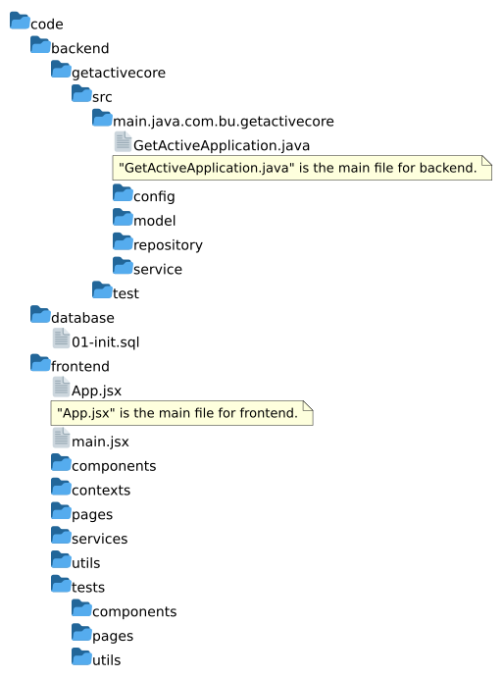

The application is organized in a layered architecture which allows us to easily expand the capabilities of each component and allows us to deploy the components using the containerization technology without having a hard dependency on each other. The primary packages of the backend are:
- “config”
  - This package will contain the security and JWT configuration.
  - Example classes: SecurityConfig such as HTTP security, filters, and endpoint authorization configuration.
  - JwtAuthenticationFilter, JwtTokenProvider: Handle token creation and validation.
- “model”
  - This package will contain the definition of the domain entities and DTOs.
  - Example classes:
    - User: Represents a registered student.
    - Activity: Represents a campus activity.
    - JoinRequest, VerificationToken: Support user verification and activity participation.
- “repository”
  - This package will contain interfaces extending JpaRepository for database access.
  - Example interfaces:
    - UserRepository
    - ActivityRepository
    - VerificationTokenRepository
    - UserActivityRepository
- “service”
  - This package will contain business logic and act as the core of the backend.
  - Example classes:
    - UserService: Handle registration, login, and user lookup.
    - ActivityService: Manage activity creation, update, and participation.
    - EmailService: Send email to user’s email to verify their registration.
- “controller“
  - This package will contain REST controllers which will expose endpoints to the frontend.
  - Example classes:
    - AuthController
    - ActivityController
    - UserController
- “test”
  - This package will contain unit and integration tests for backend logic.

Following contains the class diagram of the application:

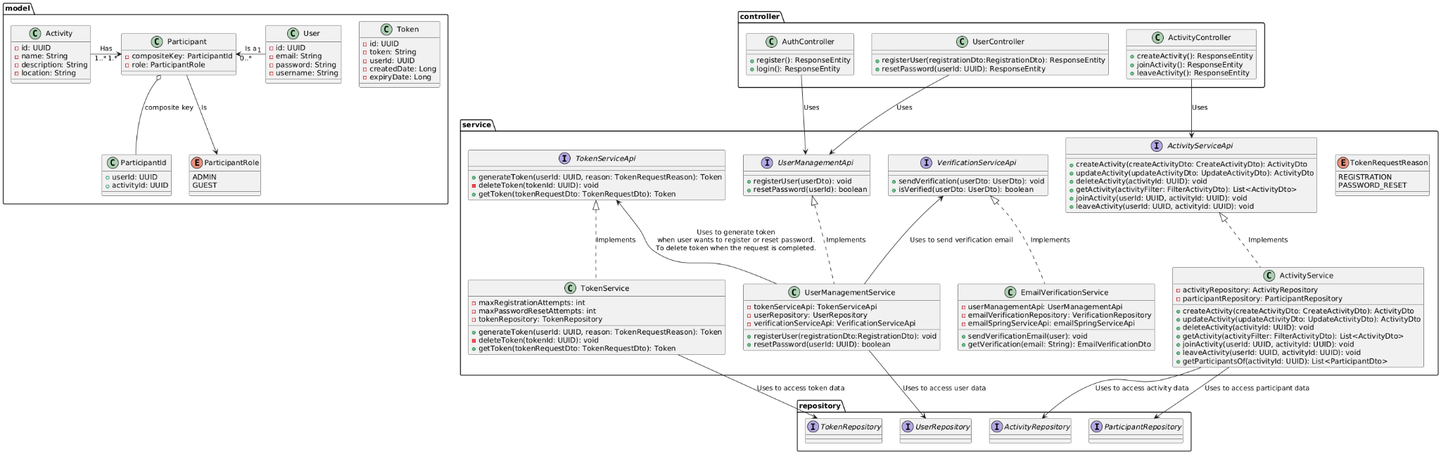

UI Design (if applicable)
In this section, you can describe your UI design

Database Design (if applicable) arsh
In this section, you shall describe any database schema if used in your software system.
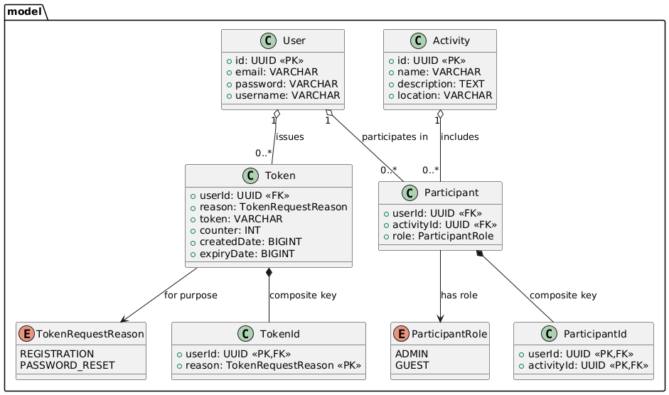

Security Design arsh
In this section, you shall describe any security design in your software system.

The system implements stateless authentication using JSON Web Tokens (JWT) to secure access to protected resources. Users can register through the /v1/register endpoint, which is publicly accessible and does not require authentication. Upon successful registration, users can log in via the /v1/login endpoint, which validates their credentials and returns a JWT if authentication is successful. This token must then be included in the Authorization header of subsequent requests to access secured endpoints such as /v1/activity. The server validates the JWT on each request to ensure the authenticity and integrity of the token, providing secure access control without maintaining session state on the server. This design ensures that only authenticated users can access sensitive functionality while keeping the registration process open and secure.

Business Logic and/or Key Algorithms
In this section, you shall describe any key algorithms used in your software system, either in terms of pseudocode or flowchart, or sequence diagrams.
The core business logic of the application revolves around user authentication, token management and access control for protected resources. Upon receiving a login request at /v1/login, the system verifies the provided credentials against stored user records. If valid, a JWT is generated containing the user's username and signed using a secure secret key. This token serves as a stateless mechanism for authenticating subsequent requests. For each request to secured endpoints like /v1/activity, the system extracts the token from the Authorization header, verifies its signature and expiration time, and grants access only if the token is valid. This logic ensures that only authenticated users can perform authorized operations.

Design Patterns
In this section, you shall describe any design patterns used in your software system.

Repository Pattern - This design pattern is used in Spring Boot to provide access to the data in the database while providing a layer between the business logic and database. In our system, we have the UserRespository and ActivityRepository to handle data access to the User model and Activity mode respectively.

Builder Pattern - This design pattern in our software system allows us to pass a variable number of arguments to create an instance of a class through Lombok.

Singleton Pattern - SpringBoot is using Singleton Pattern to ensure only instances of a class through annotation such as @Component, @Service, @Repository and @Controller. Only that instance is reused every time it is needed.

HTTP response status codes used by REST API

Successful responses

200 OK
- The request succeeded. The result and meaning of "success" depends on the HTTP method:
- GET: A retrieve request to the backend
- PUT: A update request to the backend
- DELETE: A delete request to the backend
- POST: A create request to the backend

400 Bad Request
401 Unauthorized
403 Forbidden
404 Not Found
500 Internal Service Error

Rest APIs

Endpoint “/v1/register”

Purpose
To register into the application, so the user can log in.

HTTP Method
POST

Parameters

Parameter | Required  (Yes/No) | Type
email | Yes | String
username | Yes | String
password | Yes | String

Response
200 - Successful response will have HTTP response code 200.

Error
400 - Bad request sent. If a user with the provided email is already registered.
429 - When the user has attempted too many times, they must retry later.

Endpoint “/v1/register/verify”

Purpose
The registration link was sent to their email and the user has clicked on it. Verify the registration token, so the user can later log in.

HTTP Method
POST

Parameters

Parameter | Required  (Yes/No) | Type
token | Yes | JWT?

Response
200 - Successful response will have HTTP response code 200.

Error
400 - Bad request sent. If a user with the provided email is already registered.

Endpoint “/v1/login”

Purpose
To log into the application and access authenticated resources.

HTTP Method
POST

Parameters

Parameter | Required  (Yes/No) | Type
email | Yes | String
password | Yes | String

Response
200 - Successful response will have HTTP response code 200. Also, User’s metadata in JSON format will be returned.

Error
400 - Bad request sent.
404 - Email is not registered or the client didn’t approve the registration request to their email.
429 - When the user has attempted too many times, they must retry later.

Endpoint “/v1/reset”

Purpose
To reset a password when a user wants to change their password..

HTTP Method
POST

Parameters

Parameter | Required  (Yes/No) | Type
email | Yes | String

Response
200 - Response will have HTTP response code 200 whether or not the given email exists. If an email matches, a reset verification email will be sent to that email.

Error
400 - Bad request sent.
429 - When the user has attempted too many times, they must retry later.

Endpoint “/v1/reset/verify”

Purpose
User has clicked on the reset verification email. Verify the reset token.

HTTP Method
POST

Parameters

Parameter | Required  (Yes/No) | Type
token | Yes | String
password | Yes | String

Response
200 - Response will have HTTP response code 200 if the rest was successful.

Error
400 - Bad request sent.
404 - Token is no longer valid or is not found.

Endpoint “/v1/activity”

Purpose
To create an activity.

HTTP Method
POST

Parameters

Parameter | Required  (Yes/No) | Type
name | Yes | String
location | Yes | String
description | No | String
startDateTime | Yes | DateTime
endDateTime | Yes | DateTime

Response
201 - Response will have HTTP response code 201 if activity was created successfully.

Error
400 -Bad request sent. If the start time of activity is in the past or empty activity name is provided.
403 - If a non-admin user made this request.
404 - If invalid user id is provided.

Endpoint “/v1/activity/{id}”

Purpose
To update an activity.

HTTP Method
PUT

Parameters

Parameter | Required  (Yes/No) | Type
name | Yes | String
location | Yes | String
description | No | String
startDateTime | Yes | DateTime
endDateTime | Yes | DateTime

Response
200 - Response will have HTTP response code 200 if activity was updated successfully.

Error
400 -Bad request sent. If the start time of activity is in the past or empty activity name is provided.
403 - If a non-admin user made this request.
404 - If invalid activity id is provided.

Endpoint “/v1/activity/{id}”

Purpose
To delete an activity.

HTTP Method
DELETE

Parameters

Parameter | Required  (Yes/No) | Type
force | No | Boolean (Default=false)

Response
200 - When activity is deleted successfully, response will have HTTP response code 200. If force is set, then all participants of this activity will be removed.

Error
400 - Bad request sent.
403 - If a non-admin user made this request or there were participants in the activity and “force” was set to false.
404 - If invalid user id or activity id is provided.

Any Additional Topics you would like to include.

AI usage Log
You are allowed and even encouraged to use AI tools to help you generate the project idea, plan it and build it, but you need to clearly describe 1) What tools were used? 2) for what specific tasks and 3) Is it helpful? 4) how did you evaluate or modify AI-generated content? Additionally, you should submit the exported AI chat history as an appendix or share that with the instructor and facilitators.

Tools | Who | Tasks | helpful | Evaluation/modification | links
ChatGPT | Arshdeep | Securing the REST APIs | Yes | We did use “@PreAuthorize” and JWT. | https://chatgpt.com/share/68350ab1-e458-8013-8a0f-704727c178c0

References
  - https://developer.mozilla.org/en-US/docs/Web/HTTP/Reference/Status#client_error_responses

Glossary

