**CS673 Software Engineering** 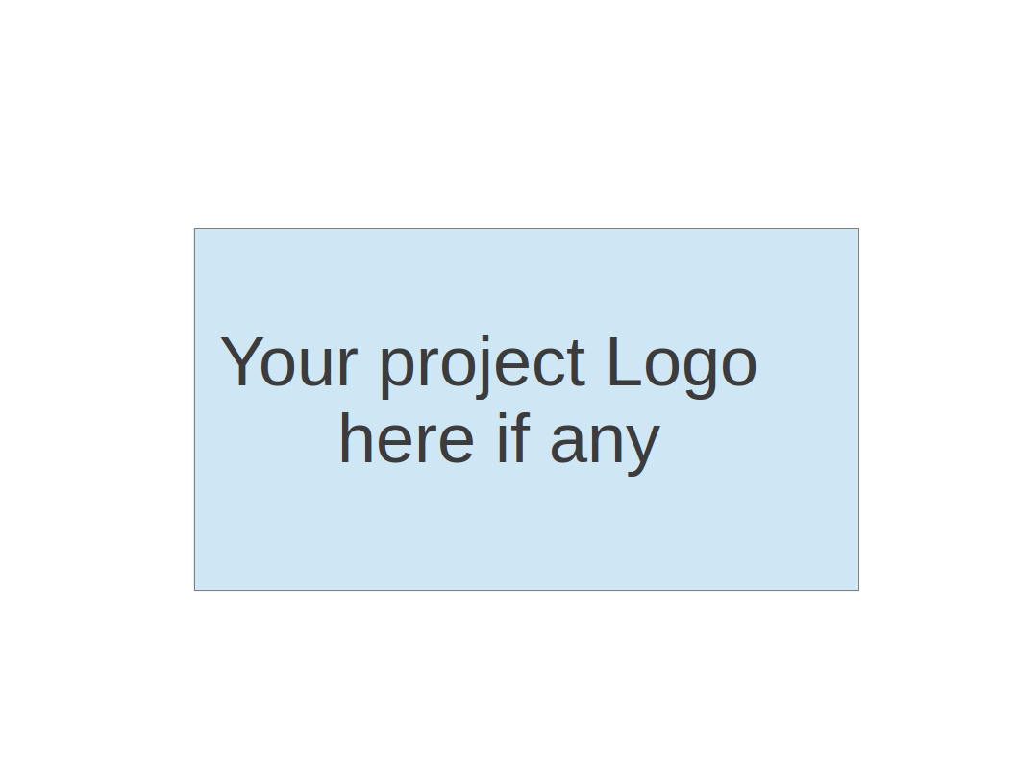

**Team X - Project Name**

**Project Proposal and Planning**

| Team Member | Role(s) | Signature | Date |
| --- | --- | --- | --- |
|  |  |  |  |
|  |  |  |  |
|  |  |  |  |
|  |  |  |  |
|  |  |  |  |
|  |  |  |  |
|  |  |  |  |
|  |  |  |  |
|  |  |  |  |

**Revision history**

| **Version** | **Author** | **Date** | **Change** |
| --- | --- | --- | --- |
|  |  |  |  |
|  |  |  |  |
|  |  |  |  |
|  |  |  |  |

Overview

Related Work

Proposed High level Requirements

Management Plan

Objectives and Priorities

Risk Management (need to be updated constantly)

Timeline (need to be updated at the end of each iteration)

Configuration Management Plan

Tools

Deployment Plan if applicable

Quality Assurance Plan

Metrics

Code Review Process

Testing

Defect Management

References

Glossary

# Overview

(Please give an overview of your project. It should include the motivation, the purpose and the potential users of the proposed software system, the basic functionality of the proposed software system and the possible technology stack to be used. )

# Related Work

(Please describe any similar software systems that you have found through the online research, and the differences between your software and those software systems.)

# Proposed High level Requirements

* 1. Functional Requirements  
     (For each functional requirement, please give a feature title and a brief description using the following format: As (a role), I want to (action), so that (value).)
     1. Essential Features (the core features that you definitely need to finish):

(For each essential features, please give a rough estimation in terms of person hours or an range of person hours)

* + 1. Desirable Features (the nice features that you really want to have too):
    2. Optional Features (additional cool features that you want to have if there is time):
    3. Existing Features (delete this item if your project starts from scratch)
  1. Nonfunctional Requirements
     1. Security requirements

# Management Plan

## Objectives and Priorities

(Please describe your project objectives with highest priority first. Project Goals can include but not limited to complete all proposed (essential) features, deploy the software successfully, the software has no known bugs, maintain high quality, etc )

## Risk Management (need to be updated constantly)

(Please write a summary paragraph about the main risks your group identified and how you plan to manage these risks. Then use the separate google sheet for detailed risk management. The template is provided in the same folder with this file. Please provide the link to the sheet.)

**Risk Management Sheet Link:**

## Timeline (this section should be filled in iteration 0 and updated at the end of each later iteration)

| Iteration | Functional Requirements(Essential/Disable/Option) | Tasks (Cross requirements tasks) | Estimated/real person hours |
| --- | --- | --- | --- |
| 1 |  |  |  |
| 2 |  |  |  |
| 3 |  |  |  |

# Configuration Management Plan

## Tools

(In this project, we will use Git and Github as the version control tools. Please also specify any other tools to be used, e.g. IDE tools, CI/CD tools, container tools, SAST or DAST tools, and any other DevOps tools)

* 1. Code Commit Guideline and Git Branching Strategy  
     (Please briefly describe criteria for the code commitment and the branching strategy used, e.g. what are the branches to be used, how the pull request will be used etc. Here is an article to give you some basic knowledge about different git branching strategies: <https://www.flagship.io/git-branching-strategies/>

## Deployment Plan if applicable

(If you plan to deploy your application (e.g. your web application), briefly describe how you plan to deploy your application).

# Quality Assurance Plan

## Metrics

(Describe the metrics to be used in the project to measure the quality of your software. Each metric should be measurable and quantifiable. Examples of metrics include product complexity (LOC, # of files, # of classes, # methods, cyclomatic complexity, etc.) , defect rate (# of defect per KLOC), # of test cases, test case pass rate, cost (# of person hours used), # of user stories completed, etc. **The result of these metrics should be reported in the progress report/ iteration summary sheet.**)

| Metric Name | Description |
| --- | --- |
|  |  |
|  |  |
|  |  |
|  |  |
|  |  |

* 1. Coding Standard

(Describe any coding standard to be used)

## Code Review Process

(Everyone should review all documents to be submitted. Here you will mainly describe how the code review will be done. Who will review the code, e.g. design or implementation leader will review all code or team members review each other’s code. Do you use pull requests for the code review? Is there a checklist to help review? What feedback should the reviewer provide?)

## Testing

(Both manual testing and automated testing should be considered. Both unit testing and integration testing should be considered. Briefly describe the testing tools/framework to be used, the personnel involved (e.g. the QA leader will focus on the integration testing and each developer will unit test their own code), when and what types of testing will be performed, the testing objectives, etc)

## Defect Management

(Describe the tool to be used to manage the defect (e.g github issues). The types of defects to look at. The actions or personnel for defect management. )

# References

(For more details, please refer to the encounter example in the book or the software version of the documents posted on blackboard. )

# Glossary

(Any acronym used in the document should be explained here)