**CS673 Software Engineering** 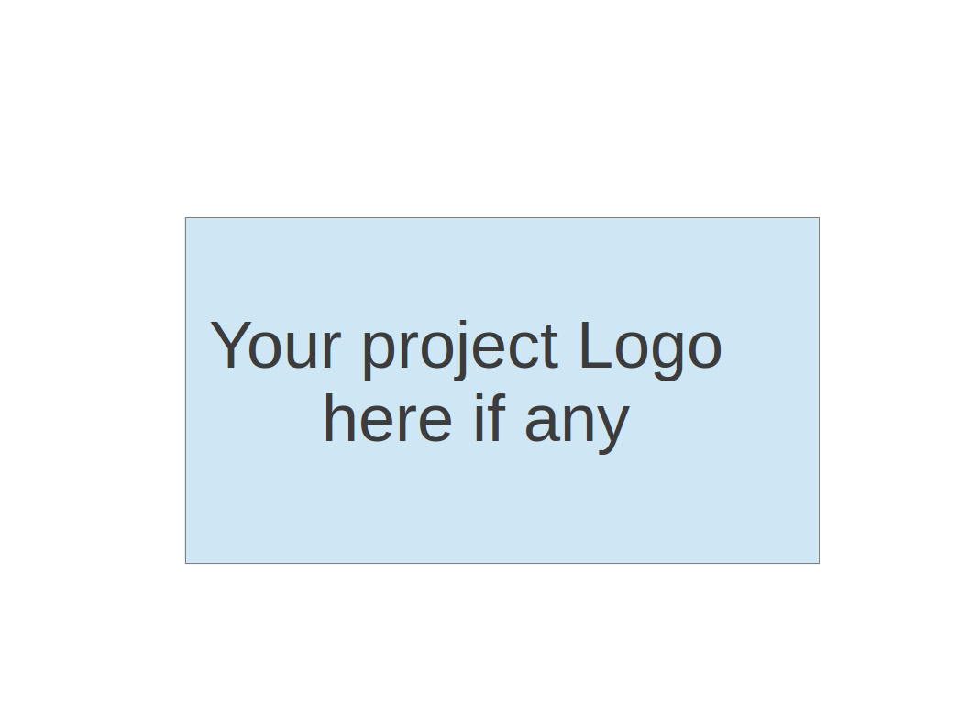

**Team 4 - TeamBuilder**

**Software Test Document**

| Team Member | Role(s) | Signature | Date |
| --- | --- | --- | --- |
| Vishal Sundaram | QA Leader | *Vishal Sundaram* | 22-Sep-2024 |
| Wenli Gai | Security Leader | *Wenli Gai* | 23-Sep-2024 |
|  |  |  |  |
|  |  |  |  |
|  |  |  |  |
|  |  |  |  |
|  |  |  |  |
|  |  |  |  |

**Revision history**

| **Version** | **Author** | **Date** | **Change** |
| --- | --- | --- | --- |
|  |  |  |  |
|  |  |  |  |

Testing Summary

Manuel Tests Reports

Automated Testing Reports

Testing Metrics

References

Glossary

# Testing Summary

What was tested:

* UI components unit tests
  + Sidenav
    - Creation of sidenav component
    - test presence of three navigation items - Home, Add Student, View/Edit Students
  + Student details
    - Creation of student details component

Testing techniques used:

* Manual
* Automated
  + Unit tests

Test result:

* UI:
  + Test coverage summary:
    - Statements : 70% ( 7/10 )
    - Branches : 0% ( 0/1 )
    - Functions : 66.66% ( 2/3 )
    - Lines : 62.5% ( 5/8 )
* Server: To be worked

# 

# Manual Testing Report

*Test 1*

* Test case ID: 1
* Test case name: Side navigation
* New or old: new
* Test items:
  + Side navigation bar
  + navigation items
* Test priority (high/medium/low)
  + High
* input data:
* Test steps:
  + Navigate to website
  + See whether the side navigation bar is loaded to the left side of the app
  + Three navigation items should be displayed on the side navigation bar
* Expected output:
  + Side navigation bar shall be displayed on the left side of the application with three items
    - Home
    - Add Student
    - View/Edit Student
* Actual output:

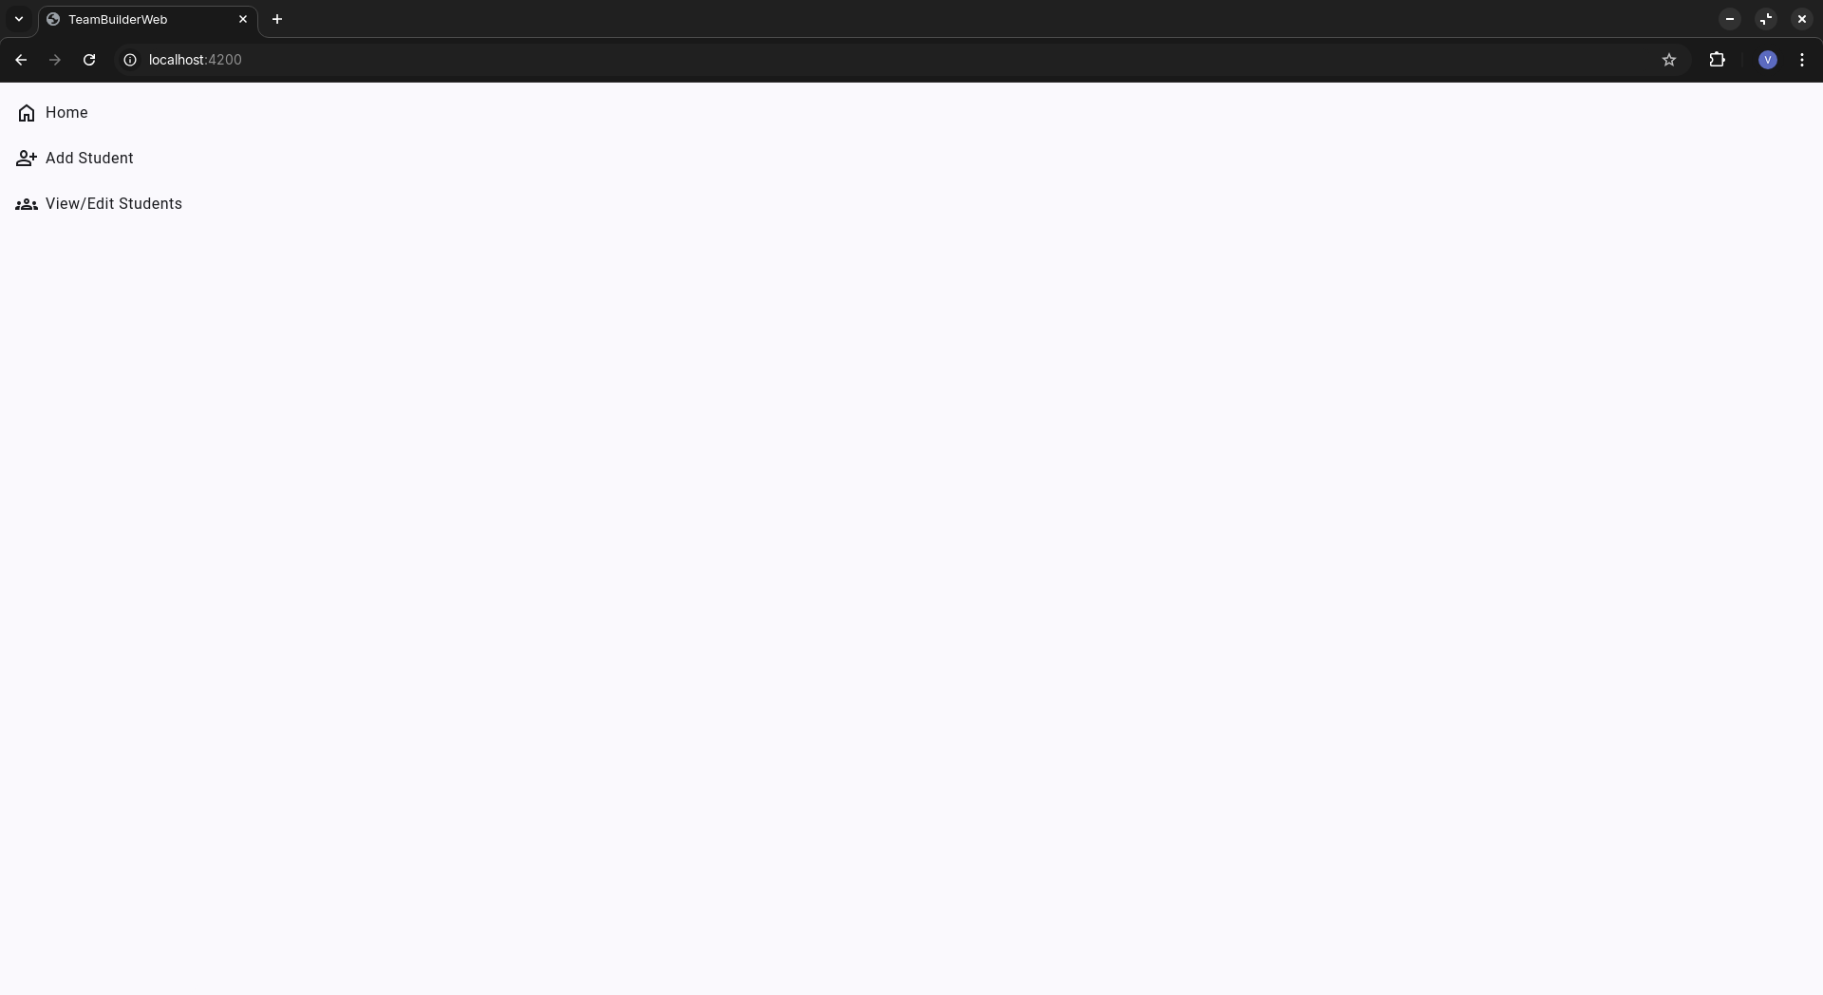

* Pass or Fail: Pass

*Test 2*

* Test case ID: 2
* Test case name: Add student details
* New or old: new
* Test items:
  + Add student page
  + Form input
  + Save button
* Test priority: high
* Test steps:
  + Navigate to website
  + On the side navigation, click on ‘Add Student’
  + On the ‘Basic details’ section, give valid and invalid inputs
* Expected output:
  + Three sections shall be displayed on ‘Add Student’ page
  + On ‘Basic details’, four input fields - Name, Email, Degree, Concentration shall be displayed
  + Given valid values, the save button shall be enabled
* Actual output:

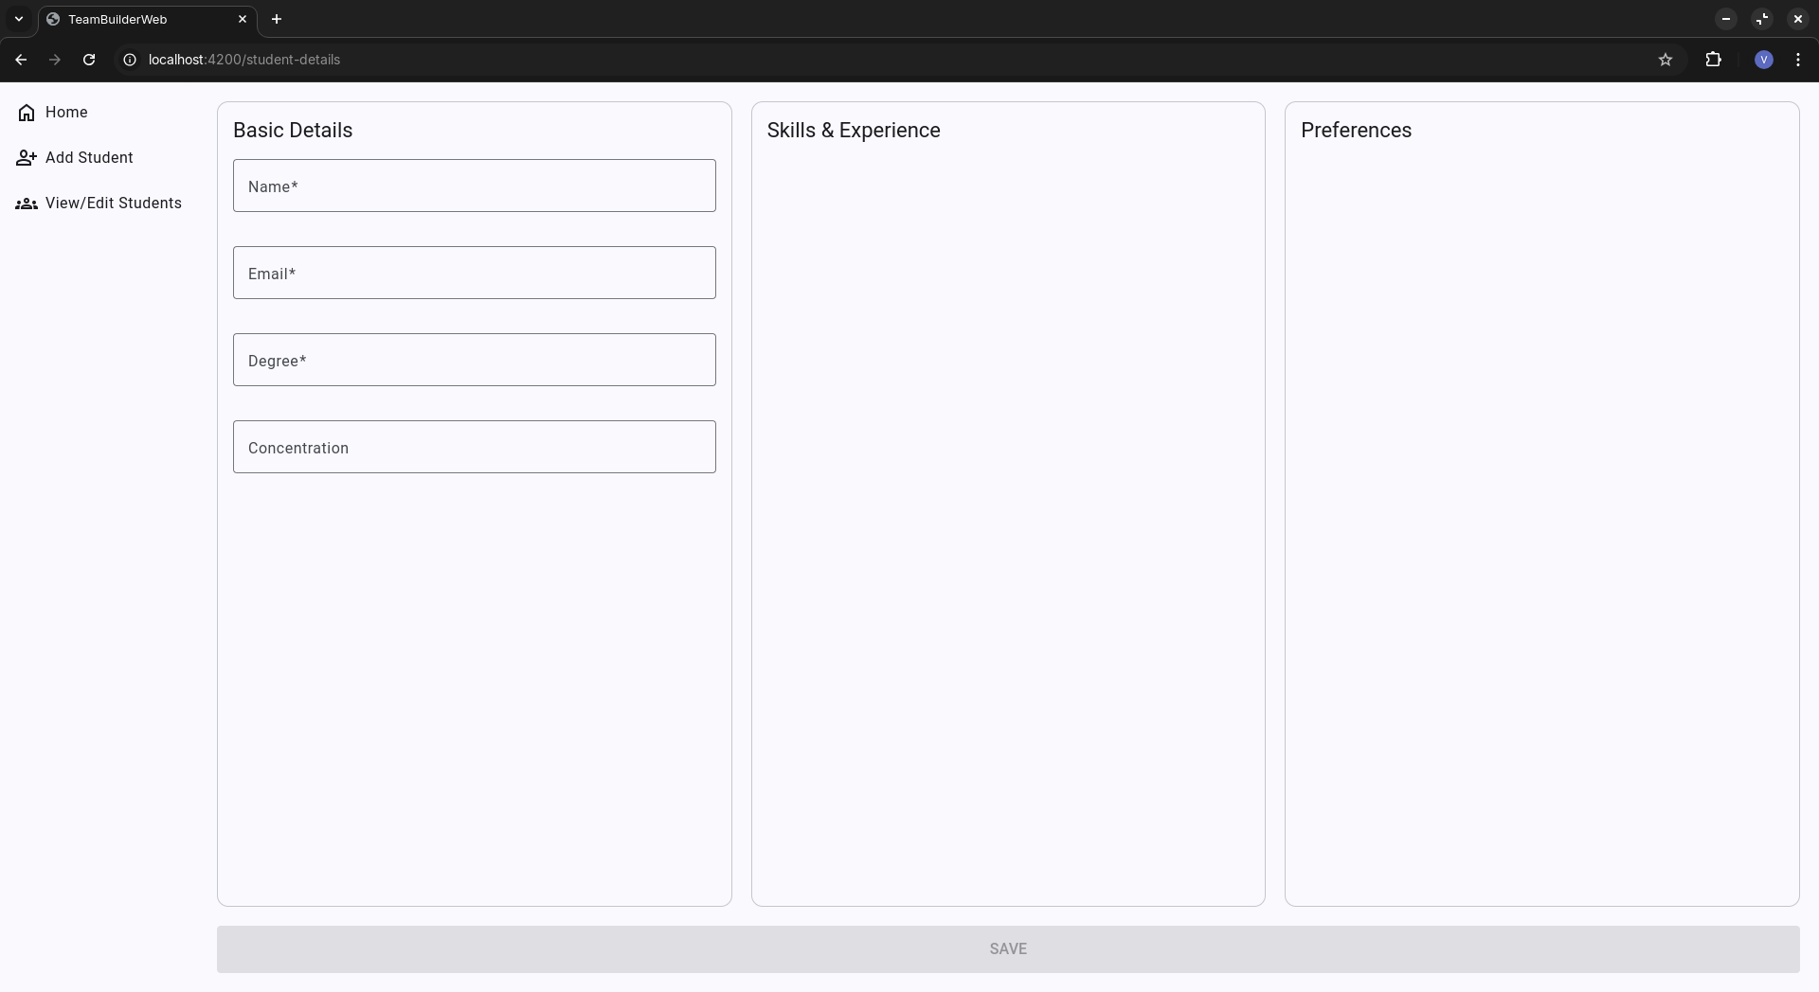

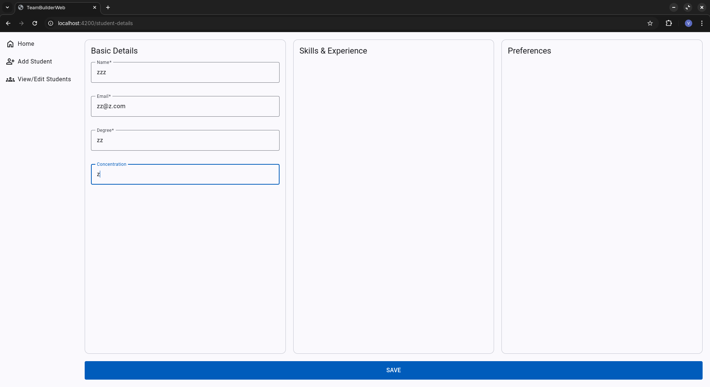

* Pass or Fail: Pass

# 

# Automated Testing Report

Unit testing - UI:

Each unit test resides inside each component with .spec.ts extension:

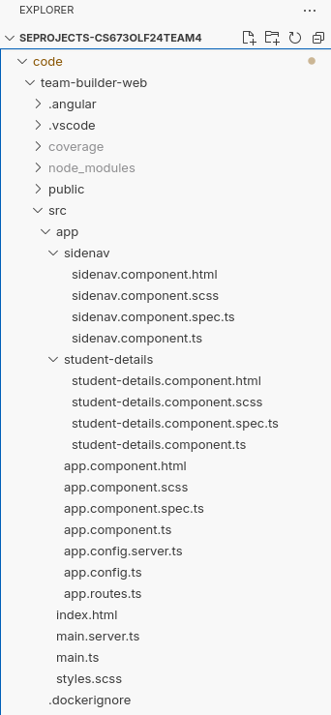

Automated test run:

Run ng test in the root directory

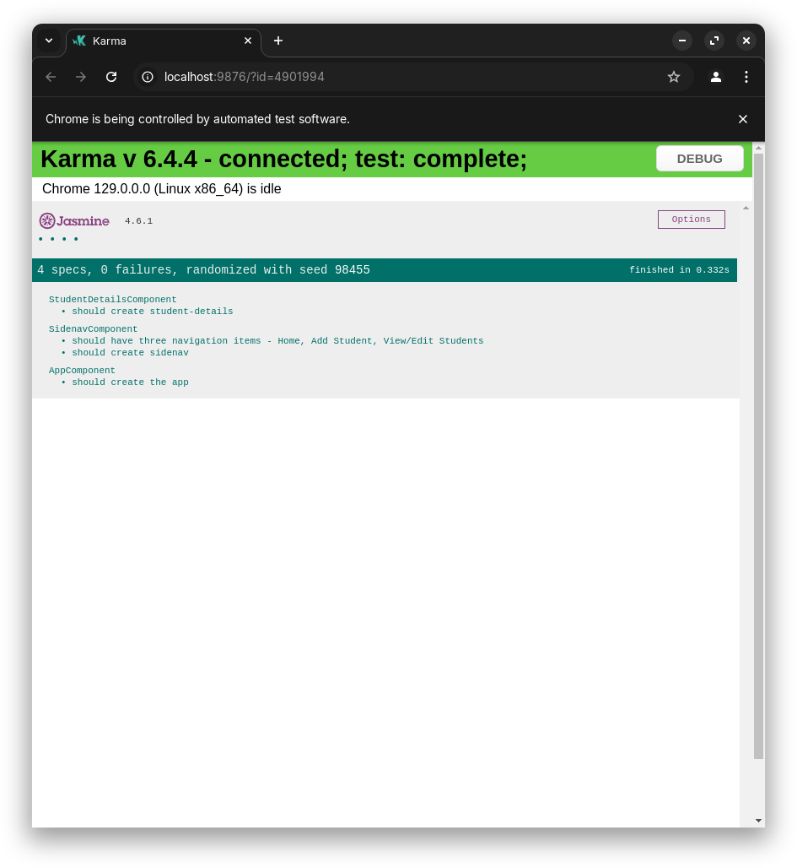

Test coverage report

Coverage results are stored in the team-builder-web/coverage directory

Coverage report of Sidenav component:

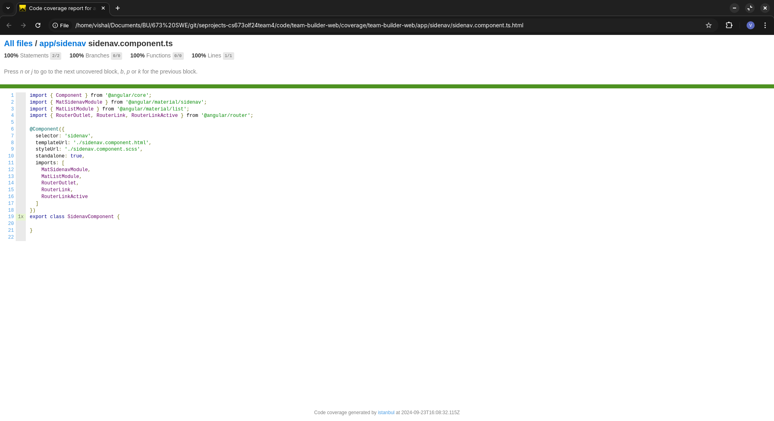

Coverage report of Student details component:

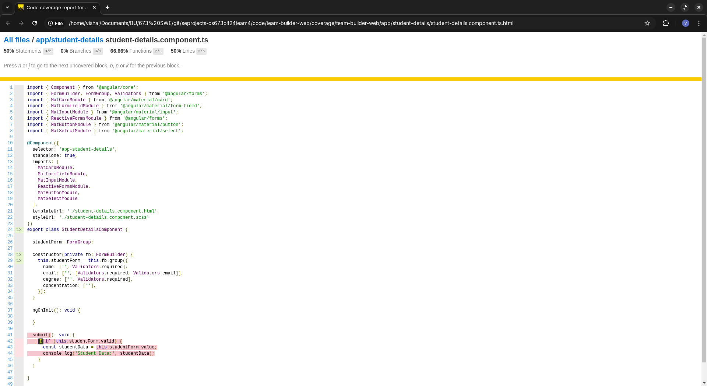

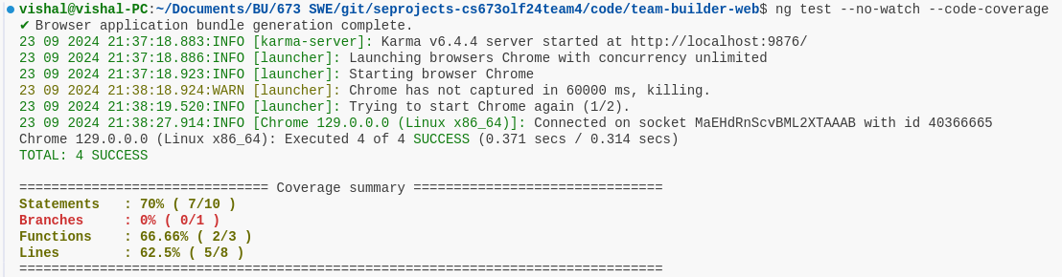

# Testing Metrics

Number of test cases: 4

Test coverage: 62.5%

Defects: 0

# References

# Glossary