
CS673 Software Engineering
Team 2 - Health Management System
Project Proposal and Planning

Team Member | Role(s) | Signature | Date
Y.Chen | Team Leader | Chen | 09242025
Michael | Requirement Leader | Michael | 09242025
Zhiyao Song | Design and Implementation Leader | Zhiyao Song | 09242025
Haopeng | Configuration Leader | Haopeng Zeng | 09242025
Mark | QA Leader
Hanxiao | Security Leader | Hanxiao | 09242025

Revision history
Version | Author | Date | Change
1.0 | Zhiyao Song | 25/10/15 | First Runable
2.0 | Haopeng Zeng | 25/11/5 | Iteration2

Overview
Related Work
Proposed High level Requirements
Management Plan
Objectives and Priorities
Risk Management (need to be updated constantly)
Timeline (need to be updated at the end of each iteration)
Configuration Management Plan
Tools
Deployment Plan if applicable
Quality Assurance Plan
Metrics
Code Review Process
Testing
Defect Management
References
Glossary

Overview
This system is a web-based health management platform that integrates user data uploading, AI assistant conversations, and health evaluations.
Users can register and log in, upload personal health data (height, weight, vision, blood pressure, blood sugar, etc.), and receive automatic health assessments. An AI assistant, powered by a large language model, provides interactive Q&A and recommendations. The system also displays exercise knowledge and health-related information.

Related Work
Existing health apps such as Fitbit, MyFitnessPal, and Apple Health provide calorie tracking, step counting, or data aggregation. These apps depend heavily on devices or predefined metrics.
Our system is simpler but focuses on AI conversational assistance, direct health evaluations, and knowledge sharing. It aims to provide core functionality without requiring wearables or complex integrations.

Proposed High level Requirements

Functional Requirements
Essential Features (must-have):
- Login & Registration – As a user, I want to register and log in, so I can securely access my account.
- AI Chat Module – As a user, I want to ask health-related questions and receive AI-generated responses.
- Personal Data Upload – As a user, I want to upload health information (height, weight, vision, blood pressure, blood sugar).
- Health Evaluation – As a user, I want the system to evaluate my health condition based on uploaded data.
- Exercise Knowledge – As a user, I want to view general exercise and health knowledge provided by the system.

Desirable Features (nice-to-have):

- Data Visualization Dashboard – Some visual elements are already available in the evaluation module (e.g., charts for metabolism and health score), but a more complete dashboard would enhance usability.
- Conversational AI Health Coach – The current AI assistant supports basic Q&A, but expanding it into a more proactive “health coach” would add more value.
- Notifications and Reminders – Future versions could provide reminders for exercise, check-ups, or data updates.

Optional Features (if time allows):
- Wearable Device Integration – Syncing data from smartwatches or fitness trackers.
- Gamification – Badges, challenges, or leaderboards to increase user motivation.
- Community or Group Support – Allowing users to share progress, tips, and experiences with others.

Nonfunctional Requirements
- Security – User data must be protected with authentication, encryption, and role-based access control.
- Scalability – The system should support increasing amounts of health data and more users as it grows. The current version runs in a local/development environment, but future deployment can scale to cloud infrastructure.
- Reliability – The system should remain stable with minimal downtime. While the current version works for demonstration, future versions should improve uptime and system monitoring for production use.

Management Plan

Objectives and Priorities
Complete all core features listed above.
Ensure smooth deployment and usability.
Maintain a stable system with no critical bugs.

Risk Management (need to be updated constantly)
AI accuracy: Mitigate by keeping AI responses general and informative.
Data privacy: Secure database storage and role-based access.
Time limitation: Focus only on essential features in the first release.

Risk Management Sheet Link:

Timeline (this section should be filled in iteration 0 and updated at the end of each later iteration)
Iteration | Functional Requirements(Essential/Disable/Option) | Tasks (Cross requirements tasks) | Estimated/real total person hours
1 | - User Authentication & Profile  - Health Data Tracking  - Goal Setting & Monitoring | - Design database schema (User, HealthData)  - Implement login/registration with JWT  - Build basic frontend pages (login, profile, data input)  - Develop backend APIs for health data CRUD  - Unit testing for login and data operations | ~100–120 hours
2 | - AI Weekly Summary  - AI Meal/Workout Plans  - Data Visualization Dashboard | - Integrate Spring AI / ChatGPT API  - Implement AI summary and recommendation module  - Develop frontend dashboard with charts/graphs  - Create backend APIs for BMI, BMR, risk analysis  - Perform integration testing with AI features | ~120–150 hours
3 | - Conversational AI Health Coach  - Notifications and Reminders  - Wearable Device Integration  - Community/Group Support | - Implement reminder/notification system  - Build conversational AI health coach (NLP Q&A)  - Integrate APIs for wearable devices  - Develop community sharing module (posts, comments)  - Final QA testing, bug fixes, and deployment | ~150–180 hours

Configuration Management Plan

Tools
GitHub for version control
IntelliJ IDEA for backend (Spring Boot)
VS Code for frontend (Vue 3)
Docker for deployment
GitHub Actions for CI/CD

  - Code Commit Guideline and Git Branching Strategy
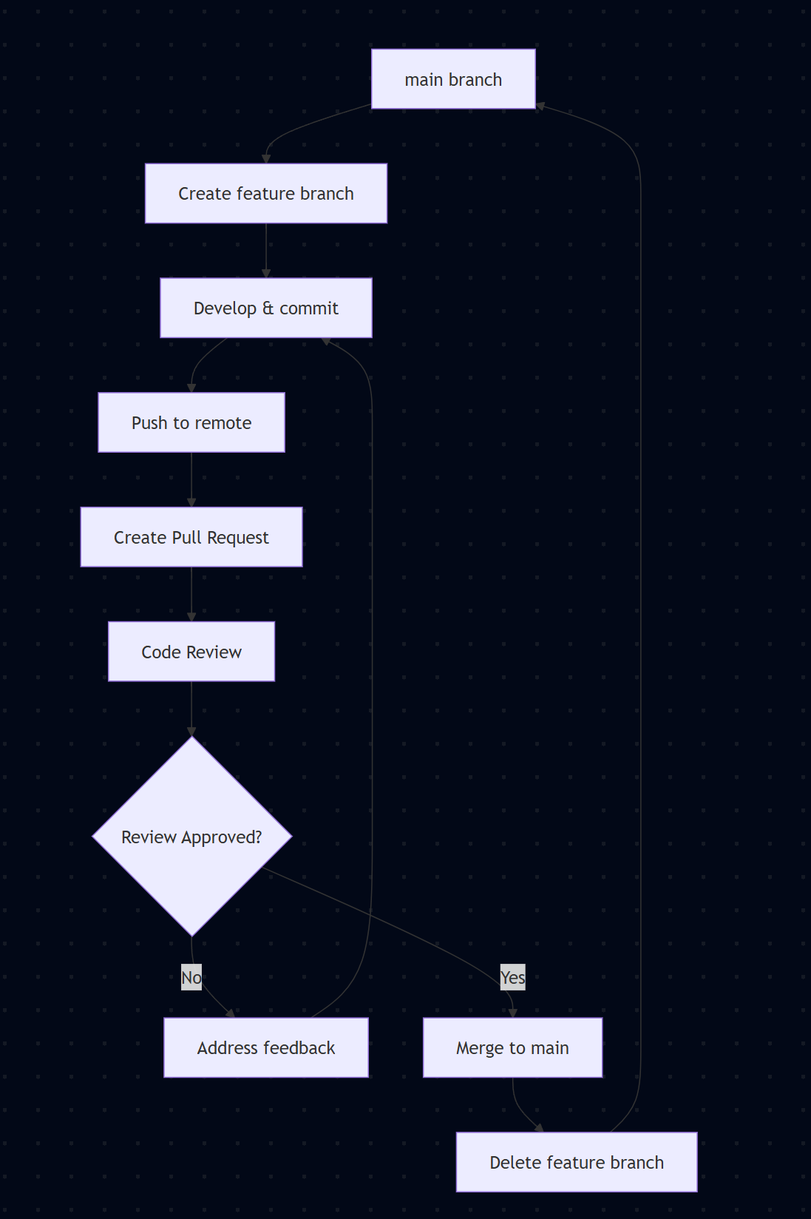

Types
· feat: New feature
· fix: Bug fix
· docs: Documentation changes
· style: Code formatting
· refactor: Code restructuring
· test: Adding tests
· chore: Build/config changes

Examples
feat(auth): add JWT token validation
fix(api): resolve health data endpoint timeout
docs(readme): update installation instructions
test(user): add unit tests for user service

Pull Request Process
1. Create PR with descriptive title and task reference
2. Add reviewers (minimum 1 team member)
3. Link to task/issue in description
4. Ensure CI passes (tests, linting, build)
5. Address review feedback promptly
6. Squash merge to maintain clean history

Branch Protection Rules
· main branch requires:
o Pull request reviews (1+ approvals)
o Status checks must pass
o Up-to-date branches before merge
o No direct pushes allowed

Best Practices
· Keep feature branches small and focused
· Rebase feature branches before creating PR
· Delete merged branches to keep repository clean
· Use meaningful branch names with task references
· Test locally before pushing commits

Use feature branches → pull requests → review before merge.
Main branch is always stable.
Commit messages should be clear and linked to tasks.

CI/CD Plan
Automatic builds and tests on each pull request.
Deploy staging version for testing.
Merge only after successful test runs.

Quality Assurance Plan

Metrics

Metric Name | Code Quality: LOC, class count.  Defects: defect count and fix rate.  Testing: # of test cases, pass rate.  Progress: completion of planned user stories.
Code Quality & Complexity | track lines of code, classes, cyclomatic complexity.
Defect Metrics | defect density, bug resolution rate.
Testing Metrics | test coverage, pass rate, # of test cases.
Productivity & Progress | completed user stories, team velocity.
Deployment & Reliability | build success rate, uptime, API response time.

  - Coding Standard
(Describe any coding standard to be used)
Java(Backend)
The backend follows Oracle Java Code Conventions with Spring Boot best practices. Code formatting uses 4-space indentation with UTF-8 encoding. Class names follow PascalCase (e.g., UserController, HealthService), method names use camelCase (e.g., getUserById, validateHealthData), and constants use UPPER_SNAKE_CASE (e.g., MAX_RETRY_COUNT). Package structure follows reverse domain naming (com.example.health.controller, com.example.health.service). All public methods require Javadoc comments, exception handling uses specific exceptions rather than generic ones, and dependency injection follows constructor injection pattern. Maven enforces UTF-8 source encoding and Java 17+ compatibility.
Vue.js(Frontend)
The frontend adheres to Vue.js Style Guide with ESLint enforcement via .eslintrc.js configuration. Code formatting uses 2-space indentation with single quotes for strings and no semicolons. Component names follow PascalCase in both file names and template usage (e.g., UserProfile.vue, HealthDashboard.vue). Vue component structure follows <template>, <script>, <style scoped> order with Composition API preferred for new components. Variable naming uses camelCase for JavaScript and kebab-case for HTML attributes. ESLint rules enforce consistent spacing, bracket usage, and Vue-specific patterns including maximum 10 attributes per line for single-line elements and PascalCase for component name properties.
SQL
Database queries follow ANSI SQL standards with SQLite-specific optimizations. Table names use snake_case (e.g., j_user, j_body, sport_info) with descriptive prefixes for categorization. Column names use snake_case with meaningful descriptors (e.g., user_id, created_at, blood_pressure). Primary keys follow id naming convention, foreign keys use table_name_id pattern. All SQL keywords use UPPERCASE (SELECT, FROM, WHERE, JOIN) while identifiers remain lowercase. MyBatis XML mappers use parameterized queries with #{} syntax to prevent SQL injection. Index naming follows idx_table_column pattern, and all DDL statements include IF NOT EXISTS clauses for idempotency.

Code Review Process
Peer reviews via pull requests.
Design leader reviews architecture.
Check for readability, maintainability, and security.

Testing
Backend (Java/Spring Boot)
- JUnit 5 : Primary unit testing framework for service classes, controllers, and business logic
- Mockito : Mocking framework for isolating dependencies during unit tests
- Spring Boot Test : Integration testing with @SpringBootTest for full application context
- TestContainers : Database integration testing with containerized SQLite/PostgreSQL
- AssertJ : Fluent assertion library for readable test assertions
Frontend (Vue.js)
- Jest : JavaScript unit testing framework (configured in jest.config.js )
- Vue Test Utils : Official Vue.js testing utilities for component testing
- Cypress : End-to-end testing for user workflows and UI interactions
- ESLint : Static code analysis for code quality enforcement
API Testing
- Postman/Newman : Automated API endpoint testing with collection runners
- REST Assured : Java-based REST API testing framework
- WireMock : API mocking for integration testing
CI/CD Integration
- Maven Surefire : Automated test execution during build process
- GitHub Actions : Continuous integration with automated test pipelines
- SonarQube : Code coverage analysis and quality gates

Defect Management
Track issues in GitHub.
Classify defects as critical, major, or minor.
Assign fixes and retest before closing.

AI usage Log
You are allowed and even encouraged to use AI tools to help you generate the project idea, plan it and build it, but you need to clearly describe 1) What tools were used? 2) for what specific tasks and 3) Is it helpful? 4) how did you evaluate or modify AI-generated content? Additionally, you should submit the exported AI chat history as an appendix or share that with the instructor and facilitators.

Tools | Who | Tasks | helpful | Evaluation/modification | links
Chatgpt | Michael | PRD Overview | Yes | Reviewed and adjusted feature list to fit project scope
Cursor | Zhiyao | Set up the backend environment | Yes | AI can quickly help us set up backend development environments using natural language, significantly reducing the time required for pre-development preparation. | Cursor can’t provide link
ChatGPT | Zhiyao | Supporting Learning BCrypt Password Encryption | Yes | AI provides excellent explanations of key concepts. | https://chatgpt.com/share/68f1c55f-a9a8-8010-95ae-18c8f775d7a6
Trae+Cursor | Y.Chen | Artificial intelligence automatically scans and organizes documents, and helps update readme files. | Very Helpful | I am a terrible writer, and AI has greatly improved document processing, especially the ability to automatically update documents. | trae/cursor cannot export such record links
Cursor | Hanxiao | Rewrite and refactor frontend code (auth utilities, view components, API modules) | Very helpful | Used Cursor AI to modernize 22 frontend files with improved code structure and error handling. Manually reviewed and customized business logic to match project requirements. Significantly improved code quality and maintainability | Cursor can’t provide link

References
MyFitnessPal, Fitbit, Apple Health – product comparisons.
GitHub and Docker best practices.
Spring Boot, Vue.js official docs.

Glossary
- SCRUM — An agile framework for managing projects in short cycles called sprints.
- QA (Quality Assurance) — The process of ensuring software quality and preventing defects.
- CI/CD (Continuous Integration/Continuous Delivery) — Automates the process of building, testing, and deploying code changes.
- IDE (Integrated Development Environment) — A software application that provides comprehensive tools for developers, like an editor, debugger, and builder.
- VSCode (Visual Studio Code) — A popular, free code editor/IDE from Microsoft.
- Git — A version control system for tracking changes in code during development.
- PR (Pull Request) — A request to merge new code changes into the main codebase.
- E2E (End-to-End) — A type of testing that simulates a full user workflow from start to finish.
- ADR (Architecture Decision Record) — A document that captures an important architectural decision, its context, and consequences.
- PEP 8 — The official style guide for writing clean and readable Python code.
- SDK (Software Development Kit) — A collection of tools and libraries for developing applications on a specific platform.
- LOC (Lines of Code) — A basic measure of the size of a software program.
- AWS (Amazon Web Services) — A major cloud computing platform offering a wide range of services.
- DB (Database) — An organized collection of data, typically stored electronically.
- SQL (Structured Query Language) — The standard language for managing and querying data in relational databases.
- CRUD (Create, Read, Update, Delete) — The four fundamental operations for managing data.
- OS (Operating System) — The core software that manages all the hardware and software on a computer (e.g., Windows, macOS, Linux).
- Docker — A platform for creating, deploying, and running applications in isolated environments called containers.
- Kubernetes (K8s) — An open-source system for automating the deployment and management of containerized applications.
- API (Application Programming Interface) — A set of rules that allows different software applications to communicate with each other.
- HTTP (Hypertext Transfer Protocol) — The foundation of data communication for the World Wide Web.
- REST (Representational State Transfer) — An architectural style for designing networked applications and web services.
- UI (User Interface) — The visual part of an application that a user interacts with.
- OAuth (Open Authorization) — A standard that allows a user to grant a third-party application access to their data without sharing their password.
- CORS (Cross-Origin Resource Sharing) — A browser security feature that controls how web pages in one domain can request resources from another domain.
- DNS (Domain Name System) — The system that translates human-friendly domain names (like www.google.com) into computer-friendly IP addresses.
- SSH (Secure Shell) — A network protocol for secure remote login and other secure network services over an unsecured network.

