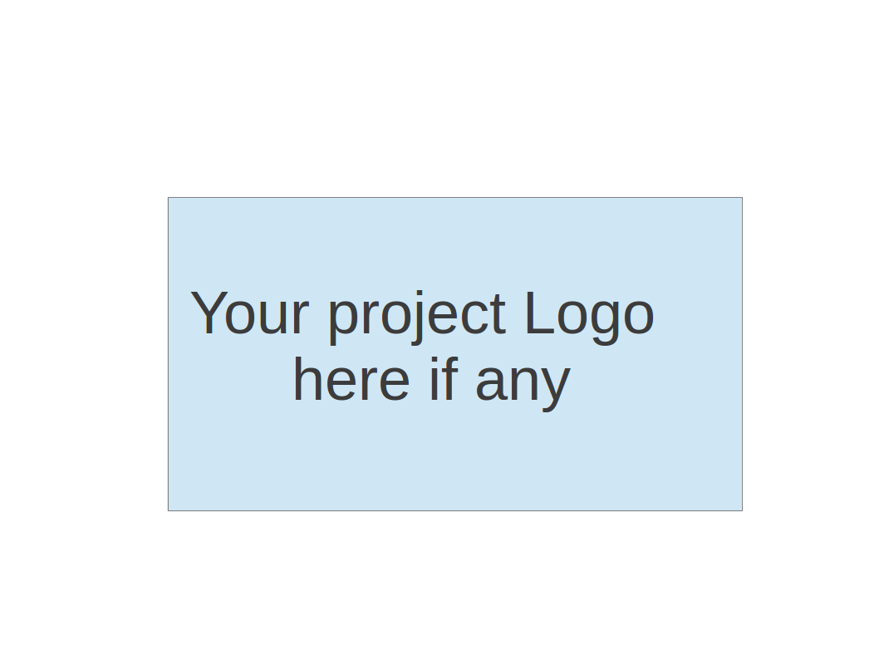
CS673 Software Engineering
Team 3 - Study Buddy
Software Design Document

Team Member | Role(s) | Signature | Date
Melissa Cron | Project Leader / Requirements Leader | Melissa Cron | 10/16/2025
Ittoop Shinu Shibu | Configurations Management Leader and Requirements Leader | Ittoop Shinu Shibu | 10/16/2025
Bohan Lin | Design & Implementation Leader / QA Leader | Bohan Lin | 10/16/2025
Junzhe Chen | Security Leader | Junzhe Chen | 10/16/2025
Qiuting Zhao | Design & Implementation Leader / QA Leader | Qiuting Zhao | 10/16/2025
Dexiao Zhang | Design & Implementation Leader/QA Leader | Dexiao Zhang | 10/16/2025

Revision history
Version | Author | Date | Change
1.1 | Bohan Lin | 10/1/2025 | Database design
1.2 | Junzhe Chen | 10/1/2025 | HTML design
1.3 | Ittoop Shinu Shibu | 13/10/2025 | Class Diagram
1.4 | Melissa Cron | 10/14/2025 | Introduction, REST APIs, and AI log
1.5 | Bohan Lin | 10/14/2025 | Software architecture
1.6 | Bohan Lin | 10/15/2025 | Design patterns
1.7 | Junzhe Chen | 10/16/2025 | UI design, security design
1.8 | Qiuting Zhao | 10/16/2025 | Business Logic and Key Algorithms
1.9 | Dexiao Zhang | 10/16/2025 | Design patterns
2.1 | Bohan Lin | 10/30/2025 | Class Diagram (AuthContext, Login, LoginForm, Statistics)
2.2 | Melissa Cron | 11/4/2025 | AI Log
2.3 | Qiuting Zhao | 11/6/2025 | Business Logic and Key Algorithms
3.1 | Bohan Lin | 11/22/2025 | Security Design

Introduction
Software Architecture
Class Diagram
UI Design (if applicable)
Database Design (if applicable)
Security Design
Business Logic and/or Key Algorithms
Design Patterns
Any Additional Topics you would like to include.
References
Glossary

Introduction - Melissa
Study Buddy is an app to encourage studying and reduce distractions while studying. As such, our goal is to make a sleek approachable design that has students ready to study in the least amount of clicks possible, while still being engaging enough to encourage them to come back for more.

Software Architecture - Bohan/Dexiao
The Study Buddy follows a client-server architecture with a three-tier structure, consisting of the frontend, backend, and database layers. The frontend is implemented as a component-based system, organized into two main folders: screens and components. The screens folder defines the main user interfaces for different pages, such as login, study timer, settings, and so on, while the components folder contains reusable UI components such as buttons, checkboxes and background. The backend is organized into routes, models, and db folders. The routes folder defines API endpoints that serve as the interface between the frontend and backend, handling HTTP requests and responses. The models folder defines the data structures and schemas used to interact with the database, while the db folder manages the actual database connection and queries. The frontend communicates with the backend via RESTful API calls, typically using HTTP GET, POST, PUT, and DELETE methods. The backend depends on the database for persistent data storage and retrieval. The project uses the React Native framework for the frontend and Express.js with Node.js for the backend.

Class Diagram - Shinu
In this section, you will provide a detailed description of each component (or package) and use one or multiple class diagrams to show the main classes and their relationships in each component.

This section has been divided into a general class diagram of our application as well as a component diagram of the frontend.

Class diagram:

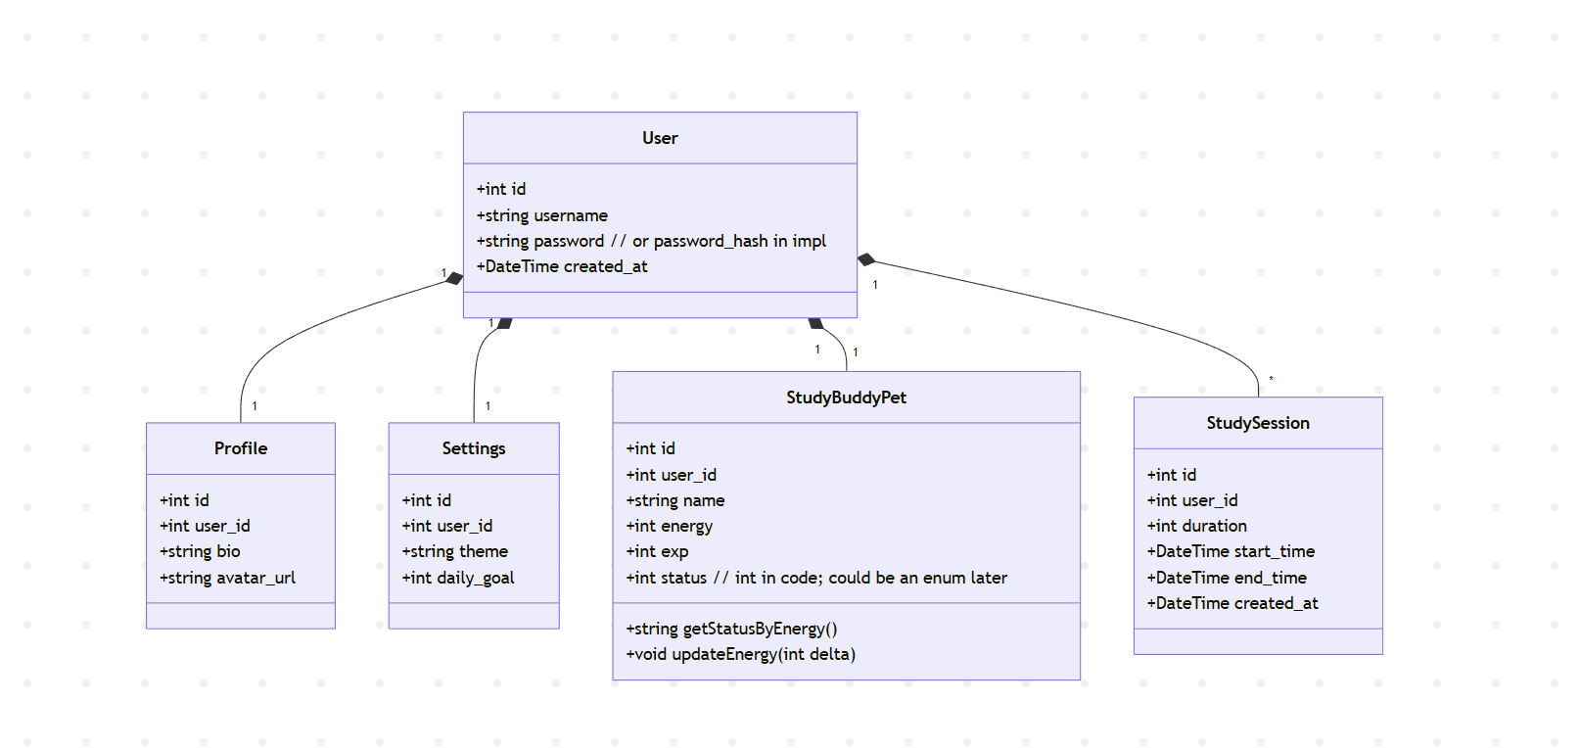
User
Role: Account holder; root owner of related data.
Relationships: Owns exactly one of each: Profile, Settings, StudyBuddyPet; owns many StudySession.

Profile
Role: Public/visual user info.
Relationship: Belongs to User.

Settings
Role: Personal app preferences.
Relationship: Belongs to User.

StudySession
Role: A single timed study interval.
Relationship: Many per User.

StudyBuddyPet
Role: Pet reflecting study progress.
Relationship: Belongs to User.

Component diagram:
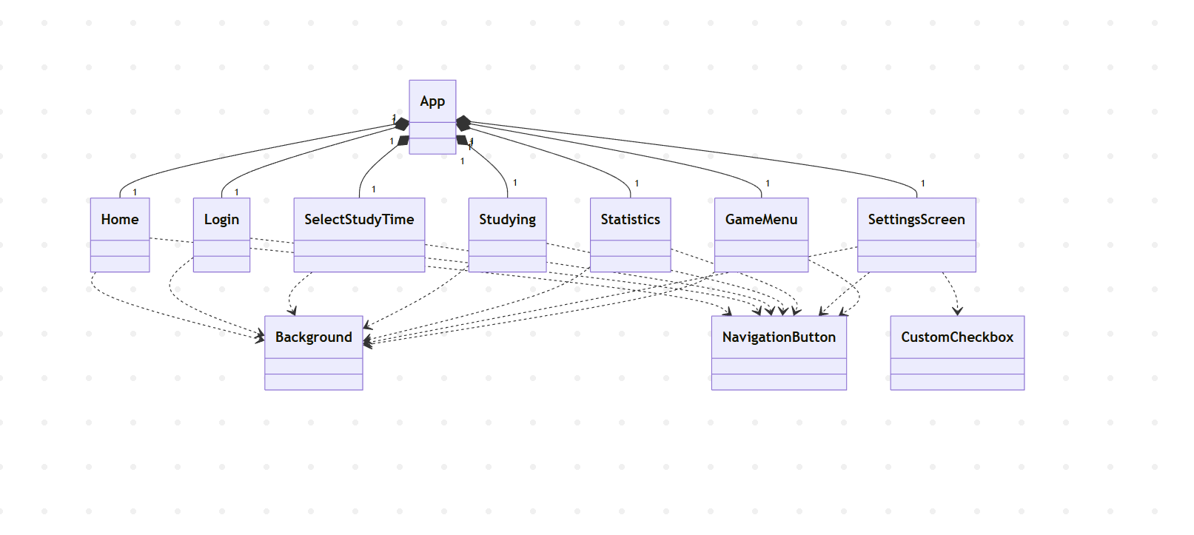

App shell & navigation
Component: App
Purpose: Bootstraps the React Native app and declares the navigation graph.
Responsibilities:
• Initialize the navigation container and stack. Owns (creates/destroys) screens as users navigate.
• Register screens (Home, Login, SelectStudyTime, Studying, Statistics, Settings, GameMenu).
Collaborators: All screen components.

Component: AuthContext
Purpose: The AuthContext provides a centralized authentication state management system for the frontend. It manages global authentication flow - login, logout, token storage, and auto-expiration - so that all components can access user info securely and consistently.
Responsibilities:
Provide global authentication state
Persist session in storage
Validate JWT tokens
Auto-login on app start
Handle token expiration
Login and logout management

Screens package (screens/)
Home
Purpose: Landing hub after login.
Responsibilities:
• Presents primary actions (start studying, view stats, open settings, pet/game menu).
• Simple routing to other screens.
Collaborators: Background, NavigationButton.
State/events: Stateless besides local UI; navigates on button press.

Login
Purpose: Serves as the entry point for users to authenticate into the application.
Responsibilities:
• Render a background image and overlay layer for visual styling
• Contain the LoginForm component
• Manage no state of its own
• Provide a consistent visual environment for the login flow
Collaborators: LoginForm component (handles actual input & submission), styles/style.js

SelectStudyTime
Purpose: Configure a session length before starting.
Responsibilities:
• Let users pick a duration (preset options or input).
• Start the session by routing to Studying with params.
Collaborators: Background, NavigationButton.
State/events: Holds the selected duration; validates non-zero positive time.
Studying
Purpose: Focus/timer view during an active session.
Responsibilities:
• Countdown timer, pause/stop controls.
• (Optionally) update pet’s energy/exp at milestones or on completion.
Collaborators: Background, NavigationButton.
State/events: Timer state, lifecycle hooks on mount/unmount; emits “session complete.”

Statistics
Purpose: Displays the user’s study performance, daily and total statistics, and interactive calendar for session history.
Responsibilities:
• Fetch study session data from backend API (/study/me)
• Compute statistics (total sessions, days, total duration)
• Manage and render calendar markings for each study day
• Display sessions for a selected day with detailed time and duration
• Handle loading and error states gracefully
Collaborators: AuthContext (for authentication token), Backend API (/study/me), Calendar component (react-native-calendars), styles/style.js for shared visual design
State/events: Reads from stored sessions; handles empty state gracefully.
Settings
Purpose: Personal preferences (theme, daily goal, toggles).
Responsibilities:
• Render controls for preferences and persist changes locally.
Collaborators: Background, NavigationButton, CustomCheckbox.
State/events: Local settings state bound to UI; save on change/navigation.
GameMenu
Purpose: Entry point to pet/game-related actions.
Responsibilities:
• Navigate to pet status, actions, or cosmetics (as implemented).
Collaborators: Background, NavigationButton.
State/events: Stateless hub; routes into pet features.

Reusable UI components (components/)
Background
Role: Shared layout/visual wrapper that applies consistent theming/background.
NavigationButton
Role: Primary CTA button with consistent styling and spacing.
CustomCheckbox
Role: Styled checkbox for settings toggles.
LoginForm
Purpose: provides the UI and logic for user authentication - both login and registration - inside the app
Responsibilities:
- Manage local state for username, password, visibility toggle, and loading.
- Validate input fields before sending requests.
- Send API requests to /users/login or /users/register
- Call global login() from AuthContext to persist authentication
- Navigate to the Home screen upon successful login
- Toggle between “login” and “Register” modes
- Handle basic loading UI feedback
Collaborators: AuthContext: provides user, login(), logout() functions, useNavigation: to direct the user after authentication, styles/style.js

UI Design (if applicable) - Kimi
The login page adopts a clean and modern design style, developed using HTML, CSS, React, and Babel, with Visual Studio Code as the main development and debugging environment.
The styling combines TailwindCSS utility-based design principles with custom CSS (styles.css), using Flexbox layout for centered alignment and responsive adaptation. Ant Design Icons are applied to enhance visual consistency and interactive feedback.

The UI prototype was first created using the Pixso framework and refined in Figma for color palette selection, typography, and component arrangement.
The theme background applies a linear gradient (linear-gradient(135deg, #d041a0, #d3b3d1)), while some page backgrounds experiment with Nano Banana to generate more visually appealing icons, improving the overall interface aesthetics.

Database Design - Bohan
The Study Buddy app uses SQLite as its database to store user information, study records, and personalization settings. The main design goal is to keep the structure simple, scalable, and ensure that each user’s data is isolated from others.

The Users table stores basic identity information. Each user has a unique id and username, along with their registration time. In the future, if Google login is integrated this table can store the Google-provided user ID and email instead of managing passwords directly.

Each user also has a Profile, which contains personal details such as full name, avatar, and their study buddy. This has a one-to-one relationship with the Users table, separating authentication data from user-facing profile information.

In addition, users have their own Settings that define app preferences, such as theme and notification preferences. This is another one-to-one relationship, ensuring that each user has their own independent configuration.

The Study Sessions table is central to the application’s purpose. Each record corresponds to a study session and stores the start time, end time, duration, and optional notes. Since users can log multiple sessions, this forms a one-to-many relationship with the Users table.

In summary, the database consists of four main tables: Users, Profiles, Settings, and Study Sessions. One user has one profile and one setting but has many study sessions. This design ensures clean data organization while leaving room for future features such as achievements and reminders.

Security Design - Kimi

Our Study Buddy App is designed with security built in to support core goals of confidentiality, integrity, availability (CIA) and IAAA controls (identification, authentication, authorization, accountability). During registration, each user is uniquely identified by their username, and passwords are never stored in plain text. Instead, we use bcrypt with a per-user salt and an appropriate cost factor to hash password, making offline cracking significantly more difficult. On the frontend, we enforce password constraints (e.g., minimum length and complexity rules) to reduce weak-password and brute-force risks. All communication between the frontend and backend is sent over HTTPS to protect credentials and other sensitive data in transit. After a successful login, the server issues a signed JSON Web Token (JWT) that encodes the user’s ID and role; this token has a limited lifetime and is validated on every request to provide stateless authentication and simple role-based access control. Sensitive data is never stored inside the JWT payload, and token expiration on logout reduces the risk of token reuse.

Business Logic and/or Key Algorithms - Mia
- Frontend Logic (React Native + Expo)
  - Study Timer Control Logic
To manage starting, stopping, and recording a study session. When the user taps the study button, the app either starts or stops a session, depending on the current state.

When the study session starts, isRunning triggers a one-second interval that decrements the counter. When the time hits zero or the user stops, the timer resets or records the session.

if start pressed then:
isRunning = true
while isRunning:
timeLeft = timeLeft - 1 each second
if timeLeft = 0: stop

  - Daily Goal Progress Update
To retrieve user session data, calculate today’s total study duration, and compare it against the daily goal.

Each time the user opens the statistics screen, two backend requests are made to retrieve study sessions and user settings. The system calculates the percentage of the daily goal completed and updates the progress bar accordingly.
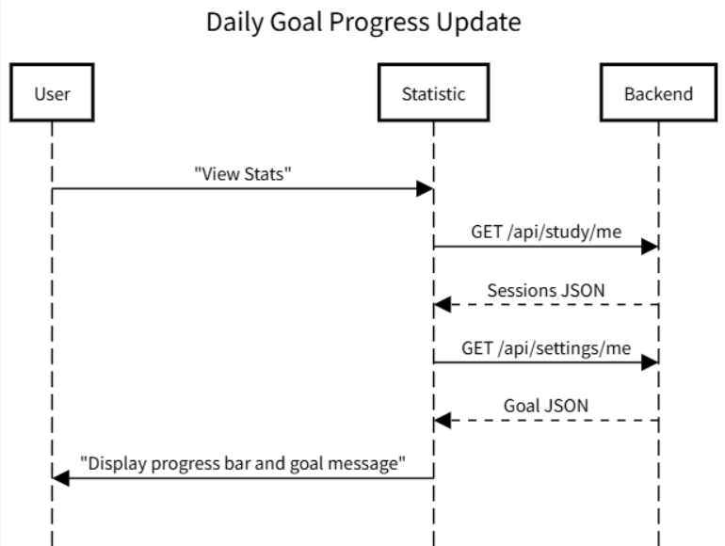

  - Study Time Selection
To allow the user to pick study durations (15min, 30min, 60min, or counting-up) and sends the value to Studying screen.

User-selected time is passed as navigation parameter, time = 0 activates count-up mode.

Display buttons [15,30,60,CountUp]
when pressed -> navigate(“Studying”, time)

  - Settings and Checkbox Control
To change user preferences (sound, vibration, etc.) with independent checkbox states.

if checkbox toggled: update corresponding preference state

  - Navigation Structure
To manage transitions between app screens (Login, Study, Settings, GameMenu) while preserving state.

Using Expo Router’s <Stack /> component, this algorithm ensures navigation without losing in-memory state. It allows users to switch between modules seamlessly. The state persistence is critical for preserving study timers and user session tokens.

if isAuthenticated():
navigate(“Studying”)
else:
navigate(“Login”)
onNavigation(target):
Stack.navigate(target)

  - Game Time Restriction
To balance study and rest, a “45 minutes study → 10 minutes play” rule was implemented.
When total focused time ≥ 45 minutes, the Game Menu unlocks. A 10-minute countdown begins upon game launch; after that, access is disabled until the next 45 minutes of study are logged. This logic is handled in the frontend via canPlay state flags and validated on the backend for integrity.
if totalStudyTime >= 45 and isBreakNotActive:
canPlay = true;
breakTimer = 600; // 10 minutes

  - Responsive Game Parameter Scaling
To prevent inconsistent gameplay speeds and sizes across devices.
All game constants—movement speed, gravity, and collision bounds—are computed from relative screen ratios.

GRAVITY = screenHeight * 0.0015
PLAYER_SIZE = screenWidth * 0.04.

- Backend Logic (SQLite)
  - User Registration and Hashing
To safely store user credentials by hashing passwords before database insertion.

The system uses bcrypt to hash the password. This prevents exposure of plaintext passwords in the event of data breaches.

receive username, password
passwordHash <- bcrypt(password)
INSERT user(username, passwordHash)

  - JWT Token Login
To authenticate users and issue a JSON Web Token for secure access to protected routes.

After verifying the entered credentials, the system signs a JWT containing the use’s ID. This token is returned to the frontend, where it is stored for authorization in future requests.

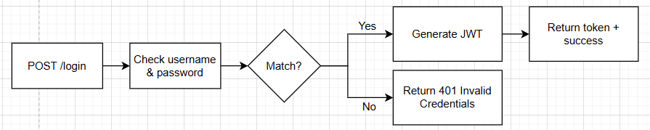

  - Study Session Creation and Calculation
To record a study session and automatically calculate its duration.

If the frontend sends only start and end times, the backend computes the total duration in minutes and stores the completed record in the StudySessions table.

extract user_id from token
if duration is missing:
duration = (end_time - start_time)/60000
INSERT study session (user_id, start_time, end_time, duration)
return confirmation

  - Retrieve Study Sessions
To fetch all study session records belonging to the authenticated user.

This algorithm queries the StudySessions table using the current user’s ID and returns all results in descending chronological order.

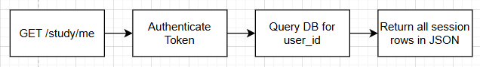

  - Profile Creation and Update
To create or update the user’s profile data efficiently.

Use SQLits’s INSERT OR REPLACE syntax to perform an “upsert” —
if a record exists for the user, it’s replaced; otherwise, a new record is created.

receive user_id, bio, avatar_url
INSERT OR REPLACE INTO Profiles(user_id, bio, avatar_url)
return updated profile

  - Settings Upsert
To save or update a user’s theme preferences and daily goal in the Settings table.

The algorithm ensures idempotency by replacing previous entries with the same user_id, allowing smooth updates without duplicate data.
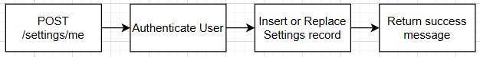
  - Buddy Energy and Status Update
To dynamically update the virtual buddy’s energy level and emotional status based on study performance.

Energy is capped at 100. The system categorizes the buddy’s mood:
- Energy > 80 → “Happy”
- 40 < Energy ≤ 80 → “Okay”
- ≤ 40 → “Tired”
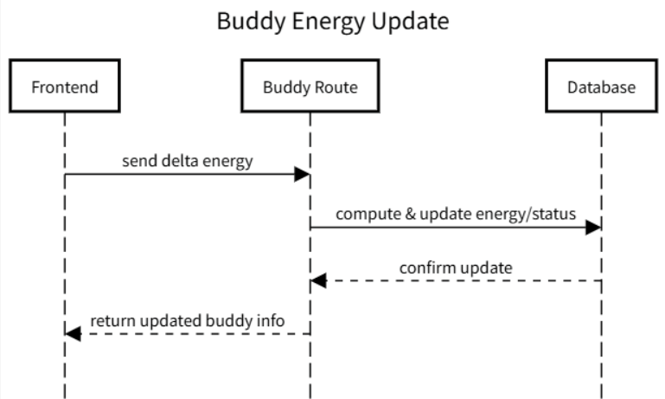

  - Goal Evaluation (Progress Tracking)
To calculate total study time for the current day and compare it with the user’s goal.

By summing today’s session durations and retrieving the daily goal,
the system can report completion percentage or notify when the goal is achieved.

goal = SELECT daily_goal FROM Settings WHERE user_id=id
total = SUM(duration) WHERE date(start_time)=today AND user_id=id
progress = total / goal * 100
return progress

- Game Logic (Reac Native)
  - Game1 Physics Simulation Loop
To simulate continuous gravity and motion in the player character across frames.

Each frame increases the player’s vertical velocity by the gravity constant and updates the Y-position accordingly. If the player collides with the ground, velocity resets to 0, stopping downward motion. This loop produces realistic jump/fall motion similar to side-scrolling physics games.

for each frame:
velocity.y = velocity.y + GRAVITY
player.y = player.y + velocity.y
if player.y + PLAYER_SIZE ≥ groundY:
velocity.y = 0
isJumping = false
if player.y > groundY:
gameover

  - Game1 Jump Mechanism
To apply jump velocity when the player releases a press, creating upward motion.

This algorithm triggers when the player releases the screen(onPressUp).
It sets the Y-velocity to a negative jump speed, simulating upward acceleration. Gravity then gradually pulls the player down again.
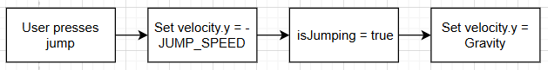

  - Game Menu Navigation
To provide an interface for choosing between available games within the app.

This algorithm defines a simple menu with navigation buttons. Each button triggers navigation to either Game1 or Game2 components.

function GameMenu():
display "Game Menu" screen
display button "Game 1"
if user clicks Game 1": navigate("Game1")
display button "Game 2"
if user clicks "Game 2": navigate("Game2")
display button "Return Home"
if user clicks "Return Home": navigate("Home")

  - Game2 Core Logic
To implement Bamboo’s complete gameplay loop: player movement, bamboo growth, color evolution, collision reaction, and scoring within a continuous frame update.

Each frame, all bamboo objects grow upward; yellow bamboo turns green after reaching a certain height.
The player moves horizontally and reverses direction on wall contact or when colliding with bamboo.
Colliding with yellow bamboo destroys it and increases score; colliding with green bamboo cuts its height instead.
If any bamboo grows too tall, the game ends.

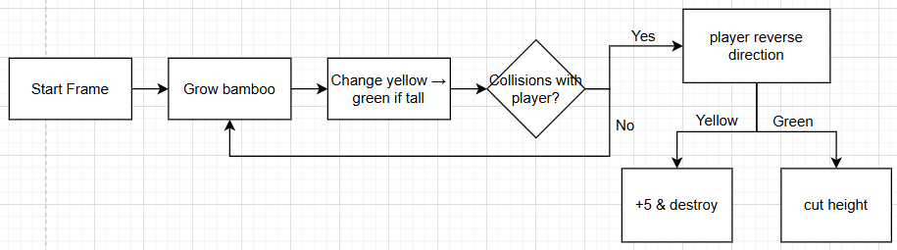

Design Patterns - Dexiao
Our software incorporates several design patterns to ensure modularity, maintainability, and scalability.
1. MVC Pattern
The backend is built following the Model–View–Controller (MVC) architecture:
Models define the database structure and encapsulate data access logic (e.g., userModel.js, eventModel.js, buddyModel.js).
Controllers / Routes handle incoming HTTP requests, perform validations, invoke model functions, and send JSON responses (e.g., /api/users, /api/events, /api/buddy).
Views are implemented in the frontend (Next.js / React), consuming RESTful APIs exposed by the backend.
This structure improves code readability, supports parallel frontend–backend development, and simplifies debugging and maintenance.
2. Middleware Pattern
Express middlewares such as auth.js, logger.js, and errorHandler.js are used to handle cross-cutting concerns:
auth.js validates JWT tokens and ensures secure access control.
logger.js records request information for debugging and monitoring.
errorHandler.js unifies error responses for better consistency.
This pattern promotes reusability and clean separation of concerns.
3. Singleton & Modular Configuration Pattern
Database connections (SQLite / PostgreSQL) and configuration files use the singleton pattern to ensure only one active connection throughout the app.
Modules like db.js and config.js are imported wherever needed, reducing redundancy and preventing connection conflicts.
4. RESTful API Design Pattern
The backend follows RESTful principles — each resource (users, events, buddies, attendees) is accessed via standardized endpoints (GET, POST, PUT, DELETE).
This pattern ensures scalability and allows future extension (e.g., analytics, notifications) without major architectural changes.

Rest APIs - Melissa

GET /api/profiles/me
Get the profile of the logged-in user
Parameters:
None
Responses:
200 Profile Data Retrieved Successfully
Returns:
{
id: integer
user_id: integer
bio: string
avatar_url: string
}
401 Unauthorized
500 Internal server error
POST /api/profiles/me
Update the profile of the logged-in user
Notes:
If a profile does not exist, it creates a new profile
Parameters:
None
Request Body:
{
bio: string (required)
avatar_url: string (required)
}
Responses:
200 Profile Updated Successfully
Returns:
{
user_id: integer
bio: string
avatar_url: string
}
401 Unauthorized
500 Internal server error
GET /api/settings/me
Get the settings of the logged-in user
Parameters:
None
Responses:
200 Settings Data Retrieved Successfully
Returns:
{
id: integer
user_id: integer
theme: string
daily_goal: integer
}
401 Unauthorized
500 Internal server error
POST /api/settings/me
Update the settings of the logged-in user
Notes:
If a settings does not exist for this user_id, it creates a new settings
Parameters:
None
Request Body:
{
theme: string (required)
daily_goal: integer (required)
}
Responses:
200 Settings Updated Successfully
Returns:
{
user_id: integer
bio: string
avatar_url: string
}
401 Unauthorized
500 Internal server error
GET /api/study/me
Get all the study sessions of the logged-in user
Parameters:
None
Responses:
200 List of Study Sessions
Returns array of jsons formatted in the following way:
{
id: integer
user_id: integer
duration: integer
start_time: timestamp
end_time: timestamp
created_at: timestamp
}
401 Unauthorized
500 Internal server error
POST /api/study/me
Add a new study session for the logged-in user
Parameters:
None
Request Body:
{
duration: integer (required)
start_time: timestamp
end_time: timestamp
}
Responses:
201 Study Session Added Successfully
Returns:
{
id: integer
This is the id of the study session
user_id: integer
duration: integer
start_time: timestamp
end_time: timestamp
}
401 Unauthorized
500 Internal server error
POST /api/users/register
Register a new user
Parameters:
None
Request Body:
username: string (required)
password: string (required)
Responses:
201 User Registered Successfully
Returns:
{
message: string
user: {
id: integer
username: string
}
}
400 Bad request
E.g. missing username/password
POST /api/users/login
Login with username and password
Parameters:
None
Request Body:
username: string (required)
password: string (required)
Responses:
200 Login Successful
Returns:
{
message: string
user: {
id: integer
username: string
}
token: string
}
400 Bad request
E.g. user not found
401 Invalid Credentials
User found but password does not match
GET /api/users/me
Get Current Logged-in User Info
Parameters:
None
Responses:
200 Current User Info
Returns:
{
id: integer
username: string
}
401 Unauthorized
Invalid or missing token

Any Additional Topics you would like to include.

AI usage Log
You are allowed and even encouraged to use AI tools to help you generate the project idea, plan it and build it, but you need to clearly describe 1) What tools were used? 2) for what specific tasks and 3) Is it helpful? 4) how did you evaluate or modify AI-generated content? Additionally, you should submit the exported AI chat history as an appendix or share that with the instructor and facilitators.

Tools | Who | Tasks | helpful | Evaluation/modification | links
chatgpt | Bohan | Produce swagger code | yes | The AI tool does help to put in swagger comments to the backend code file. However, it does not give the precise and correct comments. It does a great job in providing templates. However, human works are needed to examine and make corrections.
Nano banana | Junzhe | Find the picture of the buddy | no | The AI tool can provide the thing that we have. We don’t have the basic idea about buddy.
ChatGPT | Melissa | Consulted about how to use React Native functions | yes | I read the code generated until I understood the function, and then rewrote it to my specifications | https://chatgpt.com/share/68dde7ce-8d7c-8011-a5df-c7505429da47
ChatGPT | Melissa | Fix a broken test | yes | I copy and pasted error codes into it. ChatGPT was able to describe possible causes and give possible fixes. One of the fixes worked | https://chatgpt.com/share/68e821e5-8b98-8011-aaae-f4cd791a3945
ChatGPT | Melissa | Consulted about expo command that stopped working |  | I copy and pasted error codes into it. ChatGPT was able to describe possible causes and give possible fixes. One of the fixes worked (yes, this is the same text as the above, but I used it the same way and it was just as effective) | https://chatgpt.com/share/68ed15a7-2b80-8011-b9aa-2f6e5fc80df1
Github Copilot | Shinu | Consulted Copilot about building a class diagram based on the code |  | Copilot was able to iterate through my code and build a sufficiently good class diagram. I was then able to manually edit it using my own understanding of the code. I manually evaluated if it was accurate.
ChatGPT | Shinu | Consulted ChatGPT to put together some of the explanations for the class diagram |  | I used chatgpt to put together the explanations on the class diagram. Manually looked through the explanations and edited it as necessary to ensure it was accurate.
ChatGPT | Melissa | consult about bugs | somewhat | Described the problem and copied code into the AI.  This time was not super useful, perhaps because the problems were more niche and thus did not have as many people talking about them | https://chatgpt.com/share/68f52d5f-2644-8011-94ef-531ea029b702
ChatGPT | Melissa | consulted about a bug | yes | Told AI the bug and copied our code. It gave me the one-line fix. Probably saved me an hour | https://chatgpt.com/share/690a46ee-439c-8011-85c1-8ee0eba31b3b
Cursor | Melissa | Made Cursor write Acceptance tests. | yes | Very quick and painless. Needed to make only minor changes | https://drive.google.com/file/d/1lgscWNkzynEv6CIyHqjO_TPaPP3P1fkX/view?usp=drive_link

References

Glossary

