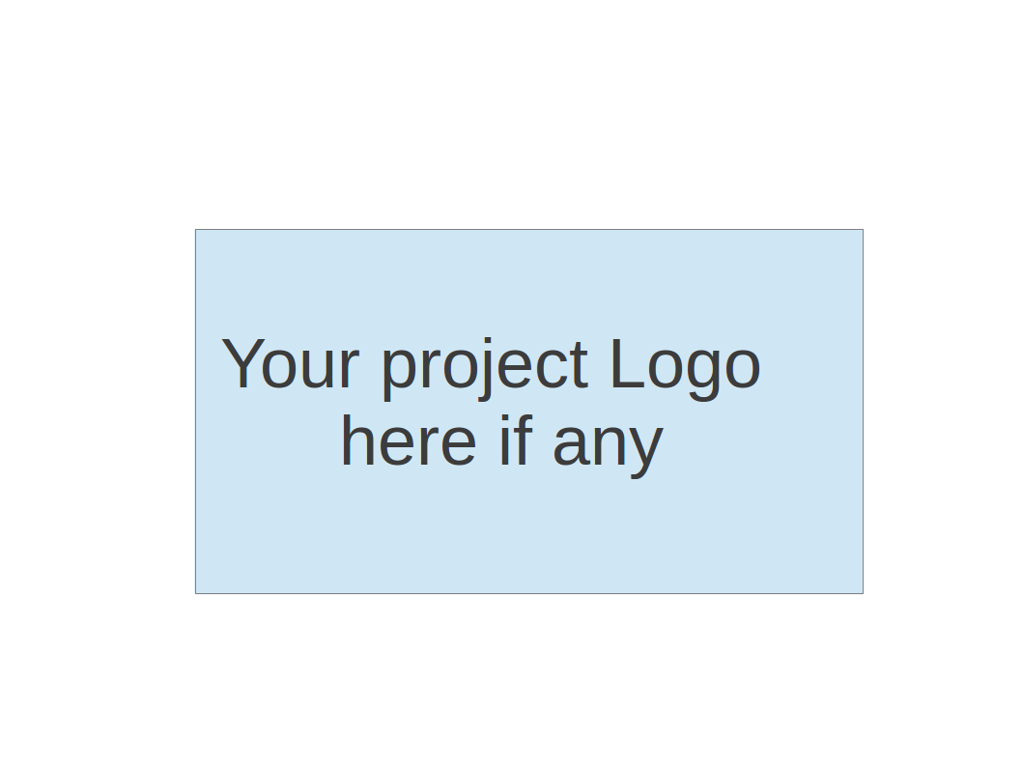
CS673 Software Engineering
Team 3 - Study Buddy
Software Test Document

Team Member | Role(s) | Signature | Date
Bohan Lin | Design & Implementation Leader / QA Leader | Bohan Lin | 10/16/2025
Ittoop Shinu Shibu | Configurations Management Leader | Ittoop Shinu Shibu | 10/16/2025
Melissa Cron | Project Leader and Requirements Leader | Melissa Cron | 10/16/2025
Junzhe Chen | Security Leader | Junzhe Chen | 10/16/2025
Qiuting Zhao | Design & Implementation Leader / QA Leader | Qiuting Zhao | 10/16/2025
Dexiao Zhang | Design & Implementation Leader / QA Leader | Dexiao Zhang | 10/16/2025

Revision history
Version | Author | Date | Change
1.1 | Bohan Lin | 10/6/2025 | Backend test
1.2 | Bohan Lin | 10/16/2025 | Metrics of backend test
1.3 | Melissa Cron | 10/16/2025 | Manual Test Reports
2.1 | Bohan Lin | 10/31/2025 | Testing Metrics
2.2 | Qiuting Zhao | 11/6/2025 | Manual Test
3.1 | Bohan Lin | 12/2/2025 | Manual Test
3.2 | Melissa Cron | 12/4/2025 | Manual Test

Testing Summary
Manuel Tests Reports
Automated Testing Reports
Testing Metrics
References
Glossary

Testing Summary
Throughout the development of the Study Buddy application, both manual and automated testing were conducted to ensure the correctness, reliability, and usability of the system. Testing activities were carried out continuously during each sprint and covered both backend and frontend components. The testing effort focused on validating functional requirements, identifying regressions, and ensuring that the user workflow behaves consistently across different scenarios.
What was tested
The following categories of tests were performed:
- Unit Testing – validation of isolated logic such as JWT authentication, logging middleware, and helper utilities.
- Integration Testing – verification of interactions between backend components, including models, controllers, and the database.
- System Testing – full end-to-end workflows such as study session logging, profile updates, and settings management.
- Acceptance Testing – API-level validation ensuring endpoints comply with functional requirements.
- Manual Testing – UI interaction testing across all key screens including registration, login, study session flow, calendar logging, and gamification features.
- Regression Testing – repeated execution of automated tests on every PR to ensure new changes do not break existing functionality.
Who performed testing
- Backend automated tests were primarily implemented and maintained by Bohan Lin.
- Manual tests were contributed by Melissa, Qiuting, Dexiao, and Bohan, with additional regression checks from the entire team.
- Frontend testing and UI verification were jointly completed by frontend contributors and QA support.
When testing occurred
Testing was performed at the end of each milestone and continuously during development. Automated tests were executed during every GitHub Pull Request through CI/CD integration.
Testing techniques used
- Black-box testing
- White-box testing for middleware logic
- Exploratory manual testing
- Boundary value testing (timer, login validation, settings update)
- Error-handling testing (invalid tokens, empty input, unauthorized requests)
Overall results
- All backend automated tests (18/18) passed successfully.
- Manual tests show that all core functionalities—including authentication, study session tracking, and game unlock logic—are functioning correctly.
- One major issue (timer count-up bug) was detected and resolved.
- Navigation and screen accessibility are stable with no broken links detected.
The application demonstrates solid reliability for core study and gamification features, with remaining improvements mostly involving UI edge cases and front-end automation.

Manual Testing Report
In this section, you will give a detailed description of each manual test case performed and the result. If this is a previous You shall list what are existing tests developed in the previous semester and what are new tests developed currently.

In this project, we conducted a series of manual tests to verify the functionality, usability, and reliability of the Study Buddy App. The primary goal of manual testing is to ensure that the application meets its functional requirements and provides a smooth user experience.

- Screen Traversal
  - New or old: new
  - Test items: Can all screens be accessed through only links
  - Test priority: medium
  - Dependencies: no
  - Preconditions: no
  - input data: Click on the links one at a time
  - Test steps: Starting on the home screen, click through every link
  - Postconditions: Either every link has been tested or every screen has been reached
  - Expected output: Every screen has been reached
  - Actual output: Every screen has been reached
  - Pass or Fail: Pass
  - Bug id/link: N/A
  - Additional notes: This might be able to be automated

- Clock Changes Screen
  - New or old: new
  - Test items: When the clock hits 0, it changes the state of the screen
  - Test priority: high
  - Dependencies: no
  - Preconditions: N/A
  - Input data: 1
  - Test steps: Go to the “studying” page. Input 1 into the prompt for the timer. Click “start study session”. Wait for the clock to hit 0
  - Postconditions:
  - Expected output: The screen should switch to read “Session Complete”
  - Actual output: As expected
  - Pass or Fail: Pass
  - Bug id/link: https://bu-team-cs673team3.atlassian.net/browse/KAN-214
  - Additional notes: None

- Test Case Name: Game Access Restriction
  - New or old: New
  - Test items: Verify that users can only access games after studying for 45 minutes and may play for up to 10 minutes.
  - Test priority: High
  - Dependencies: Requires working study session recording (FR-10, KAN-218).
  - Preconditions: User must have completed at least one study session.
  - Input data: 45-minute study duration.
  - Test steps:
    - Attempt to enter GameMenu before 45 minutes of study.
    - Complete a total of 45 minutes of study time.
    - Re-enter GameMenu and start Game 1.
  - Postconditions: The game unlocks only after 45 minutes and ends automatically after 10 minutes.
  - Expected output: Access blocked before study completion; unlocked after 45 minutes; play stops automatically at 10 minutes.
  - Actual output: Matches expected behavior.
  - Pass or Fail: Pass
  - Bug id/link: KAN-218

- User Registration
  - New or Old: New
  - Test items: Can a new user register successfully
  - Test priority: High
  - Dependencies: No
  - Preconditions: User is on the registration screen
  - Input Data: valid username and password
  - Test steps: Fill in registration form and click “Register”
  - Postconditions: User account is created
  - Expected output: Register button changes to Login button and user data is stored
  - Actual output: Register button changes to Login button
  - Pass or Fail: Pass
  - Bug id: N/A
  - Additional notes: test invalid input separately.

- User Login
  - New or old: New
  - Test items: Can a registered user log in
  - Test priority: High
  - Dependencies: Registration successful
  - Preconditions: User account exists
  - Input data: Username and password
  - Test steps: Enter credentials and click “Login”
  - Postconditions: User session started
  - Expected output: User is redirected to Home screen
  - Actual output: User is redirected successfully
  - Pass or Fail: Pass
  - Bug id/link: N/A
  - Additional notes: Test incorrect password/login failure

- Study Session logged
  - New or old: New
  - Test items: Can a study session logged
  - Test priority: High
  - Dependencies: Registration successful
  - Preconditions: User on study screen
  - Input data: Study time
  - Test steps: Enter study time and click stop & log
  - Postconditions: Study session logged in this user data
  - Expected output: When click calendar screen, this study session is successfully logged
  - Actual output: This study session is successfully logged
  - Pass or Fail: Pass
  - Bug id/link: N/A

- Color Contrast Accessible
  - New or old: New
  - Test items: Can a study session logged
  - Test priority: Low
  - Dependencies: Screen Traversal
  - Preconditions: App is open with chrome browser, user is logged in
  - Input data: N/A
  - Test steps: Open WAVE Evaluation Tools, traverse all screens, when done log out to see log-in screen as well
  - Postconditions: All screens have been checked
  - Expected output: WAVE does not give any contrast errors
  - Actual output: WAVE does not give any contrast errors
  - Pass or Fail: Pass
  - Bug id/link: N/A

Summary of Manual Testing Results
  - The core functionalities of the app, including user registration, login, study session logging, and game access restriction are functioning as intended.
  - Navigation is smooth, and all screens are accessible through links.
  - The main issue identified is the timer functionality on the “Studying” screen, which counts up instead of down. This has been logged as a bug and has been solved successfully.
  - The app demonstrates a high level of reliability for user workflow scenarios. Some minor edge cases are tested as well.
  - Color contrast meets the requirements listed under WCAG 2.0

Conclusion
The Study Buddy App passes most of the critical manual tests, demonstrating that the core study and gamification features are functioning correctly. Manual testing has provided valuable insights into usability and revealed critical bugs that have been solved successfully.

Automated Testing Report
Describe briefly the automated testing you have done, including where the test code resides in your code repository, what test frameworks are used, and the screen shots or generated testing report.

Jest and supertest are tools used in backend testing. A mix of unit tests, integration tests, acceptance tests, and system tests are applied. The unit tests focus on isolated middleware logic, such as JWT authentication and logging, without relying on the database or HTTP layer. The integration tests cover the interaction between models and the database. The acceptance tests test the full API workflow via HTTP request. The system tests simulate a complete user journey across multiple components, which would be helpful to validate the end-to-end functionality, state changes, and security under realistic scenarios.

All backend test files are in the backend/__tests__/ folder in the develop branch. Manual tests will occur on the terminal using npm test command after the backend code is complete. When a pull request happens on Github, all the tests in the folder will be tested automatically.

Unit Tests
Test File | Covered Functionality | Test Points | Improvement
unit/auth.test.js | JWT verification logic | - No token -> 401  - Invalid token -> 401  - Valid token -> calls next | - Test expired tokens
unit/logger.test.js | Logging middleware | - Logs method/url  - Calls next

Integration Tests
Test File | Covered Functionality | Test Points | Improvement
studySession.test.js | Study session model & database | - Add Session  - Get all sessions  - Get latest session
profile.test.js | Profile model + API | - Get profile  - Update profile  - Edge cases (no token / invalid data)
settings.test.js | Settings model + API | - Get settings  - Update settings  - Edge cases (no token / invalid data)

Acceptance Tests (API Tests)
Test File | Covered Functionality | Test Points | Improvement
buddyAPI.test.js | Buddy API workflow | - Create buddy  - Get buddy  - Edge cases (duplicate creation / no token) | - Verify token works when calling other protected endpoints
usersAPI.test.js | Login workflow | - Successful login  - Wrong password  - Non-existent user | - Test empty username/password  - Test expired or forged token calling protected APIs
profileAPI.test.js | Profile API | - Get profile  - Update profile  - No token / invalid data
settingsAPI.test.js | Settings API | - Get settings  - Update settings  - No token / invalid data
studyAPI.test.js | Study session API | - Add/Get/Validate sessions  - Invalid cases (illegal duration / no token) | - Test timestamp boundaries  - Test consecutive session additions

Testing Metrics
In this section, you shall report any metrics used for the evaluation, e.g. # of test cases, test coverage, defects rate, etc.

For backend tests in automated testing, 18 of total 18 tests passed including unit tests, integration tests, and acceptance tests.

Metric Name | Description | Formula / Measurement Method | Target / Expected Value | Actual Value | Tools / Source
Test Coverage | Measures the percentage of code that is tested by automated tests | (Lines of code tested / Total lines of code) x 100 | ≥ 80% | 32.21% | Jest, React Native Testing Library
Test Case Execution Rate | Indicates the percentage of test cases executed out of total planned | (Executed test cases / Total planned test cases) x 100 | 100% | 100% | Test reports, CI/CD logs
Pass Percentage | Shows the percentage of test cases that passed | (Passed test cases / Executed test cases) x 100 | ≥ 95% | 100% | Jest output, CI/CD
Automation Rate | Percentage of automated test cases among total cases | (Automated test cases / Total test cases) x 100 | ≥ 70% | 90% | Jest, CI/CD
Review Coverage | Percentage of commits or PRs reviewed by peers | (Reviewed PRs / Total PRs) x 100 | ≥ 90% | 100% | Github PR review logs

Frontend Automated Testing
In addition to backend automation, a limited set of frontend automated tests were implemented to verify component behavior and UI logic. The frontend tests focus on critical UI components and ensure that the application responds correctly to different user actions.
Test Frameworks Used
- Jest – JavaScript testing framework for component logic
- React Native Testing Library (RNTL) – for rendering components, simulating events, and asserting UI behavior
- Mock Service Worker (MSW) – used to mock backend API responses during component testing
- Expo Test Environment – provides a React Native-compatible execution environment
Location of Test Files
All frontend test files are located under:
frontend/__tests__/
frontend/components/__tests__/
frontend/screens/__tests__/

Automated Test Coverage Includes
- Component rendering tests (header, buttons, navigation elements)
- Form validation (registration and login fields)
- State updates in Study Screen (timer start/stop logic)
- Calendar component rendering and event display
- Mocked API calls for login and study session retrieval
Example Test Cases
- Registration form fails with empty username
- Login screen displays error for incorrect credentials
- Timer component switches state when countdown ends
- Calendar screen shows study sessions when API returns data
- Navigation routes correctly between Home → Study → Calendar
Limitations
- Complex screens such as the full calendar view and game screens require more mock integration and are currently tested manually.
- UI animations and transitions are difficult to automate with the current toolset.
Impact
Despite partial automation on the frontend, the automated tests greatly reduced repeated regression testing for core UI workflows, improving development speed and reliability.

References

Glossary

