
2CS673 Software Engineering
Team 4 - Beatmap
Software Design Document

Team Member | Role(s) | Signature | Date
Edoardo Cavallero | D&I Leader | Edoardo Cavallero | 9/20/2025
Zhehao Liao | Requirement Leader | Zhehao Liao | 9/20/2025
Michael Laszlo | Security Leader | Michael Laszlo | 9/21/2025
Sam Akerman | Team and Configuration Leader | Samuel Akerman | 9/21/2025
Greg Grimaylo | QA Leader | Greg Grimaylo | 9/22/2025

Revision history
Version | Author | Date | Change
1.0.0 | Edoardo Cavallero | 9/20/2025 | Added introduction software architecture, design patterns, Rest API sections
1.0.0 | Zhehao Liao | 9/20/2025 | Added Class Diagram and Business Logic and/or Key Algorithms sections
1.0.0 | Michael Laszlo | 9/21/2025 | Added Security Design section
1.0.0 | Sam Akerman | 9/22/2025 | Reviewed doc.

Introduction
Software Architecture
Class Diagram
UI Design (if applicable)
Database Design (if applicable)
Security Design
Business Logic and/or Key Algorithms
Design Patterns
Any Additional Topics you would like to include.
References
Glossary

Introduction
The BeatMap system is organized into a backend (FastAPI with external API clients and domain logic) and a frontend (React with Vite, React Router, and modular components. The architecture follows a client-server model: the frontend issues requests to the backend via REST endpoints, and the backend normalizes data from different providers into a standardized Concert object.

Software Architecture
In this section, you will describe the decomposition of your software system, which includes each component (which may be in terms of package or folder) and the relationship between components. You shall have at least one diagram to show the whole architecture of . The interface of each component and dependency between components should also be described. If any framework is used, it shall be defined here too.

Backend Structure
- app/main.py
  - Entry point for FastAPI server.
  - Defines / (healthcheck) and /search endpoints.
  - Delegates to the appropriate provider client (JamBase, Ticketmaster).
  - Uses htttpx.AsyncClient for outbound HTTP requests.
- app/api/concerts.py
  - Defines the Concert class (id, name, venue, date, artist, lineup).
  - Provides methods to transform external API responses into standardized Concert objects.
  - Functions:
    - get_concert_objs_from_jambase: fetches and normalizes JamBase events
    - jambase.parse_performers: extracts headliner and lineup
  - app/clients/jambase_client.py/ticketmaster_client.py
    - Encapsulate raw HTTP requests to third-party APIs.
    - Each client abstracts provider-specific logic.
    - Return JSON data for processing in concerts.py
Relationships:
- main.py depends on clients to fetch raw data
- concerts.py depends on clients and provides standardized objects for the rest of the backend.

Frontend Structure
- Assets (src/assets)
  - Contains static media (logos, banners, etc.)
- Components (src/components)
  - Banner.jsx: renders the top header/banner.
  - Searchform.jsx: structured search form.
  - NLform.jsx: natural language search form.
  - ResultsPanel.jsx: wrapper to display context (city/date range) and passes items to Results.
  - Results.jsx: renders list of results.
  - ResultCard.jsx: renders concert details.
- Pages
  - SearchPage.jsx: shows banner, tagline, forms
  - ResultsPage: shows banner and results panel
- Global Styling (src/styles/globals.css)
  - Defines theme colors, fonts, and layout rules.
- App Entrypoint (src/main.jsc, src/App.jsx)
  - Main.jsx mounts React app into index.html
  - App.jsx sets up routes (/search, /results) using React Router.
Relationships:
- SearchPage depends on SearchForm, NLForm, and Banner.
- ResultsPage depends on ResultsPanel (which depends on Results and ResultsCard).
- Shared styling via globals.css.

Frameworks and tools
- Backend: FastAPI (Python), httpx, Docker (for containerization).
- Frontend: React, Vite (bundler/dev server), React Router (client-side routing).
- CI/CD: Github Actions (defined in .yml workflows).
- External APIs: JamBase, Ticketmaster.

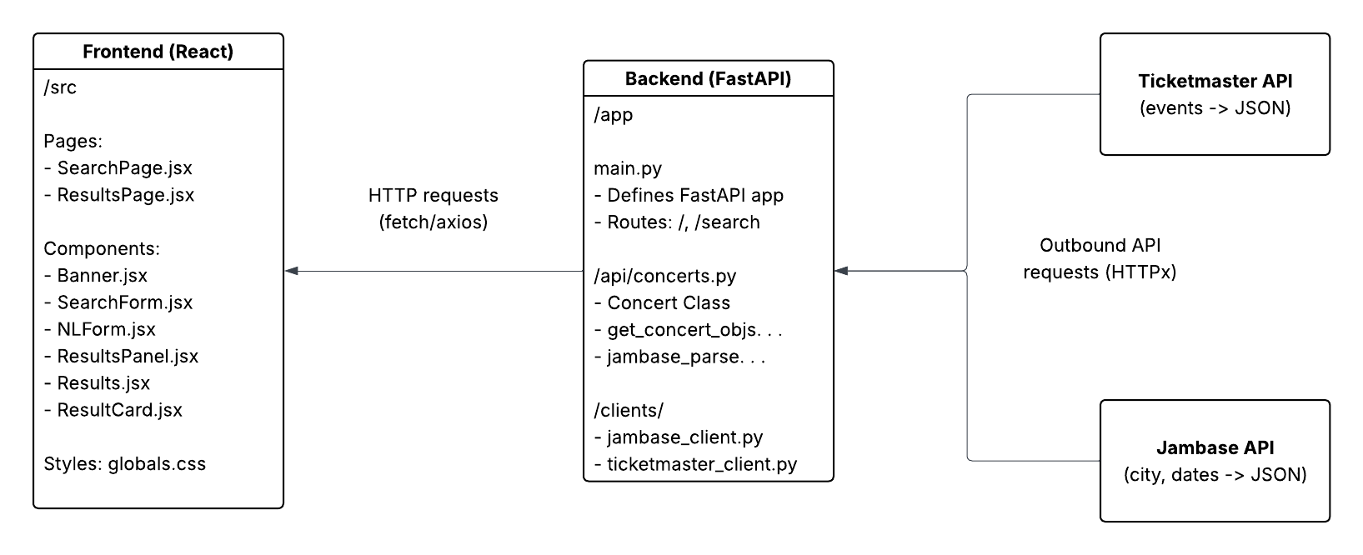

Class Diagram
Backend:
- API Layer (app/main.py): FastAPI entry; exposes / and /search; validates query params and delegates to service.
- Domain & Mapping (app/api/concerts.py): Defines Concert model and mapping helpers to normalize provider JSON into Concert.
- Provider Clients (app/clients/*.py): JamBaseClient, TicketmasterClient encapsulate HTTP calls and provider-specific payloads.
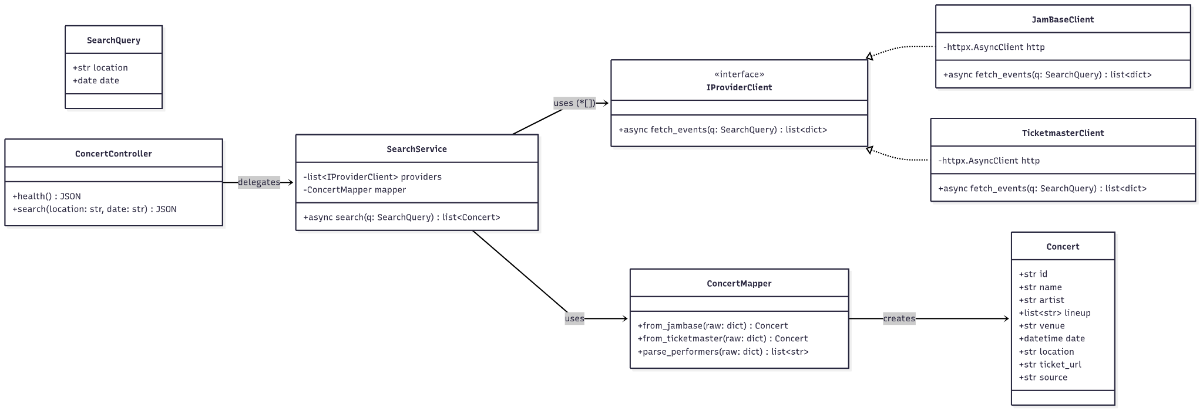
Frontend:
- App Entrypoint (src/main.jsx, src/App.jsx): Mounts React app and defines routes (/search, /results).
- Pages:
  - SearchPage: shows banner + search form; on submit navigates to results.
  - ResultsPage: reads query params; fetches concerts and renders a list.
- Core Components:
  - SearchForm: collects location + date and triggers search.
  - Results: lists items; ResultCard displays a single concert.
- API Client (src/api/client.js): getConcerts({location, date}) → ConcertDTO[]; wraps /search.
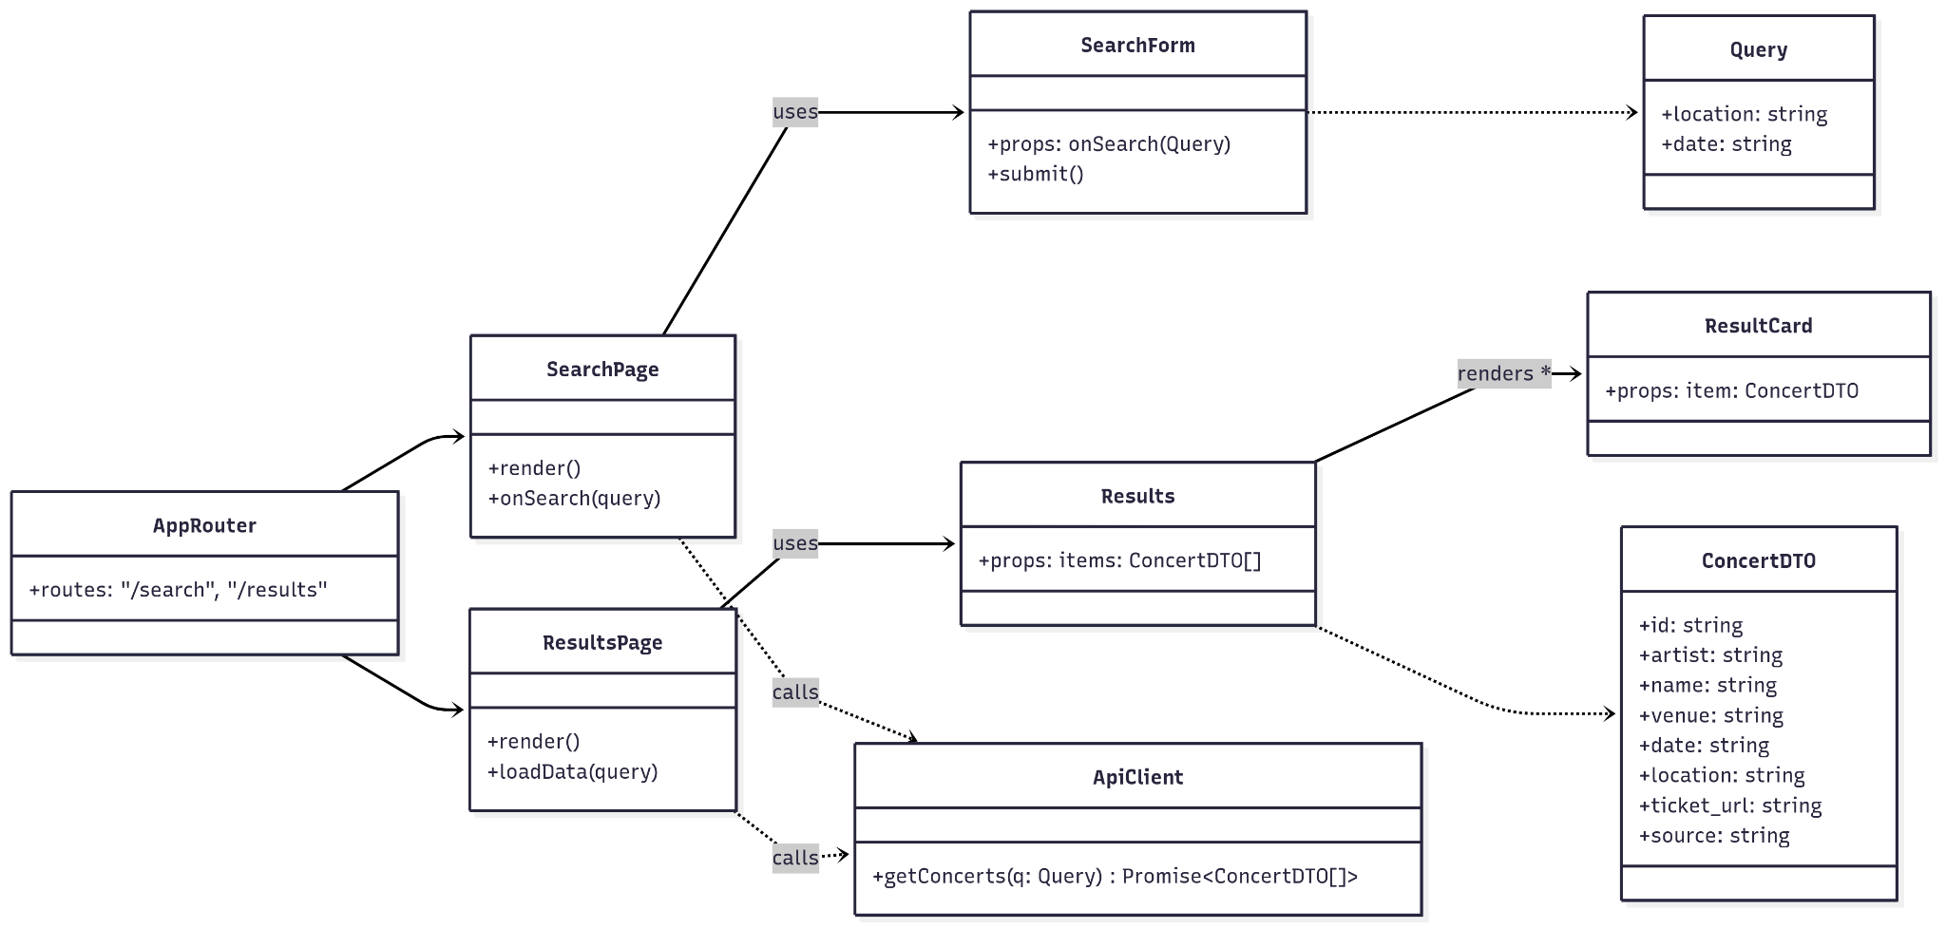

UI Design (if applicable)
The frontend of BeatMap is implemented in React with Vite as the build tool. The user interface emphasizes simplicity and clarity, providing two main pages: SearchPage and ResultsPage. A banner at the top of both pages reinforces branding.
On the SearchPage, users can interact with two search options: a structured form that accepts keyword, city, date range, and vendor, and a natural language form that accepts free-text queries (e.g., “Show me jazz concerts in NYC this weekend”). The ResultsPage displays results in a card-based layout, with a contextual status line summarizing the search criteria (city, date range). Components such as SearchForm, NLForm, ResultsPanel, and ResultCard are modular and reusable, making it easy to extend or adjust the UI in future iterations.

Database Design (if applicable)
In this section, you shall describe any database schema if used in your software system.

Security Design
BeatMap is a web application that helps travelers and music fans discover live concerts in cities they plan to visit. The system consists of a FastAPI backend, React frontend, and multiple microservices for external API integrations, all containerized with Docker.

The system architecture consists of three main components that define the security boundaries. The Frontend (React) runs on Port 3000 and serves as the user interface layer with minimal security controls. The Backend API (FastAPI) operates on Port 8000 and handles the main application logic and external integrations. The Provider Services run on Ports 8001-8002 and consist of isolated microservices for external APIs like Jambase and Ticketmaster. All components communicate through a Docker-managed internal network infrastructure that provides service discovery via container names and limits port exposure to only necessary services.

Currently, the application has no authentication or authorization mechanisms implemented, which represents a significant security gap. All API endpoints are publicly accessible with no user session management or access control on data or functionality. This creates potential for abuse of external API quotas and unauthorized access to system resources. The planned security model will implement OAuth2 with JWT tokens or trusted providers such as Auth0 or Okta for authentication. Authorization will use role-based access control (RBAC) or attribute-based access control (ABAC). The system will support passwordless "magic link" login as mentioned in the README, and user management will provide secure sign-in with personal wishlist functionality.

Data security encompasses both data at rest and data in transit considerations. For data at rest, no database is currently implemented, though Azure SQL Database is planned with TLS encryption and Bcrypt or Argon2 for password hashing when implemented. Configuration data is currently stored in environment variables, and API keys are managed through Docker environment variables. For data in transit, internal Docker network communication is unencrypted, external API calls to Jambase use HTTPS, and frontend-backend communication uses HTTP in development. Security gaps include no TLS/HTTPS enforcement in production and unencrypted internal service communication. Secrets management currently uses environment variables in docker-compose.yml with JAMBASE_API_KEY sourced from environment variables. Security features include .env files excluded from git and secrets stored in GitHub Actions for CI/CD, with implementation details found in src/backend/app/clients/jambase_client.py:16-25.

API security implementation currently uses FastAPI with Pydantic models for request validation and query parameter validation in the search endpoint. The search endpoint in src/backend/app/main.py:26-31 demonstrates this with required parameters for city, start_date, end_date, and provider, each with proper descriptions and validation. However, security headers and CORS are not implemented, creating security gaps including no security headers configured, no CORS policy implemented, missing rate limiting, and no request throttling. Error handling currently provides basic FastAPI error responses with no custom security-focused error handling, creating potential for information leakage in stack traces.

Infrastructure and deployment security encompasses container security, network security, and deployment processes. Container security features in src/backend/Dockerfile:1-20 use Python 3.12 Alpine Linux base with security measures including preventing .pyc files and ensuring output visibility through environment variables PYTHONDONTWRITEBYTECODE=1 and PYTHONUNBUFFERED=1. The system uses minimal dependencies with apk add --no-cache gcc musl-dev libffi-dev and pip install --no-cache-dir. Security strengths include Alpine Linux base for minimal attack surface, no package cache retention, and pinned Python version, while security gaps include running as root user (no USER directive) and no security scanning in build process.

Network security is managed through Docker network configuration that provides internal service communication via Docker networking, port exposure limited to necessary services only, and service discovery via container names. Network ports include Frontend on 3000 (external), Backend on 8000 (external), Jambase Provider on 8002 (internal), and Ticketmaster Provider on 8001 (internal).

Deployment security is handled through GitHub Actions in .github/workflows/deploy.yml and includes secrets management via GitHub Secrets, SSH key authentication for deployment, branch restriction (main only), and environment variable injection. Security configurations include EC2_HOST (server endpoint secret), EC2_DEPLOY_KEY (SSH private key secret), and JAMBASE_API_KEY (API credential secret). The deployment process security involves fresh repository clone for each deployment, complete container rebuild (--no-cache), and graceful container shutdown before update.

Security monitoring and assessment is implemented through automated security scanning via GitHub Actions Security Pipeline in .github/workflows/security-check.yml. The pipeline runs Bandit static analysis with "bandit -c bandit.yaml -r src/backend src/providers", pip-audit dependency scan with "pip-audit --requirement src/backend/requirements.txt", and Safety dependency scan with "safety check --full-report". Security tools implemented include Bandit for Python static security analysis, pip-audit for dependency vulnerability scanning, Safety for additional dependency security checks, and daily automated scans (cron: "0 3 * * *"). Current status shows security checks run with continue-on-error: true, with findings visible but non-blocking (Phase 1 rollout). The Bandit configuration in bandit.yaml skips assert_used checks for "*_test.py", "test_*.py", and "*/tests/*" files.

Security risks and mitigation status are categorized by priority level. High priority risks include no authentication (currently unprotected, OAuth2/JWT implementation planned), no authorization (currently open access, RBAC implementation planned), no HTTPS in production (currently HTTP only, TLS configuration needed), root container execution (currently security risk, add USER directive to Dockerfiles needed), and no rate limiting (currently DoS vulnerable, API Gateway or middleware needed). Medium priority risks include no security headers (currently missing, FastAPI middleware configuration planned), internal HTTP communication (currently unencrypted, service mesh or TLS proxy planned), no input sanitization (currently basic validation, enhanced Pydantic validation planned), and error information leakage (currently potential risk, custom error handlers planned). Low priority risks include container security scanning (currently not implemented, add to CI/CD pipeline planned), dependency pinning (currently implemented, maintain current practice), and secrets in the environment (currently properly managed, monitor and rotate regularly).

Security compliance and best practices include implemented security practices for dependency management with pinned dependency versions in requirements.txt, automated vulnerability scanning (pip-audit, safety), and regular security updates via GitHub Actions. Secrets management uses environment variables for API keys, GitHub Secrets for CI/CD credentials, and no hardcoded secrets in source code. Code quality implements static security analysis with Bandit, automated security checks in CI/CD, and documented security guidelines. Security standards alignment with OWASP Top 10 shows A1 (Injection) has basic input validation with Pydantic, A2 (Broken Authentication) is not implemented, A3 (Sensitive Data Exposure) is partial (no HTTPS), A4 (XML External Entities) is not applicable (JSON API), A5 (Broken Access Control) is not implemented, A6 (Security Misconfiguration) is partially addressed, A7 (Cross-Site Scripting) needs frontend validation, A8 (Insecure Deserialization) uses JSON/Pydantic, A9 (Using Components with Known Vulnerabilities) has scanning implemented, and A10 (Insufficient Logging & Monitoring) has basic logging only.

The security roadmap and recommendations are organized into three phases. Phase 1 focuses on immediate security improvements (critical priority) and includes implementing authentication and authorization by adding OAuth2/JWT authentication, implementing role-based access control, and securing all API endpoints. It also involves enabling HTTPS/TLS by configuring TLS for production deployment, adding security headers middleware, and implementing CORS policy. Container security improvements include adding non-root USER directives to Dockerfiles, implementing container security scanning, and applying principle of least privilege. Phase 2 addresses enhanced security features (high priority) by enhancing API security through implementing rate limiting and throttling, adding request/response logging, and custom error handling for security. It also implements monitoring and alerting through security event logging, automated security alerts, and incident response procedures. Phase 3 covers advanced security (medium priority) by improving infrastructure security through service mesh for internal TLS, network segmentation, and security policy enforcement. It establishes compliance and audit processes including regular security assessments, penetration testing, and compliance documentation.

Security contact and incident response procedures are established for the project. The primary contact is the project development team, with GitHub Issues used for security concerns and a responsible disclosure process followed for vulnerabilities. The incident response process includes immediate containment of security incidents, assessment of impact and scope, mitigation implementation, documentation in security changelog, and post-incident review and improvements. Security documentation maintenance ensures documentation is located in /SECURITY.md and /SECURITY-DESIGN.md, with updates made with each security implementation and regular review during security assessment cycles.

This security design document reflects the current state of the BeatMap project as of the analysis date, 09/20/2025. Regular updates will be made as security features are implemented and the system evolves.

Business Logic and/or Key Algorithms
Business Logic
- User Flow: A visitor enters location and date on the SearchPage and submits the query.
- Request Handling: The frontend calls the backend /search endpoint. FastAPI validates input and builds a SearchQuery.
- Provider Integration: The backend delegates to JamBaseClient and TicketmasterClient, each fetching raw events.
- Normalization: Results are transformed into standardized Concert objects (id, name, artist, lineup, venue, date, ticket_url, source).
- Response: A list of Concerts is returned as JSON, which the frontend displays in ResultsPage using Results and ResultCard components.
Key Algorithm
- Parallel Fetching: Run JamBase and Ticketmaster API calls concurrently with httpx.AsyncClient.
- Mapping: Convert raw JSON payloads into Concert objects using ConcertMapper.
- Deduplication: Merge results and remove duplicates based on (artist, venue, date) or provider id.
- Sorting: Order concerts by date (ascending) and name for deterministic output.
- Error Handling: If one provider fails, return partial results instead of failing the whole request.

Design Patterns
In this initial iteration, no explicit design patterns have been fully implemented. However, the system already demonstrates emerging patterns: the Composite Pattern is inherent in the React frontend, where pages are composed of reusable components (e.g., SearchPage containing SearchForm, NLForm, and ResultsPanel). On the backend, the structure of Concert and the API client modules is naturally aligned with the Adapter Pattern, since multiple vendor APIs (JamBase, Ticketmaster) are standardized into a common Concert object. In addition, the process of selecting and delegating calls to different providers follows the Strategy Pattern, with elements of the Factory Pattern, since the backend dynamically chooses the appropriate provider implementation at runtime. These patterns will be further developed and formalized in future iterations.

Rest APIs
The backend is implemented using FastAPI, exposing a small set of RESTful endpoints in this iteration:
- GET /
  - Description: Health check endpoint for the BeatMap backend.
  - Response: JSON object with status and a message confirming the backend is running.
- GET /search
  - Description: Queries a specific concert provider for events within a city and date range.
  - Query Parameters:
    - city (string, required): City to search concerts in.
    - start_date (string, required, format: YYYY-MM-DD): Start of the date range.
    - end_date (string, required, format: YYYY-MM-DD): End of the date range.
    - provider (string, required): API provider to query (e.g., jambase, ticketmaster).
  - Response: JSON array of standardized Concert objects with fields:
    - id, name, venue, date, artist, lineup.
In future iterations, additional endpoints will be added to support natural language queries, user preferences, and filtering by genre or price.

Any Additional Topics you would like to include.
In this iteration, the two external data APIs we are using expose slightly different signatures. For iteration 2, we plan to refactor them so that they conform to a common interface, explicitly implementing an adapter design pattern.

AI usage Log
You are allowed and even encouraged to use AI tools to help you generate the project idea, plan it and build it, but you need to clearly describe 1) What tools were used? 2) for what specific tasks and 3) Is it helpful? 4) how did you evaluate or modify AI-generated content? Additionally, you should submit the exported AI chat history as an appendix or share that with the instructor and facilitators.

Tools | Who | Tasks | helpful | Evaluation/modification | links
ChatGPT | Sam | CI/CD setup | Yes | It provided a starting point that I had to tweak as new issues became apparent. I used it iteratively to refine workflow files. | https://chatgpt.com/share/68c9eeef-0178-8013-a6ea-ddacd31bb844
ChatGPT | Sam | Cloud deployment pivot | yes | Couldn’t make Google Cloud Run. Needed to consider options, got a good overview. | https://chatgpt.com/share/68d0b291-211c-8013-a84b-1cbd87cb30f8
ChatGPT | Sam | FastAPI usage | yes | I wanted to determine if there was an easy way to test FastAPI endpoints. The AI told me exactly what I needed. | https://chatgpt.com/c/68d0b304-6f80-8328-91ec-3e8ee412a747
ChatGPT | Ed | Suggestions for document organization and content, design patterns, | yes | Used as a starting point for document organization/layout, as well as suggestions for useful design patterns to be implemented. | https://chatgpt.com/share/68d1ae80-51e0-800d-95a3-a88cdca6cafe
ChatGPT | Greg | Integrating external API, FastAPI, pytest | Yes | I used ChatGPT for guidance on the architecture of integrating an external API JamBase into our backend. I also wanted to see examples of using mock data to test an API endpoint, as well as how to create endpoints and handle them correct using FastAPI. I evaluated the results from ChatGPT by considering feasibility of each answer as well as accuracy applying the idea to our application. | https://chatgpt.com/share/68d1bda4-c638-8013-96c3-73e5ff5767ad

References

Glossary

