
2CS673 Software Engineering
Team 4 - Beatmap
Software Design Document

Team Member | Role(s) | Signature | Date
Edoardo Cavallero | D&I Leader | Edoardo Cavallero | 9/20/2025
Zhehao Liao | Requirement Leader | Zhehao Liao | 9/20/2025
Michael Laszlo | Security Leader | Michael Laszlo | 9/21/2025
Sam Akerman | Team and Configuration Leader | Samuel Akerman | 9/21/2025
Greg Grimaylo | QA Leader | Greg Grimaylo | 9/22/2025

Revision history
Version | Author | Date | Change
1.0.0 | Edoardo Cavallero | 9/20/2025 | Added introduction software architecture, design patterns, Rest API sections
1.0.0 | Zhehao Liao | 9/20/2025 | Added Class Diagram and Business Logic and/or Key Algorithms sections
1.0.0 | Michael Laszlo | 9/21/2025 | Added Security Design section
1.0.0 | Sam Akerman | 9/22/2025 | Reviewed doc.
2.0.0 | Ed Cavallero | 10/4/2025 | Revised class and UML diagrams and updated software architecture to reflect Iteration 2 changes
2.0.0 | Michael Laszlo | 10/5/2025 | Revised Security Design section to reflect Iteration 2 changes
2.0.0 | Sam Akerman | 10/06/2025 | Revised Design Patterns, Introduction, Security Design sections.

Introduction
Software Architecture
Class Diagram
UI Design (if applicable)
Database Design (if applicable)
Security Design
Business Logic and/or Key Algorithms
Design Patterns
Any Additional Topics you would like to include.
References
Glossary

Introduction
The BeatMap system is organized into a backend, implemented in FastAPI, and a frontend, implemented in React with Vite, React Router, and modular components. The architecture follows a client–server model: the frontend sends user input ( natural language queries) to the backend through REST endpoints, while the backend coordinates multiple provider and AI services to return structured, personalized results. At the core of the backend lies the /api/concerts.py module, which orchestrates communication between the AI parsing and recommendation component (GroqService), and two external provider modules (JambaseService and TicketmasterService) defined under /providers. The groq_client serves as the interface to the Groq provider API, enabling the backend to interpret user intent, extract search parameters, and refine event data into recommendations. All responses are normalized into a consistent Concert domain model, ensuring that clients receive a standardized schema regardless of source differences.

In designing BeatMap, we have emphasized consistency, modularity, scalability, and maintainability as key design goals. Consistency is achieved through the unified concert model that abstracts away vendor-specific inconsistencies, though at the cost of potentially omitting some unique provider data. Modularity is reflected in the separation of concerns between microservices - each encapsulating its logic, API interactions, and responsibilities - at the expense of added communication overhead and coordination complexity. Scalability naturally follows from this modular structure, as each service (e.g., the GroqService or a provider API) can be deployed and scaled independently on cloud infrastructure. Finally, maintainability is enhanced by the system’s service-oriented design: each component exposes a clear contractual interface, allowing most changes or fixes to be isolated within a single module, thereby reducing integration risks and enabling faster iteration and deployment cycles.

Software Architecture

Backend Structure
- app/main.py
  - Entry point for the BeatMap backend.
  - Initializes FastAPI application and mounts all API routes by instantiating ConcertsService from app/api/concerts.py
  - Defines minimal routes (such as / for health check)
  - Delegates all concert-related operations to ConcertsService layer
- app/api/concerts.py
  - Implements the ConcertsService, which acts as the core orchestrator for BeatMap’s backend logic.
  - Registers API routes for:
    - / – health check endpoint
    - /search – direct provider-based search (structured queries)
    - /recommendations – AI-assisted search using natural language input and personalized recommendations.
  - Core responsibilities:
    - Request Handling and Routing: receives requests from the frontend and delegates them to the correct provider or AI service.
    - Provider Management: maintains a registry of available data providers (Jambase, Ticketmaster) and rotates between them automatically using itertools.cycle if no provider is specified.
    - External Communication: uses httpx.AsyncClient to make asynchronous HTTP requests to each provider microservice (each provider runs in its own Docker container and exposes a REST endpoint
    - AI Integration: instantiates a GroqClient to communicate with the Groq microservice, which performs three major functions:
      - Token extraction: parses natural language input into structured search parameters
      - Preference extraction: identifies user interests and musical preferences
      - Recommendation generation: ranks events and provides explanations for each recommendation
    - Result Aggregation and Enrichment: combines AI output with raw concert data, replacing event IDs with complete event objects and returning an enriched JSON response to the frontend
    - Error handling and logging: provides structured error responses using FastAPI’s HTTPException, with centralized logging and observability.
- app/core/groq_client.py
  - Provides an asynchronous client interface for interacting with the Groq microservice.
  - Handles low-level network communication, authentication, and serialization for AI tasks.
  - Supports three primary operations:
    - extract_tokens(user_input) – extracts search parameters (locations, dates, artists) from user input.
    - get_user_preferences(user_input) – generates a user preference profile based on language cues
    - create_recommendations(user_preferences, events) – sends preferences and events to the Groq API and retrieves ranked recommendations.
  - Implements retry-safe request handling via httpx.AsyncClient, raising FastAPI HTTPExceptions on network or validation errors.
  - Used exclusively within ConcertsService to interface with the Groq provider.
- app/providers/
  - Contains three independent FastAPI microservices, each containerized and exposing REST APIs. Each provider is responsible for communicating with an external upstream API and returning data in BeatMap’s standardized schema.
    - groq_service.py
      - Acts as the AI provider service, responsible for all natural language processing and recommendation tasks
      - Uses the Groq SDK (groq package) to interact with external Groq API via chat completion endpoints.
      - Endpoints:
        - /tokens - Extracts structured search parameters (locations, artists, date range)
        - /preferences - Extracts user music preferences (genres, artists, locations)
        - /recommendations - Accepts user preferences and a list of events, returning top-ranked recommendations and reasoning
      - Each endpoint uses run_in_threadpool() to safely execute Groq API calls synchronously within FastAPI’s async runtime
      - Input/output validation handled via Pydantic models (TokenResponse, UserPreferencesResponse, RecommendationsResponse)
    - jambase_service.py
      - Interfaces with the JamBase REST API
      - Retrieves concert and event data filtered by city, date, or keyword
      - Performs city ID lookups using the /geographies/cities JamBase endpoint
      - Normalizes all events into a shared EventSearchResponse schema, with consistent field names (id, name, venue, genre, priceRanges, etc.)
      - Handles date format conversions (ddMMyyyy → YYYY-MM-DD) and safely manages optional fields (e.g., missing venue data)
    - ticketmaster_service.py
      - Connects to the Ticketmaster Discovery API, fetching event data based on artist, city, or date range
      - Normalizes classification and venue data into the same schema used by JamBase for interoperability
      - Handles multi-keyword queries by splitting comma-separated inputs
      - Returns consistent EventSearchResponse objects, including pagination and event metadata
      - Implements rate-limit and authorization error handling (401, 429, 5xx) to gracefully degrade during provider outages
Relationships:
- main.py initializes the FastAPI app and mounts the router defined in ConcertsService
- ConcertsService (concerts.py) acts as the integration layer, orchestrating calls between the Groq AI microservice and the two concert data microservices (Jambase, Ticketmaster)
- The GroqClient in /core handles outbound HTTP requests from the backend to the Groq AI service
- Each provider microservice (groq_service, jambase_service, ticketmaster_service) uses its own httpx.AsyncClient internally to communicate with its respective upstream API
- All microservices run in isolated Docker containers, allowing for independent deployment, scaling, and maintenance
Frontend Structure
- Assets (src/assets)
  - Contains static media (logos, banners, etc.)
- Components (src/components)
  - Banner.jsx: renders the top header/banner.
  - NLform.jsx: natural language search form.
  - ResultsPanel.jsx: wrapper to display context (city/date range) and passes items to Results.
  - Results.jsx: renders list of results.
  - ResultCard.jsx: renders concert details.
- Pages
  - SearchPage.jsx: shows banner, tagline, forms
  - ResultsPage: shows banner and results panel
- Global Styling (src/styles/globals.css)
  - Defines theme colors, fonts, and layout rules.
- App Entrypoint (src/main.jsc, src/App.jsx)
  - Main.jsx mounts React app into index.html
  - App.jsx sets up routes (/search, /results) using React Router.
Relationships:
- SearchPage depends on SearchForm, NLForm, and Banner.
- ResultsPage depends on ResultsPanel (which depends on Results and ResultsCard).
- Shared styling via globals.css.

Frameworks and tools
- Backend: FastAPI (Python), httpx, Docker (for containerization).
- Frontend: React, Vite (bundler/dev server), React Router (client-side routing).
- CI/CD: Github Actions (defined in .yml workflows).
- External APIs: JamBase, Ticketmaster.

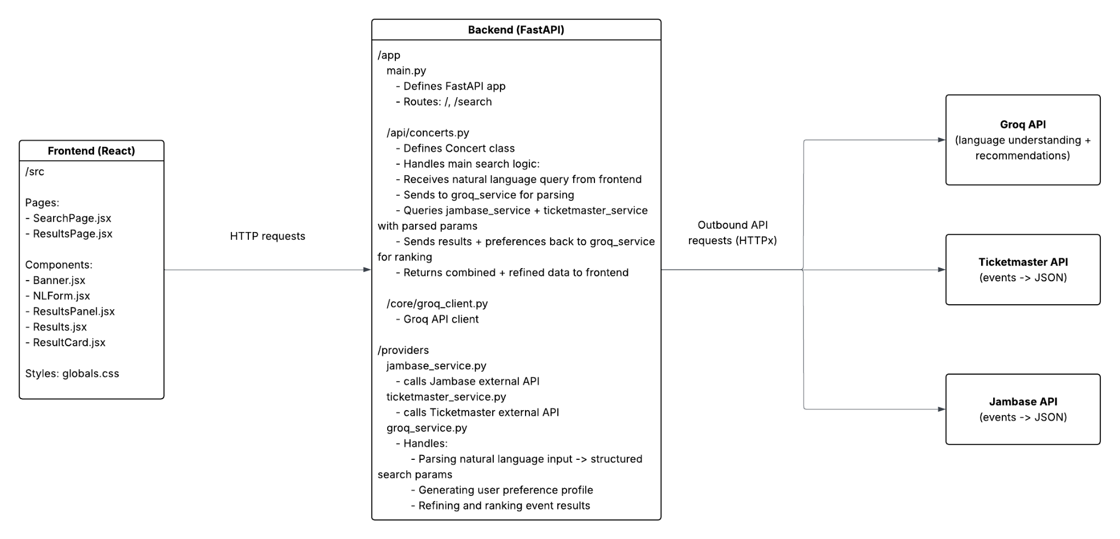

Class Diagram
Backend:
- API Layer (app/main.py): FastAPI entry point that initializes the application and mounts the ConcertsService router. Defines a health check endpoint (/) to confirm the backend is running.
- Core Service (app/api/concerts.py): implements the ConcertsService, which orchestrates the entire request flow. Receives a natural language query from the frontend, calls the GroqClient to extract structured parameters and user preferences, queries the JamBase and Ticketmaster provider microservices for matching events, and finally requests AI-driven ranking and recommendations from the Groq provider before returning results to the frontend.
- AI Client (app/core/groq_client.py): encapsulates all interactions with the Groq provider microservice. Provides asynchronous methods to extract tokens, infer user preferences, and generate ranked concert recommendations.
- Provider Microservices (services/jambase_service.py, services/ticketmaster_service.py, services/groq_service.py):
  - JamBaseService and TicketmasterService act as adapters to their respective external APIs, normalizing data into a shared event schema.
  - GroqService acts as an AI gateway that parses user input, extracts preferences, and ranks events using the Groq API.
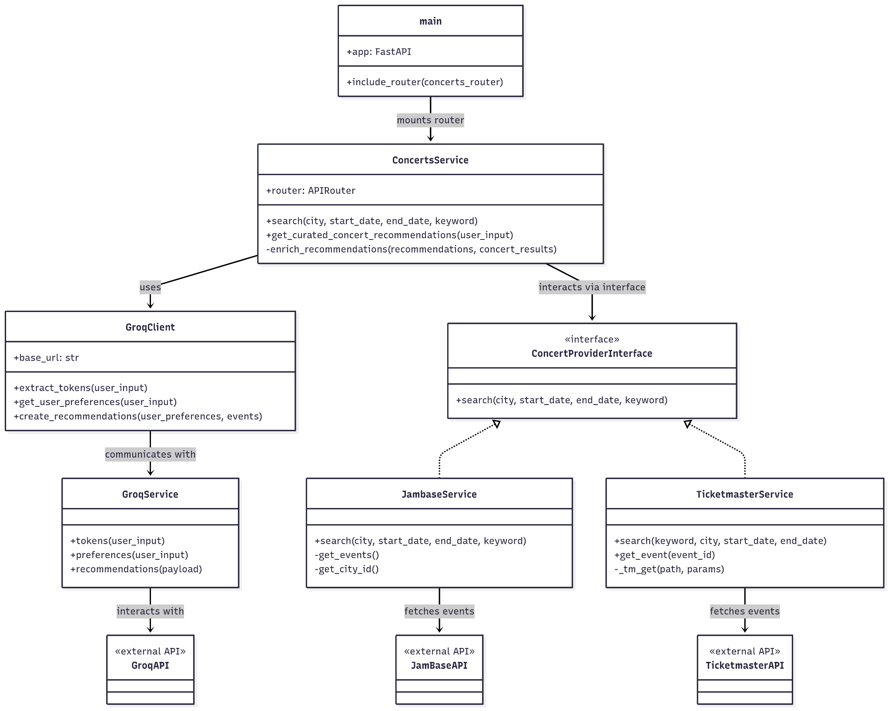

Frontend:
- App Entrypoint (src/main.jsx, src/App.jsx): Mounts React app and defines routes (/search, /results).
- Pages:
  - SearchPage: Displays the banner and a single natural language input form (NLForm). When the user submits a query (e.g., “Find indie concerts in Denver next month”), it sends the text to the backend /recommendations endpoint and navigates to the results page.
  - ResultsPage: Reads the query or state from navigation, fetches AI-ranked concert recommendations from the backend, and renders them in a list layout.
- Core Components:
  - Banner: displays the site’s header and branding, reused across pages.
  - NLForm: collects natural language input and triggers the backend request
  - ResultsPanel: wraps search results with contextual summary (e.g., inferred city or date range).
  - Results: iterates over recommended events and renders them as cards.
  - ResultsCard: displays a single concert’s details, including title, venue, and reasoning text from the AI output.

- API Client (src/api/client.js):
  - get_recommendations: returns a list of AI-ranked concert recommendations from the backend /recommendations endpoint.

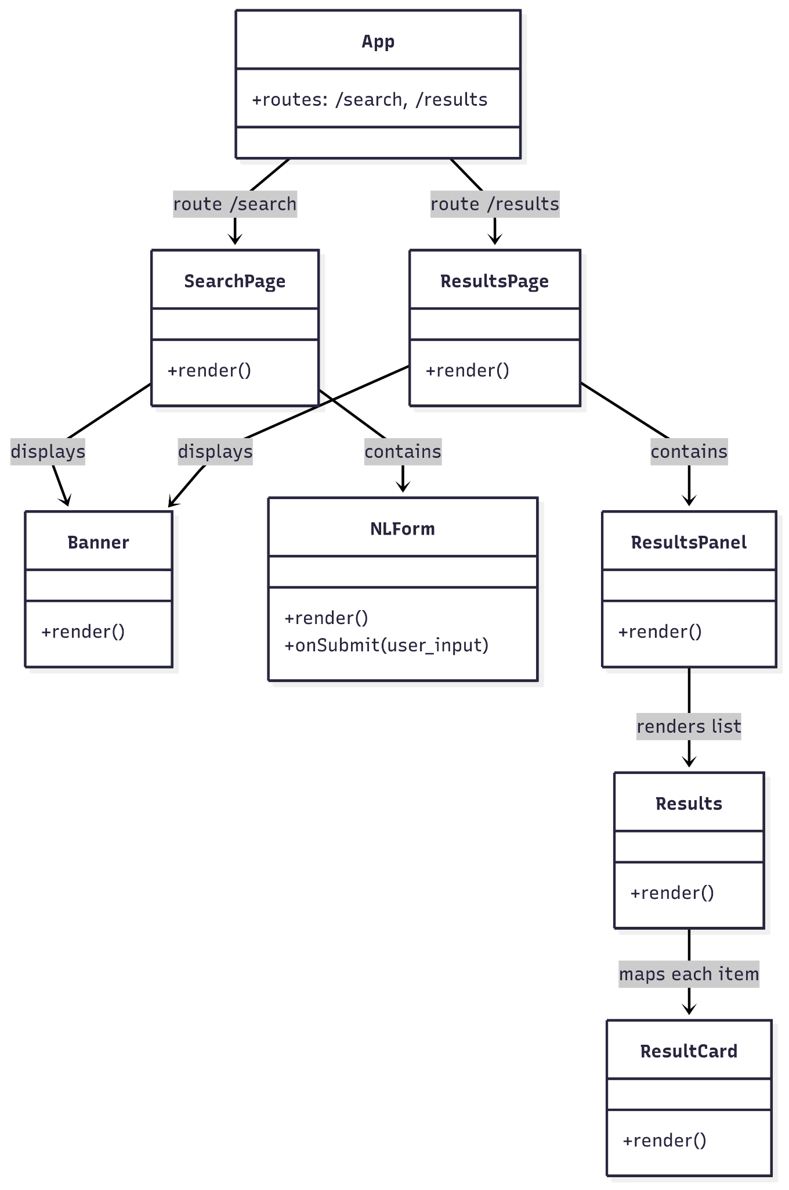

UI Design (if applicable)
The frontend of BeatMap is implemented in React, with Vite as the build and development tool. The user interface emphasizes simplicity and clarity, providing two main pages: SearchPage and ResultsPage. A banner at the top of both pages reinforces branding and maintains a consistent visual identity.

On the SearchPage, users can enter natural language queries through a single input form powered by the NLForm component. The frontend sends the user’s free-text query to the backend’s /recommendations endpoint for AI-driven parsing and recommendation generation. The ResultsPage displays results in a clean, card-based layout using components such as ResultsPanel, Results, and ResultCard. These modular, reusable components make it easy to extend or refine the interface in future iterations.

The following is our current UI iteration:

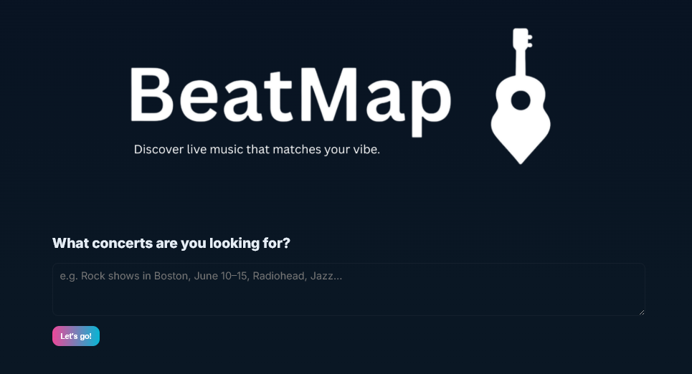

Database Design (if applicable)
We haven’t implemented any database functionality.

Security Design

The system architecture is organized into three main components that define clear security boundaries. The Frontend (React) runs on port 3000 and provides the user interface layer. The Backend API (FastAPI) operates on port 8443, managing the core application logic, request routing, and integration with external services. The Provider Services, running on ports 8001–8003, implement isolated microservices for third-party APIs such as JamBase, Ticketmaster, and the Groq AI/LLM API.
All components now communicate securely over HTTPS, even within the Docker-managed internal network. This ensures encrypted data exchange between microservices while maintaining service discovery through container names and minimizing exposed ports. The design not only enforces end-to-end security but also lays the groundwork for future scalability, allowing each microservice to be deployed independently on separate hosts or environments with HTTPS communication already fully supported.
Currently, the application has no authentication or authorization mechanism since we don’t support the registration of users. While in the development phase all API endpoints are publicly accessible so that we can test services independently; this is an intentional choice and can be reverted by changing the security policies with our AWS EC2 instance so that only port 3000 (frontend) is exposed. Directly exposing our application’s port 3000 to the internet creates potential for abuse of external API quotas and unauthorized access to system resources. This could be addressed using AWS tools that are readily accessible like AWS API Gateway, which enforces a gateway to our app, adding rate limiting and throttling mechanisms. Given time constraints and impending ending of the course, we decided to exclude the user features out of the project’s scope. With more time we would have implemented OAuth2 with JWT tokens or trusted providers such as Auth0 or Okta for authentication. Due to time constraints, we excluded user features from the project. If implemented, authentication would use OAuth2 with JWT or providers like Auth0/Okta, with RBAC or ABAC for authorization. Passwordless “magic link” login and personal wishlists would also be supported.
Data security covers both data at rest and data in transit. For data at rest, no database is currently implemented; however, if one were added, TLS encryption would be used to protect stored data. Configuration values and API keys are securely managed through environment variables, with secrets injected at build and deployment time using GitHub Secrets.
For data in transit, all microservices—including the backend, frontend, and provider services—now communicate over HTTPS, even within the Docker network. This ensures end-to-end encryption between internal components as well as with external APIs such as JamBase and Ticketmaster. Environment-specific certificates are mounted into each container to enable encrypted communication across all services. Overall, the system now provides strong protection for sensitive data and secure communication channels across the entire architecture, while maintaining a scalable setup for future deployments.
API security is implemented through FastAPI, leveraging Pydantic models for strict request and query parameter validation within the search endpoint. All API traffic now flows over HTTPS, ensuring encrypted communication between the frontend, backend, and provider microservices. CORS is configured via FastAPI’s middleware to enable secure interaction between the React frontend and backend API. However, other security measures such as strict security headers, rate limiting, and request throttling remain unimplemented, leaving potential exposure to common web threats. Error handling currently relies on FastAPI’s default responses without custom security-focused error management, which could lead to unintended information disclosure through detailed stack traces.
Infrastructure and deployment security covers container, network, and build-level protections. The system uses Python 3.12 on an Alpine Linux base image, minimizing the attack surface and dependency footprint. Container builds disable .pyc file creation and ensure real-time logging via the environment variables PYTHONDONTWRITEBYTECODE=1 and PYTHONUNBUFFERED=1. Dependencies are installed using apk add --no-cache and pip install --no-cache-dir, avoiding cached packages and reducing image bloat.

The architecture now enforces HTTPS communication across all microservices, including internal Docker network traffic, strengthening network security during both local and production deployments. Key strengths include the use of lightweight, immutable containers and a fully encrypted service network. Remaining security gaps include containers still running as the root user (no USER directive specified) and the absence of automated vulnerability or image security scanning during the build process.

Network security is managed through Docker network configuration that provides internal service communication via Docker networking, port exposure limited to necessary services only, and service discovery via container names. Network ports include Frontend on 3000 (external), Backend on 8000 (external), Jambase Provider on 8002 (internal), and Ticketmaster Provider on 8001 (internal).

Deployment security is managed through GitHub Actions (.github/workflows/deploy.yml) using GitHub Secrets for credential management, SSH key authentication, branch protection (main only), and secure environment variable injection. Key secrets such as EC2_HOST, EC2_DEPLOY_KEY, and JAMBASE_API_KEY are resolved at deployment time. Each deployment performs a fresh repository clone, full container rebuild using the --no-cache flag, and a graceful restart of running services to ensure a clean and secure pipeline.

Infrastructure security relies on Python 3.12 running on an Alpine Linux base image, providing a minimal attack surface and dependency footprint. The configuration disables .pyc file generation and ensures real-time log visibility using PYTHONDONTWRITEBYTECODE=1 and PYTHONUNBUFFERED=1. Dependencies are installed with --no-cache options to avoid cached packages. All microservices now communicate over HTTPS, including within the internal Docker network, guaranteeing encrypted communication across the entire architecture and enabling future independent deployment of each service. Remaining infrastructure gaps include containers still running as root (no USER directive) and the absence of automated image vulnerability scanning during build.

Security monitoring and assessment are handled through the GitHub Actions Security Pipeline (.github/workflows/security-check.yml), which performs daily automated scans using Bandit for Python static analysis, pip-audit and Safety for dependency vulnerability detection, and scheduled cron execution at 03:00. The current configuration uses continue-on-error: true, allowing builds to proceed while still reporting findings for review.

Security risks are prioritized according to their severity. High-priority risks include the absence of authentication and authorization mechanisms, containers running as root, and limited rate limiting for request control. Medium-priority issues include incomplete implementation of custom security headers such as CSP and HSTS, limited sanitization of error messages that may expose stack traces, and missing automated image scanning. Low-priority risks include the lack of secrets rotation automation and ongoing enhancements to continuous monitoring.

The project adheres to secure coding and deployment practices through pinned dependencies, automated vulnerability scans, and secrets stored securely in GitHub Secrets. No hardcoded credentials exist in the source code. Static analysis with Bandit is integrated into the CI/CD pipeline. The system aligns with OWASP Top 10 principles: injection risks are mitigated through Pydantic validation, sensitive data exposure is prevented by comprehensive HTTPS/TLS coverage, and security misconfigurations are addressed with proper CORS, SSL, and middleware configuration. Authentication and access control features are planned for future iterations, while dependency vulnerabilities are already mitigated by automated scanning.

Substantial progress has been made in the first phase of security implementation. All services now support HTTPS/TLS with Let’s Encrypt and self-signed certificates, security middleware has been deployed with HSTS, CSP, X-Frame-Options, and related headers, CORS is configured with environment-aware origin filtering, rate limiting of 100 requests per minute per IP has been introduced, and centralized request and response logging supports ongoing monitoring. The next steps include implementing user authentication and authorization, introducing non-root container users, adding automated image scanning in CI/CD, improving custom error handling to prevent information leakage, and implementing security event alerting.

Security incidents are handled by the project development team through GitHub Issues, following a responsible disclosure process. Incident response involves immediate containment, assessment of scope and impact, application of mitigations, documentation in the security changelog, and post-incident review. Security documentation is maintained in /SECURITY.md and /SECURITY-DESIGN.md, with updates performed after each implementation phase. Additional technical details are available in ssl/README.md for certificate management, src/backend/app/core/ssl_settings.py for SSL configuration, and src/backend/app/core/middleware.py for middleware implementations.

As of October 6, 2025, BeatMap has achieved end-to-end HTTPS communication, consistent security middleware deployment, and daily automated vulnerability scanning, marking the completion of Phase 1. Future work will focus on implementing authentication and access control, adding container security scanning, and strengthening infrastructure hardening to reach production-grade security maturity.

Business Logic and/or Key Algorithms
Business Logic
- User Flow: A visitor enters a natural language query (e.g., “Find jazz concerts in Denver this weekend”) on the SearchPage and submits it.
- Request Handling: The frontend calls the backend /recommendations endpoint. FastAPI validates the input and routes the request through the ConcertsService.
- AI Processing: The backend sends the user query to the GroqService, which extracts structured search parameters (locations, artists, date range) and user preferences (genres, favorite artists, etc.).
- Provider Integration: Using the extracted parameters, the backend queries both the JamBase and Ticketmaster provider microservices, each returning normalized event data.
- Recommendation generation: the aggregated event data and user preferences are then sent back to the GroqService, which ranks and refines results based on inferred relevance and reasoning.
- Response: The backend returns a list of ranked concert recommendations as JSON, which the frontend displays in the ResultsPage using Results and ResultCard components
Key Algorithms
- Asynchronous Fetching: Provider requests (JamBase and Ticketmaster) are executed concurrently with httpx.AsyncClient to reduce latency
- AI-driven Ranking: The Groq model evaluates retrieved events against user preferences and context, assigning ranks and textual reasoning for each recommendation.
- Deduplication: Overlapping results from multiple providers are merged based on shared attributes (e.g., event name, venue, date).
- Sorting and Stability: The final list is sorted by rank and event date to ensure consistent, deterministic output.
- Error Handling: If a provider fails or returns no data, the system gracefully returns partial recommendations without disrupting the response flow.

Design Patterns
The BeatMap system explicitly applies several well-established design patterns to achieve modularity, scalability, and maintainability across its architecture.

On the frontend, the Composite Pattern is intentionally employed through the React component hierarchy, where complex pages are constructed from reusable, nested components (for example, the SearchPage composed of NLForm, ResultsPanel, and ResultCard). This promotes clear structure, reusability, and separation of concerns in the user interface.

On the backend, the Adapter Pattern is explicitly implemented in the provider microservices (JamBaseService, TicketmasterService), which translate and normalize differing external API schemas into a consistent internal Concert model. This ensures that the backend and frontend interact with a unified data representation, regardless of the source API.

The Facade Pattern is clearly realized in the ConcertsService, which provides a single, simplified REST interface that coordinates requests across multiple provider services and the AI microservice. By hiding the complexity of underlying integrations, the Facade improves maintainability and decouples higher-level logic from specific provider implementations.

In addition, elements of the Strategy Pattern are present in the dynamic provider selection mechanism, allowing different data sources to be used interchangeably at runtime. Aspects of the Factory Pattern also emerge through the on-demand instantiation of provider clients. Together, these patterns establish a cohesive, extensible design that supports independent service deployment and future system growth.

Rest APIs
The backend is implemented using FastAPI, exposing a small set of RESTful endpoints in this iteration:
- GET /
  - Description: Health check endpoint for the BeatMap backend.
  - Response: JSON object with status and a message confirming the backend is running.
- GET /concerts
  - Description: Retrieves a collection of concerts filtered by city, date range, keyword, or provider. This endpoint represents the Concert resource in the BeatMap API and aggregates results from multiple external providers into a uniform format.
  - Query Parameters:
    - city (string, optional) — City where concerts take place.
    - start_date (string, optional, format: YYYY-MM-DD) — Start of the search date range.
    - end_date (string, optional, format: YYYY-MM-DD) — End of the search date range.
    - keyword (string, optional) — Keyword filter matching artist names, genres, or event titles.
    - provider (string, optional) — Data source to query (e.g., jambase, ticketmaster). If omitted, the system cycles or aggregates results across all available providers.

  - Response: Returns a JSON array of standardized Concert objects with the following fields:
    - artist (string) — Primary performing artist or group.
    - lineup (array[string]) — List of additional artists performing at the event.
    - venue (object) — Venue details with properties name, address, city, and country.
    - date (string, format: YYYY-MM-DD) — Scheduled event date.
    - provider (string) — Source API from which the concert data originated.
- GET /concerts/recommendations
  - Description: Provides access to the Recommendation subresource of the Concert collection. Each Recommendation represents an AI-generated, ranked subset of Concert resources derived from user preferences. The endpoint processes natural-language queries by sending user input to the Groq microservice for semantic parsing, retrieving matching Concert data from JamBase and Ticketmaster, and returning a curated list of Recommendation resources—each linking a Concert with a contextual explanation of why it was suggested.
  - Query parameters: user_input (string, required): Natural language query (e.g., “Find indie concerts in Seattle next month”).
  - Response: JSON object with ranked recommendations and reasoning for each suggested event:
    - recommendations (array[object]) — List of recommendations.
    - rank (integer) — Ranking of the recommendation (1 = highest).
    - reason (string) — Explanation of why the event matches the user’s input.
    - event (object) — Standardized Concert object containing:
- id (string) — Unique identifier of the concert.
- name (string) — Event or tour name.
- artist (string) — Primary performing artist.
- venue (object) — Venue details (name, address, city, country).
- date (string, format: YYYY-MM-DD) — Event date.
- provider (string) — Data source (e.g., ticketmaster, jambase).

Any Additional Topics you would like to include.
At the beginning of Iteration 2, the team held a discussion to plan the remaining development schedule, which included both Iteration 2 (two weeks) and the shorter final Iteration 3 (one week). During this conversation, the team collectively decided to focus the remaining effort on expanding the system’s AI functionality and integration rather than implementing user-related features such as authentication or account management. This direction was chosen because the team found the AI components—particularly natural-language processing and recommendation generation—more technically engaging and aligned with the project’s innovative goals.

AI usage Log
You are allowed and even encouraged to use AI tools to help you generate the project idea, plan it and build it, but you need to clearly describe 1) What tools were used? 2) for what specific tasks and 3) Is it helpful? 4) how did you evaluate or modify AI-generated content? Additionally, you should submit the exported AI chat history as an appendix or share that with the instructor and facilitators.

Tools | Who | Tasks | helpful | Evaluation/modification | links
ChatGPT | Sam | CI/CD setup | Yes | It provided a starting point that I had to tweak as new issues became apparent. I used it iteratively to refine workflow files. | https://chatgpt.com/share/68c9eeef-0178-8013-a6ea-ddacd31bb844
ChatGPT | Sam | Cloud deployment pivot | yes | Couldn’t make Google Cloud Run. Needed to consider options, got a good overview. | https://chatgpt.com/share/68d0b291-211c-8013-a84b-1cbd87cb30f8
ChatGPT | Sam | FastAPI usage | yes | I wanted to determine if there was an easy way to test FastAPI endpoints. The AI told me exactly what I needed. | https://chatgpt.com/c/68d0b304-6f80-8328-91ec-3e8ee412a747
ChatGPT | Ed | Suggestions for document organization and content, design patterns, | yes | Used as a starting point for document organization/layout, as well as suggestions for useful design patterns to be implemented. | https://chatgpt.com/share/68d1ae80-51e0-800d-95a3-a88cdca6cafe
ChatGPT | Greg | Integrating external API, FastAPI, pytest | Yes | I used ChatGPT for guidance on the architecture of integrating an external API JamBase into our backend. I also wanted to see examples of using mock data to test an API endpoint, as well as how to create endpoints and handle them correct using FastAPI. I evaluated the results from ChatGPT by considering feasibility of each answer as well as accuracy applying the idea to our application. | https://chatgpt.com/share/68d1bda4-c638-8013-96c3-73e5ff5767ad
ChatGPT | Ed | Assistance in laying out core structure of software architecture overview and class/UML diagrams | Yes | I used ChatGPT to provide a rough draft of the software architecture and class diagrams sections. I reviewed the output and restructured/reformatted it, and used it as a starting point to create the architecture summary and UML diagrams | https://chatgpt.com/share/68e2f145-e8d0-800d-8ead-420f81854939

References

Glossary

