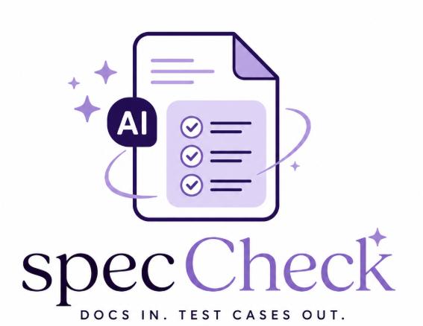
CS673 Software Engineering
Team 3 - SpecCheck
Software Design Document

Team Member | Role(s) | Signature | Date
Vy Trinh | Design & Implementation Lead, Security Lead | Vy Trinh | 05/24/2026
Danielle Leask | Team Leader &Requirement Lead | Danielle Leask | 5/25/2026
Jannatul Tuba | QA Lead and Configuration Lead | Jannatul Tuba | 5/25/2026

Revision history
Version | Author | Date | Change
0.0 | Vy Trinh | 05/22/2026 | Added updated software architecture, frontend/backend design, MongoDB structure, and AI workflow implementation details.
0.0 | Danielle | 5/24/2026 | Modified and added to the UI Design section. Implemented Mock UI pictures.
0.0 | Jannatul | 5/25/2026 | Updated git workflow with latest workflow and reviewed this SDD document, made small change in test management mockup

Modified and added to the UI Design section. Implemented Mock UI pictures.
1. Introduction
Design Goals
2. Software Architecture
3. Class Diagram
4. UI Design
5. Database Design (if applicable)
6. Security Design
Authentication Security
File Upload Security
API Security
AI Security
7. Business Logic and/or Key Algorithms
Document Upload Workflow
AI Test Case Generation Workflow
Retrieval Augmented Generation (RAG)
8. Design Patterns
MVC-Inspired Structure
Modular Architecture
Repository Pattern
9. Rest APIs
Authentication APIs
+POST /api/auth/register: Registers new users.
+POST /api/auth/login: Authenticates users.
+Document APIs: POST /api/upload
Uploads product documents.
+GET /api/documents: Retrieves uploaded documents.
+DELETE /api/documents/:id: Deletes uploaded document.
+AI APIs: POST /api/generate
Generates AI-assisted test cases.
+POST /api/retrieve: Retrieves contextual document chunks
10. Additional Topics
Git Workflow
The project uses:
● feature branches
● pull requests
● development branch integration
● GitHub Actions validation
Main branch merges occur only after:
● testing passes
● review approval
● iteration completion
Current Iteration Status
Completed:
● upload pipeline
● dashboard management
● MongoDB integration
● indexing workflow
In Progress:
● user story form
● AI generation integration
Pending:
● export functionality
● advanced regression analysis
AI usage Log
References
Glossary

(In your submitted document, please delete all instructions)

Introduction
Overview
This document describes the software design and technical architecture for SpecCheck, an AI-powered web application that generates software test cases using uploaded product documentation and user stories.
The purpose of this document is to:
  - describe the system architecture
  - define software components
  - explain database and API design
  - describe frontend and backend interactions
  - explain AI integration workflow
  - document security and deployment design

Design Goals
The main design goals are:
  - Build a scalable AI-assisted testing platform
  - Reduce manual QA effort
  - Support contextual AI test generation
  - Maintain modular frontend/backend architecture
  - Provide secure document upload handling
  - Support collaborative development workflows
  - Enable future scalability and deployment

Software Architecture

High-Level Architecture
SpecCheck is designed as a decoupled, full-stack web application. The architecture consists of four primary layers working synchronously to handle document processing, data persistence, and AI-driven test case generation:
Frontend Layer: Handles user interaction and responsive data visualization.
Backend Layer: Manages RESTful API routing, business logic, and security workflows.
AI Processing Layer: Governs document parsing, OCR extraction, and the RAG (Retrieval-Augmented Generation) pipeline.
Database Layer: Provides permanent data storage for application states and assets.
Architecture Components
- Frontend Layer
Technologies: React, Vite, JavaScript, CSS3.
Responsibilities:
Renders the User Authentication interfaces (Sign In / Sign Up).
Provides an interactive drag-and-drop Document Upload interface.
Displays the Document Dashboard to monitor and manage processed files.
Contains the User Story submission form.
Renders the final generated AI test cases in a structured format.
- Backend Layer
Technologies: Node.js, Express.js, JavaScript.
Responsibilities:
Handles incoming REST API requests from the frontend client.
Processes user authentication and session management.
Manages file upload streams via memory storage middleware (multer).
Orchestrates core system logic and routes requests to the AI pipeline.
Communicates securely with the database layer.
- AI Processing Layer
Technologies: pdf-parse-fork, Tesseract.js, OpenAI API / Claude API.
Responsibilities:
Extracts raw text content from uploaded PDF documents.
Performs Optical Character Recognition (OCR) to extract text from images (.png, .jpg).
Executes document text chunking and indexing.
Manages context retrieval using a RAG-based flow.
Generates structured software test cases via LLM processing.
- Database Layer
Technologies: MongoDB.
Responsibilities:
Stores permanent user account credentials and profiles.
Saves uploaded document metadata (e.g., file names, file sizes, upload timestamps).
Persists generated test cases and historical records.
Maintains the application dashboard states and execution histories.
Component Relationships
The components interact seamlessly through established data communication pathways:
Client Interaction:
Frontend → Express API → MongoDB
(For user sessions and saving/deleting document metadata).
Knowledge Processing:
Frontend → Express API → AI Processing Layer
(For text parsing and OCR extraction requests).
AI Generation Flow:
AI Pipeline → Vector Retrieval Context → External LLM APIs
(For final test case synthesis).

Class Diagram
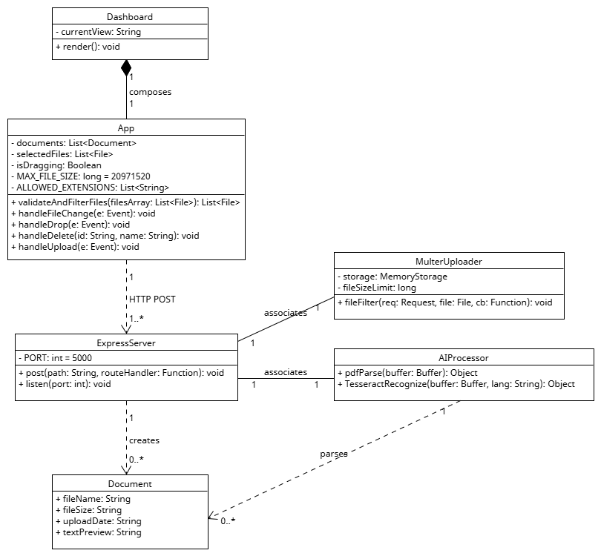
Figure 2.1: Scoped Class Diagram for Document Management Module (CT-19 & CT-70).

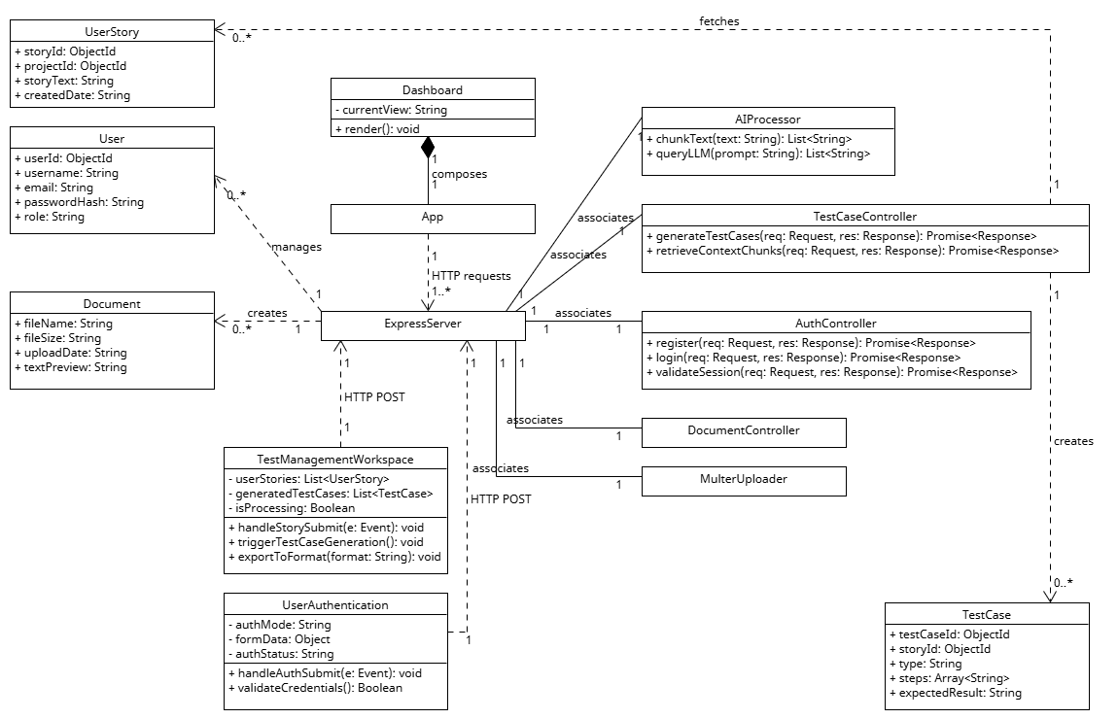
Figure 3.1: Full System Class Diagram for SpecCheck Application.

UI Design
The UI design for this project is focused on a clean, simple, and structured interface that supports the main workflow of the system: uploading project documents and generating AI-based test cases. The goal of the design is to make the process straightforward for users while still handling important functions like project management, document handling, and test case generation.
The application is built to help users create test cases for their own projects. Users first create or select a project they will generate test cases for. This project is where all documents and generated test cases are organized. This helps keep the system organized when dealing with multiple client projects.
The system includes two main areas: the Project Management view and the Document and Test Management workspace. The Project Management view is used to create, open, and manage client projects. Each project acts as a container that holds all related documents and test cases. The Document Dashboard is the main workspace where users upload files, view document status and select documents for AI processing.
The Dashboard is designed to support the core workflow of the system. Users can upload PDFs and other documents using drag-and-drop or manual upload. Once uploaded, documents appear in a list where users can track their status, delete files, or select them for test case generation. A User Story input section allows users to describe requirements in natural language, which is then used by the AI system to generate test cases.
The Test Management section is where generated test cases are displayed. Test cases are organized into categories such as functional, negative, and edge cases. Users can review results, regenerate test cases if needed and export them in formats such as PDF or CSV. Additionally, user can delete, archive test cases.
The Login and Registration pages are kept minimal and simple to ensure secure access to the system. The Login page authenticates users before they can access the dashboard, while the Registration page allows new users to create an account.
The overall UI is designed to be clean and minimal, focusing on usability rather than visual complexity. The layout uses structured sections such as cards and tables to separate information clearly. Navigation is consistent across the system, allowing users to move between projects, documents, and test cases easily.
This design supports the main purpose of the system by connecting project management, document handling, and AI-generated test case creation into one simple and organized workflow.
Link to Figma Mock UI:
https://www.figma.com/community/file/1640487220246753618/speccheck-web-app-ui-design
The current UI represents a mock design, and the color scheme and visual styling will be refined in future iterations to improve overall aesthetics and user experience.
Project Management view :
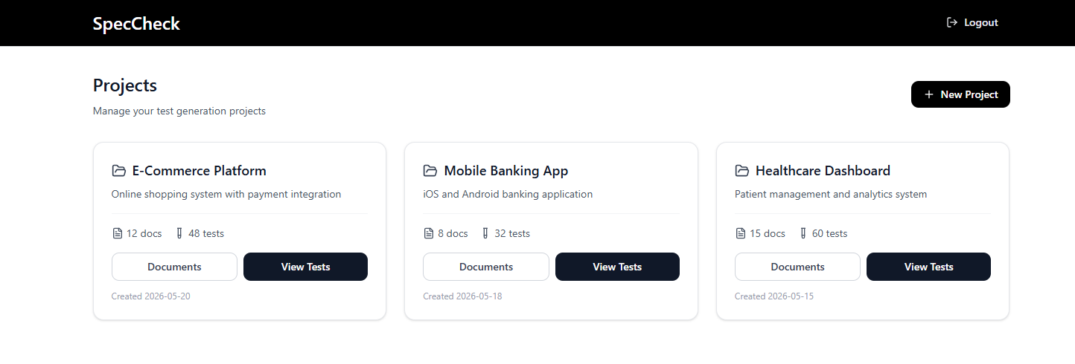
Document :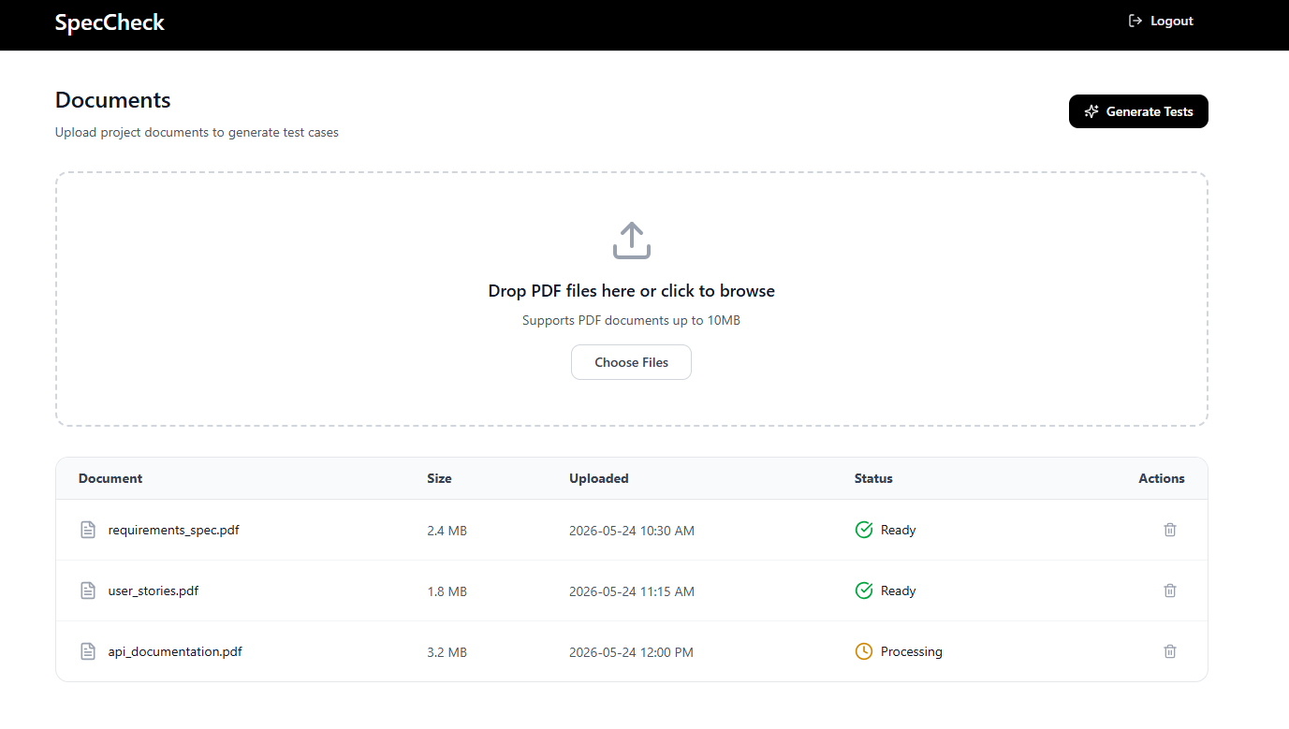
Test Management workspace:
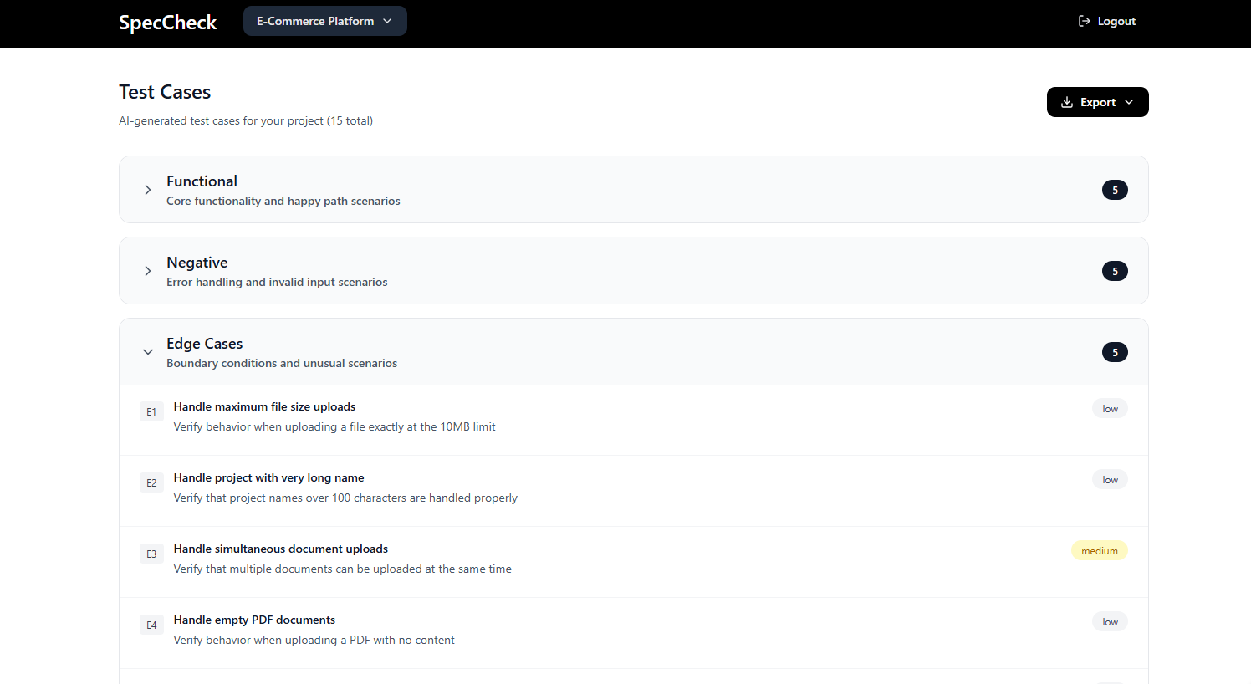

Login:
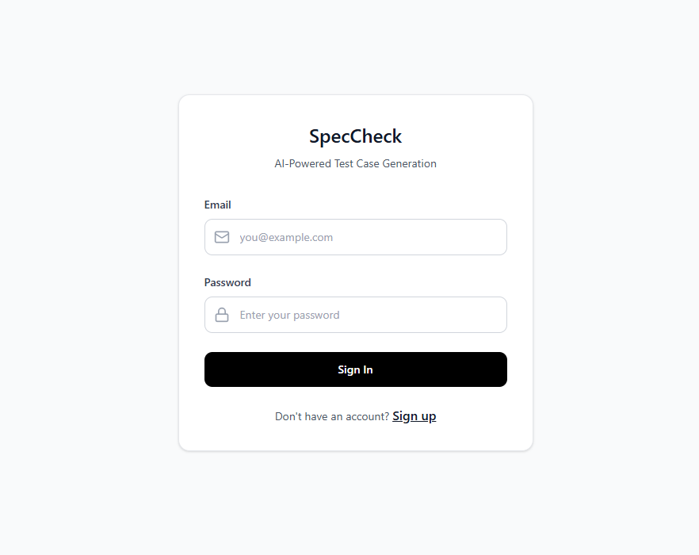

Registration:
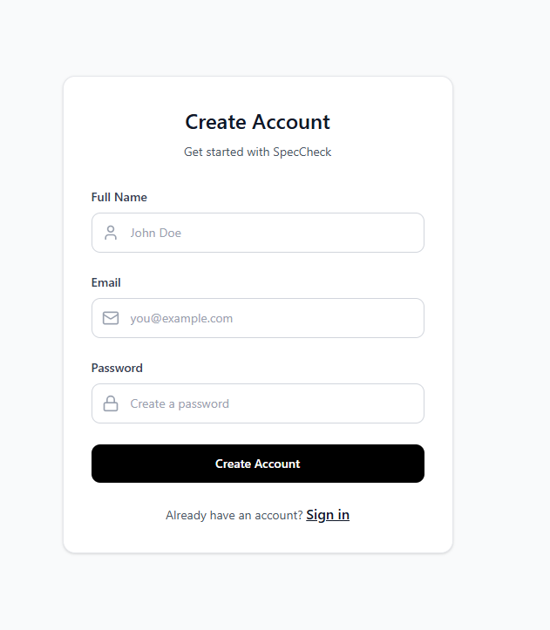

Database Design (if applicable)

User:

Field | Type
userId | ObjectId
username | String
email | String
passwordHash | String
role | String

Document Collection

Field | Type
documentld | Objectld
filename | String
uploadDate | Date
extractedText | String
embeddingStatus | Boolean

UserStories Collection

Field | Type
storyId | ObjectId
ObjectId | String
createdDate | Date

TestCases Collection

Field | Type
testCaseId | ObjectId
storyId | ObjectId
type | String
steps | Array
expectedResult | String

Security Design
The application includes several security mechanisms:

Authentication Security
  - password hashing
  - protected API routes
  - session validation

File Upload Security
  - file type validation
  - upload size restriction
  - MIME type verification

API Security
  - request validation
  - error handling
  - protected backend endpoints

AI Security
  - prompt validation
  - user input sanitization
  - restricted AI generation workflow

Business Logic and/or Key Algorithms

Document Upload Workflow
  - User uploads PDF
  - Backend validates file
  - PDF text extracted
  - Text cleaned and chunked
  - Embeddings generated
  - Data stored in MongoDB/vector storage

AI Test Case Generation Workflow
  - User submits user story
  - System retrieves related product context
  - Relevant chunks selected
  - AI prompt generated
  - OpenAI/Claude API called
  - Structured test cases returned
  - User reviews output

Retrieval Augmented Generation (RAG)
The system uses RAG to:
  - reduce hallucinations
  - improve contextual relevance
  - ground AI outputs using uploaded documents

Design Patterns

MVC-Inspired Structure
Frontend:
- React UI components
Backend:
+Express route handlers
+Service layer logic
+Database models

Modular Architecture
The system separates:
- frontend
- backend
- AI processing
- database access
to improve scalability and maintainability

Repository Pattern
Database operations are abstracted into reusable service modules.

9. Rest APIs
Authentication APIs

+POST /api/auth/register: Registers new users.

+POST /api/auth/login: Authenticates users.

+Document APIs: POST /api/upload

Uploads product documents.

+GET /api/documents: Retrieves uploaded documents.

+DELETE /api/documents/:id: Deletes uploaded document.

+AI APIs: POST /api/generate

Generates AI-assisted test cases.

+POST /api/retrieve: Retrieves contextual document chunks

10. Additional Topics

Git Workflow

This section explains how the team manages code changes, reviews, and releases throughout the project.

Our branches

We maintain two main branches that stay active for the entire project:

main : this is our stable, production-ready code. We only update it at the end of each iteration when we are ready to demo or deploy. Nobody pushes directly to this branch.

development : this is where all of our daily work comes together. Every new feature gets merged here first. It should always be in a working state.

For every piece of work, we create a short-lived branch off of development using one of these naming patterns:

feature/your-feature-name : for new features

setup/your-setup-task-name : for configuration and environment tasks

test/your-test-automation-feature-name: for automated test work

bugfix/your-fix-description: for fixing bugs found during testing

How to contribute code

Every change follows the same steps:

Switch to “development” and pull the latest code

Create a new branch using the naming convention above

Make your changes and commit with one of these prefixes: [HUMAN], [AI], or [HYBRID]

Push your branch to GitHub

Open a pull request into “development”

Wait for at least one teammate to review and approve

Merge and close your branch

Releasing at the end of each iteration

Once the team is happy with everything in development and all tests pass, we open a pull request from development into main. After at least one teammate approves, we merge and use that version for our demo or deployment. We repeat this at the end of iterations 1, 2, and 3.

Current Iteration Status

Completed:

upload pipeline

dashboard management

MongoDB integration

indexing workflow

In Progress:

user story form

AI generation integration

Pending:

export functionality

advanced regression analysis

11. AI usage Log
(This table summarizes AI contribution in this document)
Section | Who | AI contribution (%) | Description | Verified by
UI Design | Danielle | 70% | Generated UI design mockups were created using Figma based on the initial UI requirements. The original bullet-point UI specifications were converted into a structured paragraph format using ChatGPT to improve clarity and documentation quality. A Figma prompt was then generated to support the creation of a consistent and realistic mock user interface for the SpecCheck application. | Team 3
Document Dashboard, Upload, and Test Generation | Vy Trinh | 75% | The layout and design for the Document Dashboard and the User Story Input Form were created to manage user workflows. The system steps for Document Upload and Knowledge Indexing were set up to handle file reading, and the interface for AI Test Case Generation was planned to show the testing steps. ChatGPT was used to help write simple descriptions for these features, explain how the form saves text input, and organize the data steps so that test cases can be prepared for exporting later. | Team 3

References
- Martin, R. C. (2008). Clean code: A handbook of agile software craftsmanship. Prentice Hall.
- Pressman, R. S., & Maxim, B. R. (2020). Software engineering: A practitioner’s approach (9th ed.). McGraw-Hill Education.
- Sommerville, I. (2015). Software engineering (10th ed.). Pearson.

Glossary

