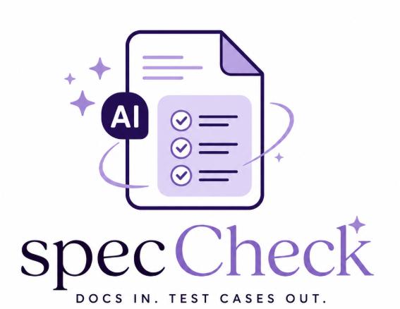
CS673 Software Engineering
Team 3 - SpecCheck
Software Test Document

Team Member | Role(s) | Signature | Date
Vy Trinh | Design & Implementation Lead, Security Lead | Vy Trinh | 05/24/2026
Jannatul Tuba | QA Lead and Configuration Lead | Jannatul Tuba | 5/25/2026
Danielle Leask | Team Leader &Requirement Lead | Danielle Leask | 5/25/2026

Revision history
Version | Author | Date | Change
0.0 | Vy Trinh | 05/24/2026 | Added testing summary, testing metrics, and AI usage documentation
0.1 | Jannatul Tuba | 5/25/2026 | Added Automation testing Report, Frameworks details , Architecture, Updated Test Matrics Result

Testing Summary
Manuel Tests Reports
Automated Testing Reports
Testing Metrics
References
Glossary

Testing Summary
The purpose of testing for the SpecCheck project is to ensure that the AI-powered web application functions correctly, securely, and reliably when generating software test cases from uploaded product documentation and user stories
The testing process includes validation of frontend interfaces, backend APIs, AI processing workflows, document uploads, database operations, authentication, and export functionality. Testing is conducted collaboratively by the development and QA team throughout each interaction of the software development lifecycle
The following testing approaches are used:

  - Unit Testing:
Unit testing validates individual modules and functions independently. Examples include:
- User authentication validation
- PDF upload processing
- API endpoint responses
- Database CRUD operations
- AI test-case generation logic
- Export file formatting
  - Integration testing:
Integration testing ensures communication between system components works correctly:
- Frontend ↔ Backend API communication
- Backend ↔ MongoDB database integration
- AI model ↔ vector database workflow
- File upload ↔ document indexing pipeline

  - System Testing:
System testing validates the complete application workflow:
- User login and session management
- Uploading product documentation
- AI-generated Gherkin test case generation
- Dashboard interaction
- Exporting generated test cases
  - Acceptance Testing:
Acceptance testing verifies that the application satisfies project requirements and user expectations:
- Correct generation of functional test cases
- Correct generation of negative and edge test cases
- Easy-to-use dashboard interface
- Accurate export functionality
  - Regression Testing:
Regression testing is performed after each iteration to ensure newly added features do not break existing functionality:
- Re-testing authentication
- Re-testing AI generation pipeline
- Re-testing upload/export features
- Re-testing dashboard functionality

Manual Testing Report
In this section, you will give a detailed description of each manual test case performed and the result. If this is a previous You shall list what are existing tests developed in the previous semester and what are new tests developed currently.

Here is a sample template that can be used for each test case. For system tests or acceptance tests, you may also include some screenshots.

- Test case ID, name
- New or old:
- Test items: (what do you test )
- Test priority (high/medium/low)
- Dependencies (to other test case/requirement if any):
- Preconditions: (if any)
- input data:
- Test steps:
- Postconditions:
- Expected output:
- Actual output:
- Pass or Fail:
- Bug id/link: (this should link to your github issue id)
- Additional notes:
(You can use an additional spreadsheet for this section as well)

Manual Test Report For Iteration 1:
For this iteration we performed 20 manual tests covering the Document Dashboard feature. The full test case details can be found in the following Google Sheet: https://docs.google.com/spreadsheets/d/1QlB513ss0ulv4wOulia82itIcsblQkO8x22lTNdEre8/edit?usp=sharing
Test summary
Metric | Count
Total test cases | 20
High priority | 11
Medium priority | 7
Low priority | 2
Passed | 18
Failed | 2
Not executed | 3
Features covered
Testing this iteration focused on four areas of the Document Dashboard: file upload, document table display, delete functionality, and dashboard UI and usability.
Failed test cases
Two tests failed and have been logged for resolution:
- TC-DOC-005 : Uploading more than 10 files was blocked as expected, but the error message returned was a raw server error (Upload failed: Unexpected field) instead of the user-friendly message Maximum 10 files allowed per upload. This needs a proper validation message on the frontend.
- TC-DOC-006 : A file of exactly 20 MB should be accepted at the boundary limit, but the system incorrectly rejected it with a size exceeded error. The boundary condition in the file size validation logic needs to be adjusted.
Not executed
Three test cases were not executed this iteration: TC-DOC-014 (delete document), TC-DOC-018 (page load for authenticated user), and TC-DOC-019 (unauthenticated access redirect). These should be prioritized in the next iteration.

Automated Testing Report
Describe briefly the automated testing you have done, including where the test code resides in your code repository, what test frameworks are used, and the screen shots or generated testing report.

Test Automation Code Repository Location:
Branch: Development [ We are not merging our test automation code in the production (main) branch for now.]
Location: https://github.com/BUMETCS673/cs673olsum26project-cs673olsum26team3/tree/test/framwork-and-document-dashboard/test

Path | Purpose
tests/features/dashboard.feature | Gherkin BDD Scenarios which covered 22 bdd test Cases
tests/pages/dashboard_page.py | Page object Model which covers all locators and browser interaction
tests/step_definitions/dashboard_steps.py | @given, @when, @then step definitions calling dashboard_page methods
tests/fixtures/ | Sample test data files
tests/conftest.py | Session scoped fixture, fetch mock, screenshots on failure
tests/test_dashboard.py | Pytest bdd entry point which links feature file to pytest runner
tests/pytest.ini | Markers , html report output patch and verbose flag configuration
tests/reports/report.html | Auto generated html report for test result (pass, failed,skipped etc)

Test Automation Framework:
The test suit follows BDD( Behaviour Driven Development) methodology using following framework and libraries
- Browser Automation: Playwright = 1.44. 0
- Test Runner: Pytest 8.2
- BDD Integration: pytest-bdd
- Playwright plugin: pytest-playwright
- Html Report: pytest-html
- Runtime: Python 3.12

Test Architecture:
The test automation framework follows the Page Object Model pattern to separate test logic from browser interaction. This ensures that changes to UI requires update only in the dashboard_page.py not across all test files. Here is an example:
• dashboard.feature: human-readable Gherkin specification for all 22 scenarios
• dashboard_page.py : all locators and browser interactions encapsulated in DashboardPage class
• dashboard_steps.py : @given/@when/@then step definitions that call DashboardPage methods
• conftest.py: session-scoped fixtures, fetch mock (for offline testing), and screenshot-on-failure hook

Iteration 1 Test Automation Coverage:
- Page shows header and upload section on load
- Document table shows pre-loaded documents with correct columns
- Successful upload of valid document types (Parameterized — runs 3 times)
- Selected files preview appears before upload
- Clicking Upload Files with no file selected shows an alert
- Multiple files uploaded in a single request all appear in the table
- Upload zone shows accepted formats and size hint
- Unsupported file format is rejected before upload (Parameterized — runs 2 times)
- Oversized file is rejected with a size-limit alert
- Mixed valid and invalid files — only the valid file is kept in the preview
- Deleting a document with confirmation removes it from the table
- Cancelling the delete dialog keeps the document in the table
- Deleting all documents shows the empty-state message
- Dragging a file over the upload zone adds the dragging CSS class
- Dragging away from the upload zone removes the dragging CSS class
- Dropping a valid PDF file shows it in the preview
- Dropping a valid file then uploading adds a row to the table
- Dropping an unsupported file shows the format rejection alert
- Dropping an oversized file shows the size-limit alert

Test Execution Report:
All 22 automated BDD scenarios passed on first execution with a 100% pass rate. Testing covered four functional areas of the Document Dashboard: page load and UI display, file upload with positive, negative, and edge case scenarios, delete functionality, and drag-and-drop interactions. Parameterized tests were run across multiple valid file types and unsupported formats to ensure broad input coverage. The full results are captured in the HTML report generated by pytest-html at tests/reports/report.html folder when run locally

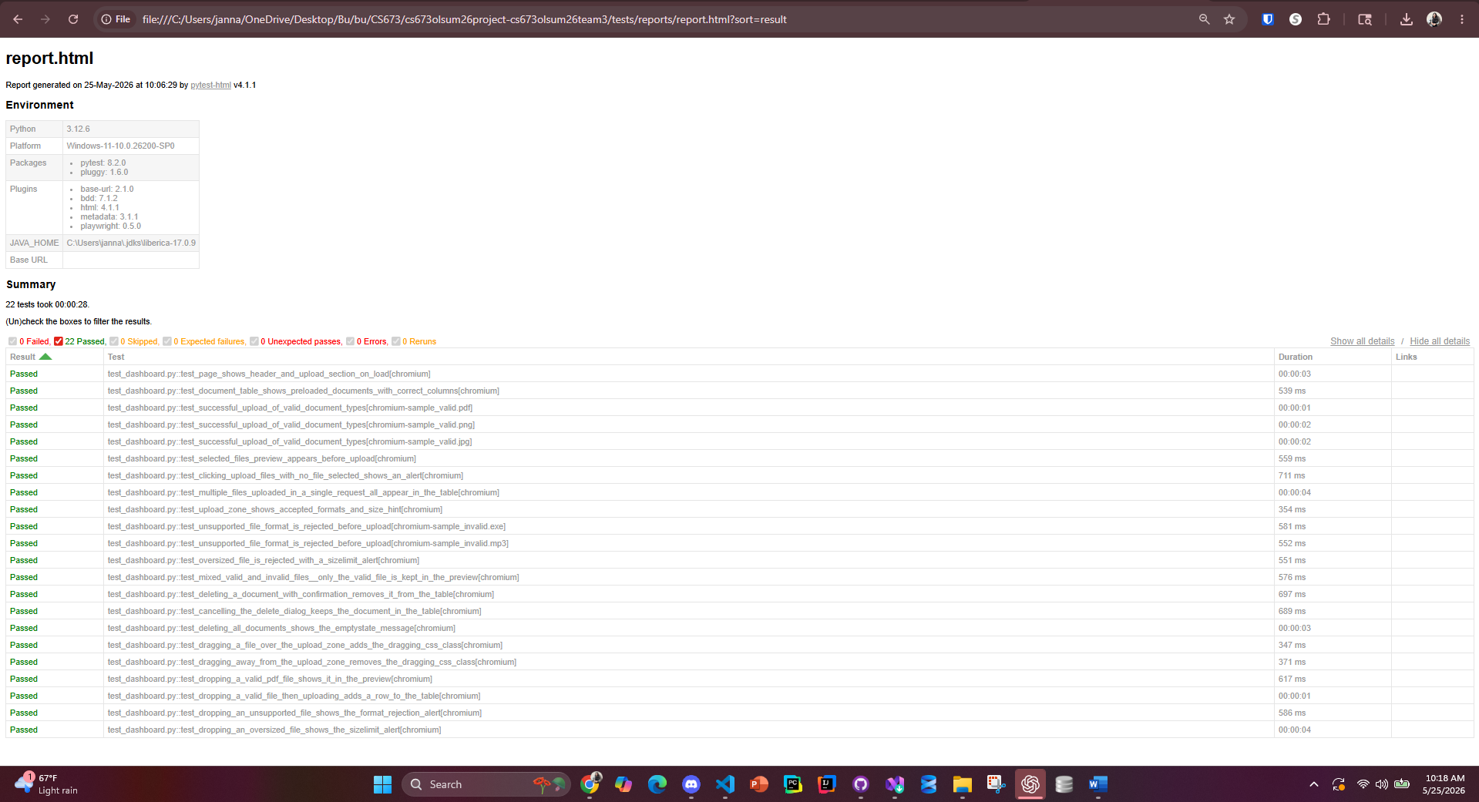

Testing Metrics
- Product Metrics: Product metrics evaluate the quality, reliability, and performance of the SpecCheck application itself

Metric | Description | Result
Total Test Cases | Total number of manual and automated test cases executed | 44
Passed Test Cases | Number of successfully passed test cases | 40
Failed Test Cases | Number of failed test cases | 2
Test Coverage | Percentage of application features tested | 80%
Defect Density | Number of defects identified per module | 1%
Authentication Success Rate | Successful login/authentication attempts | 100%
PDF Upload Success Rate | Successful document upload and processing rate | 90%
AI Test Generation Accuracy | Accuracy of generated Gherkin test cases | not yet applicable : iteration 2
Export Functionality Success Rate | Successful export operations | not yet applicable : iteration 2
System Response Time | Average response time during AI generation | not yet applicable : iteration 2

- Process Metrics: evaluate the effectiveness and efficiency of the software development and testing process.

Metric | Description | Result
Number of Iterations Completed | Agile development iterations completed | 2
Bugs Resolved per Iteration | Average defects fixed during each iteration | 0
GitHub Commits | Total code commits contributed by team | TBD
Pull Requests Reviewed | Number of reviewed pull requests | TBD
Automated Build Success Rate | Successful CI/CD pipeline executions | TBD
Team Meeting Frequency | Scrum/project meetings conducted weekly | TBD
Average Bug Resolution Time | Average time to fix reported issues | TBD
Requirement Completion Rate | Percentage of planned requirements completed | TBD
Documentation Update Frequency | Frequency of SPPP/SDD/Test document updates | TBD
AI-Assisted Development Usage | Percentage of AI-assisted documentation/coding support | TBD

AI usage Log
(This table summarizes AI contribution in this document)
Section | Who | AI contribution (%) | Description | Verified by
Testing Summary | Vy Trinh | 40% | AI assisted in formatting and refining test cases | Team 3
Testing Metrics | Vy Trinh | 20% | AI assisted in summarizing testing metrics | Team 3
Manual and Test Automation Report | Jannatul Tuba | 30% | Ai assisted summarizing test results , number of test cases and generated manual test plan initial template with steps | Team 3

References

Glossary

