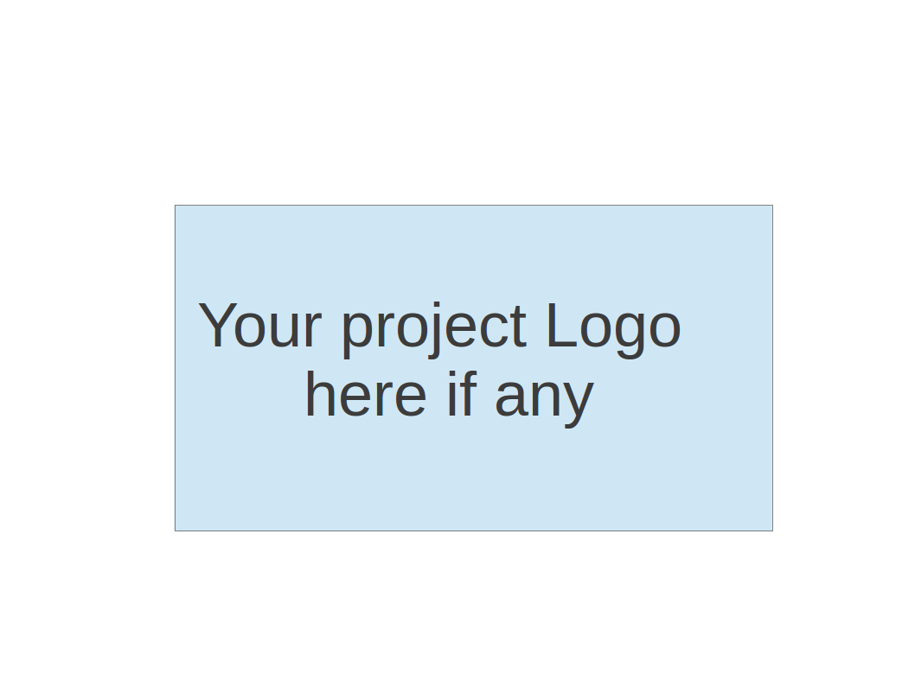
CS673 Software Engineering
Team 3 - DJVY
Project Proposal and Planning

Team Member | Role(s) | Signature | Date
Danielle Leask | Team Lead & Requirement Lead | Danielle Leask | 5/13/26
Vy Trinh | Design and implementation lead & Security Lead | Vy Trinh | 5/13/2026
Jannatul Tuba | Configuration Lead &QA Lead | Jannatul Tuba | 5/13/26
Yuting Shi | Design and implementation lead

Revision history
Version | Author | Date | Change
0.0 | Danielle Leask | 5/10/2026 | Updated Roles,  Overview of Project, added risk management link
0.0 | Jannatul Tuba | 5/11/2026 | Added Related work and Functional Requirements
0.0 | Danielle Leask | 5/12/2026 | Updated configuration management plan and quality assurance plan, including metrics and code review process.
0.1 | Vy Trinh | 5/12/2026 | Updated essential feature, nonfunctional requirements, management plan (priorities) and testing
0.0 | Jannatul Tuba | 5/13/2026 | Updated with details for Code Commit Guideline and Git Branching Strategy, Testing (timeline,assignee,type), Defect Management(severity)

1. Overview
2. Related Work
3. Proposed High level Requirements
4. Management Plan
a. Objectives and Priorities
b. Risk Management (need to be updated constantly)
c. Timeline (this section should be filled in iteration 0 and updated at the end of each later iteration)
5. Configuration Management Plan
a. Tools
c. CI/CD Plan
6. Quality Assurance Plan
a. Metrics
c. Code Review Process
d. Testing
e. Defect Management
7. AI usage Log
8. Project Links
9. References
10. Glossary

Overview
Motivation: Help software companies reduce the time and manual effort spent creating test cases and validating product features.
Purpose: Automatically generate functional, negative, and edge case test cases from product documentation to improve software quality and provide early feedback on features.
Potential Users: Software companies, including developers, QA engineers, and product teams.
Basic Functionality: Users upload product documents (PDFs, API specs, etc.), and the system uses AI to analyze them and generate test cases from a given user story.
Technology Stack: The system will be built using Django for the backend and web interface, MongoDB as the database, and Jira for agile project management. AI/ML tools will be integrated to enable automated document processing and natural language understanding for test case generation.

Related Work
TestSigma, TestRail, and Katalon Studio can generate test cases based on a user story, but the biggest gap is that these tools do not have an option to provide existing product knowledge as context or upload additional documents to let the AI understand the full context of the product. The generated test cases therefore tend to be generic and often miss existing product validation rules, known edge cases, or business logic that only exists inside internal documentation. There is also no way to build on that context over time, meaning every session starts from scratch.
Our goal is to develop a web-based application where users can provide context in the form of PDFs, API specs, and feature documents, and then have the AI generate targeted test cases when a user story is submitted. The system stores the uploaded knowledge persistently using a vector database so that it can be retrieved and used as grounded context at generation time, rather than relying on the AI to guess at product behavior it has never seen.

Proposed High level Requirements
Functional Requirements:
- Essential Features:
  - Login and Registration: As a user, I want to create an account and log into the system securely so that I can manage my uploaded documents and generated test cases.
  - Document Upload and Knowledge Indexing : As a QA, I want to upload pdf and image file so that the system has product context
  - User Story Input and Analysis: As a QA Engineer, I want to provide product user story and have AI retrieve product information automatically so that it can generate test case while having product context
  - AI Test Case Generation : As a QA Engineer, I want AI to generate functional, positive, negative, edge cases test cases with steps based on the user story while considering existing product context
  - Document Management Dashboard : As a QA Engineer I want to view, add, update, delete documents uploaded in for knowledge
  - Export Test Case : As QA, I want to export generated test cases as a text or CSV file, so that I can import it in other test management system
- Desired Features:
  - Impacted Feature Highlighting : As QA lead I want the system to list all impacted feature based on the user story
  - Test case history: As a user, I want the system to save previously generated test cases so that I can review and reuse them later
- Optional Features:
  - Github PR analyzer: As QA, I want the system to automatically analyze a pull request and to analysis based on the code change and suggest test cases based on the PR code change
Nonfunctional Requirements:
- The system should generate test cases within a reasonable response time
- The application should support secure authentication and protected user data
- Uploaded documents should be processed reliably and stored securely
- The system should be scalable to support multiple users simultaneously
- The UI should be responsive and user-friendly
- AI-generated outputs should be clear, structured, and easy to understand

Management Plan

Objectives and Priorities
This project focuses on integrating AI-driven test case generation into existing applications to streamline the testing process, reduce manual effort, and enable teams to dedicate more time to building and enhancing new features.

The highest priority objectives are:
- Build a reliable document upload and processing system for PDFs, API specifications, and product documents
- Integrate AI models to generate accurate functional, negative, and edge-case test cases
- Ensure generated test cases are context-aware and based on uploaded product knowledge
- Create a clean and user-friendly dashboard for managing uploaded documents and generated test cases
- Maintain system performance, security and scalability

Risk Management (need to be updated constantly)

The highest priority risks are mainly around system design, testing, and technology competence. If the architecture isn’t planned properly from the start, the system could become messy and hard to scale. This will cause a bigger issue when connecting the AI with document processing. To avoid that, the team should agree on a clear design early on and keep reviewing it as features are added. Testing is also a major risk because if we don’t test continuously, bugs can build up and the AI-generated outputs may not be reliable or accurate. This can be prevented by testing each feature as it is built instead of waiting until the end. Technology competence is another concern since not everyone is confident in the same programming language and we also do not have experience yet with how to implement the AI component of the project. We plan to split tasks based on individual strengths, learn the required tools together through documentation and tutorials, and rely on regular team check-ins to support each other as we build the system.

Risk management link:
https://docs.google.com/spreadsheets/d/1TGf5X4D6LBQliZie8Sje-MLOzPqzJq3oUjNYyLj5sdw/edit?usp=sharing

Risk Management Sheet Link:

Timeline (this section should be filled in iteration 0 and updated at the end of each later iteration)

Iteration | Functional Requirements(Essential/Disable/Option) | Tasks (Cross requirements tasks) | Estimated/real total person hours
1 | User authentication, document upload, dashboard | Set up GitHub repository, Jira, CI/CD, UML design, set up frontend, backend architecture, pdf & document upload,framework build | 40 hours
2 | User story analysis and test case generator | Integrate open AI,claud api, process user story | 60 hours
3 | Export Test cases, validation deployment, history, improve UI | Download feature, save generated test case, improve UI, error handling, refactor, integration test. | 40 hours

Configuration Management Plan

Tools
- Language backend: Python
- Front end: Python, CSS, HTML
- Framework: Django
- DB: MongoDB
- Ai Tool: OpenAI/Claude
- IDE: VS Code
- DevOps: Github
- Project Management: Jira
- Testing: Playwright, pytest

  - Code Commit Guideline and Git Branching Strategy
Branching Strategy:
- Main: Production version. Only merged at the end of each iteration for demo. Never commit directly
- Development:Integration purpose. All feature branches merge here via pull request. Must always be in working state
- feature (each feature): One branch per Jira user story. It should be branched from develop, merged back via pull request. Close after merge
- bug fix branch: For bug fixes found during testing.Similar pattern as feature branch

Naming Convention for Branch
- main
- develop
- feature/document-upload
- bugfix/pdf-parse-empty-file

Code Commit Guideline:
- Commit descriptions should be clear and simple.
- Every comment should start with either [HUMAN],[AI],[HYBRID]

Quality Assurance Plan

Metrics

Metric Name | Description
Lines of Code | Total number of lines for backend and frontend to track project growth.
# of generated test cases | Number of test cases from users story Measures how many functional, negative, and edge-case test cases are generated from a user story
Defect rate | Number of bugs logged for iteration
Test case accuracy | Measures whether generated test cases correctly reflect the uploaded product documentation
Test pass rate | Integration test, unit test,function test
User satisfaction | Measures whether users find the generated test cases useful, clear, and accurate

CI/CD Plan
We will use a shared repository and every feature will need to go through a pull request and be tested in GitHub Action before merging to the main branch. If it fails the merge will be blocked. We will be using Django, this will allow us to keep deploying on the web. We will deploy the application on a BU private domain.

  - Coding Standard
We will be using Google’s coding standards for HTML/CSS and for Python.
https://google.github.io/styleguide/htmlcssguide.html
Google Python Style Guide
A lot of these standards are very common in industry and are good habits to learn, and also will make our code more understandable to each other. The commenting standards cover what is important about each class/function/method/etc.

Code Review Process
We will be tracking which documents have been reviewed by which team members to make sure that everybody is on the same page. The design/implementation leader should be making sure that each new additional piece of code will fit into the existing infrastructure, or deciding if the existing infrastructure should be changed to allow for updates. We will be adding detailed comments to each commit, and using pull requests for merging separate branches.

Testing
The project will include both manual and automated testing to ensure system reliability and software quality.
+Manual Testing:
Team members will manually test:
- User login and registration
- PDF and document uploads
- AI-generated test cases
- Dashboard and export functionality
- Error handling and invalid inputs
+Automated Testing:
- PlayWright python for automated testing
- PyTest will be used for backend unit testing
- GitHub Actions will automatically run tests during pull requests and deployments
+Testing Objectives:
-Verify uploaded documents are processed correctly
-Detect bugs early during development
-Prevent integration failures between frontend, backend, database, and AI
-Validate system performance and stability

Type | Tool | Assignee | When
Unit Test (backen | pytest | Develover | Before opening a pull request for each implement feature
Functional Testing | Manual | QA | After adding a new feature manually test functionali
Integration testing | pytest+Postman /Playwright | QA | End Of each iteration
Regression (Front End) | Playwright+python | QA | -Before each demo,  - for every pull request in github action

Defect Management
The project will use Jira to manage and track all defects. Defects may include functional bugs, UI issues, integration problems, and incorrect AI-generated outputs. Developers will be responsible for fixing defects in bugfix branches, while testers or team members will identify and report issues during testing and code reviews. Each defect will be logged in Jira and then assigned for resolution, reviewed through pull requests, tested, and closed after verification.
We will follow following defect severity level:
- Critical: Application crashes, core feature completely blocked
- High: A Major feature works incorrectly or produced incorrect output
- Medium: A feature works but behavior unexpectedly in certain ways
- Low: Edge cases. A feature doesn’t works as expected in certain exact flow and the user flow is not normal

AI usage Log
(This table summarizes AI contribution in this document)
Section | Who | AI contribution (%) | Description | Verified by
1 | Jannatul Tuba | 1% | Used AI for brainstorming project ideas, exploring functional requirement ideas, and researching different tech stack options to consider all possible solutions and best practices | Danielle Leask

Project Links
Github link: https://github.com/BUMETCS673/cs673olsum26project-cs673olsum26team3
Project management tool link (e.g. Jira):

References
https://google.github.io/styleguide/htmlcssguide.html
https://google.github.io/styleguide/pyguide.html

Glossary
N/A at the moment

