**CS673 Software Engineering** 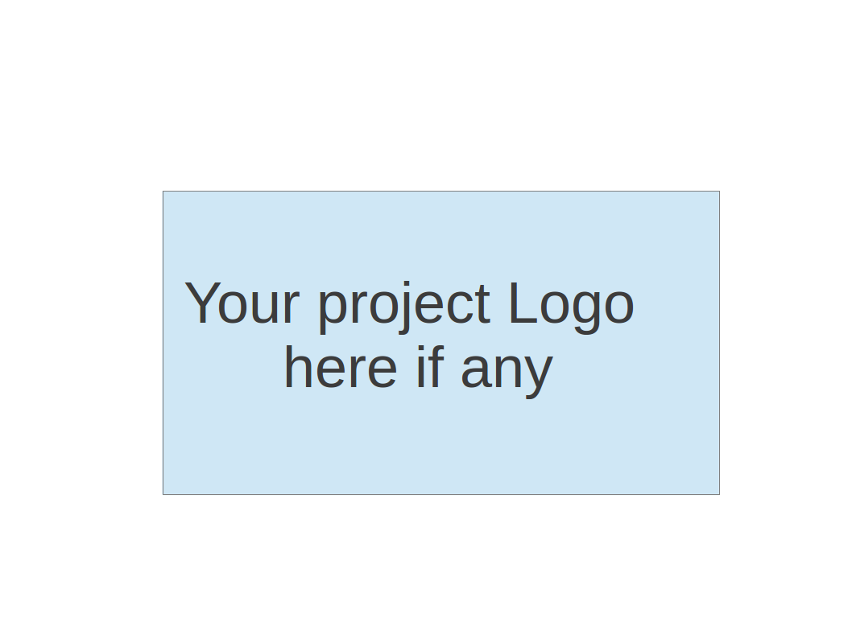

**Team 3 - Project Name**

**Software Design Document**

| Team Member | Role(s) | Signature | Date |
| --- | --- | --- | --- |
| Magnus Urosev | Team Leader |  |  |
| Adrian Ortiz | Configuration Leader / Security Leader |  |  |
| Xi Zeng | QA Leader |  |  |
| Jack Cairns |  |  |  |
| Jianing Li |  |  |  |
|  |  |  |  |
|  |  |  |  |
|  |  |  |  |

**Revision history**

| **Version** | **Author** | **Date** | **Change** |
| --- | --- | --- | --- |
|  |  |  |  |
|  |  |  |  |

Introduction

Software Architecture

Class Diagram

UI Design (if applicable)

Database Design (if applicable)

Security Design

Business Logic and/or Key Algorithms

Design Patterns

Any Additional Topics you would like to include.

References

Glossary

# Introduction

In this section, give an overview of this document, and also address the design goals of your software system.

# Software Architecture

In this section, you will describe the decomposition of your software system, which includes each component (which may be in terms of package or folder) and the relationship between components. You shall have at least one diagram to show the whole architecture of . The interface of each component and dependency between components should also be described. If any framework is used, it shall be defined here too.

# Class Diagram

In this section, you will provide a detailed description of each component (or package) and use one or multiple class diagrams to show the main classes and their relationships in each component.

# UI Design (if applicable)

In this section, you can describe your UI design. You can include both your initial design before the implementation and the screenshots of your UI after the implementation.

# Database Design (if applicable)

In this section, you shall describe any database schema if used in your software system.

# Security Design

In this section, you shall describe any security design in your software system.

# Business Logic and/or Key Algorithms

In this section, you shall describe any key algorithms used in your software system, either in terms of pseudocode or flowchart, or sequence diagrams.

# Design Patterns

In this section, you shall describe any design patterns used in your software system.

# Any Additional Topics you would like to include.

# References

# Glossary