**CS673 Software Engineering** 

**Team X - Project Name**

**Software Test Document**

| Team Member | Role(s) | Signature | Date |
| --- | --- | --- | --- |
| Bharat Gogineni | Team leader | *Bharat Gogineni* | 5/28/2022 |
| Ruiqi Chang | Requirement Leader | *Ruiqi Chang* | 5/28/2022 |
| Chinmay Bhelke | Design and Implementation Leader | *Chinmay Bhelke* | 5/15/2022 |
| Benoît Clemenceau | QA Leader | *Benoît Clemenceau* | 5/15/2022 |
| Taina Conde | Configuration Leader | *Taina Conde* | 5/30/2022 |
| Chinmay Bhelke | Security Leader | *Chinmay Bhelke* | 5/28/2022 |

**Revision history**

| **Version** | **Author** | **Date** | **Change** |
| --- | --- | --- | --- |
| **1.0** | **Benoît Clemenceau** | **05/31** | **Initial version** |
| **2.0** | **Benoît Clemenceau** | **06/14** | **Manual tests**  **Automated Testing reports** |
| **3.0** | **Benoît Clemenceau** | **06/19** | - Manual Testing Report page with 6 new manual tests including one negative test  - Updated metrics reports |

Testing Summary

Manuel Tests Reports

Automated Testing Reports

Testing Metrics

References

Glossary

# Testing Summary

In this section, you will summarize what was tested, who is involved in testing, testing techniques used, and testing result. You may have the following tests

* + Unit Testing
  + Integration testing
  + System Testing
  + Acceptance Testing
  + Regression Testing

We are using manual tests as well as automated tests. Each team member tested what they developed before committing, but we will need automatic testing for the next iteration. For that, the Jest testing framework has been installed on the front-end and QA Leader and team members started writing unit tests.

# Manual Testing Report

In this section, you will give a detailed description of each manual test case performed and the result. If this is a previous You shall list what are existing tests developed in the previous semester and what are new tests developed currently.

[CS673_STD_Manual_Testing_Report_team2.docx](https://docs.google.com/document/d/1TxB2KyvERcxgSfvgS2QhARo68Up7PCpn/edit#)

# Automated Testing Report

Describe briefly the automated testing you have done, including where the test code resides in your code repository, what test frameworks are used, and the screen shots or generated testing report.

For the front-end, each component file has an associated Component.test.js file for writing unit tests.

When running npm test or yarn test, the Jest framework is being used to run all the tests and produces a report of the output of the tests as well as test coverage. This report looks like this in the CLI:

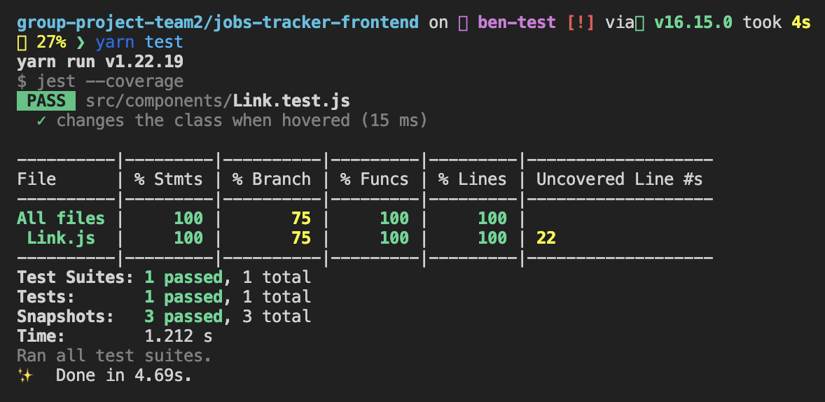

Coverage report can be browsed as an HTML webpage being generated each time (group-project-team2/CS673_Frontend_TS_React/coverage/lcov-report/index.html):

**06/20 feature-branch test report:**



# Testing Metrics Report

In this section, you shall report any metrics used for the evaluation, e.g. # of test cases, test coverage, defects rate, etc.

The metrics we defined in the SPPP regarding the testing strategy are: **Number of tests**, **Test Coverage**, **Percentage of tests passed**, **Total test duration**.

The Jest testing framework provides us with all these metrics and divides the Test Coverage one into 4 different metrics: Function coverage, Statement coverage, Branch coverage, and Line coverage. These metrics can be defined as follows:

* Function coverage: Has each function (or subroutine) in the program been called?
* Statement coverage: Has each statement in the program been executed?
* Branch coverage: Has each branch (also called DD-path) of each control structure (such as in if and case statements) been executed? For example, given an if statement, have both the true and false branches been executed? Another way of saying this is, has every edge in the program been executed?
* Line coverage: has each executable line in the source file been executed?

**06/20 feature-branch metrics:**

LOC: 2,367

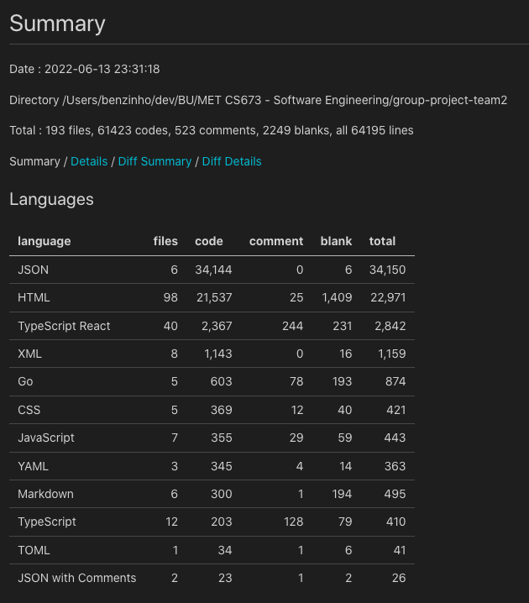

Test Coverage: see upper section

Nonfunctional testing metrics: provided by lighthouse, can be accessed at

group-project-team2/CS673_Frontend_TS_React/metrics/lighthouse-report-deployed.html

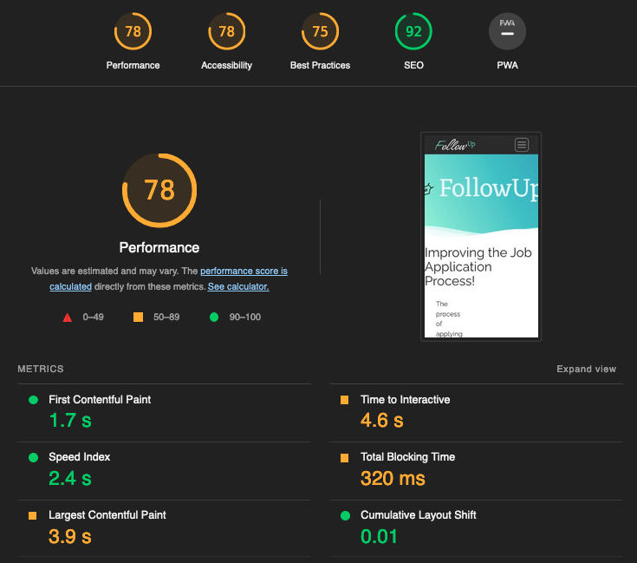

# References

<https://krishankantsinghal.medium.com/how-to-read-test-coverage-report-generated-using-jest-c2d1cb70da8b>

# Glossary