**CS673 Software Engineering**

**Team 3 - StockPickers**

**Software Test Document**

| Team Member | Role(s) | Signature | Date |
| --- | --- | --- | --- |
| Sylvie Xiang | Team Leader | *Sylvie* | 05/24 |
| Duy Nguyen | QA Leader | *Duy Nguyen* | 5/26 |
| Serguei | Design Leader | *Serguei* | 6/12 |
| Jing Tian | Configuration Leader | *Jing Tian* | 5/14/22 |

**Revision history**

| **Version** | **Author** | **Date** | **Change** |
| --- | --- | --- | --- |
| **V1** | Sylvie, Duy, Jing | 05/28 | Initial |
| **V2** | Sylvie, Duy, Jing | 06/08 | Add more unit, integration, and manual testing on new features.  Changed integration test command. |
| **V3** | Sylvie, Serguei, Duy | 06/18 | Unit test on “Forecast” feature and config file.  Modified integration test for longer timeout and delay  Updated QA Metrics |

Testing Summary

Manuel Tests Reports

Automated Testing Reports

Testing Metrics

Glossary

# 1. Testing Summary

Unit tests will be written for key functions of the program. Every team member will help with unit tests but the QA leader will be responsible for developing an adequate amount of unit tests to validate through integration tests. QA leader is also responsible for running unit tests and integration testing.

* + Unit Testing
    - URL
    - Get and Post requests for each view
    - Card.JS methods for front-end
    - Tests on Forecaster and ProphetModel classes on the backend
  + Integration testing
    - Tests use Selenium webdriver
    - Test selecting a stock without forecasting and plotting the chart for selected stock all work as intended
    - Test selecting a stock with forecasting and plotting the chart for selected stock all work as intended
    - Test selecting and deselecting favorite stock both work as intended
    - Modified tests to extend timeout and added delay so that all features can be tested at once
  + System Testing
    - Site navigation to make sure the app is working properly.
    - Test various stocks to make sure price and forecast data is displayed
    - Test print functionality

# 2. Manual Testing Report

All Manual Test Reports are stored at the link below.

[Test Reports_Team3](https://docs.google.com/document/d/1ulR8VQDvu6ybvlsn-DFFNZ7oX5rbXkr0P-g-XdpbCVg/edit#)

# 3. Automated Testing Report

Test framework with Selenium was used to add integration tests and automate the testing. Tests reside in the [integration_tests/tests folder](https://github.com/BUMETCS673/group-project-team3/tree/main/stock_getter/integration_tests/tests) (click to open link) and can be ran with command:

* npm test **/*.test.js

Detailed instructions about how to run the integration tests and information about the code used can be found in the [README.md](https://github.com/BUMETCS673/group-project-team3/blob/main/stock_getter/integration_tests/README.md) (click to open link) file in the integration_tests folder.

Selenium tests are opening Web browser windows and simulating User actions, such as clicking a button or selecting a checkbox. They are also checking the state of the application after actions to make sure that elements like Charts are displayed correctly.

Here is an example of the test screenshot running the tests:

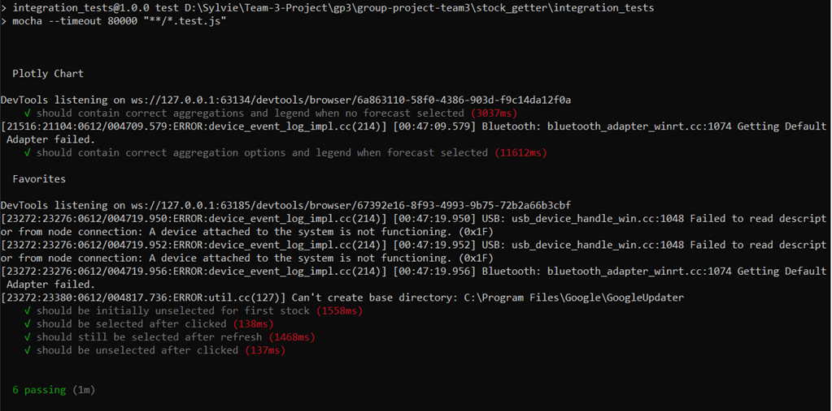

First test is checking that selecting stock displays the correct Chart with and without forecasting options. Second test is checking that selecting stock as favorite works property and information is persistent after reloading the page.

During testing, a [bug](https://github.com/BUMETCS673/group-project-team3/issues/23) (click to open link) was identified, it was showing forecast data in the legend when there is no forecast selected, displayed as below:

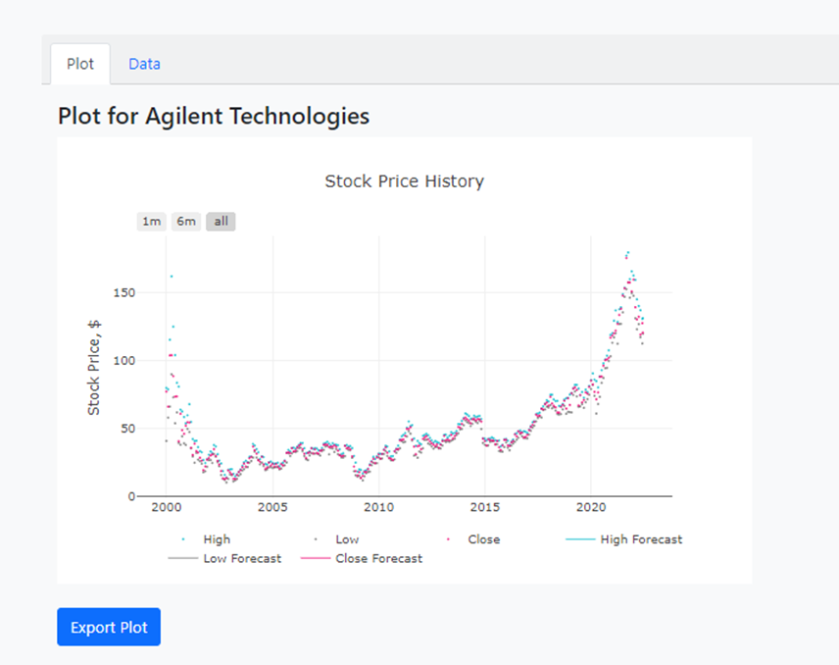

After fixing the bug:

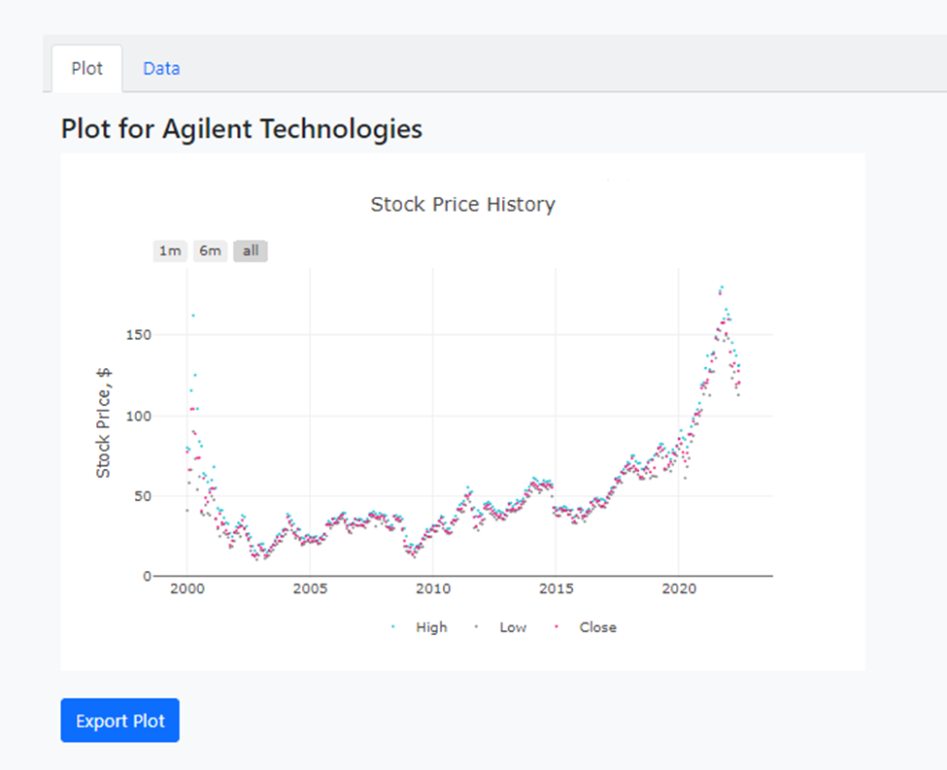

# 4. Testing Metrics

| **Metric Name** | **Description** | **Results** |
| --- | --- | --- |
| **Cost** | # of person hours used | 201.5 of person hours used to have app up and running |
| **Test case pass** | % of unit test passed/total unit test | 100% of all unit test passed |
| **# of Feature completed** | Number of planned features that are completed | 6 essential features and 1 optional feature were planned and all 7 were implemented |
| **Customer Rating** | MFA of completed program to be sent out to customer for rating via SurveyMonkey. Targeted customers to gather surveys from will be friends and families of Group 3.  <https://www.surveymonkey.com/r/LW5WPFZ> | Survey Results: 75% of all survey takers gave StockPickers app a 5/5 while 25% gave stock picker a 4/5. |

# 

# Glossary

MFA - Market Feedback Analysis, a survey that tracks performance of a process based on end user(market) opinion.