**CS673 Software Engineering** 

**Team 4 - Rxcellent**

**Project Proposal and Planning**

| Team Member | Role(s) | Signature | Date |
| --- | --- | --- | --- |
| Zahit | QA Leader | *Zahit Odabas* | 12-10-2022 |
| Nivan | Implementation Leader | *Nivan Hanjura* | 10-19-2022 |
| Ryan | Team Leader | *Ryan Burns* | 12/10/2022 |
| Chenfei | Design Leader | *Chenfei Yu* | 10/19/2022 |
| Ignacio Moral | Requirement Leader and Configuration Leader | *Ignacio Joaquin Moral* | 10-19-2022 |
| Tsing | Security Leader | *Youqing Shao* | 10-19-2022 |
|  |  |  |  |
|  |  |  |  |
|  |  |  |  |

**Revision history**

| **Version** | **Author** | **Date** | **Change** |
| --- | --- | --- | --- |
| **1.01** | **Ryan Burns** | **9/25/2022** | **7:20 PM** |
| **1.02** | **Ryan Burns** | **9/30/2022** | **9:00 PM** |
| **1.03** | **Zahit Odabas** | **10/2/2022** | **12:50 PM** |
| **1.04** | **Youqing Shao(Tsing)** | **10/9/2022** | **8:11 PM** |
| **1.05** | **Ignacio Joaquin Moral** | **10/11/2022** | **6:10 PM** |

| **1.06** | **Ryan** | **10/14/2022** | **4:10 PM** |
| --- | --- | --- | --- |
| **1.07** | **Ignacio Joaquin Moral** | **12/03/2022** | **1:30 PM** |

| **1.08** | **Ryan Burns** | **12/10/2022** | **12:47 PM** |
| --- | --- | --- | --- |
| **1.08** | **Zahit Odabas** | **12/10/2022** | **4:09 PM** |

Overview

Related Work

Proposed High Level Requirements

Management Plan

Objectives and Priorities

Risk Management (need to be updated constantly)

Timeline (need to be updated at the end of each iteration)

Configuration Management Plan

Tools

Deployment Plan if applicable

Quality Assurance Plan

Metrics

Code Review Process

Testing

Defect Management

References

Glossary

# 

# Overview

Team 4 set out to build an e-commerce pharmacy website called Rxcellent that would sell prescription medications (as well as over the counter medicine and products) to patients who want the convenience to refill their prescription with a click of a button rather than calling the pharmacy or going to the pharmacy itself.

The basic functionality of the proposed software system would be that a patient will go to a doctor’s visit. Then the doctor/nurse practitioner would write a prescription for them using our Rxcellent Prescription portal. When a prescription is entered into the system, a unique prescription number will be generated. This number will be stored in our system along with the prescription and at the same time, it will be sent to the patient’s email address that is given in his prescription. After that the patient will be able to use the Prescription Search form in our system by entering his name, date of birth and prescription number. When he query his prescription, he will be able to order his prescription to his desired address. Another functionality of our system is that a user can buy over the counter medicine without login. OTC medicines will be listed in Rxcellent website and can be added to the shopping cart. Possible technology stack to be used - JS, React, MongoDB, Express & Node.js.

# Related Work

* Amazon Pharmacy - provides a web-based marketplace for prescriptions with the market price. After selecting a needed medication , a customer can then add their insurance to check the price with insurance and/or they can transfer their Rx to Amazon Pharmacy (by clicking a Big Yellow Button). **What are the differences between our software and this software?** We don’t require a log in to get a prescription while other apps do.
* Mark Cuban CostPlus Drug Company **What are the differences between our software and this software?** We don’t require a log in to get a prescription while other apps do.
* **Walmart Pharmacy** - This pharmacy offers like other pharmacies prescription refills and transfers online. If you already have a prescription you can request a refill or create an account, and request a Rx transfer. After a customer request is made and goes through the approval process the customer is given an option to pick it up at a local Walmart pharmacy. The customer can choose a pharmacy to pick up their Rx at a location within a 20 mile radius of the customer’s location.

# Proposed High Level Requirements

## Functional Requirements:

* + *Essential Features*
    1. Order Rx Online:
       - As a person with a prescription, I want to be able to order prescription medicine online so that I don’t need to walk to the store every time.
       - As a customer, I want to be able to order over the counter medicine online so that I don’t need to walk to the store every time.
    2. Order non-Rx medication online:
       - As a customer, I want to search OTC medicine by keywords or active ingredients so that I find the medicine easily
    3. Manage Shopping Cart:
       - As a customer, I want to be able to add/remove medicine to my cart, so that I can check out multiple medicines at once.
    4. Get Rx Without a Login:
       - As a customer, I don’t want to register for an online pharmacy to be able to order medicine, so that I won’t give my personal information and I don’t have to manage my password
    5. Using Prescription Number for “registration”:
       - As a patient that doesn’t want to register to another platform, I want to only have to write my prescription number and birthday on the platform so that I can access my medicines easily.
    6. Doctor/Prescriber Login:
       - As a prescriber, I want to be able to log into the prescription panel so that I can write e-prescriptions in a secure manner.
    7. Doctor Should Issue Rx:
       - As a prescriber, I want to be able to write e-prescriptions, so that patients can order their prescriptions by using it.
    8. Email Sent to Patient when Prescription is Generated:
       - As a patient, I want to receive an email with my prescription number so that I can order my prescriptions.
       - As a doctor, I wish for my patients to receive an email when their prescription is generated, so that they can purchase their medicines as soon as possible.
    9. Customer Can Have Account:
       - As a user, I would like to have an option to create an account so that I can track my prescriptions and order history.
  + *Desirable Features*

1. Customer Payment Method:
   1. As a customer, I want to pay for my medicine with a card so that I can complete my transaction and get my medicine delivered to my address.
   * *Optional Features*
     1. Inventory Control:
        + As a pharmacy store manager, I want to be able to update medicine stocks on the web store, so that the web store always presents the actual stock.

## Nonfunctional Requirements:

* + Web-based
  + Javascript-Based Application
  + High-level security
  + MongoDB Database
  + Express
  + Online Hosting
  + Accessible on mobile devices
  + Unique Branding
  + Material UI (MUI)
  + Security Requirements:

## 1: developing

* web
  + When users register, they need to agree privacy agreement
  + All sensitive can’t show the url or page
  + Prevent evil scripts inject into project
  + Use cookie to save info before getting acceptance of users
* Back-end
  + The secret key saving refers to important information such as the secret key stored by the object and the public key encrypted and decrypted by the system interface
* Source
  + Project website need a filing Number, like © Copyright 1999-2022 CVS.com
  + All resource(fonts, picture, package……) can’t be infringed
  + Website’s url use “https” rather than “http”.
* Coding
  + No bugs, no code leakage
  + We must do more than unit tests and two case tests before release.
  + Use typescript for stricter data isolation and interface definition
* Security misconfiguration

Security configuration errors can occur at any level of an application stack, including platforms, web servers, application servers, databases, architectures, and custom code. Attackers can gain authorized access to the system by accessing default accounts, unused web pages, vulnerabilities of uninstalled patches, unprotected files and directories, etc

How to prevent:

* Automated installation and deployment
* Timely understand and deploy software updates and patches for each link
* Implement vulnerability scanning and security audit

## 2: interface

* All interface need authentication processing
  + request data or response data need to be encrypted(phone, email…)
  + Use jwt to identify user’s information
* Escape ESCAPE for special characters entered(like '%M%' ESCAPE ‘M’)
* Prevent interface header was modified

## 3: attack

* Prevent violent login
* Web need to prevent XSS (Cross Site Scripting)
* Web need to prevent CSRF（Cross-site request forgery）

## 4: database

* Make sure users’ informations are safe
* Prevent SQL injection attacks
* Don’t delete all table or data, just add,edit and search

# Management Plan

## Objectives and Priorities (Basically your project goal)

(Please describe your project objectives with highest priority first. Project Goals can include but are not limited to complete all proposed (essential) features, deploy the software successfully, the software has no known bugs, maintain high quality, etc).

Satisfy all essential features and deploy the software successfully with little to no bugs, and maintain high quality..

## Risk Management (need to be updated constantly)

(Please write a summary paragraph about the main risks your group identified and how you plan to manage these risks. Then use the separate google sheet for detailed risk management. The template is provided in the same folder with this file. Please provide the link to the sheet.)

Risk management - If a team member drops the class we will have an emergency meeting to address any shortfalls the loss will cause on Discord. If the MUI doesn’t fit our needs we are aware of other tools that could be implemented. The team has been encouraged to take backup roles to mitigate any potential roadblocks during development.

**Risk Management Sheet Link:**

**https://docs.google.com/spreadsheets/d/1lSZFr1w-bII75xjAzQ1fY5GywiYhmpx7lYueFz1VqsY/edit?usp=sharing**

## Timeline (this section should be filled in iteration 0 and updated at the end of each later iteration)

| Iteration | Functional Requirements (Essential/Desirable/Optional) | Tasks (Cross Requirements Tasks) | Real Person Hours |
| --- | --- | --- | --- |
| 0 | * Define Main Requirements * Create Documentation with Workflow * Start Implementing User Stories in Pivotal Tracker | * Documentation (requirements, user stories, risk management, progress report, etc…) should begin. * Said documentation will be updated as the iterations pass and feedback is received. |  |
| 1 | * Generate Figma Web Design * Generate a Web Page Demo using said Figma Design | * Using Figma to demonstrate how to accomplish the Functional Requirements |  |
| 2 | * Begin back-end work * Generate Database with data * Prescription Models should be appropriately based on the expected input from the Front End Doctor’s Panel * Item Model should contain all the necessary information for the medicines for sale. * User Model should contain information regarding Doctor’s Log In functionality * Continue Front End Development * Shopping Cart should begin work, so that payment can begin later * Figma Design is Fully Implemented in Front End | * Unit and Integration tests will begin. * Secure access and database should be guaranteed * Update Requirements if needed, as we are using an Agile Methodology for Software Development. |  |
| 3 | * Automatic Prescription Generation backend should finish completion * Automatic Email sent to users after a prescription is registered * Website should now call to the database to fetch the Items for sale at the website, instead of using hard coded values * Doctor Prescription Panel and Login should be completed * Complete integration between the front end and the back end. | * All tests should pass without issues. * No critical bugs or errors should exist * Integration should be complete | 181.5 |

| Iteration | Functional Requirements(Essential/Desirable/Option) | Tasks (Cross requirements tasks) | Estimated/real person hours |
| --- | --- | --- | --- |
| 1 | Create a homepage for the User / provide a form for prescription submission | Define requirements, consider design structure,  Complete a design  prototype | 56 hrs per person |
| 2 | User should submit a form and upload a file | Integration tests will begin | 56 hrs per person |
| 3 | The program should be complete where the user can search select and upload their prescription | All tests should be passed and there should be no critical bugs | 56 hrs per person |

# 

# 

# Configuration Management Plan

## Tools

(In this project, we will use Git and Github as the version control tools. Please also specify any other tools to be used, e.g. IDE tools, CI/CD tools, container tools, SAST or DAST tools, and any other DevOps tools)

We are going to use VS Code as IDE; Husky for pre-commit lint check; Vercel as the first choice for deployment and Heroku as a backup.

* 1. **Code Commit Guideline and Git Branching Strategy**

When someone is assigned for a developing task, he first creates an issue for it, then creates a branch with the issue id and names it as *name/issue/:id.* We will use commitizen to normalize our commit messages. Messages are divided to following types:

* feat: a new feature
* fix: a bug fix
* docs: documentation only changes
* style: changes that do not affect the meaning of code
* test: adding tests
* chore: changes to the build process or auxiliary tools and libraries

After his development is finished, he pulls a request for merging this branch to development branch, the implementation leader or QA leader will review the code. When merge is done, the related issue will be closed. This issue mechanism is applied to cases of bug fix. After all development is finished, we will do test on test branch, and use main branch for release after all tests are passed.

## Deployment Plan if applicable

(If you plan to deploy your application (e.g. your web application), briefly describe how you plan to deploy your application).

Vercel will be our deployment of choice, Heroku will be our backup (maybe AWS if that doesn’t work)

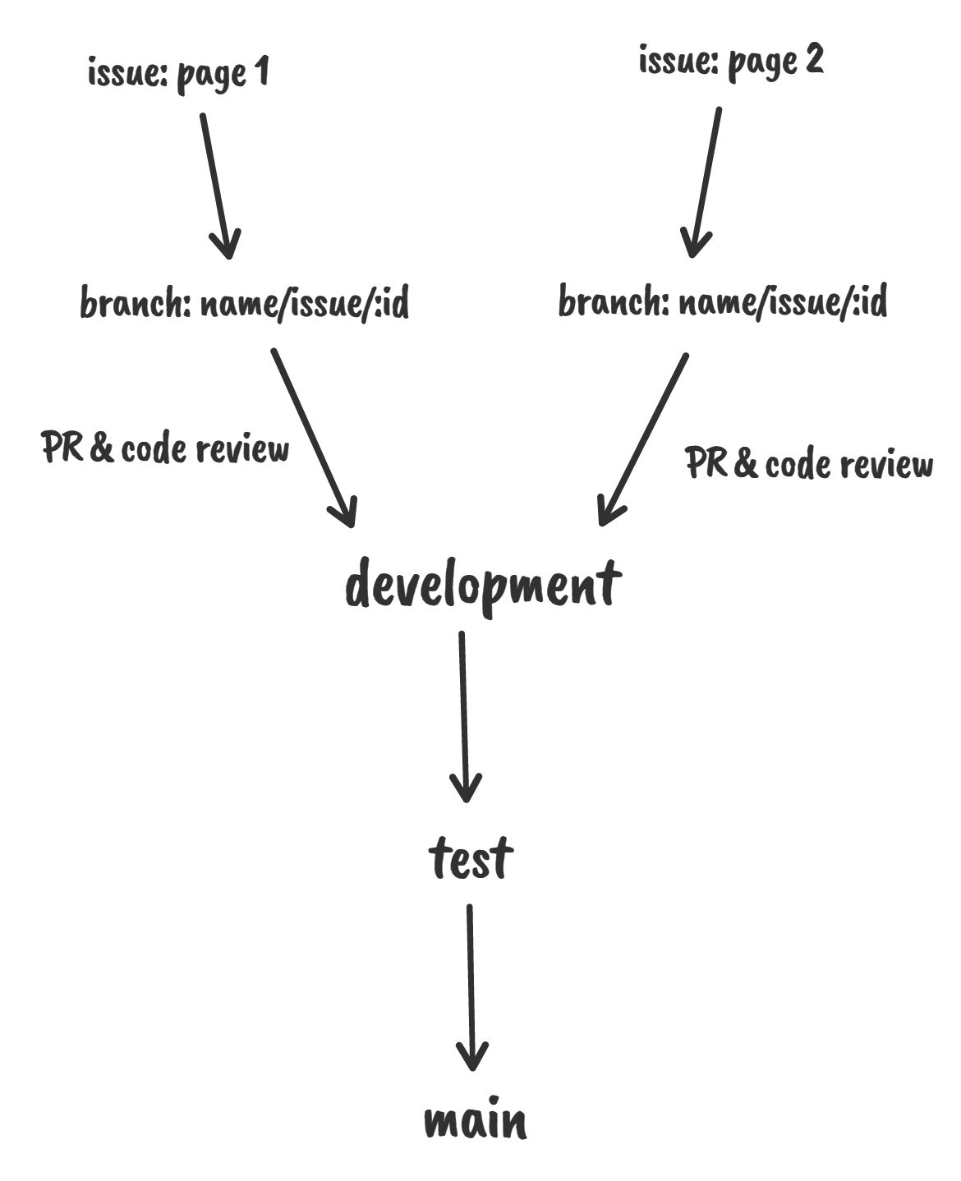

# Quality Assurance Plan

## Metrics

| Metric Name | Description |
| --- | --- |
| # of test cases | Total of unit and integration tests. At least one test case for each method |
| test cases pass rate | We aim a %100 passing rate |
| # of resolved bugs | We aim to identify the bugs with ESLint and resolve all the bugs identified |
| # of user stories completed | We aim to complete all user stories related with essential features |
| Test coverage rate | We aim to achieve at least %75 coverage (using Vitest) |
| # of critical bugs | We aim to perform static coding analysis with DeepScan.io and to produce 0 critical bugs |

* 1. Coding Standard

We will use Prettier(VSCode plugin) + ESLint as a JS coding standard. We may tweak the ESLint rules per our needs.

## Code Review Process

Design, Implementation or QA leader will review the code. We will use pull requests for code reviews as well as some tools to standardize commit messages ([commitizen - npm](https://www.npmjs.com/package/commitizen)) and automatize pre-commit testing ([Husky - Git hooks (typicode.github.io)](https://typicode.github.io/husky/#/)) to ease code reviewing.

## Testing

Manual testing and unit testing will be performed by all developers during development and before committing (using React-testing-library). Automated tests will be performed at pre-commit stage (using ESLint + Husky).

Another manual testing will be performed by the QA leader after merging into the develop branch. And integration tests will be written by the QA leader. All tests will be run using Jest. Critical bug testing will be performed on the test branch by DeepScan.io

## Defect Management

We will mainly use Github as a defect management tool. (For mostly bugs, flaws and failed tests). Anyone can report a defect but mostly the Design leader, Implementation leader or QA leader will report a defect and assign it to the related person.

# References

(For more details, please refer to the encounter example in the book or the software version of the documents posted on blackboard. )

# Glossary

(Any acronym used in the document should be explained here)

Rx: Prescription