**CS673 Software Engineering** 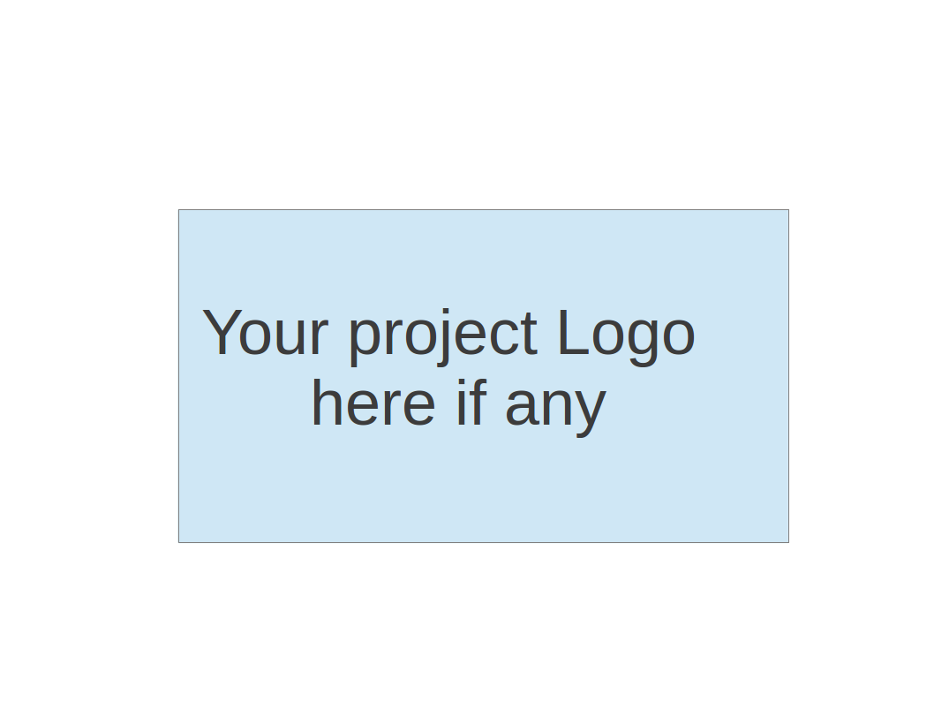

**Team 2 - ProManager**

**Project Proposal and Planning**

| Team Member | Role(s) | Signature | Date |
| --- | --- | --- | --- |
| Dipayan Mazumder | Security Lead | *DM* | 05-10-2024 |
| Pranjal Ekhande | Requirement Lead | *PE* | 05-10-2024 |
| Aman Jain | Configuration Lead | *AJ* | 05-10-2024 |
| Mukul Jangid | Design and Implementation lead | *MJ* | 05-10-2024 |
| Praveen Singh | Team Lead | *PS* | 05-10-2024 |

**Revision history**

| **Version** | **Author** | **Date** | **Change** |
| --- | --- | --- | --- |
| 1.0 | Pranjal Ekhande, Praveen Singh | 05-10-2024 | First Draft |
|  |  |  |  |
|  |  |  |  |
|  |  |  |  |

1.0 Overview

2.0 Related Work

3.0 Proposed High level Requirements

4.0 Management Plan

4.1 Objectives and Priorities

4.2 Risk Management (need to be updated constantly)

4.3 Timeline (need to be updated at the end of each iteration)

5.0 Configuration Management Plan

5.1 Tools

5.2 Deployment Plan if applicable

6.0 Quality Assurance Plan

6.1 Metrics

6.2 Code Review Process

6.3 Testing

6.4 Defect Management

7.0 References

8.0 Glossary

# Overview

We are proposing to contribute to a learning platform with **Project Management** Module that will be designed to facilitate project-based learning for students and professionals. The platform will provide an environment where users can **create** and **manage** **projects**, **access** **learning** resources, **collaborate** with team members, and **receive** **assessments** and **feedback** on their work.

We are planning to build a platform that will consist of several microservices, including User Management, Project Management. These services will work together to provide a seamless and comprehensive experience for users. The Project Management Service will be a crucial component of the platform, enabling users to create and manage projects, assign tasks, track progress, and collaborate with team members. This service will integrate with other services, such as User Management for authentication and authorization, Collaboration for real-time communication and document sharing, and Notification for sending project-related notifications.

# Related Work

Several project management tools and platforms exist in the market, such as Jira, Trello, Asana, and GitHub Projects. However, most of these tools are designed for professional software development teams and lack features specific to project-based learning, such as integration with learning resources, assessments, and feedback mechanisms.

Some learning management systems (LMS) like Blackboard and Canvas offer basic project management capabilities, but they are primarily focused on traditional course delivery and lack advanced collaboration and project tracking features. We are proposing a project-based learning platform that aims to bridge this gap by providing a comprehensive solution for project-based learning, combining project management functionalities with learning resources, collaboration tools, and assessment features.

# Proposed High level Requirements

# **Functional Requirements**

# **Essential Features**:

a. **Project Creation**

* As a user, I want to create a new project, so that I can manage tasks and resources.
* Estimated person-hours: 40-50

b. **Task Management**

* As a project member, I want to create, update, and mark tasks as complete, so that I can track my progress and responsibilities.
* Estimated person-hours: 60-80

c. **Project Access Control**

* As a project owner, I want to control who can view/edit the project and its tasks, so that I can manage project access and privacy.
* Estimated person-hours: 30-40

d. **Project Search and Filtering**

* As a user, I want to search for projects based on keywords, tags, or other criteria, so that I can find relevant projects easily.
* Estimated person-hours: 20-30

# **Desirable Features** :

a. **Integration with Other Services**

* Integrate with the User Management Service for authentication and authorization.
* Integrate with the Collaboration Service for discussions, document sharing, etc.
* Integrate with the Notification Service to send project-related notifications.

b. **Project Templates**

* As a user, I want to create new projects from pre-defined templates for common project types, so that I can quickly set up projects with predefined structures and tasks.

c. **Project Reporting and Analytics**

* As a project owner/admin, I want to view reports and analytics on project progress, task completion, team performance, etc., so that I can monitor and evaluate project status.

# **Optional Features**:

1. Advanced reporting and visualization tools for project data.

2. Project portfolio management for managing multiple projects at an organizational level.

3. Integration with external project management tools or APIs.

# **Non-functional Requirements**

# **Security Requirements**

1. Role-based access control (RBAC) for project members, allowing different levels of access and permissions.

2. Data encryption for sensitive project information and communication.

3. Input validation and protection against common web vulnerabilities (e.g., XSS, CSRF, SQL injection).

4. Secure communication between microservices using protocols like HTTPS and JWT token-based authentication.

# Management Plan

* 1. **Objectives and Priorities**

1. Deliver a fully functional and reliable Project Management Service that meets all essential requirements.

2. Maintain high code quality and test coverage for the Project Management Service.

3. Ensure proper integration and communication with other services, such as User Management, Collaboration, and Notification.

# **Risk Management**

The main risks identified for the Project Management Service include:

1. Complexity in handling project dependencies and concurrent updates from multiple users.

2. Challenges in integrating with other services, such as ensuring consistent data and communication protocols.

3. Potential performance issues or scalability concerns as the number of projects and users grows.

4. Security risks related to data breaches, unauthorized access, or vulnerabilities in the service.

**To manage these risks, we will:**

* Implement proper locking mechanisms and conflict resolution strategies for concurrent updates.
* Establish clear communication protocols and data contracts between services, and conduct thorough integration testing.
* Optimize the service for performance and scalability, and implement load testing and monitoring.
* Follow secure coding practices, conduct security testing, and regularly update dependencies and libraries.

**Risk Management Sheet Link:**

# **Timeline**

| Iteration | Functional Requirements(Essential/Disable/Option) | Tasks (Cross requirements tasks) | Estimated/real person hours |
| --- | --- | --- | --- |
| 1 | Iteration 0 | Environment Setup, Documentation, Initialisation | 8-9 |
| 2 | Project Creation  Task Management  Project Access Control (Essential) | Design, Implementation, Testing  Design, Implementation, Testing  Design, Implementation, Testing | 40-50  60-80  30-40 |
| 3 | Project Search and Filtering (Essential)  Project Reporting and Analytics (Desirable) | Design, Implementation, Testing  Design, Implementation, Testing | 20-30  60-80 |
| 4 | Integration with Other Services (Desirable)  Project Templates (Desirable)  Optional Features (if time permits) | Design, Implementation, Testing  Design, Implementation, Testing | TBD  TBD |

# Configuration Management Plan

# **Tools**

| Tech | Tool |
| --- | --- |
| Version Control | Git and GitHub |
| IDE | SpringBoot STS or IntelliJ. |
| CI/CD | Github |
| Dependency Management | Maven |

Code Commit Guideline and Git Branching Strategy

We have a basic Branching Strategy which might change as required but basic branching strategy would be as follows

* **Main** - This is the main production branch, containing the stable and deployable code.
* **Develop** - This is the integration branch where new features and bug fixes are merged before being promoted to the main branch.
* **Feature** -These are created from the develop branch and used for implementing new features or enhancements. Once complete, they are merged back into the develop branch via pull requests.
* **Bugfix** - These branches will be created from the Main branch and will be used to fix any bug on production.

Code Commit Guidelines:

* Developers will create feature branches from the develop branch and work on their assigned tasks within their respective branches.
* Commit messages should be clear, descriptive, and follow a consistent format.
* Before pushing changes to the remote repository, developers should ensure their code is properly tested and passes all existing tests.
* Pull requests should be created from feature branches to the develop branch for code review and integration.
* Code reviews should be conducted by at least one other team member before merging pull requests into the develop branch.

# **Deployment Plan if applicable**

The Project Management Service will be deployed as a containerized microservice using Docker. The containers will be orchestrated and managed using Kubernetes, enabling scalability, load balancing, and high availability.

The deployment process will follow a continuous integration and continuous deployment (CI/CD) approach using GitHub Actions. Any commits to the main branch will trigger an automated build, testing, and deployment pipeline.

The deployment environments will include:

1. Development Environment: will be Used by developers for local testing and development.

2. Staging Environment: A pre-production environment for integration testing and staging deployments.

3. Production Environment: The live environment is accessible to end-users.

The deployment strategy will be a rolling update, where new versions of the service are gradually rolled out, minimizing downtime and ensuring zero-downtime deployments.

The deployment process will also include automated testing, including unit tests, integration tests, and end-to-end tests, to ensure the quality and reliability of the deployed service.

# Quality Assurance Plan

# **Metrics**

| Metric Name | Description |
| --- | --- |
| Code Duplication | Monitor the percentage of duplicate code across the codebase to identify opportunities for code reuse and maintainability improvements. |
| Code coverage | Measure the percentage of code covered by unit tests to ensure adequate testing of the codebase. |
| Developers time and number of bugs | Evaluate the number of bugs that we found on each level of testing and how much effort it takes to fix those bugs by the developers. This will help to analyze the code quality of the system. |
| Test Execution Time | Measure the time taken to execute the entire test suite, which can indicate the need for test optimization or parallelization. |
| Cyclomatic Complexity | Cyclomatic Complexity is a software metric used to measure the complexity of a program by counting the number of linearly independent paths through a program's source code. Each decision point (e.g., if statement, loop) increments the cyclomatic complexity by one. The base complexity will be 1 and for each block we will keep incrementing it. |

# **Coding Standard**

| Language | Coding Standards |
| --- | --- |
| Java Duplication | Google Coding Standards |
| Python | Black |

# **Code Review Process**

For Development branch the following processes will be followed

Development branch -> Dev Testing -> PR raise -> peer review -> Testing -> Dev (preprod) -> Prod -> Ticket close

Peer Review would be mainly done by Mukul and Pranjal.

# **Testing**

| Testing | Description |
| --- | --- |
| JUnit | Java Testing |
| Postman | API testing |

For manual testing we will cover exploratory testing, usability testing and regression testing.

For automation testing, we will include unit testing and integration testing.

# References

(For more details, please refer to the encounter example in the book or the software version of the documents posted on blackboard. )

# Glossary

(Any acronym used in the document should be explained here)