**CS673 Software Engineering** 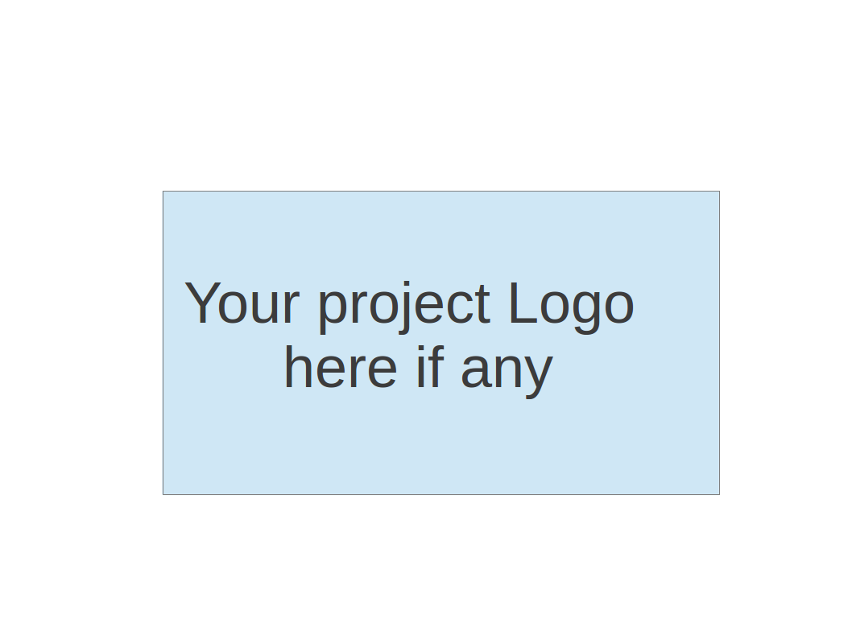

**Team 2 - Project Name**

**Software Test Document**

| Team Member | Role(s) | Signature | Date |
| --- | --- | --- | --- |
| Dipayan Mazumder | Security Lead | *DM* | 05-10-2024 |
| Pranjal Ekhande | Requirement Lead | *PE* | 05-10-2024 |
| Aman Jain | Configuration lead | *AJ* | 05-10-2024 |
| Mukul Jangid | Design and Implementation lead | *MJ* | 05-10-2024 |
| Praveen Singh | Team Lead | *PS* | 05-10-2024 |
|  |  |  |  |
|  |  |  |  |
|  |  |  |  |

**Revision history**

| **Version** | **Author** | **Date** | **Change** |
| --- | --- | --- | --- |
| **1.0** | **Dipayan**  **Mazumder, Pranjal Ekhande, Aman Jain, Praveen Singh** | **05-10-2024** | **First Draft** |
| **2.0** | **Mukul Jangid** | **05-28-2024** | **Second Draft** |

Testing Summary

Manuel Tests Reports

Automated Testing Reports

Testing Metrics

References

Glossary

# Testing Plan

# **Test Objectives**

* Verify that all essential functionalities are implemented correctly.
* Ensure integration with other services is seamless.
* Validate the security features of the platform.

**Test Criteria**

* All test cases must pass without errors.
* No critical or high-severity defects should remain unresolved.

# Testing Summary

In this section, you will summarize what was tested, who is involved in testing, testing techniques used, and testing result. You may have the following tests

* + Unit Testing
  + Integration testing
  + System Testing
  + Acceptance Testing
  + Regression Testing

# Manual Testing Report

In this section, you will give a detailed description of each manual test case performed and the result. If this is a previous You shall list what are existing tests developed in the previous semester and what are new tests developed currently.

Here is a sample template that can be used for each test case. For system tests or acceptance tests, you may also include some screenshots.

* Test case ID, name
* New or old:
* Test items: (what do you test )
* Test priority (high/medium/low)
* Dependencies (to other test case/requirement if any):
* Preconditions: (if any)
* input data:
* Test steps:
* Postconditions:
* Expected output:
* Actual output:
* Pass or Fail:
* Bug id/link: (this should link to your github issue id)
* Additional notes:

(You can use an additional spreadsheet for this section as well)

# Automated Testing Report

Describe briefly the automated testing you have done, including where the test code resides in your code repository, what test frameworks are used, and the screen shots or generated testing report.

# Testing Metrics

We decided on these metrics

* Number of Test Cases: Total number of test cases executed.
* Test Coverage: Percentage of code covered by unit tests.
* Defect Rate: Number of defects found per test case.
* Test Execution Time: Total time taken to execute all tests.
* Cyclomatic Complexity: Measure of code complexity.

# References

# Glossary