**CS673 Software Engineering** 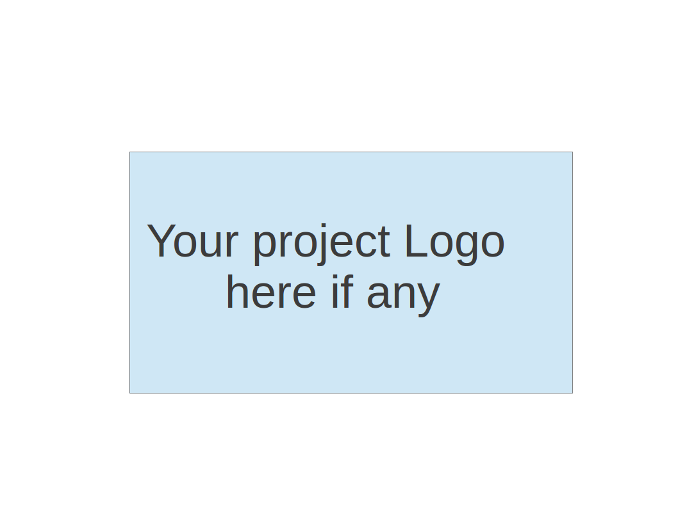

**Team 2 - Project Name**

**Software Test Document**

| Team Member | Role(s) | Signature | Date |
| --- | --- | --- | --- |
| Dipayan Mazumder | Security Lead | *DM* | 05-10-2024 |
| Pranjal Ekhande | Requirement Lead | *PE* | 05-10-2024 |
| Aman Jain | Configuration lead | *AJ* | 05-10-2024 |
| Mukul Jangid | Design and Implementation lead | *MJ* | 05-10-2024 |
| Praveen Singh | Team Lead | *PS* | 05-10-2024 |
|  |  |  |  |
|  |  |  |  |
|  |  |  |  |

**Revision history**

| **Version** | **Author** | **Date** | **Change** |
| --- | --- | --- | --- |
| **1.0** | **Dipayan**  **Mazumder, Pranjal Ekhande, Aman Jain, Praveen Singh** | **05-10-2024** | **First Draft** |
| **2.0** | **Mukul Jangid** | **05-28-2024** | **Second Draft** |
| **3.0** | **Mukul Jangid** | **06-10-2024** | **Third Draft** |
| **4.0** | **Mukul Jangid, Aman Jain** | **06-18-2024** | **Final Draft** |

Testing Summary

Manuel Tests Reports

Automated Testing Reports

Testing Metrics

References

Glossary

# Testing Plan

# **Test Objectives**

* Verify that all essential functionalities are implemented correctly.
* Ensure integration with other services is seamless.
* Validate the security features of the platform.

**Test Criteria**

* All test cases must pass without errors.
* No critical or high-severity defects should remain unresolved.

# Testing Summary

In this section, you will summarize what was tested, who is involved in testing, testing techniques used, and testing result. You may have the following tests

* + Unit Testing
  + Integration testing
  + System Testing
  + Acceptance Testing
  + Regression Testing

# Manual Testing Report

**Test Case 1: Retrieve All Projects**

* Test Case ID: TC001
* Test Name: Test Retrieve All Projects
* New or Old: New
* Test Items: ***ProjectController.getAllProjects()***
* Test Priority: High
* Dependencies: None
* Preconditions: The database must contain project data.
* Input Data: JSON payload with project details.
* Test Steps:

1. Send a GET request to ***/apiv1/project/getallprojects***.

* Postconditions: The response should contain a list of projects.
* Expected Output: A JSON array of projects.
* Actual Output: None
* Pass or Fail: Pass
* Bug ID/Link: None
* Additional Notes: None

**Test Case 2: Add Project**

* Test Case ID: TC002
* Test Name: Test Add Project
* New or Old: New
* Test Items: ***ProjectController.addProject()***
* Test Priority: High
* Dependencies: None
* Preconditions: Valid project data must be available.
* Input Data: None
* Test Steps:

1. Prepare input data:

*{*

*"projects": [*

*{*

*"projectid": "project003",*

*"projectname": "W1A206-8286-42A-SN2109F9W",*

*"userid": "user1",*

*"taskid": 24,*

*"description": "test 2",*

*"created_on": 1622548800,*

*"updated_on": 1622548800,*

*"state": "operating",*

*"type": "development"*

*},*

*{*

*"projectid": "project005",*

*"projectname": "W1A206-8286-42A-SN2109F9W",*

*"userid": "user1",*

*"taskid": 24,*

*"description": "test 2",*

*"created_on": 1622548800,*

*"updated_on": 1622548800,*

*"state": "operating",*

*"type": "development"*

*}*

*]*

*}*

1. Send a POST request to ***/apiv1/project/addprojects*** with the above data.

* Postconditions: The projects should be added to the database.
* Expected Output: A success message with the response code 200.
* Actual Output: None
* Pass or Fail: Pass
* Bug ID/Link: None
* Additional Notes: None

**Test Case 3: Edit Project**

* Test Case ID: TC003
* Test Name: Test Edit Project
* New or Old: New
* Test Items: ***ProjectController.editProject()***
* Test Priority: High
* Dependencies: None
* Preconditions: The project must exist in the database.
* Input Data: JSON payload with updated project details.
* Test Steps:

1. Prepare input data:

*{*

*"projectid": "project005",*

*"projectname": "W1A206-8286-42A-SN2109F9W",*

*"userid": "user1",*

*"taskid": 24,*

*"description": "new updated data",*

*"updated_on": 1622549800,*

*"state": "operating",*

*"type": "development"*

*}*

1. Send a POST request to ***/apiv1/project/editProject*** with the above data.

* Postconditions: The project details should be updated in the database.
* Expected Output: A success message with the response code 200.
* Actual Output: None
* Pass or Fail: Pass
* Bug ID/Link: None
* Additional Notes: None

**Test Case 4: Add Tasks to a Project**

* Test Case ID: TC004
* Test Name: Test Add Tasks to a Project
* New or Old: New
* Test Items: ***TaskController.addTasks()***
* Test Priority: High
* Dependencies: None
* Preconditions: Valid task data must be available.
* Input Data: JSON payload with task details.
* Test Steps:

1. Prepare input data:

*{*

*"tasks": [*

*{*

*"task_id": "task_7",*

*"project_id": "proj_001",*

*"task_name": "Task 7 Test",*

*"description": "Task 3 Test",*

*"status": "To Do",*

*"priority": "Low",*

*"assigned_user_id": 1,*

*"due_date": 1749477368,*

*"created_on": 1717941368,*

*"updated_on": 1717941368*

*}*

*]*

*}*

1. Send a POST request to ***/apiv1/project/addtasks*** with the above data.

* Postconditions: The tasks should be added to the project in the database.
* Expected Output: A success message with the response code 200.
* Actual Output: None
* Pass or Fail: Pass
* Bug ID/Link: None
* Additional Notes: None

# Automated Testing Report

The automated testing conducted covers various functionalities of the project and task management system within the ProManager application. The testing ensures the correctness of project and task creation, retrieval, updating, and deletion processes, as well as user project management. The following sections provide a detailed description of the tests, their locations, frameworks used, and results.

**Test Code Repository:**

**Frameworks Used**: JUnit, Mockito, Spring Boot Test

**Location of Test Code**: The test code resides in the ***src/test/java/com/cs673olsum24/promanager/controller*** directory.

**Example Test Class**: ***ProjectControllerTest.***

#### **Test Case 1: Delete Project**

**Test Case ID**: ATC001  
**Test Name**: Test Delete Project  
**Test Description**: This test verifies the deletion of a project using the deleteProject endpoint.  
**Test Steps**:

* Mock the response for the deleteProject service.
* Send a DELETE request to ***/apiv1/project/deleteproject/{id}*** with a project ID.
* Verify that the response status is OK and the response contains the success message.

**Test Code**:

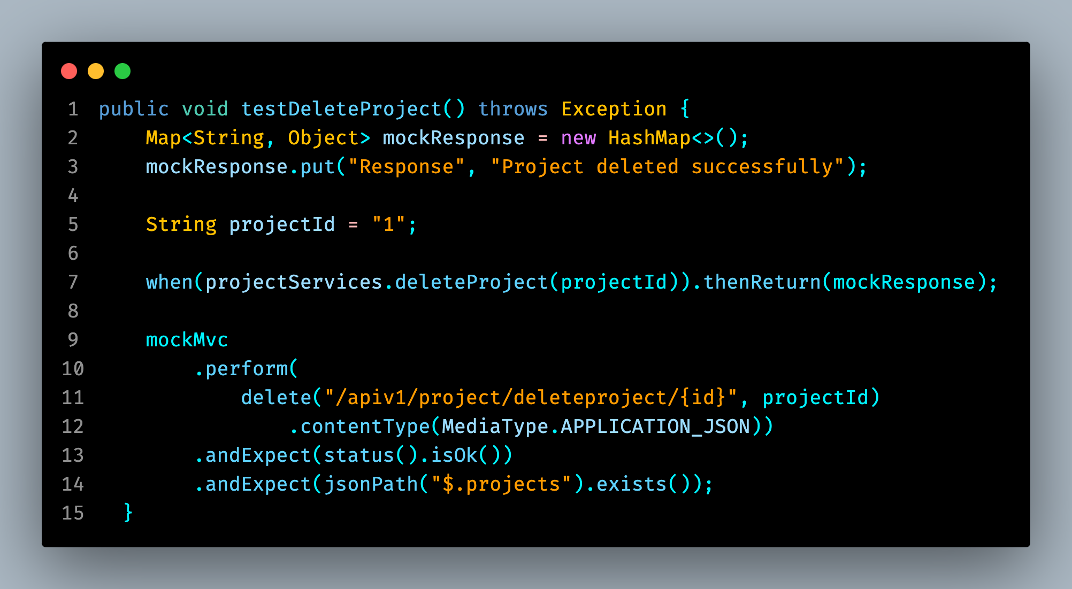

#### **Test Case 2: Add Project**

**Test Case ID**: ATC002  
**Test Name**: Test Add Project  
**Test Description**: This test verifies the addition of a new project using the addProject endpoint.  
**Test Steps**:

* Mock the response for the addProject service.
* Prepare the project data payload.
* Send a POST request to ***/apiv1/project/addprojects*** with the project data.
* Verify that the response status is OK and the response contains the success message.

**Test Code**:

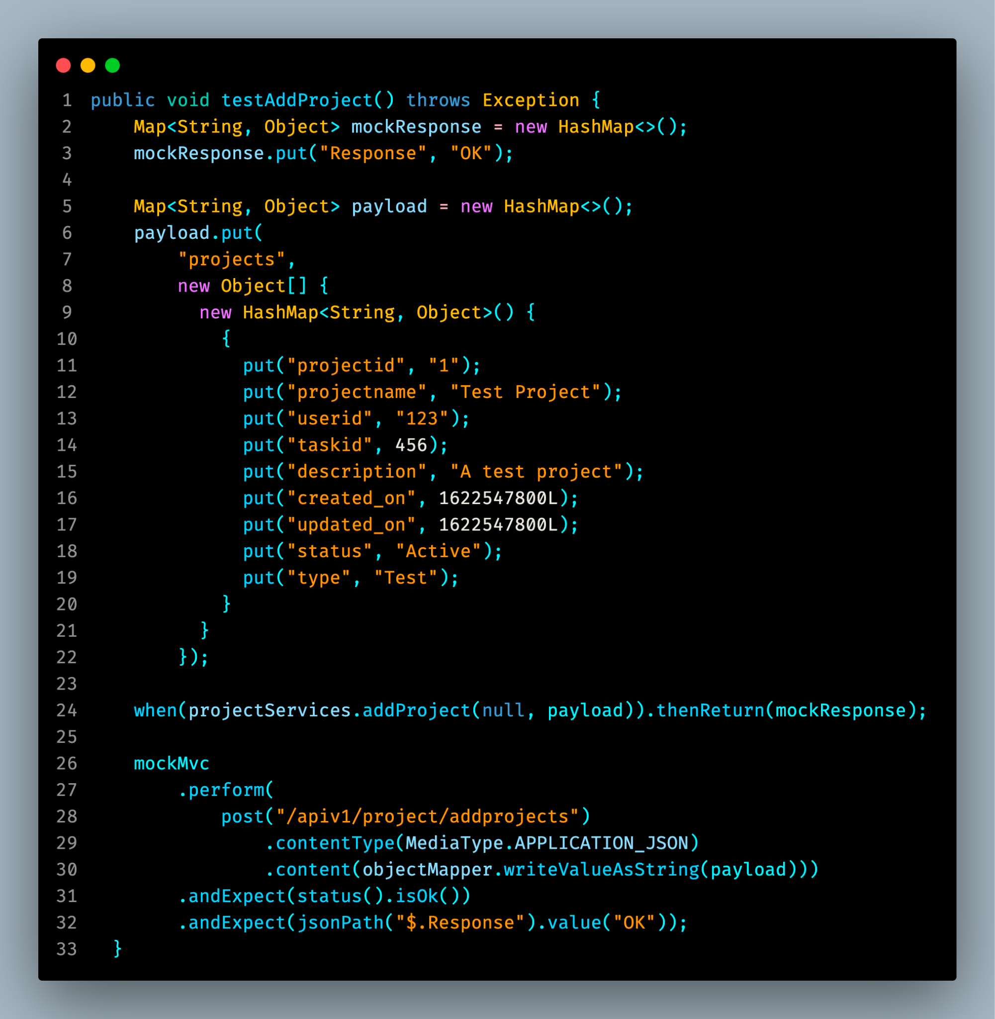

#### **Test Case 3: Edit Project**

**Test Case ID**: ATC003  
**Test Name**: Test Edit Project  
**Test Description**: This test verifies the editing of a project using the editProject endpoint.  
**Test Steps**:

* Mock the response for the editProject service.
* Prepare the updated project data payload.
* Send a POST request to ***/apiv1/project/editProject*** with the data.
* Verify that the response status is OK and the response contains the success message.

**Test Code**:

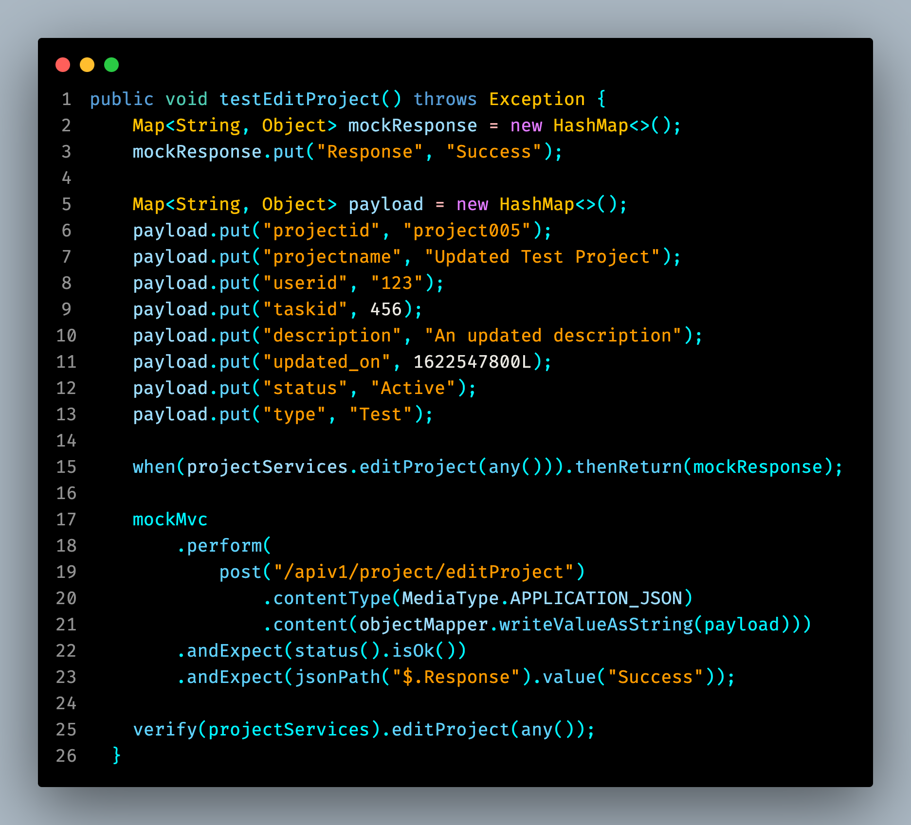

# Testing Metrics

We decided on these metrics

“Link for the following images - [Testing Images](https://drive.google.com/drive/folders/1VFgEm918lbBWpUt1bGVjtyv906unMV6P)  “

1. Number of Test Cases: **3 (Automated) + 3 (Manual)** [More will be added].
2. Test Coverage: 6%.
3. Defect Rate: Number of defects found per test case.
4. Test Execution Time: 7.259 seconds.
5. Cyclomatic Complexity: Measure of code complexity.

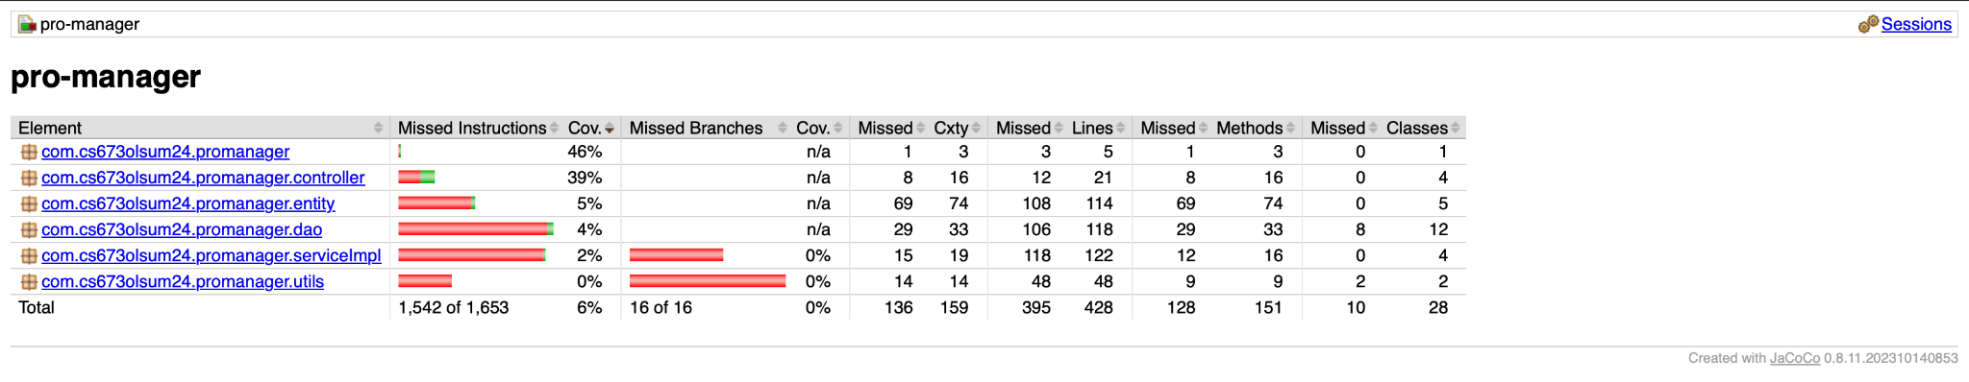

# References

1. Project Repository
2. Spring Boot Documentation
3. JUnit Documentation
4. Mockito Documentation

# Glossary

1. **API**: Application Programming Interface
2. **JUnit**: A unit testing framework for Java
3. **Mockito**: A mocking framework for unit tests in Java
4. **STD**: Software Test Document