**CS673 Software Engineering**

**Team 4 - ResumAI**

**Software Design Document**

| Team Member | Role(s) | Signature | Date |
| --- | --- | --- | --- |
| Hemant Krishnakumar | Team Lead |  | 10 - 17- 2024 |
| Faizan Ahmad | Design and Implementation Lead |  | 10 - 17- 2024 |
| Tushar | Requirement Lead |  | 10 - 17- 2024 |
| Shubh Gupta | Q/A Lead |  | 10 - 17- 2024 |
| Amruth Reddy | Security Lead |  | 10 - 17- 2024 |
| Jaindra Parvathaneni | Configuration Lead |  | 10 - 17- 2024 |
|  |  |  |  |
|  |  |  |  |

**Revision history**

| **Version** | **Author** | **Date** | **Change** |
| --- | --- | --- | --- |
| **1** | **Faizan Ahmad** | 10 - 17- 2024 | **New** |
| **1** | **Faizan Ahmad** | 11 - 07 - 2024 | **Added more APIs with descriptions  Added Class Diagram  Update Design Patterns** |

**Introduction 2**

**Software Architecture 2**

**Class Diagram 2**

**UI Design (if applicable) 2**

**Database Design (if applicable) 3**

**Security Design 3**

**Business Logic and/or Key Algorithms 3**

**Design Patterns 3**

**Rest APIs 3**

**Any Additional Topics you would like to include. 3**

**References 3**

[**Glossary 3**](https://docs.google.com/document/d/1DtRE1rbZ-r4B1ks68g76BVMscYtMKJ53oAUbKzEqhqI/edit#heading=h.8n34lvocupub)

# Introduction

**ResumAI** is an AI powered resume analysis and matching tool. The problem that we are trying to solve is to allow applicants (job seekers) to analyze their resumes using AI to make them better while also allowing them to compare their resumes to provided Job Descriptions to see how much their resumes fit for the role. The second part is for recruiters where they can upload multiple resumes provided to them along with the job description for which they are hiring so that they are able to shortlist resumes that are more suitable for the role. Lastly, as an additional feature, we also intend to allow this to become an AI powered application tool where Recruiters can create job listings and applicants can apply to those while using our AI capabilities to match with the job.

Our primary design goals are to make the platform **reliable**, **scalable**, **efficient, easy-to-use** and **secure.** We intend to use our capabilities to create a software architecture that will meet all those requirements.

# Software Architecture

We have designed our software architecture based on **Client-Server** architecture. Our design will include 3 main layers: **Frontend** and **Backend &** **Database**

## Frontend

Our Frontend is a web application built using **ReactJS** framework built using **Typescript.**

* For state management, we are using **React Redux**
* For testing, we are using **JEST** and **React Testing Library**
* For API calls, we are using **Axios (HTTPs)**
* For routing, we will be using **ReactRouter**
* For UI components, we will be using the **Material UI** library
* Developer tools:
  + **VITE** for local development tooling
  + **Prettier** + **Eslint** for formatting and linting

## Backend & Database

Our Backend server is built on top of **Fastify** which is a web framework for **Node.JS** using **Typescript**

* **Docker** as our containerization tool
* For Database, we are using **PostgreSQL**
* For Identity & Access Management, we are using **Keycloak** and **JWT tokens**
* Our Backend server also incorporate **REDIS** Cache
* We will also be using an Event Streaming service like **SQS/Kafka**
* 3rd Party API calls are handled using **Axios**
* Our APIs are **RESTFul**
* We are also using **Yup** as our schema builder for parsing and validations
* For testing, we are using **Node Tap** library
* For object storage, we are using **Disk Storage** on Fastify using **Multer**

Interaction between Frontend and Backend

* Frontend interacts with our Authentication service based on Keycloak
* Frontend interacts with our Fastify server APIs for Business logic
* Prisma is our ORM which bridges the gap between APIs and database
* We use Redis for our caching mechanisms
* We use event streams for asynchronous behavior

## Architectural Diagram

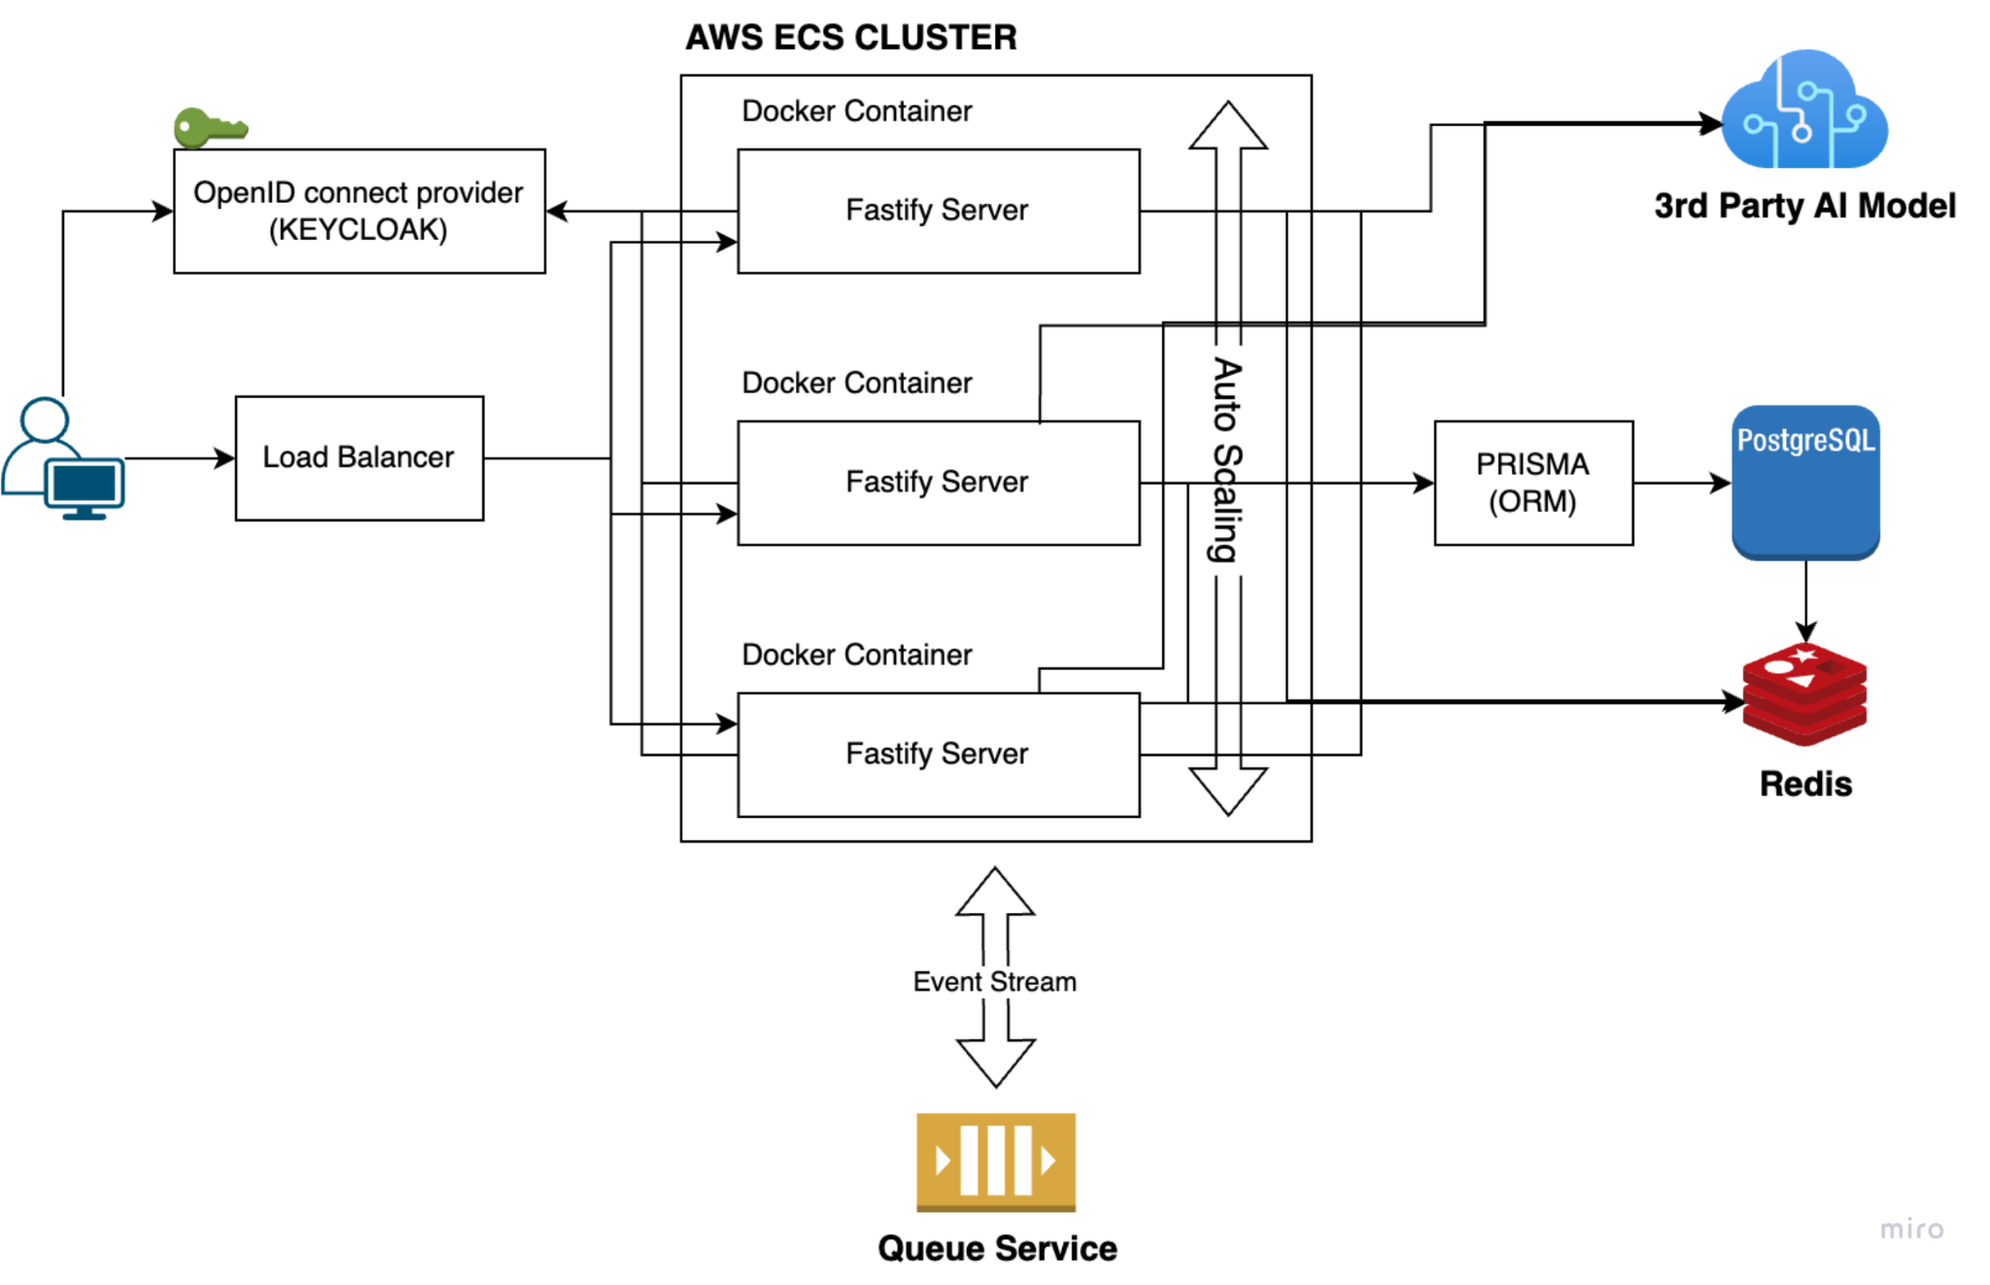

# Class Diagram

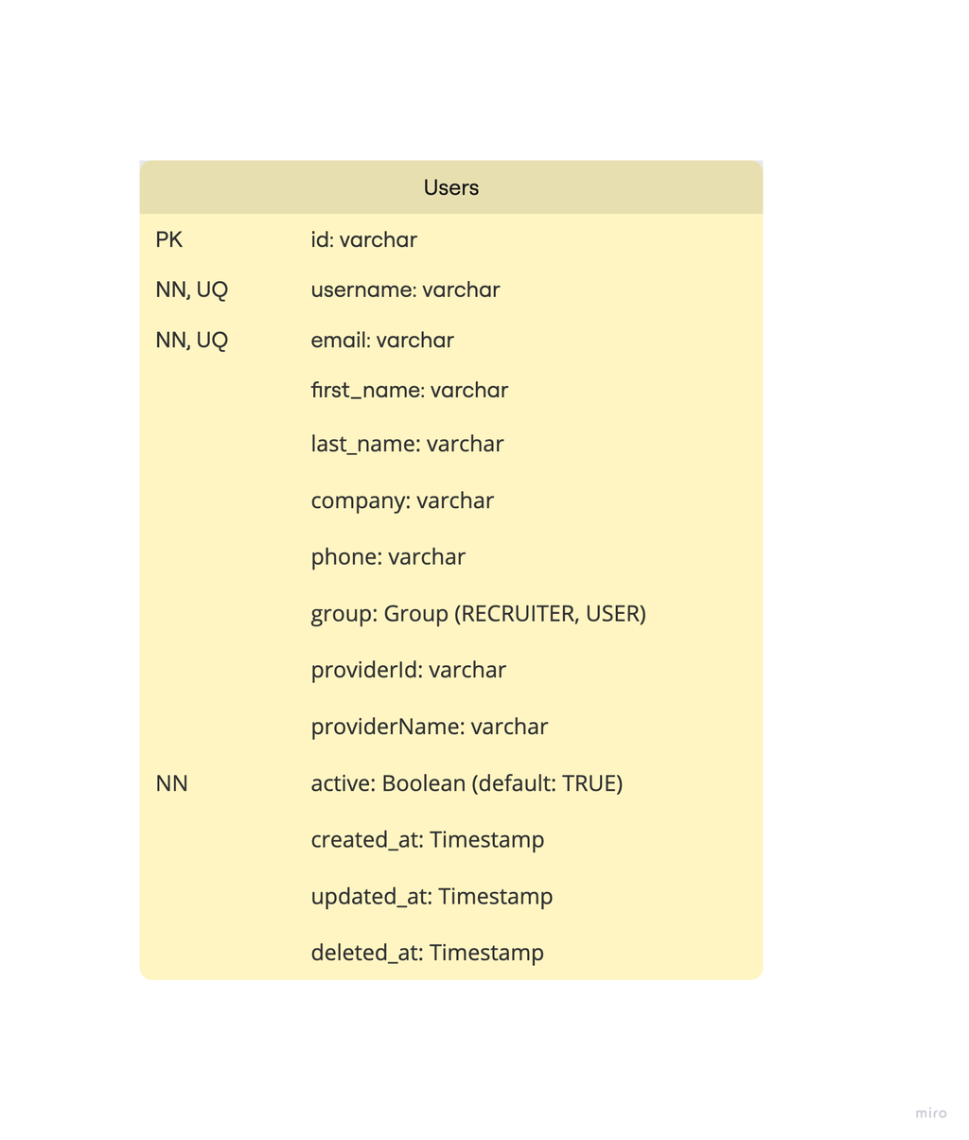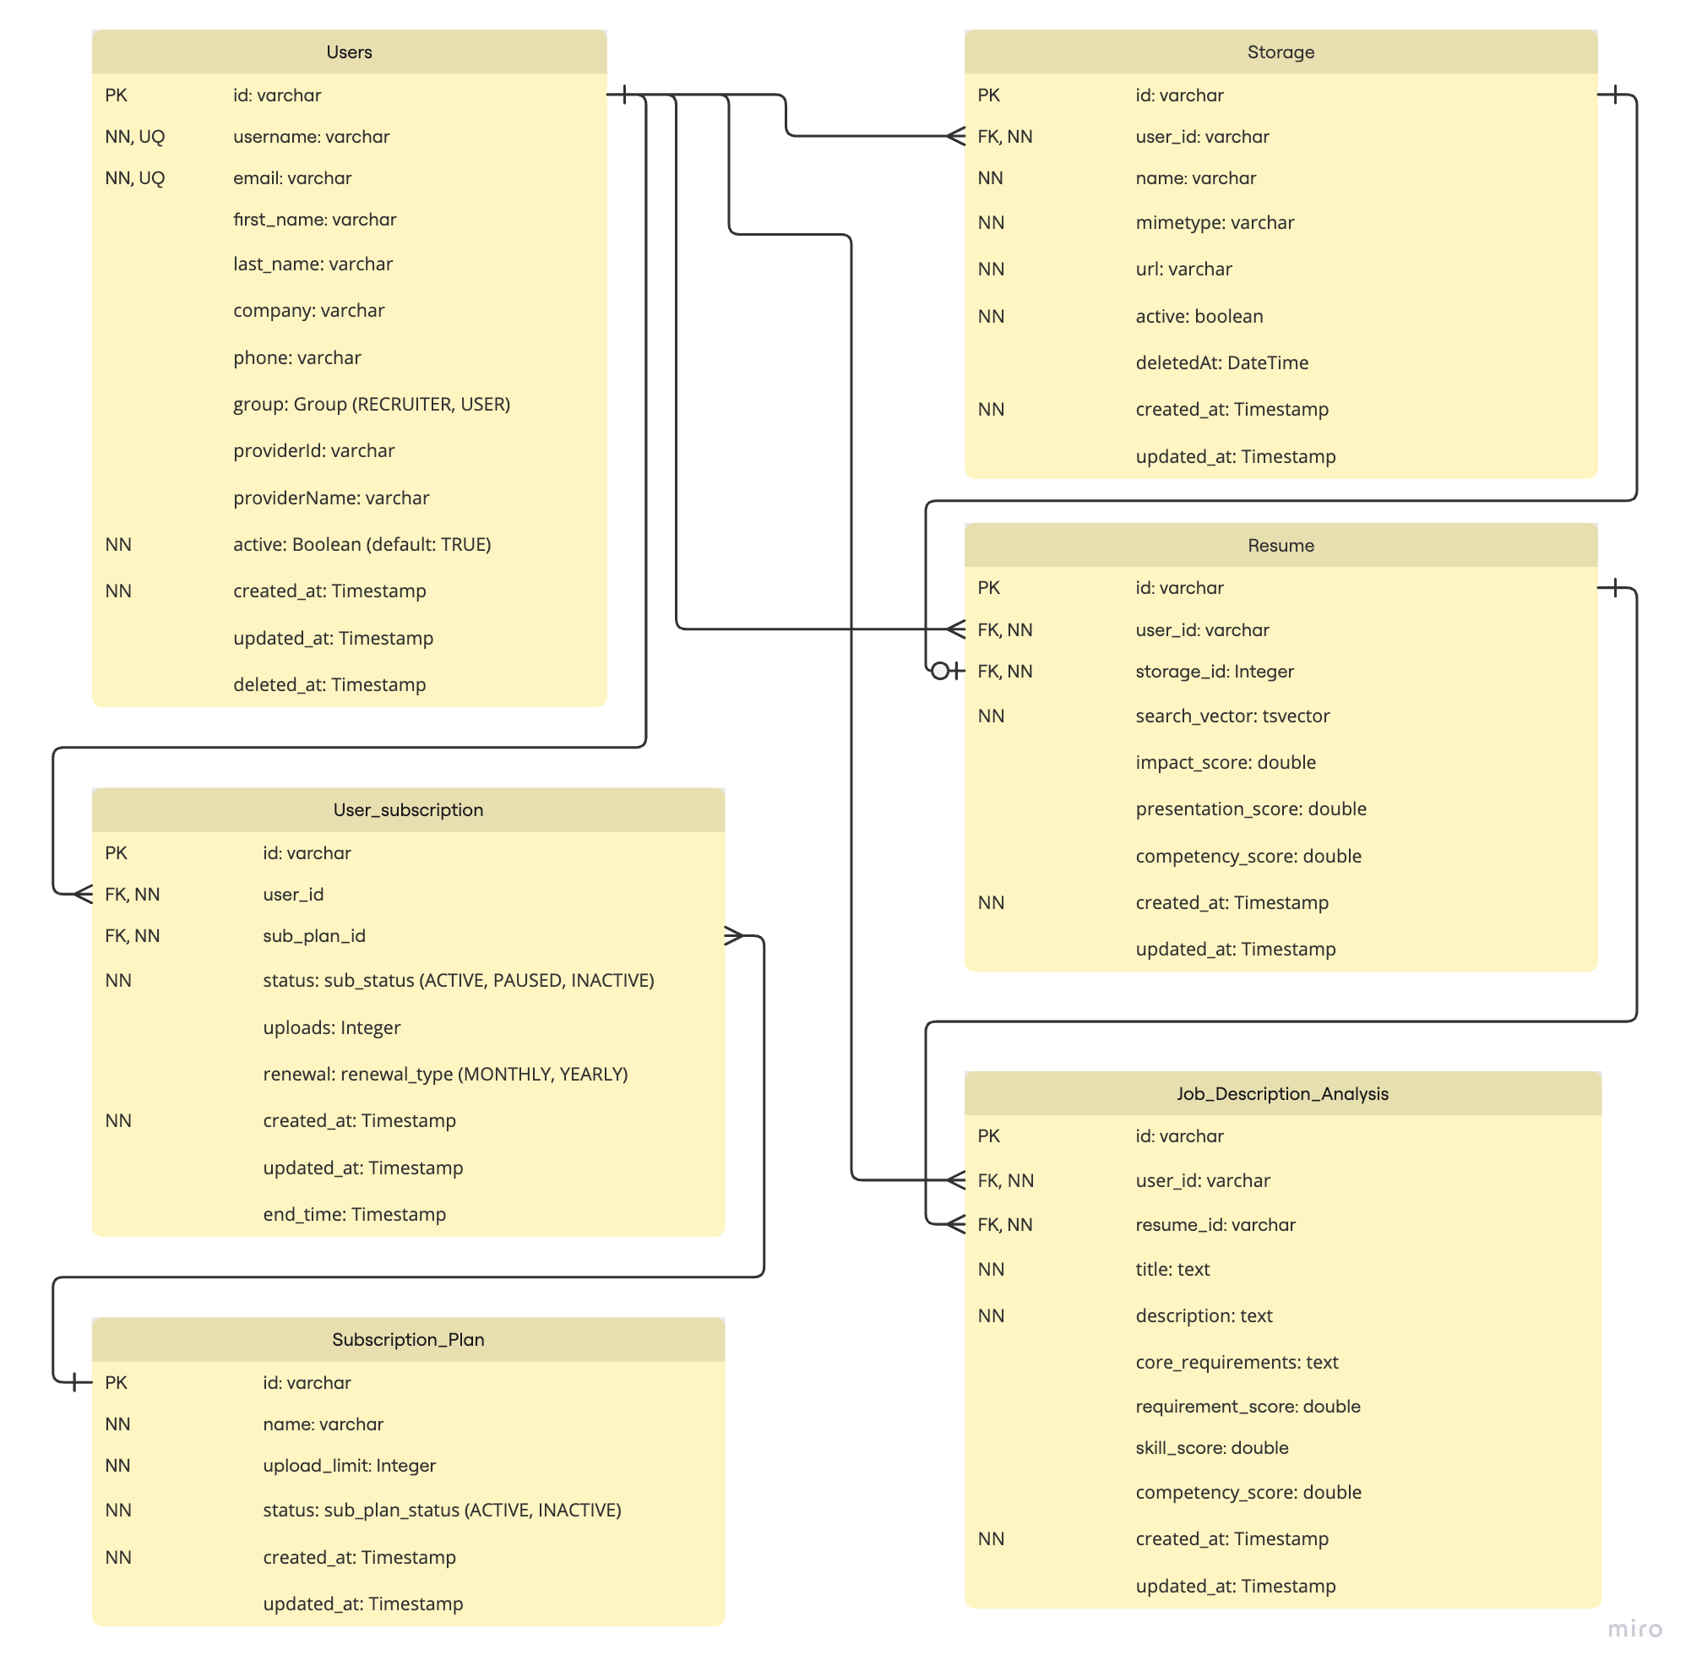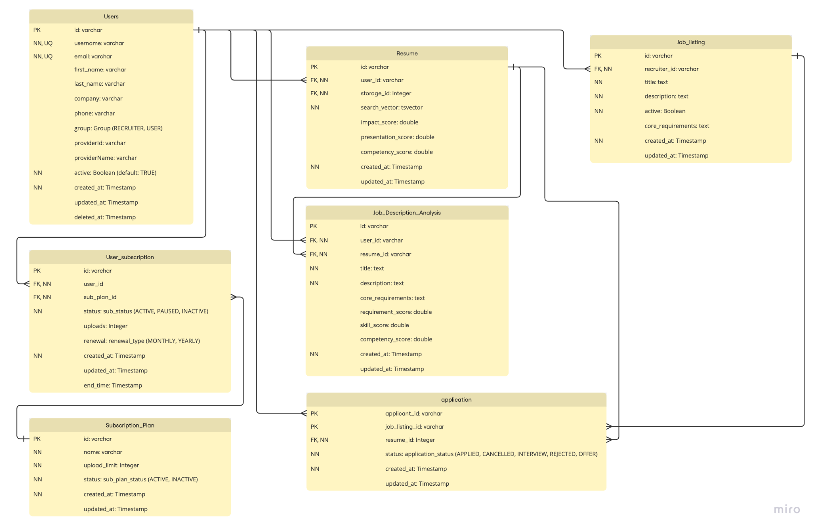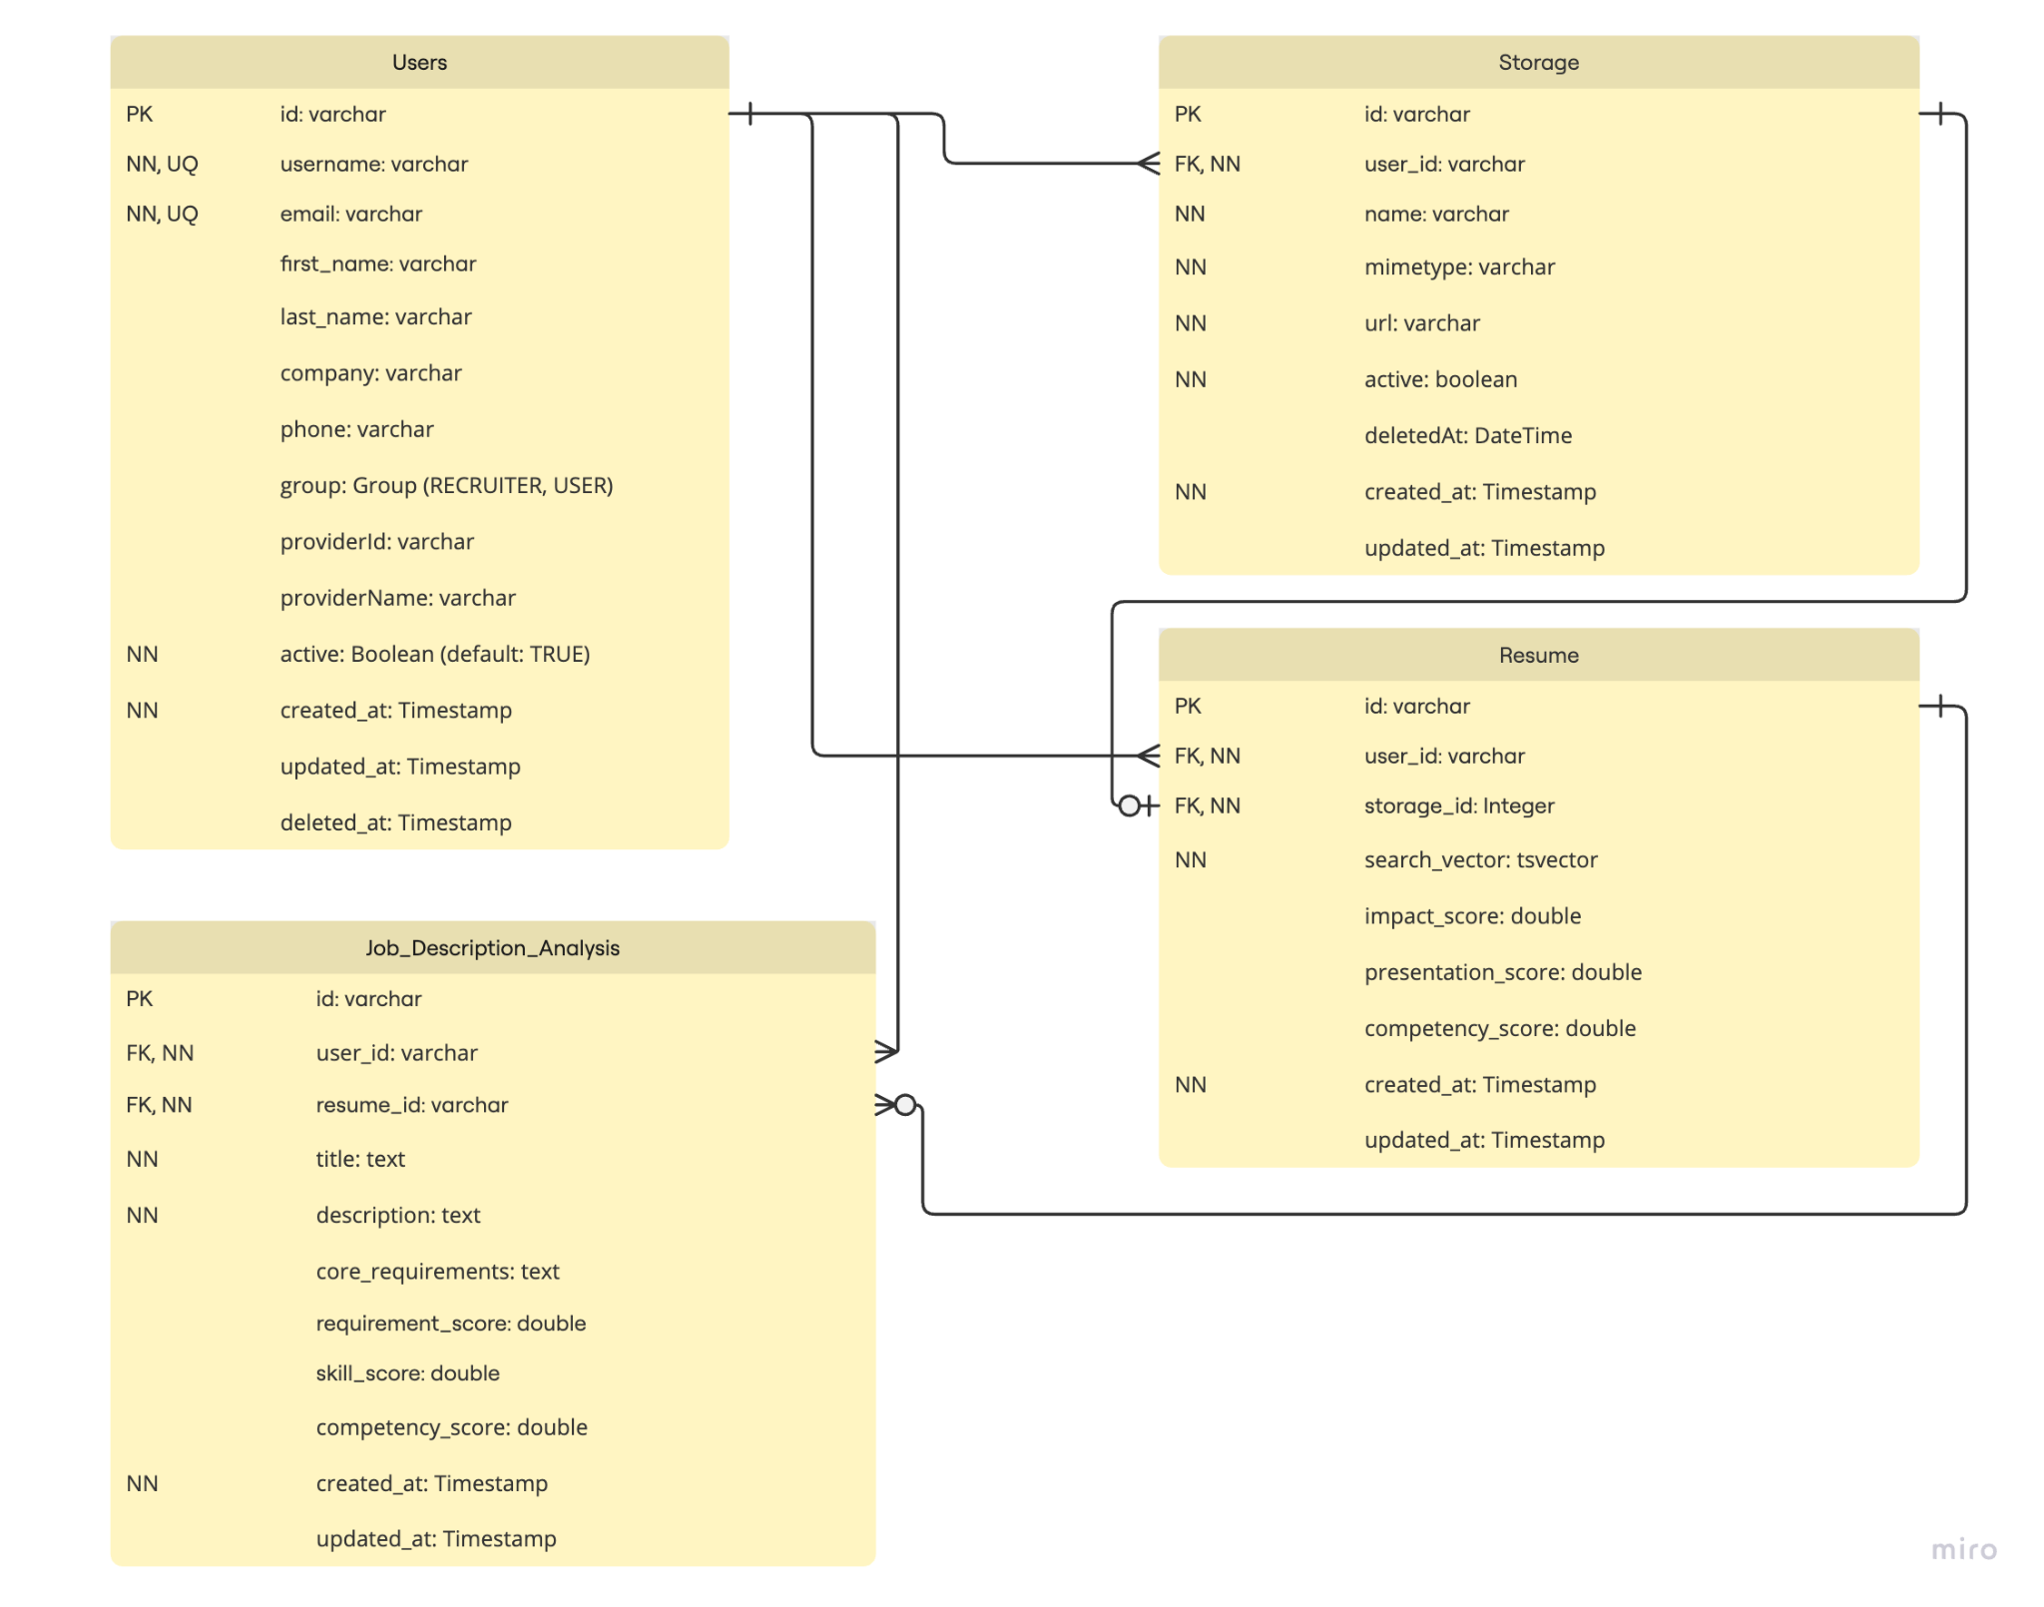

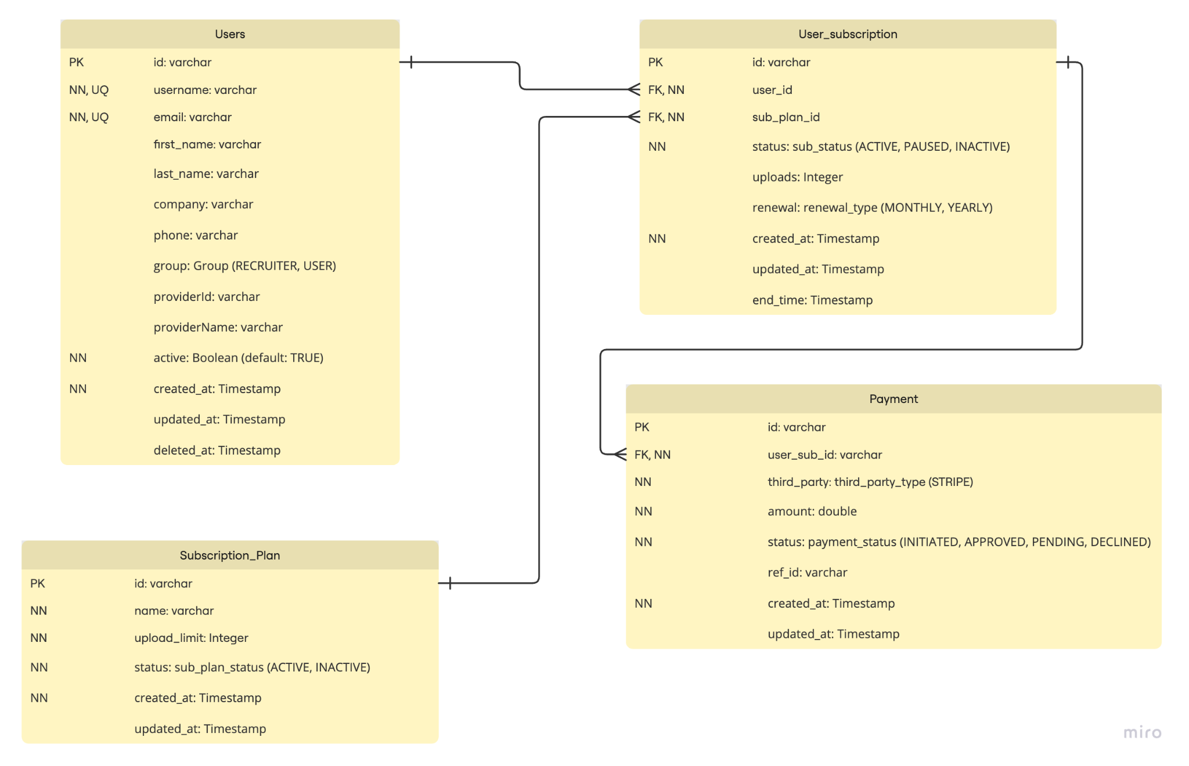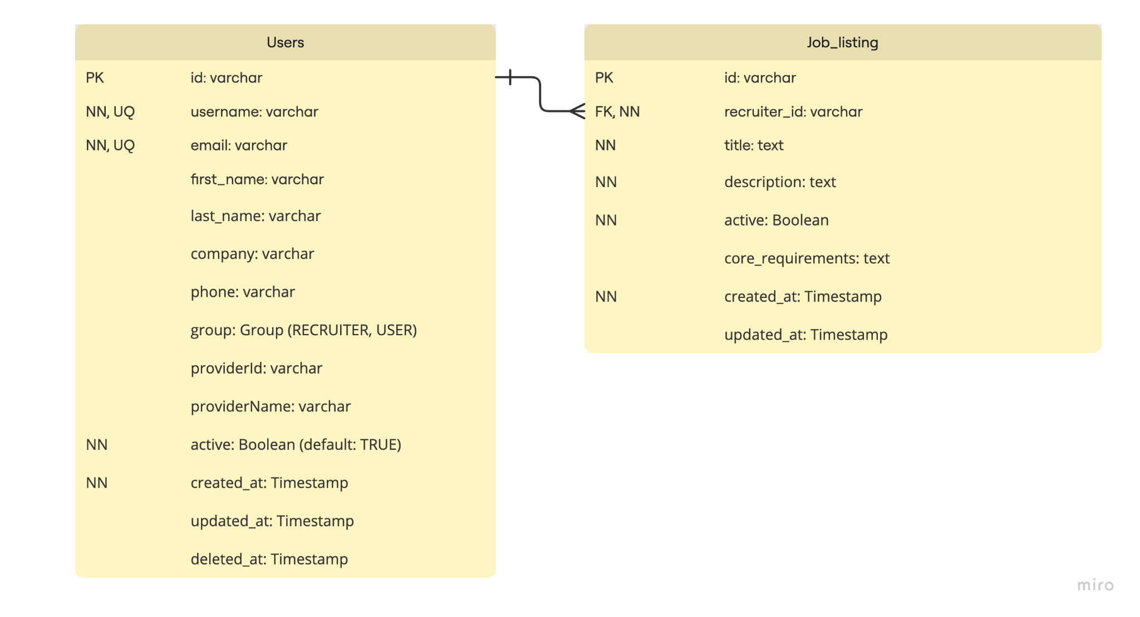

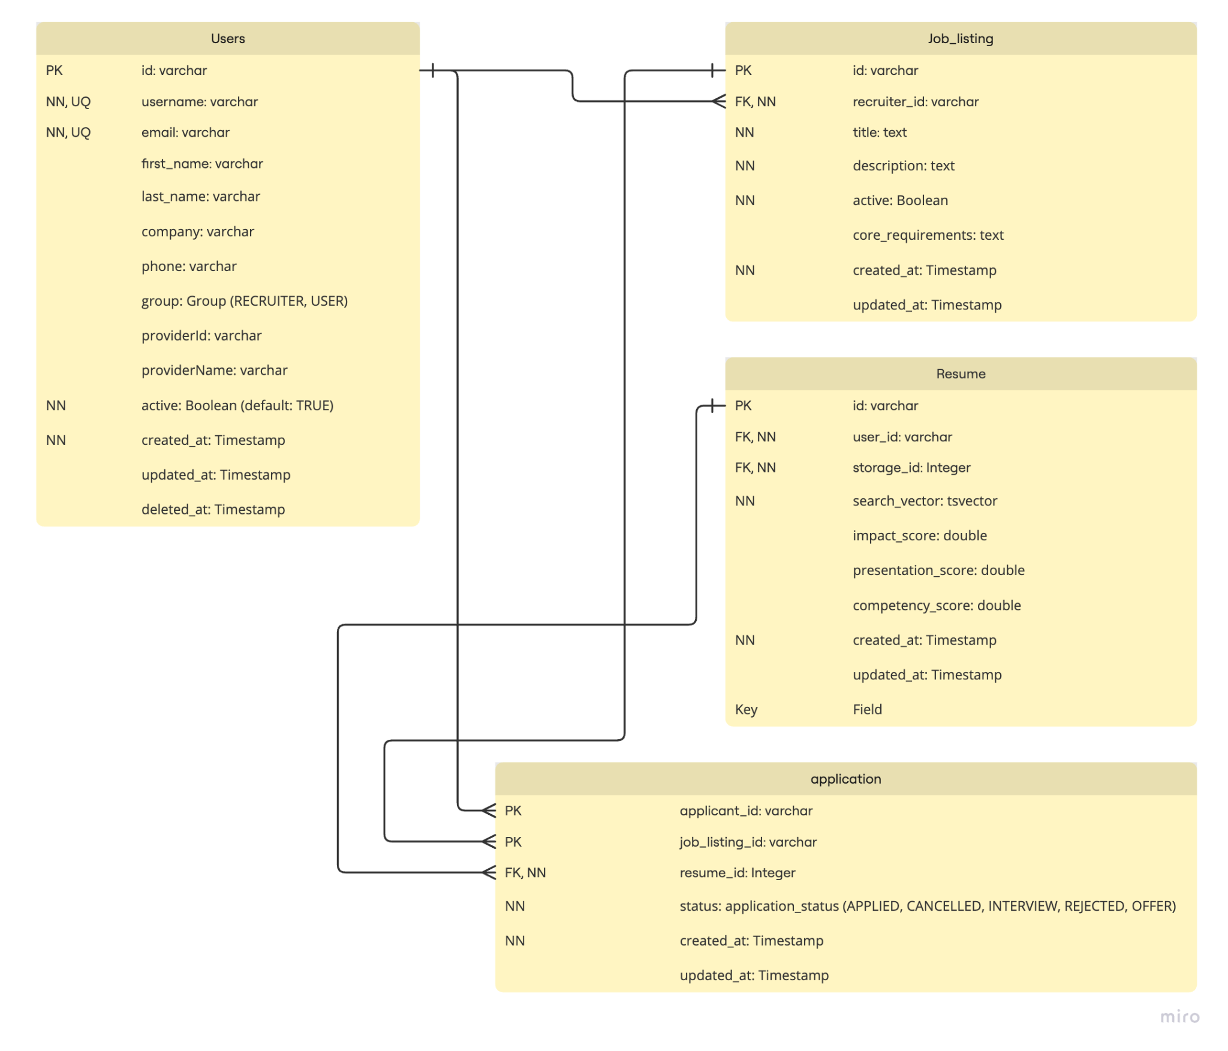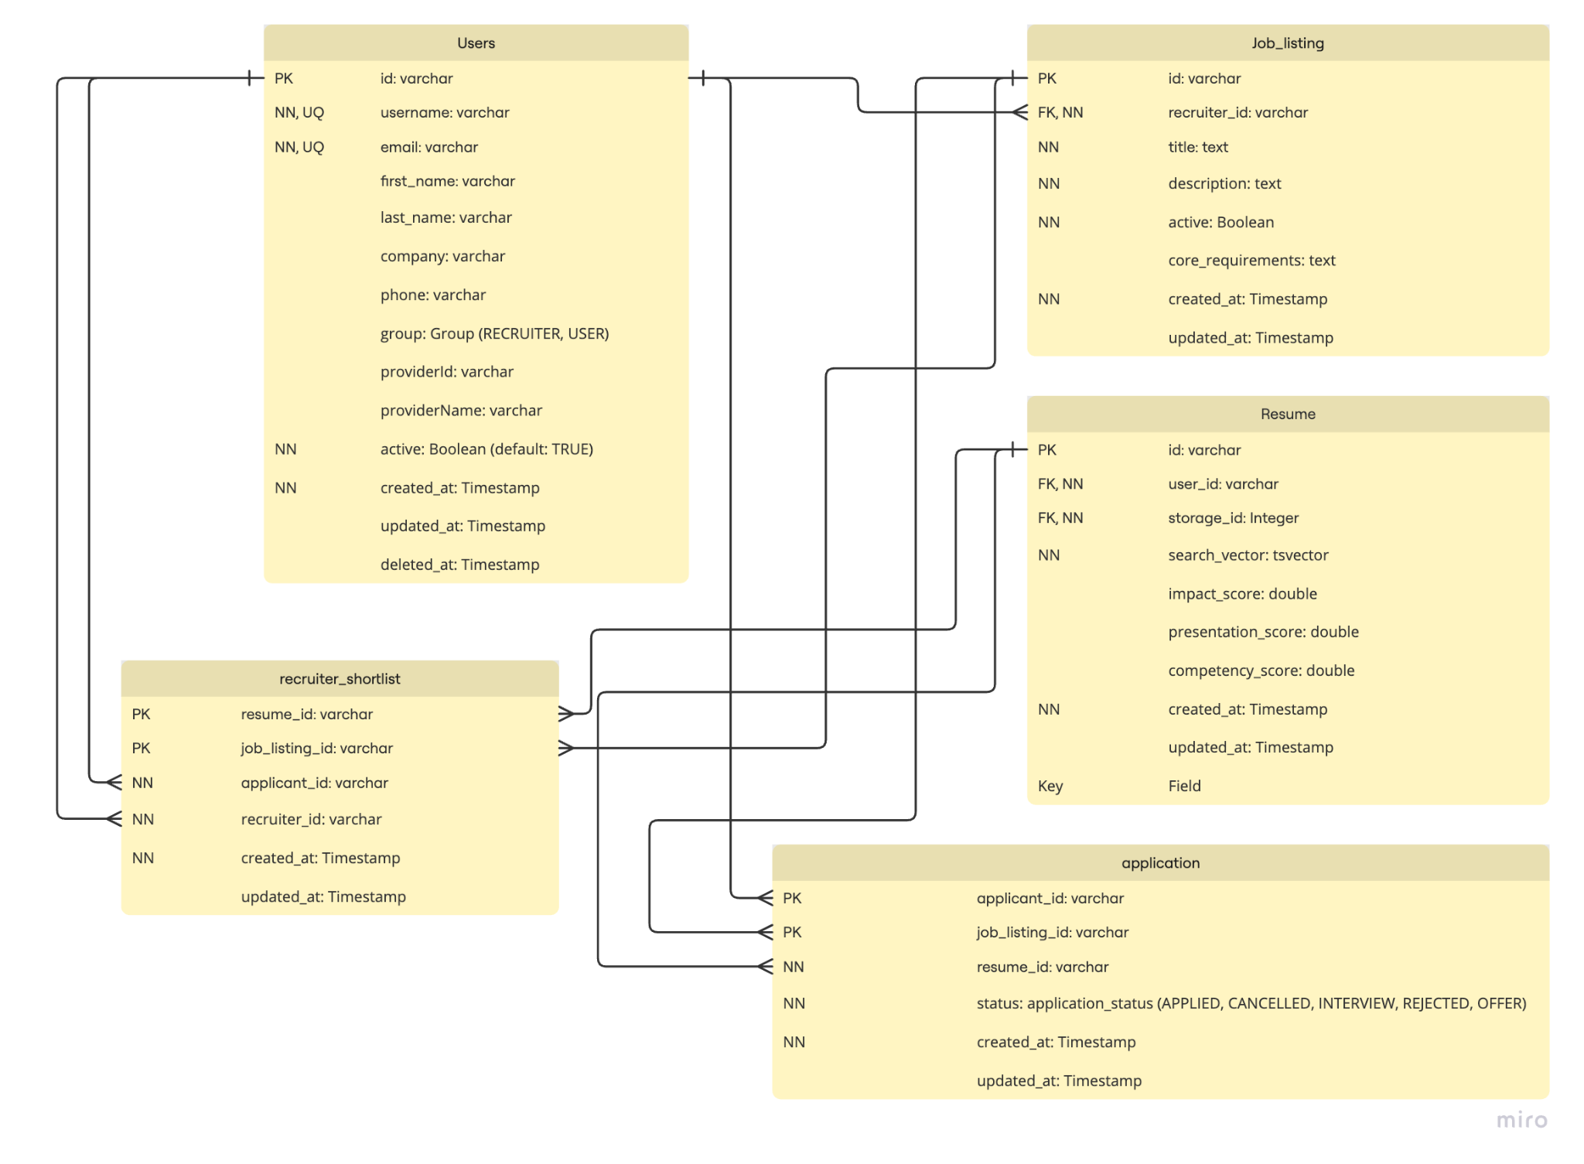

# UI Design (if applicable)

* Our UI will have initial Authentication pages which will include:
  + Landing Page
  + Login Page
  + Signup Page
  + Forgot Password Page
* Our UI will also include the following Dashboard pages
  + Analytics page
  + Resume w/ JD upload page
  + Resume w/ JD analysis page
  + Job creation page
  + Job listing page
  + Applications
  + Profile page
  + Subscribe/Unsubscribe pages
  + Payments & Billing History pages

# Database Design (if applicable)

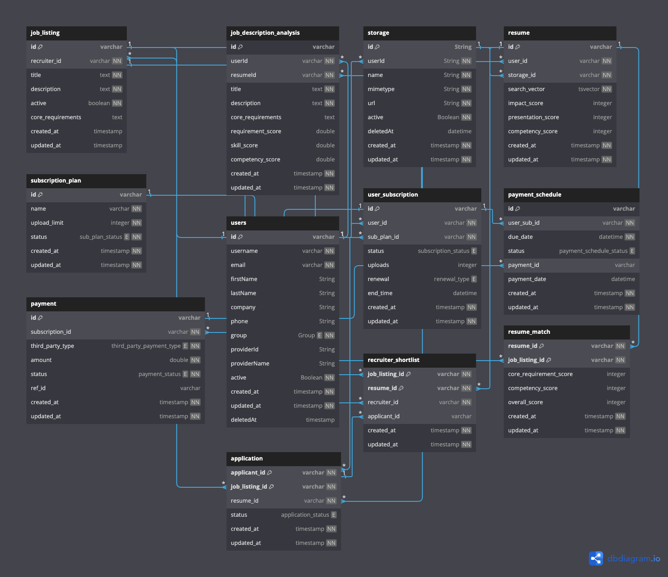

# Security Design

We are building our project with Security in mind. We have incorporated key security features in the following ways:

* We are using Keycloak for Identity Access and Management with authentication expiries to enhance security
* We are also using **JWT Tokens** with an interceptor for our APIs to extract scopes from our JWT Token and use those scopes for API access
* We plan on deploying our applications on a Private Network (AWS VPN) to secure our Backend and use a Proxy for enhanced security
* We have incorporated Prisma which provides intermediate level of security against malicious attacks.

# Business Logic and/or Key Algorithms

* **Upload Resume Bulk**: This logic allows a recruiter to upload bulk resumes against a certain job. This triggers an async analysis logic to use AI to analyze resumes against the job description and provide insights. This also involves checking whether the user can exceeded their upload limit based on their tier
* **Upload Resume (User)**: This logic allows an applicant to upload a resume against a certain job. This triggers an async analysis logic to use AI to analyze the resume against the job description and provide insights. This also involves checking whether the user can exceeded their upload limit based on their tier
* **Account Creation**: This allows the user to create an account
* **Subscribe to a plan**: This subscribe a user to a certain plan
* **Make a payment**: This allows the user to make a payment for their plan
* **Create job listing**: This allows a recruiter to post a job
* **Apply to job listings**: This allows the user to apply to a certain job

# Design Patterns

We have designed our software architecture based on **Client-Server** architecture

## Frontend Design Patterns

* Container and Presentation Pattern
* State Management with Reducers
* Component Compositions with Hooks
* Component Enhancements with HOCs
* Data Management with Providers
* Lazy Loading Components
* Promise pattern

## Backend Design Patterns

* Middleware pattern
* Dependency Injection Pattern
* Promise pattern
* Singleton pattern (db conn)
* Factory pattern

# Rest APIs

* **Applications**

**Contracts**

**type applicationPostBody = {  
 jobListingId: string;  
 resumeId: string;  
 };  
  
enum ApplicationStatus {  
 APPLIED = 'APPLIED',  
 CANCELLED = 'CANCELLED',  
 INTERVIEWING = 'INTERVIEWING',  
 REJECTED = 'REJECTED',  
 OFFER = 'OFFER',  
 }  
  
 type applicationPutBody = {  
 status: ApplicationStatus;  
 };**

* + **GET Application (/applications/{id})**
    - Returns the application with the id
  + **POST Application (/applications)**
    - Creates a new application with a validated request body
  + **PUT Application (/applications/{id})**
    - Updates an existing application with id
  + **DELETE Application (/applications)**
    - SOFT deletes an existing application with id
* **Jobs**
  + **GET Jobs (/job/{id})**
    - Returns job with the id for recruiter along with applications
  + **GET Jobs (/job/public?searchTerm={searchTerm})**
    - Returns jobs for applicant with searchTerm
  + **POST Jobs (/job)**
    - Creates a new job listing
  + **PUT Jobs (/job/{id})**
    - Updates a specific Job Listing

**Contracts:**

| **type JobListingsPostBody = {  title: string;  description: string;  coreRequirements: string;  active?: boolean;  }; type JobListingsPutBody = {  title?: string;  description?: string;  coreRequirements?: string;  active?: boolean;  };** |
| --- |

* **Resume**

**Contract**

| **type ResumePostBody = {  storageId: string;  };** |
| --- |

* + **GET Resume (/resume/{id})**
    - Fetches a specific resume with ID
  + **POST Resume (/resume) (For Applicants)**
    - Adds a resume to the database tables
    - This requires a resume upload functionality first
  + **POST Resume (/resume/bulk) (For Recruiters)**
    - This adds multiple resumes to the database tables
    - This requires an already uploaded resume first
  + **GET Resume (/resume/{id}/view-analysis)**
    - This shows analysis for a specific resume
  + **DELETE Resume (/resume/{id})**
    - This SOFT deletes an existing resume
* **Me (User)**

**Contract**

| **type MePost = {  firstName?: string;  lastName?: string;  phone?: string;  };   const MePostSchema = {  firstName: String,  lastName: String,  phone: String,  };** |
| --- |

* + **POST User (/me)**
    - Creates a new User (both applicant and recruiter)
  + **GET User (/me/{id})**
    - This returns user details of a specific user
  + **PUT User (/me/{id})**
    - This updates and existing user
* **Shortlist**

**Contract**

| **type shortListPostBody = {  applicationId: string;  jobListingId: string;  };** |
| --- |

* + **GET Shortlist (/shortlists/{id})**
    - This returns a specific shortlist that recruiter has created
  + **POST Shortlist (/shortlists)**
    - This creates a new shortlist for a recruiter with data from body
  + **DELETE Shortlist (/shortlists/{id})**
    - This soft deletes an existing shortlist
* **Storage**
  + **POST Storage (/storage)**
    - This uploads a new file in the backend and returns its id
  + **GET Storage (/storage/{filename})**
    - This returns a specific file with filename

# Any Additional Topics you would like to include.

* We are planning to deploy our project to AWS for cloud deployment
* We are planning to deploy our React App over a CDN for better performance
* For cloud deployment, we are planning to put our Backend components like Database, Object Storage, Event Streams and Redis cache under a Private Network so that only our Fastify servers can interact with database enhancing security.
* We are also exploring the possibility of including a Load Balancer in the future including a Rate Limiter (Proxy) to prevent malicious attacks such as DoS

# References

<https://react.dev/>

<https://fastify.dev/>

<https://www.postgresql.org/>

<https://v3.vitejs.dev/guide/>

<https://jestjs.io/>

<https://redux.js.org/>