**CS673 Software Engineering** 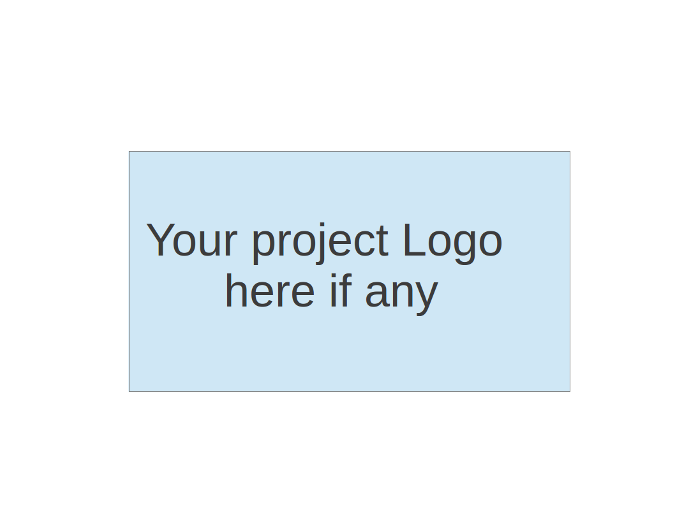

**Team 2 - Rental Ninja**

**Software Test Document**

| Team Member | Role(s) | Signature | Date |
| --- | --- | --- | --- |
| Yongjing Wu | Team Lead | *Yongjing wu* | 09/08/2024 |
| Jiacheng Ding | Security Lead | *Jiacheng Ding* | 09/08/2024 |
| Yueyang He | Design and Implementation Lead | *Yueyang He* | 09/08/2024 |
| Xueqi Zhou | Requirement Lead | *Xueqi Zhou* | 09/09/2024 |
| Rundong Zhong | Configuration Lead | *Rundong Zhong* | 09/08/2024 |
| Xiang Zhang | QA Lead | *Xiang Zhang* | 09/09/2024 |
|  |  |  |  |
|  |  |  |  |

**Revision history**

| **Version** | **Author** | **Date** | **Change** |
| --- | --- | --- | --- |
|  |  |  |  |
|  |  |  |  |

Testing Summary

Manuel Tests Reports

Automated Testing Reports

Testing Metrics

References

Glossary

# Testing Summary

Jiacheng Ding and Xiang Zhang are the primary contributors responsible for completing the testing tasks. Their focus includes Unit Testing, Integration Testing, System Testing, Acceptance Testing, and Regression Testing, ensuring that all components of the project are thoroughly tested and meet the quality standards required.

# Manual Testing Report

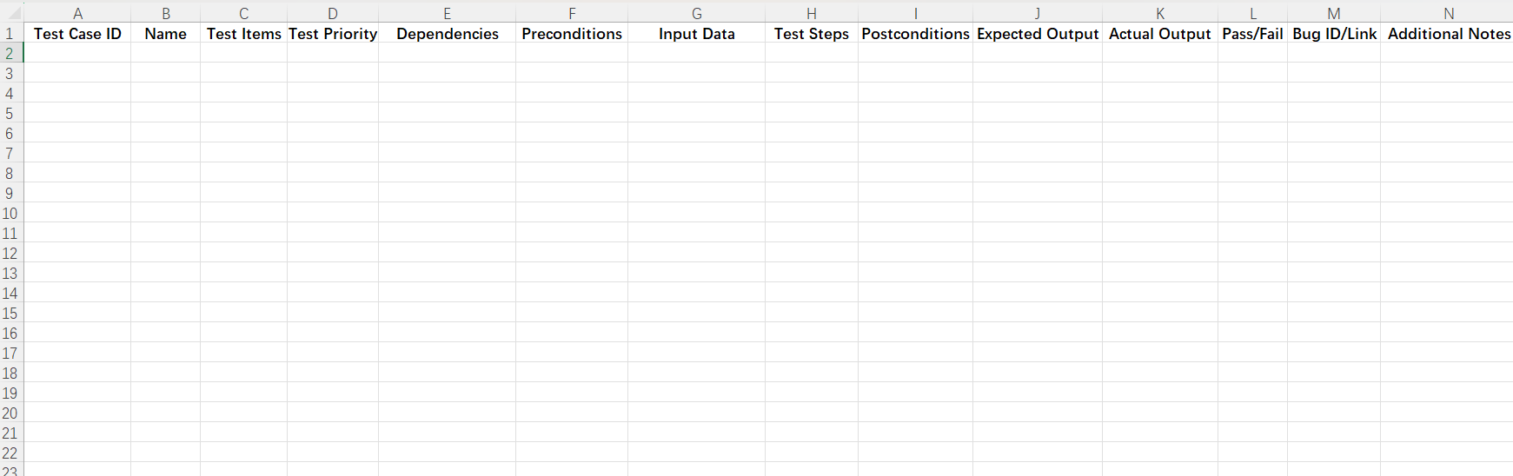

# Automated Testing Report

Unit Tests: JUnit for backend tests and Jest for frontend components.

Integration Tests: Postman for API testing.

E2E Tests: Cypress for testing the complete user flow.

# Testing Metrics

Number of test cases: 20 test cases

Test coverage: 85% code coverage

Defect rate: 5%

Resolution rate: 100% of identified defects were resolved.

# References

# Glossary