
CS673 Software Engineering
Team 3 - Health and Wellness Manager
Software Test Document

Team Member | Role(s) | Signature | Date
Amanda Yee | QA Leader | Amanda Yee | 09/22/2024
Yu Luo | Design & Implementation Leader | Yu Luo | 09/22/2024
Kenny Light | Requirements Leader | Kenny Light | 9/23/2024
Chris Ceravolo | Team Leader | Chris Ceravolo | 9/23/2024
Zihao Qian | Security | zihaoqian | 9/23/2024
Edward Lee | Configuration | Edward Lee | 9/23/2024

Revision history
Version | Author | Date | Change
1 | Team 3 | 09/23/2024 | All sections
2 | Amanda Yee | 10/07/2024 | - Updated Testing Summary, Automated Testing Report, and Testing Metrics to reflect Iteration 2  - Added Manage Profile test to Manual Testing Report
2 | Chris Ceravolo | 10/07/2024 | - Update manual test of chart
2 | Eddie Lee | 10/07/2024 | Add Authentication test to Manual Testing Report

Testing Summary
Manual Tests Reports
Automated Testing Reports
Testing Metrics
References
Glossary

Testing Summary
In this section, you will summarize what was tested, who is involved in testing, testing techniques used, and testing result. You may have the following tests
  - Unit Testing
  - Integration testing
  - System Testing
  - Acceptance Testing
  - Regression Testing

Testing is an important part of building our web application to ensure that it functions correctly and aligns with our expectations, while also helping us to identify any potential issues before integrating new features.

We are continuously implementing unit tests to test individual components of our application in isolation to ensure they are working as intended. We will continue to build out this testing suite during development and all team members will be involved. We have various unit tests for the front end as well as back end connection. They are all currently passing.

We also conduct integration testing to ensure that the front end (client-side application) and back end (external database) are properly communicating with each other. We manually verify that the data submitted is correctly saved in the database, and that the retrieved data matches our expectations. Any team member who works on features that connect the front and back end performs this integration testing and currently the integration testing passes.

Our team has set up Docker which helps to streamline the system testing process. The containerized environment ensures that system testing is consistent and replicable across different stages of development. Before each release, the QA leader will conduct a final system test through Docker to check that the application is functioning as intended. Currently, this system test passes.

Manual Testing Report
In this section, you will give a detailed description of each manual test case performed and the result. If this is a previous You shall list what are existing tests developed in the previous semester and what are new tests developed currently.

Here is a sample template that can be used for each test case. For system tests or acceptance tests, you may also include some screenshots.

- Test case ID, name
- New or old:
- Test items: (what do you test )
- Test priority (high/medium/low)
- Dependencies (to other test case/requirement if any):
- Preconditions: (if any)
- input data:
- Test steps:
- Postconditions:
- Expected output:
- Actual output:
- Pass or Fail:
- Bug id/link: (this should link to your github issue id)
- Additional notes:
(You can use an additional spreadsheet for this section as well)

Test: Create and View Users
- Test items: (what do you test ): CreateUser.js, ViewUser.js
- Test priority (high/medium/low): High
- Dependencies (to other test case/requirement if any): N/A
- Preconditions: (if any): Server and frontend are running
- Test steps: Navigate to “Create Users” page in web browser, enter user data and hit submit, navigate to “View Users” page and refresh
- Postconditions: A list of user data appears on the page, including a row for the user that has just been created
- Pass or Fail: Pass
- Bug id/link: Create Profile: https://seprojects-cs673olf24team3.atlassian.net/browse/HW-27?atlOrigin=eyJpIjoiNmY0MTQ1YjMxM2E2NDRiYjg4MWQ1MTdjNWVhMWU1ZTciLCJwIjoiaiJ9
- Additional notes: This test is to be run by admin and not users. This test ensures that the frontend and server are communicating properly.

Test: Create Goals
- Test items: (what do you test): CreateGoal.js
- Test priority (high/medium/low): High
- Dependencies (to other test case/requirement if any): No
- Preconditions: (if any): Server and front end are running
- Test steps: Navigate to “Create Goal” page in application, select health metric from dropdown, input target value and click “Submit” button.
- Postconditions: A new document in the “goals” collection on MongoDB should be created with an autogenerated goalId.
- Pass or Fail: Pass
- Bug id/link: (this should link to your github issue id): https://seprojects-cs673olf24team3.atlassian.net/browse/HW-97
- Additional notes: This test ensures that the front end and server are communicating properly, whereby the user input information is saved to the external DB.

Test: Create Daily Health Data Form Submission
- Test items: DailyData.js
- Test priority: High
- Dependencies (to other test case/requirement if any): N/A
- Preconditions: (if any)
  - The Daily Data Form must be fully rendered with all MUI components loading correctly
  - Mulish font should be applied globally
  - All form input fields should be visible and editable
- Test steps:
  - Render Form: Navigate to the Daily Data form page to ensure all fields (Weight, step count, sleep, water, exercise) are rendered properly
- Postconditions: All input fields should be filled out with valid data.
- Pass or Fail: Pass
- Bug id/link: Submit Daily Summary Health Data Form
https://seprojects-cs673olf24team3.atlassian.net/browse/HW-105?atlOrigin=eyJpIjoiMTFkMmYxNmI5NGNiNDUwODk4NDA2YzMzMzRjNWE0MzgiLCJwIjoiaiJ9
- Additional notes:
  - Ensure that the input fields reflect the proper styles as per the design: rounded corners, background color, and correct font (Mulish).
  - Verify that the dropdown fields are accessible and maintain their values after selection.
  - Check that focus states and form validation (if applicable) behave as expected.

Test: Docker Configuration
- Test items: docker-compose-dev.yml, client/Dockerfile.dev, server/Dockerfile.dev
- Test priority: High
- Preconditions: All dependencies are present in package.json, Docker images have been built
- Test steps: Run “docker-compose -f docker-compose-dev.yml up”
- Expected output: Automatic redirect to localhost:3000, where the application functions just as when run locally using “npm start” in two terminals
- Pass or Fail: Pass
- Bug ID/link: https://seprojects-cs673olf24team3.atlassian.net/browse/HW-114, https://seprojects-cs673olf24team3.atlassian.net/browse/HW-159
- Additional notes:
  - Since Docker was initially set up with a single Dockerfile in the code directory, we needed to reconfigure after having both a server and client that needed a Dockerfile for each of them
  - Also tested with “curl http://localhost:5000” to validate the server could be reached, expecting a response code: 200 with Content: “Server is running…”

Test: Login Page
- Test items: (what do you test): Login.js, App.js
- Test priority (high/medium/low): High
- Dependencies (to other test case/requirement if any): N/A
- Preconditions: (if any): Server and frontend are running
- Test steps: Navigate to “Login” page in web browser, input wrong password
- Postconditions: Pop up ‘check your password and email’ notification
- Pass or Fail: Pass
- Bug id/link: Login: https://seprojects-cs673olf24team3.atlassian.net/browse/HW-26
- Additional notes: This test is to be run by admin and not users. This test ensures that the login system and password input are communicating properly and the front end flags an incorrectly input password.

Test: Logout Button
- Test items: (what do you test): Logout.js, Logout.test.js
- Test priority (high/medium/low): High
- Dependencies (to other test case/requirement if any): N/A
- Preconditions: (if any): Server and frontend are running
- Test steps: Navigate to “Login” page in web browser after click the button
- Postconditions: Pass or Fail: Pass
- Bug id/link: Logout: https://seprojects-cs673olf24team3.atlassian.net/browse/HW-178
- Additional notes: This test is to be run by admin and not users. This test ensures that the logout button could make sure to redirect to the login page and all the information of users will be invisible.

Test: Authentication
- Test items: (what do you test): utils/authenticate.js, Login.js
- Test priority (high/medium/low): High
- Dependencies (to other test case/requirement if any): N/A
- Preconditions: (if any): Server and frontend are running, user is logged out
- Test steps: Navigate to any page aside from “Login”. Expect to be redirected to the Login page. Log in with correct credentials, and navigate to another page again.
- Postconditions: Redirect to Login page when logged out, access other pages when logged in
- Pass or Fail: Pass
- Bug id/link: Authentication: https://seprojects-cs673olf24team3.atlassian.net/browse/HW-163
- Additional notes: Validate that your JWT is stored in your local storage with Inspect. Under “Application”, there should be an “authToken” in “Local storage”

Test: Manage Profile
- Test items: (what do you test): ManageProfile.js
- Test priority (high/medium/low): High
- Dependencies (to other test case/requirement if any): No
- Preconditions: (if any): Server and front end are running and user is logged in
- Test steps: Navigate to “Manage Profile” page, update any personal information and click “Update Profile” button.
- Postconditions: The “users” collection on MongoDB is appropriately updated, specifically for the logged-in user ID and no other user IDs are impacted.
- Pass or Fail: Pass
- Bug id/link: (this should link to your github issue id): https://seprojects-cs673olf24team3.atlassian.net/browse/HW-27
- Additional notes: This test ensures that the front end and server are communicating properly, whereby the user input information is saved to the external DB.

Test: Charts on home page
- Test items: (what do you test): Home.js
- Test priority (high/medium/low): Medium
- Dependencies (to other test case/requirement if any): No
- Preconditions: (if any): Server and front end are running in a local environment and user is logged in
- Test steps: Navigate to “Home” page and view 5 charts by scrolling down. In code, change the value of the hardcoded goals.
- Postconditions: The goal lines on the charts should move when I refresh the page (indicating that charts are responding to data)
- Pass or Fail: Pass
- Bug id/link: (this should link to your github issue id): https://seprojects-cs673olf24team3.atlassian.net/browse/HW-54?atlOrigin=eyJpIjoiZDRlYzc4ZmJkYWU1NDA1MGI2YTM1MjE4YWYzYzc4NjUiLCJwIjoiaiJ9
- Additional notes: This test will be updated in Iteration3, when charts are linked dynamically to user health and goal data. (Currently they contain hardcoded data which can be updated).

Automated Testing Report
Describe briefly the automated testing you have done, including where the test code resides in your code repository, what test frameworks are used, and the screen shots or generated testing report.

We are using the Jest Testing Framework for automated testing.

The test code resides in two locations in our repository, separated by the client side and server side. Each of these folders contain multiple test files, organized by the specific functionalities being tested.

Client side testing folder: /code/client/src/__tests__
This folder contains 7 testing suites with a total of 27 tests. It tests form
validation for each of our pages, front end rendering, user authentication and connection
to the server.

Client side testing report:

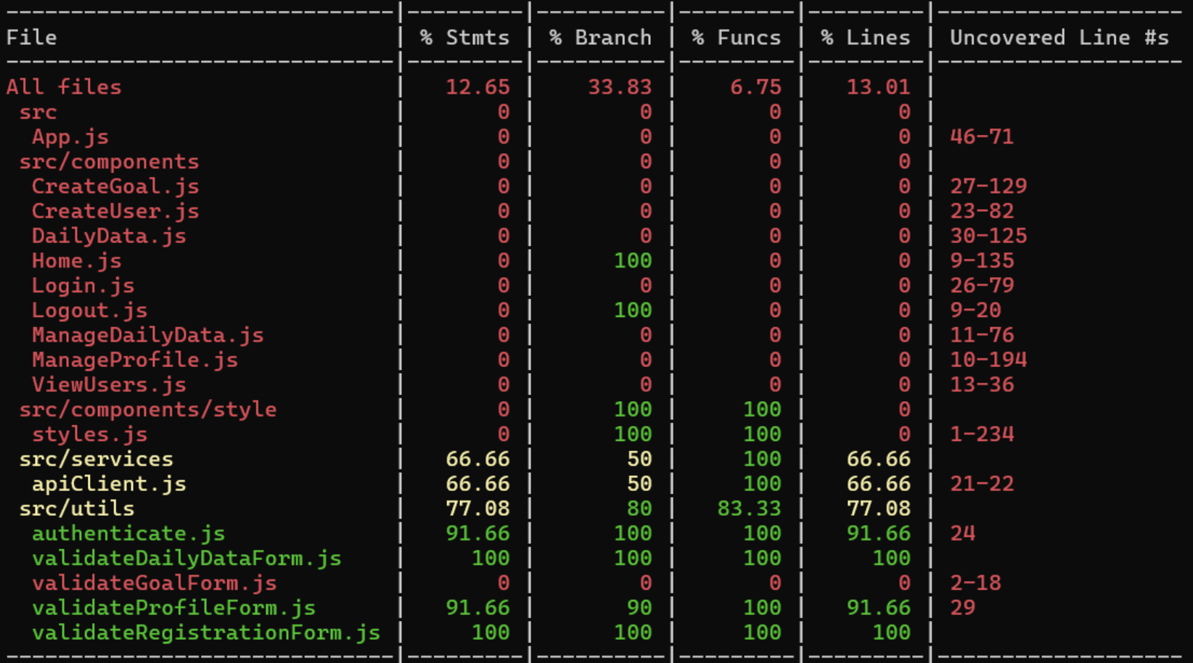
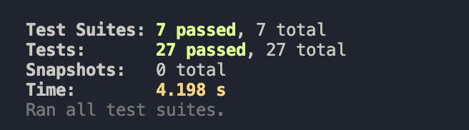

Server side testing folder: /code/server/__tests__
This folder contains 2 testing suites with a total of 11 tests. These test the user and goal endpoints, ensuring that users and goals are created successfully and that users can be retrieved. It also tests the login functionality is working as expected and the correct user is returned based on who logs in.

Server side testing report:
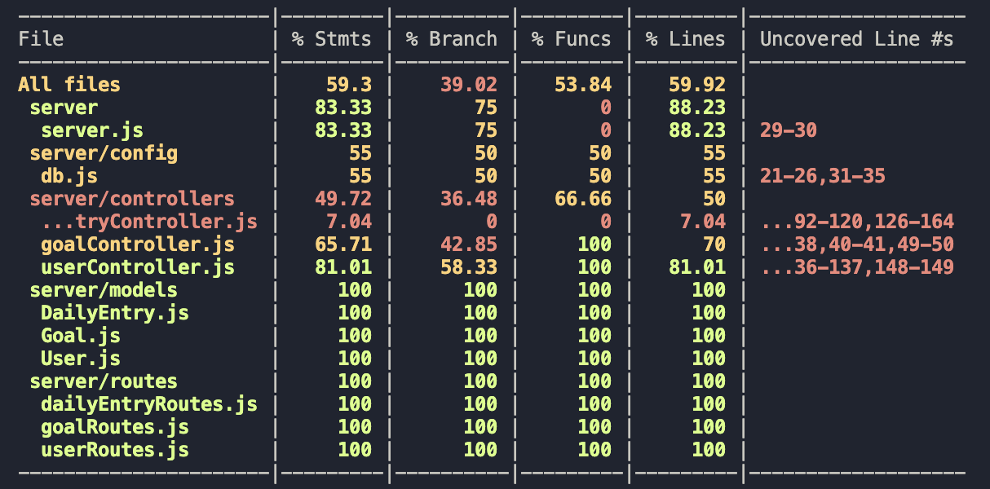
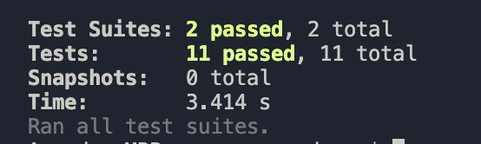

Additional tests will be created as we develop our application.

Testing Metrics
In this section, you shall report any metrics used for the evaluation, e.g. # of test cases, test coverage, defects rate, etc.

  - Test Case Count: 38
  - Test Pass Rate: 100%
  - Test Coverage for Lines (server): 59.9%
  - Test Coverage for Lines (client): 13.0%

References
  - Jest Framework: https://jestjs.io/

Glossary
N/A

