CS673 Software Engineering
Team 4 - TeamBuilder
Software Test Document
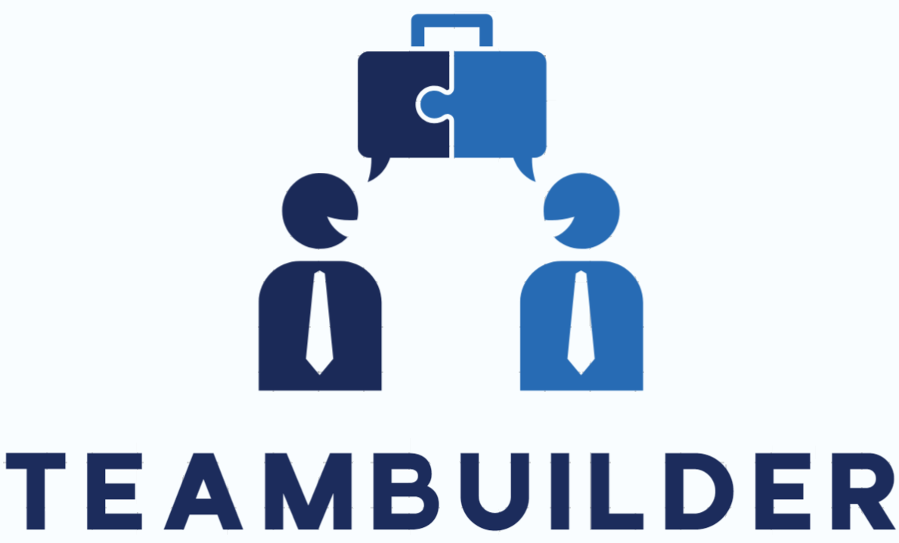
Team Member | Role(s) | Signature | Date
Vishal Sundaram | QA Leader | Vishal Sundaram | 22-Sep-2024
Wenli Gai | Security Leader | Wenli Gai | 23-Sep-2024
Jake Kelly | Team and Requirements Leader | Jake Kelly | 9-23-2024

Revision history
Version | Author | Date | Change
0.2 | Raymond | 10/6/24 | Backend Automated Testing Report
 | Vishal | 08-Oct-2024 | End-to-end testing

Testing Summary
Manuel Tests Reports
Automated Testing Reports
Testing Metrics
References
Glossary

Testing Summary

What was tested:
- UI components unit tests
  - Sidenav
    - Creation of sidenav component
    - test presence of three navigation items - Home, Add User, View Users
  - User details
    - Creation of user details component
    - Should disable save when form is invalid
    - Should enable save when form is valid
Testing techniques used:
- Manual
- Automated
  - Unit tests
  - End-to-end tests
Test result:
- UI:
  - Unit Test coverage summary:
    - Statements : 40.22% ( 35/87 )
    - Branches : 7.14% ( 2/28 )
    - Functions : 25.64% ( 10/39 )
    - Lines : 38.27% ( 31/81 )
  - End-to-end test coverage summary:
    - ----------------------------|---------|----------|---------|---------|-------------------
    - File | % Stmts | % Branch | % Funcs | % Lines | Uncovered Line #s
    - ----------------------------|---------|----------|---------|---------|-------------------
    - All files | 100 | 50 | 100 | 100 |
    - team-builder-web | 100 | 50 | 100 | 100 |
    - playwright.config.ts | 100 | 50 | 100 | 100 | 21-23
    - team-builder-web/e2e/pages | 100 | 100 | 100 | 100 |
    - user-details-page.ts | 100 | 100 | 100 | 100 |
    - team-builder-web/e2e/tests | 100 | 100 | 100 | 100 |
    - add-user.spec.ts | 100 | 100 | 100 | 100 |
    - ----------------------------|---------|----------|---------|---------|-------------------
- Server:

Manual Testing Report

Test 1

- Test case ID: 1
- Test case name: Side navigation
- New or old: new
- Test items:
  - Side navigation bar
  - navigation items
- Test priority (high/medium/low)
  - High
- input data:
- Test steps:
  - Navigate to website
  - See whether the side navigation bar is loaded to the left side of the app
  - Three navigation items should be displayed on the side navigation bar
- Expected output:
  - Side navigation bar shall be displayed on the left side of the application with three items
    - Home
    - Add Student
    - View/Edit Student
- Actual output:
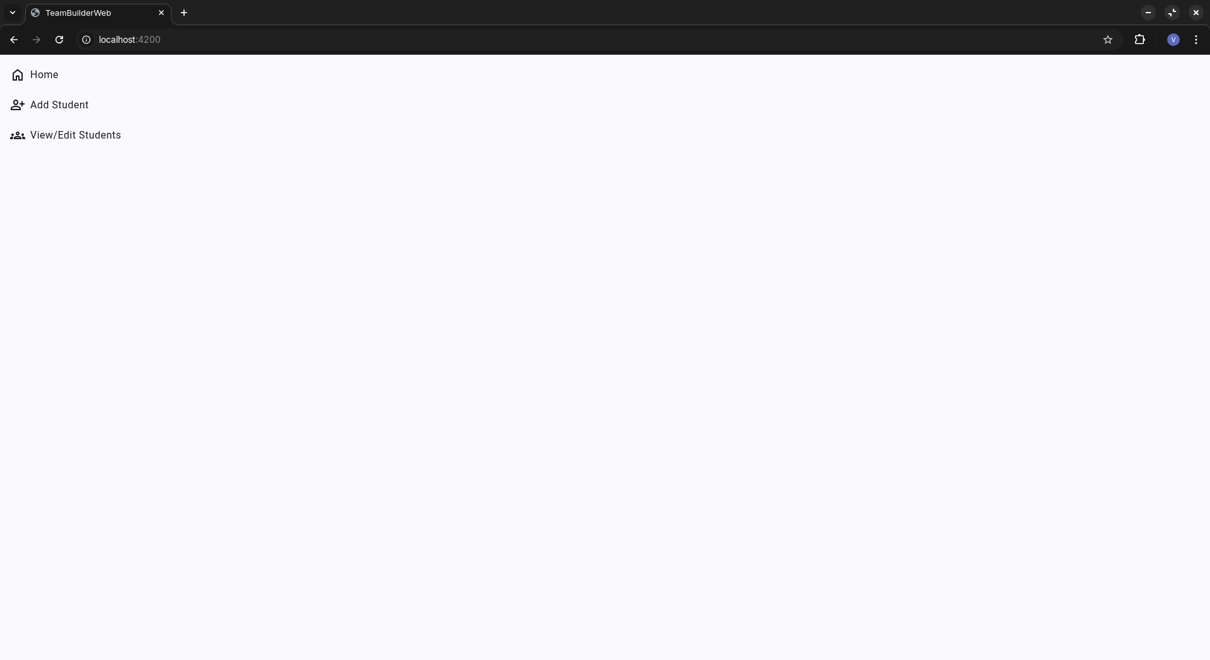
- Pass or Fail: Pass

Test 2

- Test case ID: 2
- Test case name: Add student details
- New or old: new
- Test items:
  - Add student page
  - Form input
  - Save button
- Test priority: high
- Test steps:
  - Navigate to website
  - On the side navigation, click on ‘Add Student’
  - On the ‘Basic details’ section, give valid and invalid inputs
- Expected output:
  - Three sections shall be displayed on ‘Add Student’ page
  - On ‘Basic details’, four input fields - Name, Email, Degree, Concentration shall be displayed
  - Given valid values, the save button shall be enabled
- Actual output:
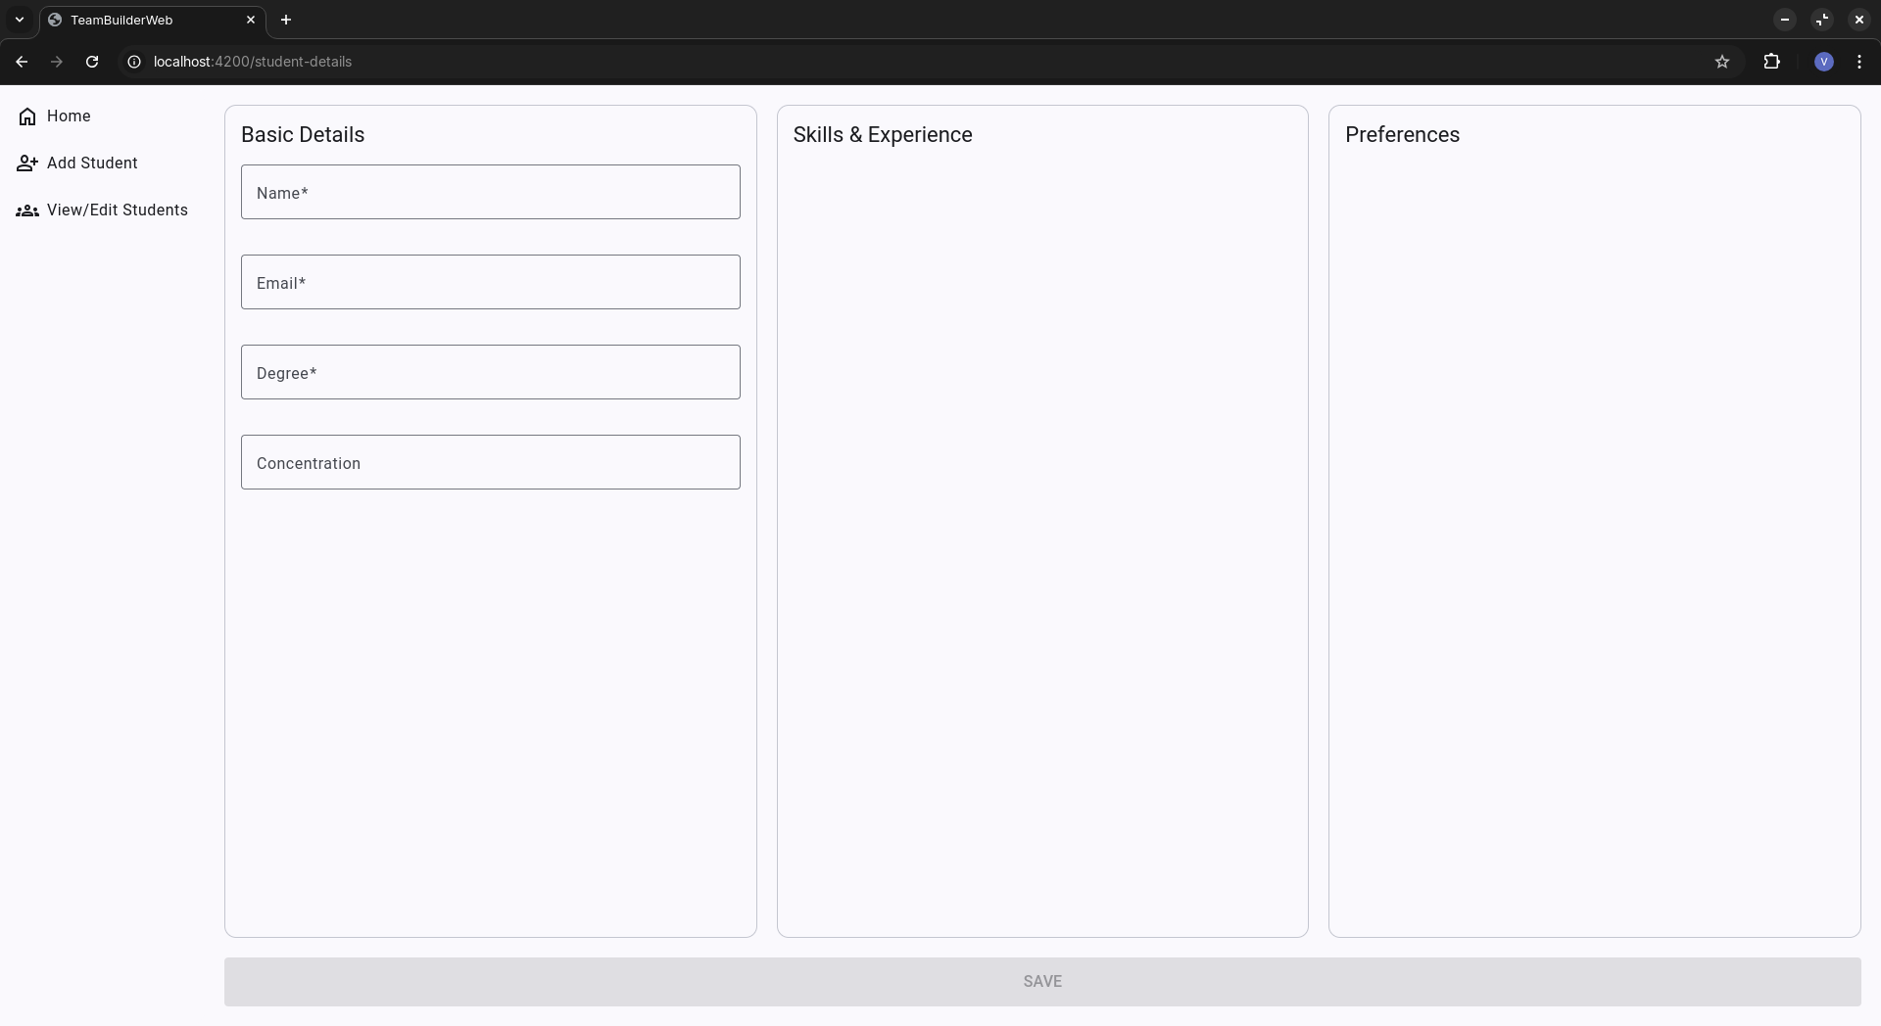

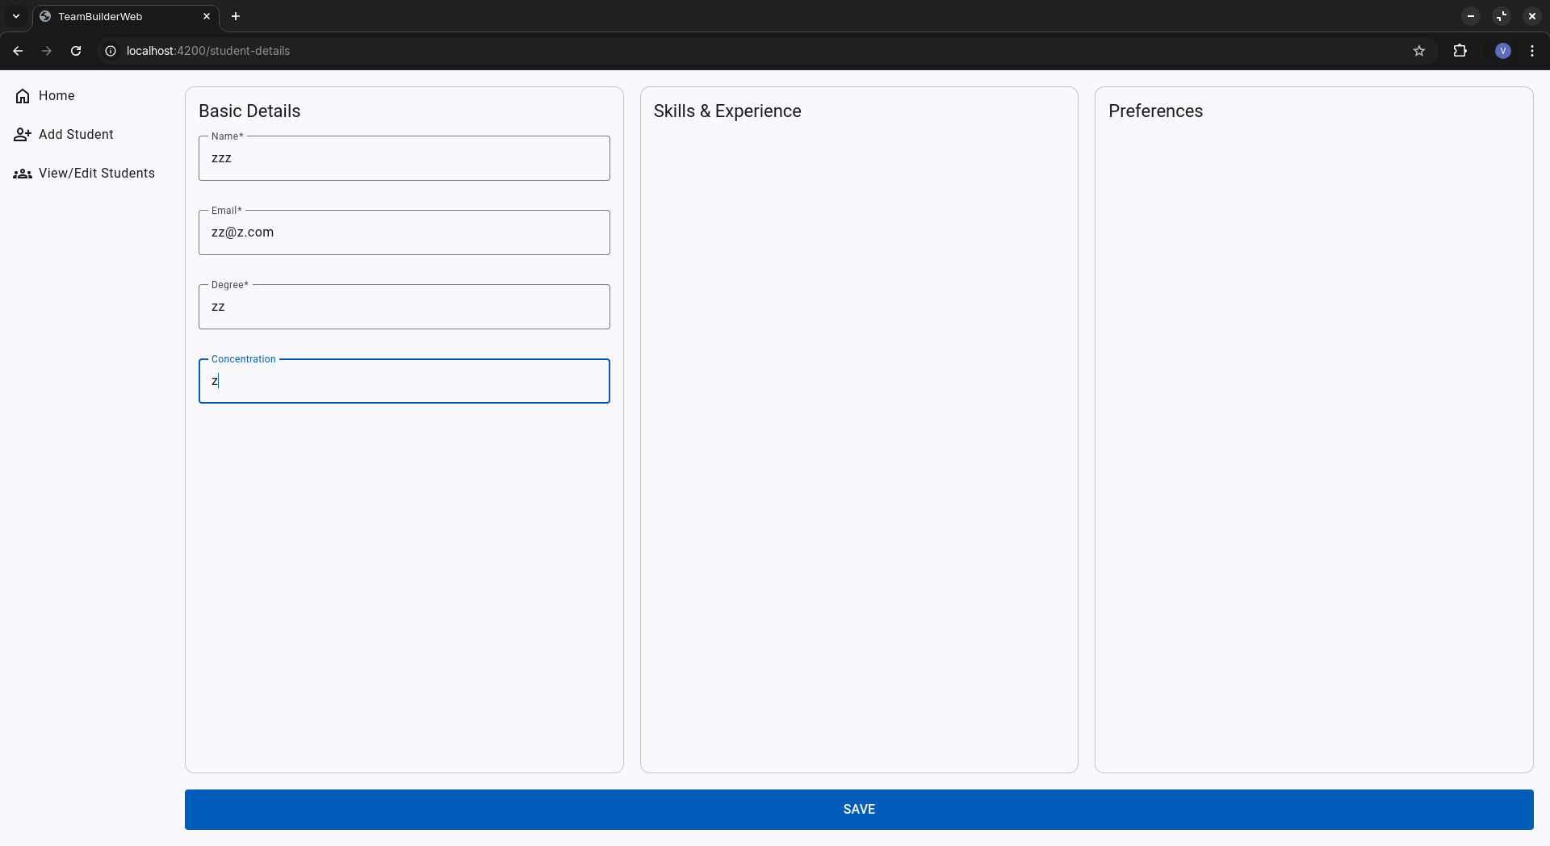
- Pass or Fail: Pass

Automated Testing Report

Unit testing - UI:

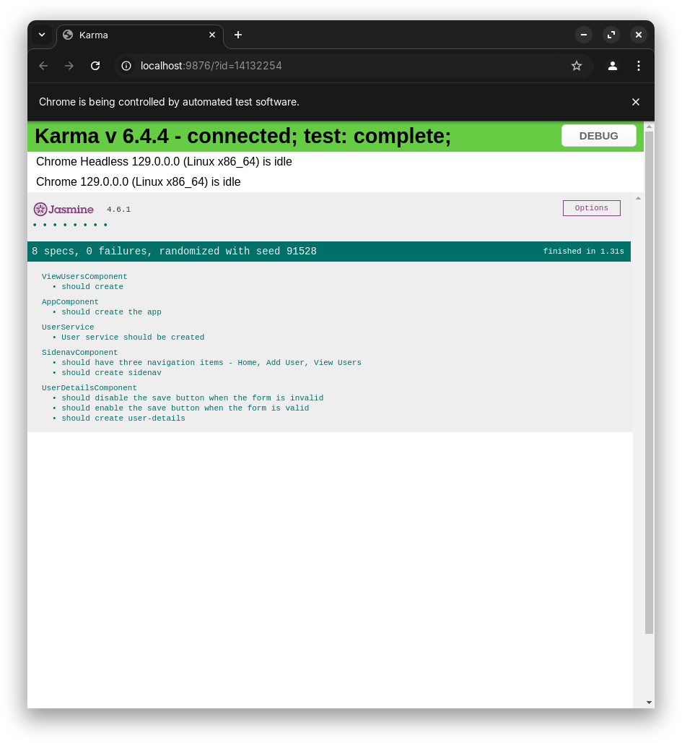

Test coverage report

Coverage results are stored in the team-builder-web/coverage directory

Coverage report of Sidenav component:

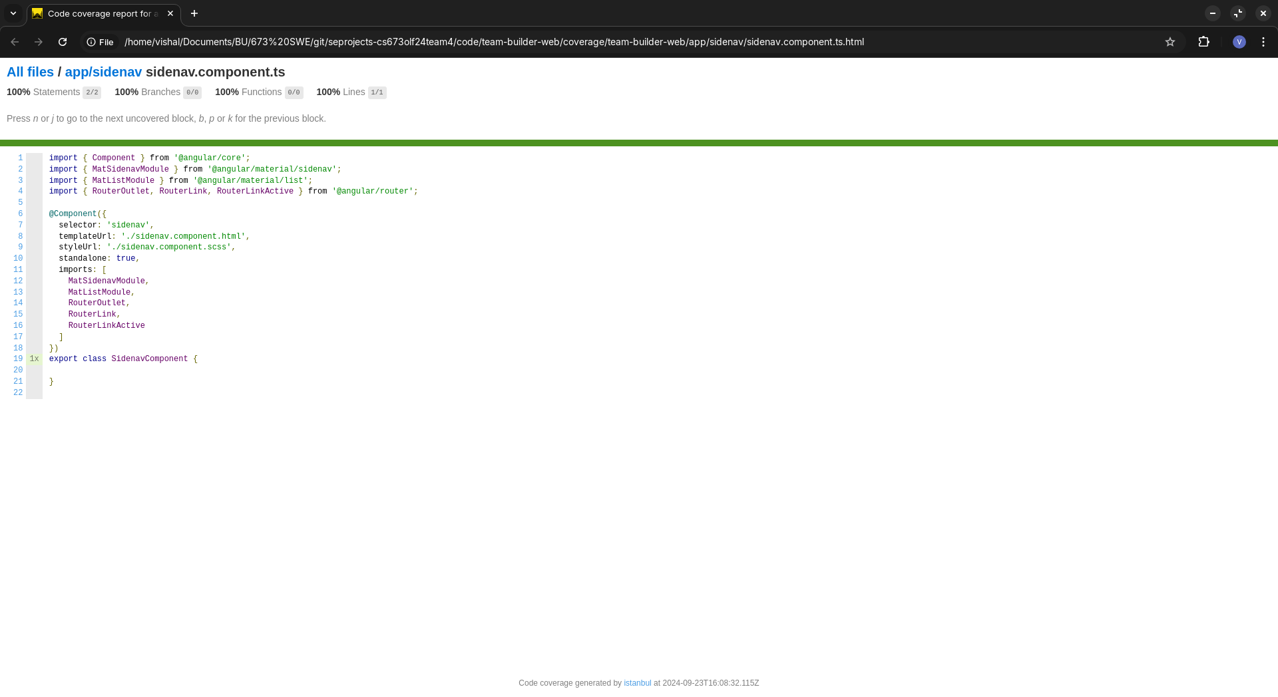

Coverage report of User details component:

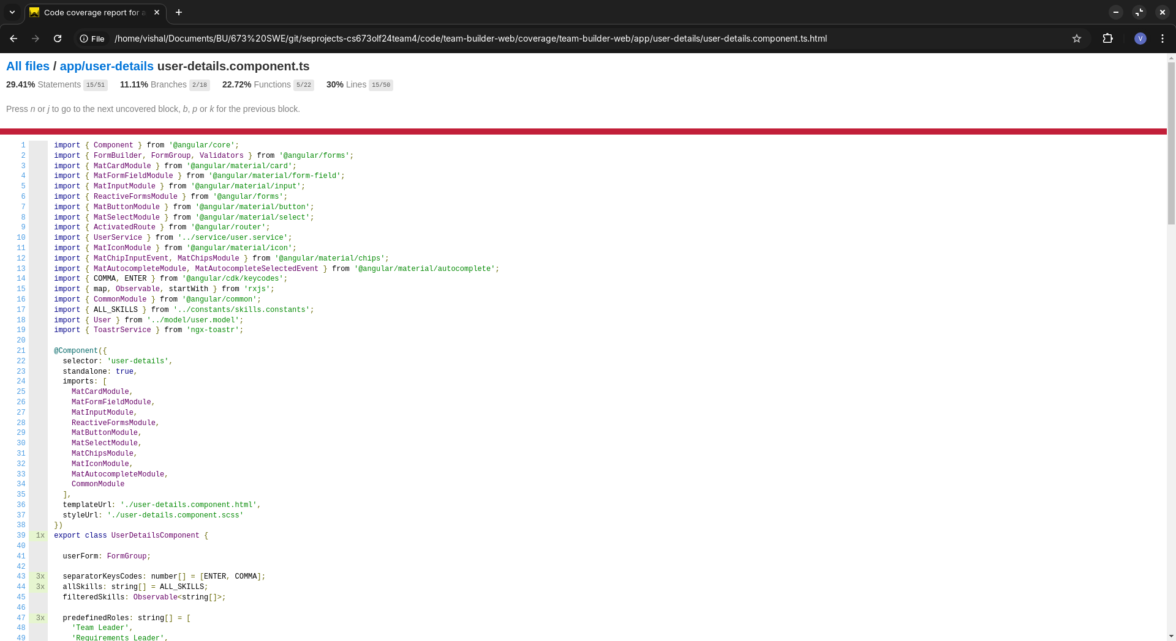
End-to-end testing:

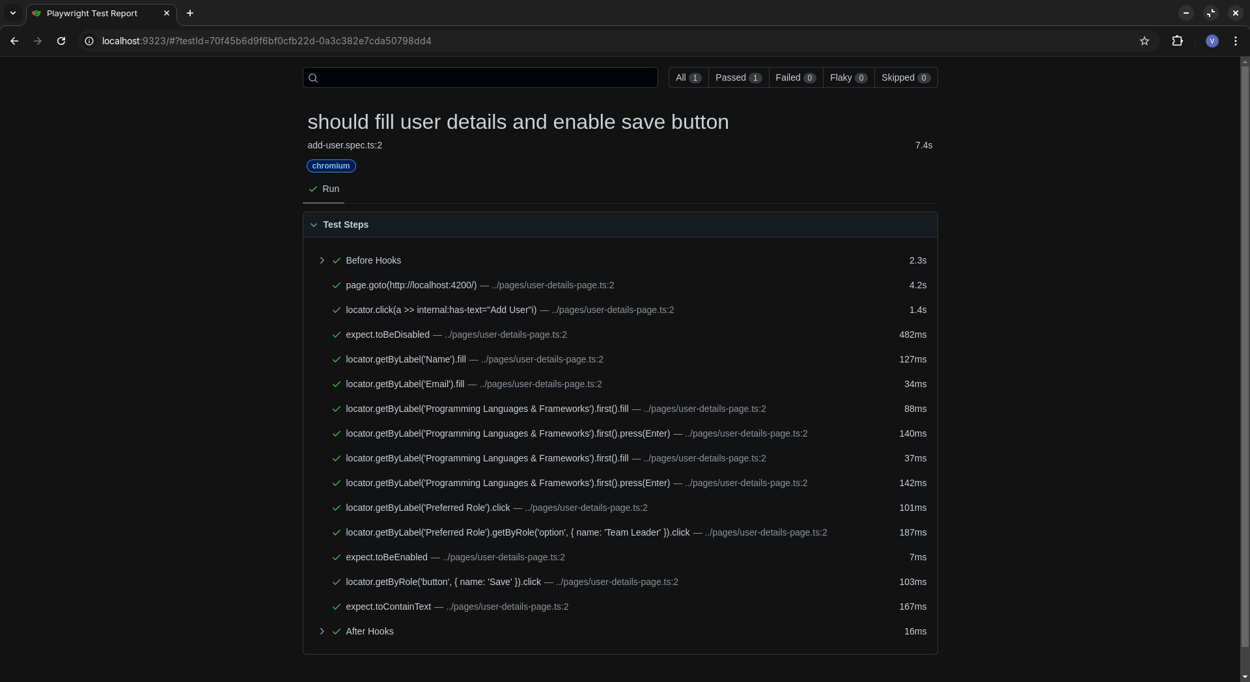

Testing Metrics

UI unit tests:

Number of test cases: 8
Test coverage: 40.22%

End-to-end tests:

Number of tests: 1
Test coverage: 100%

Server tests:

Number of tests: 14
Test coverage: 88%

Defects: 0

Backend Automated Testing Report
1. TeamBuilderApplicationTests:
a. testUserCreation
Creates a new user and verifies its properties
b. testGetAllUsers
Retrieves all users and checks the count
c. testUpdateUser
Updates a user's role and answers, then verifies the changes
d. testDeleteUser
Deletes a user and verifies the user count decreases
e. testTeamAssignment
Creates a group with multiple users
Assigns users to teams
Verifies team sizes
Checks role distribution across teams
Ensures Design and Implementation Leaders are in different teams
Verifies even distribution of roles with multiple users
Checks distribution of high-scoring users
2. ControllerTest:
User API Tests:
a. testCreateUser
Creates a new user via API and verifies the response
b. testGetAllUsers
Retrieves all users via API and checks the response format
c. testGetUserById
Creates a user, then retrieves it by ID and verifies the details
d. testUpdateUser
Creates a user, updates its details, and verifies the changes
e. testDeleteUser
Creates a user, deletes it, and verifies it's no longer retrievable
Group API Tests:
f. testCreateGroup
Creates a new group via API and verifies the response
g. testGetAllGroups
Retrieves all groups via API and checks the response format
h. testGetGroupById
Creates a group, then retrieves it by ID and verifies the details
i. testAssignTeams
Creates a group, assigns teams, and verifies the response

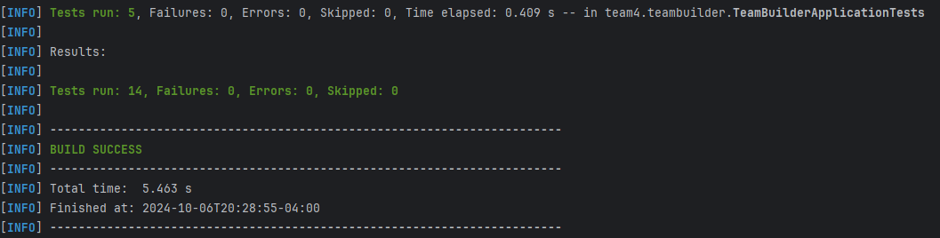

References

Glossary

