**CS673 Software Engineering**

**Team 4 - Team Builder**

**Software Design Document**



| Team Member | Role(s) | Signature | Date |
| --- | --- | --- | --- |
| Raymond Chen | Configuration Leader | *Raymond Chen* | 09/22/2024 |
| Max Zink | Design and Implementation Leader | *Max Zink* | 09/22/2024 |
| Wenli Gai | Security Leader | *Wenli Gai* | 09/23/2024 |
| Jake Kelly | Team and Requirements leader | *Jake kelly* | 9/23/2024 |
|  |  |  |  |
|  |  |  |  |
|  |  |  |  |
|  |  |  |  |

**Revision history**

| **Version** | **Author** | **Date** | **Change** |
| --- | --- | --- | --- |
| **0.2** | **Raymond Chen** | **10/6/24** | **Database Design, algorithm, class diagram** |
| **0.2** | **Max Zink** | **10/7/24** | **Design Patterns and general edits** |
| **0.3** | **Raymond Chen** | **10/14/24** | **Database Design** |

Introduction

Software Architecture

Class Diagram

● UI Design

● Database Design

● Security Design

● Business Logic and/or Key Algorithms

● Design Patterns

● Backend API endpoints

● References

● Glossary

# Introduction

TeamBuilder is a team assignment tool to help create teams based on a few simple, but important questions that users will answer. This document outlines the architecture, class structure, user interface, database, and key algorithms of the TeamBuilder system.

# 

# Software Architecture

The architecture follows a three-tiered design using Angular for the frontend, Spring Boot for the backend, and an H2 database for local data storage.

* Frontend: Angular will manage the user interface, handling user inputs via forms, and sending requests to the backend through RESTful APIs.
* Backend: Spring Boot will handle all business logic, including processing questionnaire data, team formation, and managing groups.
* Database: The H2 database will be used to store user responses and team assignments.

Architecture Diagram

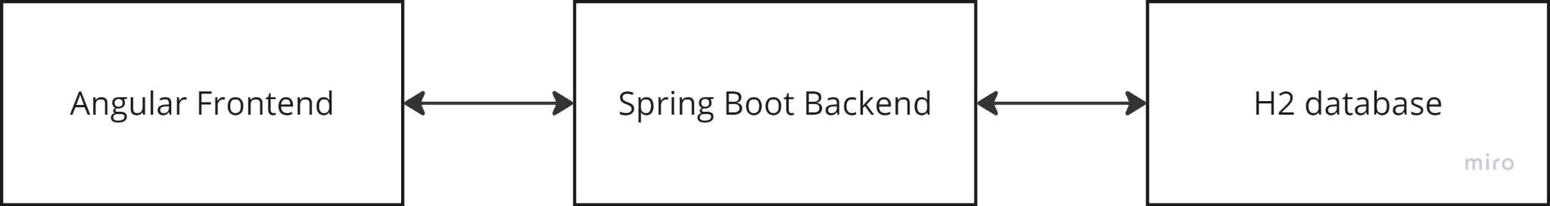

# Class Diagram

In this section, you will provide a detailed description of each component (or package) and use one or multiple class diagrams to show the main classes and their relationships in each component.

The system will be divided into several main packages:

* Controller:
  + UserController: Manages user interactions.
  + GroupController
* Service:
  + TeamAssignmentService: Implements the team formation algorithm.
  + UserService: Handles the user profile data.
  + GroupService
  + QuestionnaireService: Handles the process of questionnaire data.
* Model:
  + User: Represents a user and response.
  + Questionnaire: Represents the questionnaire filled by the user.
  + Team: Represents a team and list of users.
  + Admin

Class Diagram

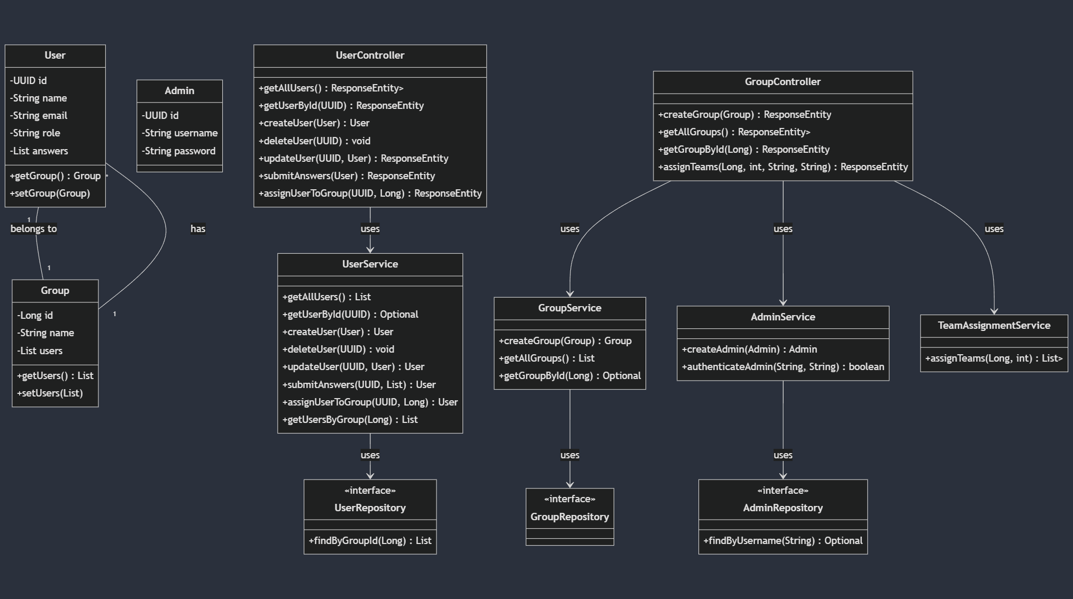

# UI Design

The UI is divided into following main components:

* Navigation (Sidenav)
  + Location: The navigation is presented as a left-aligned sidenav, always visible
  + Items:
    - Home: Redirects users to the home page.
    - Add Student: Opens the form for adding new student profiles.
    - View/Edit Students: Allows viewing and editing existing student profiles.
* Form Layout for Adding Student Details: The Add Student page uses a form that is organized into three distinct columns:
  + Basic Details: Captures the student's name, email, degree, and concentration.
  + Skills & Experience: Can include fields for the student’s years of experience, relevant skills, and past projects.
  + Preferences: Allows the user to specify their preferred role in a team (e.g., Team Leader, QA Leader) and their availability.

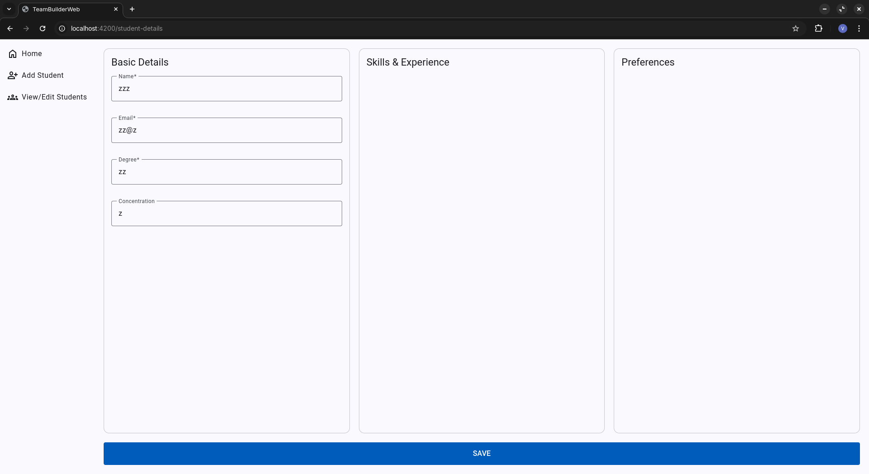

# 

# Database Design

* users Table:
  + id (UUID, Primary Key)
  + name (String)
  + email (String)
  + role (String)
  + group_id (Long, Foreign Key to groups table)
* user_answers Table (for User's answers):
  + user_id (UUID, Foreign Key to users table)
  + answers (String)
* admins Table:
  + id (UUID, Primary Key)
  + username (String)
  + password (String)
* groups Table:
  + id (Long, Primary Key, Auto-increment)
  + name (String)
  + teams Table:
  + id (UUID, Primary Key)
  + team_number (Integer)
  + group_id (Long, Foreign Key to groups table)
* team_users Table (Junction table for Team-User many-to-many relationship):
  + team_id (UUID, Foreign Key to teams table)
  + user_id (UUID, Foreign Key to users table)
* Relationships:
  + A User belongs to one Group (Many-to-One)
  + A Group can have many Users (One-to-Many)
  + A Team belongs to one Group (Many-to-One)

In relation to our project as a whole, the database has a fairly straightforward approach.

A user is a table which includes all necessary information gathered by filling out the survey. This includes the user’s name, email and a list of their provided answers on the survey. Aside from data gathered through the survey, this table also includes a member’s team_id and role. These two entries are of course dependent on Teambuilder’s algorithm executing, and will be empty if a User has yet to be assigned.

The User_Answers table contains specific data from the survey. Answers don’t include information such as name, email, or role. Rather, answers contain specific keywords gathered from a user’s answers on our survey. For example, if a user were asked the question “what programming languages are you familiar with?” and the user answered C++, then a new entry would be added to User_Answers with the answer keyword “C++” and a foreign key for the id of this user. This table allows us to have multiple of the same, or similar, keyword answers. Through these repetitions, with our algorithm, we would be able to group users together depending on the needs of a specific team.

Finally, the Teams table is a two field table used to group users. Aside from the id, Teams only includes the team name, which is of course used to differentiate the teams. This table is referenced by the User table, which stores the team’s id in its foreign key team_id. Outside of the database, a “team” is a list of users. Above the team list we have the “teams” list which is a list of all created “team” lists.

# Security Design

TeamBuilder implements essential security measures to protect user data: Users log in securely with hashed passwords using Spring Security. Data transmitted between the frontend and backend is encrypted via HTTPS. Sensitive data (like passwords) is encrypted at rest in the database. All user inputs are validated and sanitized to prevent attacks like SQL injection and cross-site scripting (XSS). Session Management: Secure session handling using HTTP-only cookies with automatic logout after inactivity. Important actions, such as team updates are logged for monitoring and security reviews. Regular database backups ensure data can be restored in case of failure.

# Business Logic and/or Key Algorithms

TeamAssignmentService

Algorithm:

1. Group users by role

2. Calculate users score by adding the answer’s keywords * weight of the keyword

3. Sort each role by the user's score (Highest to Lowest)

4. Assign users to teams, prioritizes role distribution then use score. Assign in order team1, team2, team3, team3, team2, team1.

# Design Patterns

We have now implemented the observer design pattern. Since our focus of our project is assignment of different users into teams, it was important to implement a system which could alert a user when they have been assigned. Of course, the most obvious choice of a design pattern for such a system is the observer pattern. To break it down quickly, we create multiple “observer” objects that contain the user’s data and assign these objects to monitor a certain subject. We added the subjects into the teamAssignmentService file and created a new subject for each team. Then, when users are added to the team, they are also stored by an observer to watch that team's subject. When the assignment is finished, each subject gains the value of (“Added to team (whatever the team number is)). This would then alert the observers of the assignment. The observer pattern is implemented into the final version of the product and serves as a good base for the desired addition of email alerts.

# Backend API endpoints

* Refer to link <https://github.com/BUMETCS673/seprojects-cs673olf24team4/blob/main/code/TeamBuilder/API_DOC.md>

# 

# References

# Glossary