**CS673 Software Engineering** 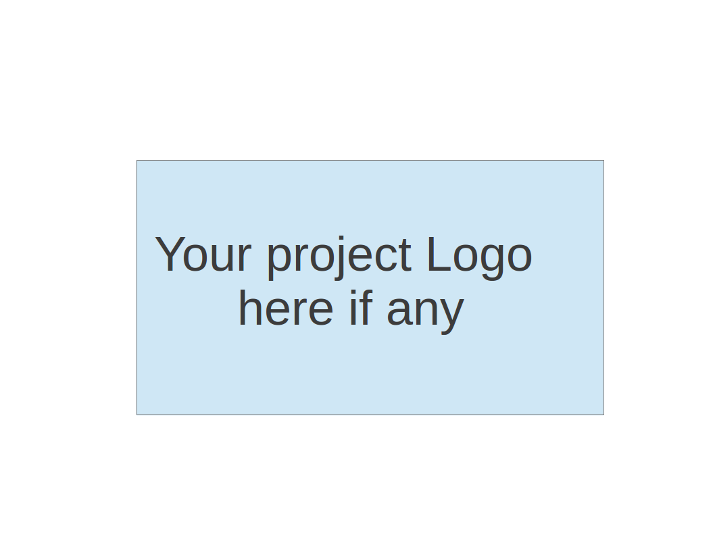

**Team 6 - Blockbuster**

**Software Design Document**

| Team Member | Role(s) | Signature | Date |
| --- | --- | --- | --- |
| Joshua Shilts | Leader | *Joshua Shilts* | 9/11/2024 |
| Elizabeth Tyree | Design and Implementation Leader | *Elizabeth Tyree* | 9/11/2024 |
| Ricky Zheng | Configuration Leader | *Ricky Zheng* | 9/11/2024 |
| Alex Flinchum | QA Leader | *Alex Flinchum* | 9/11/2024 |
| James Zheng | Security Leader | *James Zheng* | 9/11/2024 |
| Rekik Mengstu | Requirement Leader | *Rekik Mengstu* | 9/11/2024 |
|  |  |  |  |
|  |  |  |  |

**Revision history**

| **Version** | **Author** | **Date** | **Change** |
| --- | --- | --- | --- |
| **v1.0.0.** | [Joshua Shilts](mailto:jshilts@bu.edu) | **9/22** | **Creation** |
|  |  |  |  |

Introduction

Software Architecture

Class Diagram

UI Design (if applicable)

Database Design (if applicable)

Security Design

Business Logic and/or Key Algorithms

Design Patterns

Any Additional Topics you would like to include.

References

Glossary

# Introduction

This document provided a brief overview of our software design and architecture.

# Software Architecture

Our software is broken down into three main components or microservices that is built within the Python Flask framework that utilizes Rest API calls to communicate between each service.

# Class Diagram

This is a sequence diagram that shows the flow of events, responses and data when a user submits a query by pressing the generate button. This diagram is expected to grow with more features if time allows to work on cosmetic features in the UI.

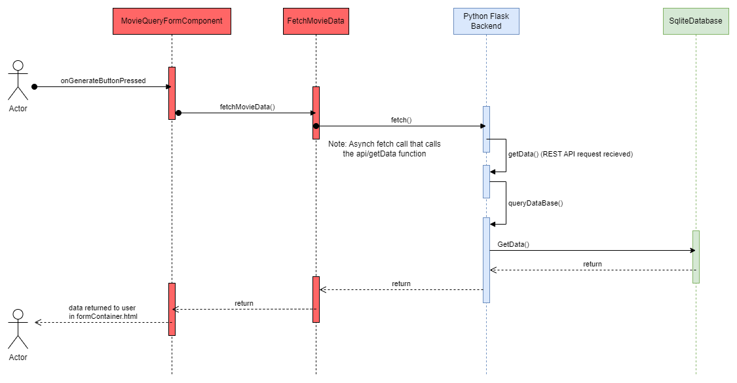

# UI Design (if applicable)

* + Use ui mock ups

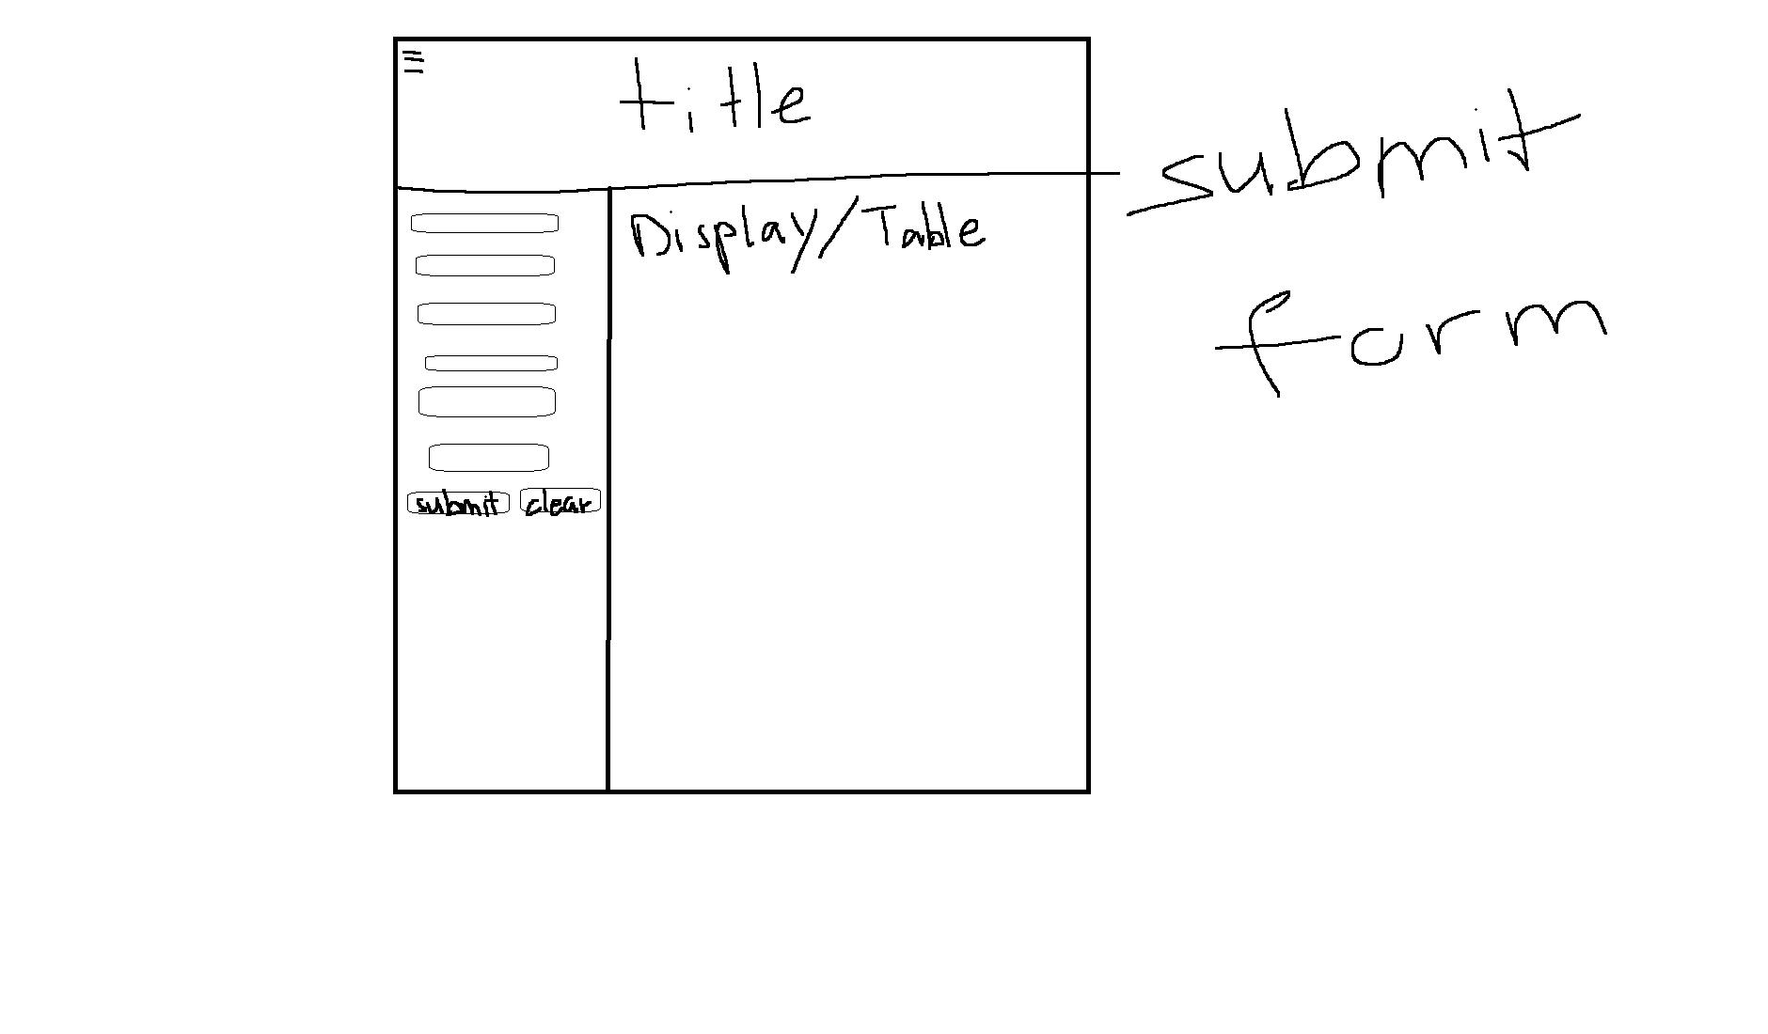

In this section, you can describe your UI design

# Database Design (if applicable)

The Database design uses joint tables in order for movies to have more than one director, writer, cast, and genre associated with it

The age rating also gets its one table so that we do not have to repeat data within the movie table.

* There is one age rating for many movies
* There is one Movie_Director entry for one movie
* There is one Movie_Writers entry for one movie
* There is one Movie_Cast entry for one movie
* There is one Movie_Genre entry for one movie
* There is one or many Directors for zero or many Movie_Directors entry
* There is one or many Writers for zero or many Movie_Writers entry
* There is one or many Casts for zero or many Movie_Casts entry
* There is one or many Genres for zero or many Movie_Genres entry

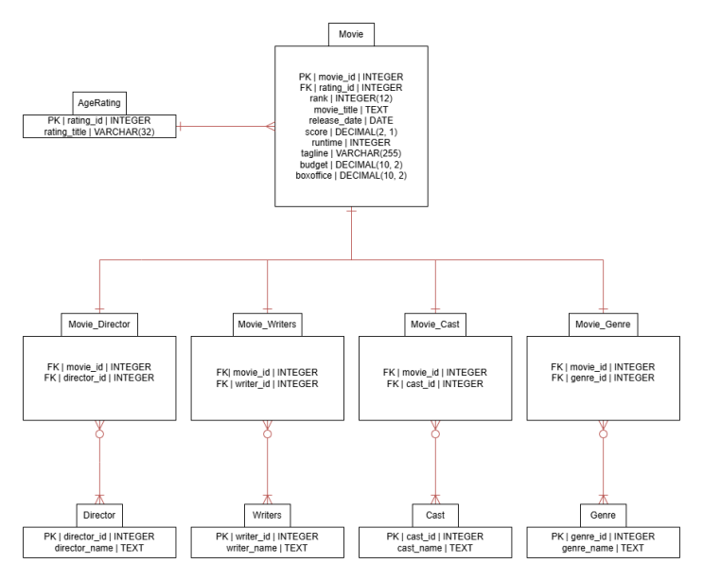

# Security Design

The security design at the moment is to utilize our pipeline and existing tools or plugging in github to find and address some vulnerabil;ities in our code. We plan to use Pylint and a static code analysis tool and pick several security defects in our code and create a bug and resolve that issue.

# Business Logic and/or Key Algorithms

N/A

# Design Patterns

We are attempting to use MVC in the frontend and also the observer pattern in React. That is everytime a state changes react will in hope will trigger an event that will call functions in the corresponding controller that will update the UI based on a user action such as a button press.

# References

# Glossary