**CS673 Software Engineering** 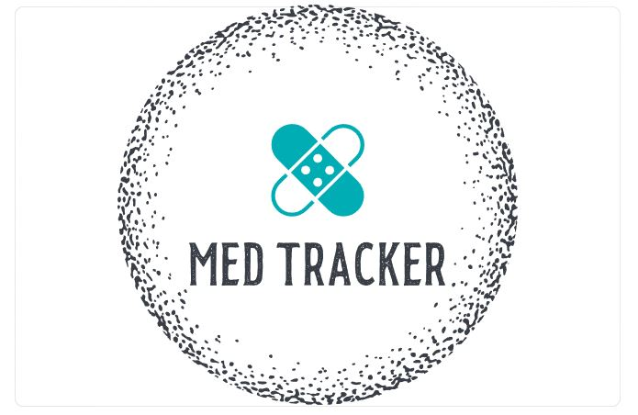

**Team 1 - Med Tracker**

**Project Proposal and Planning**

| Team Member | Role(s) | Signature | Date |
| --- | --- | --- | --- |
| Andrew Gieraltowski | Team leader | *AJG* | 2022/9/11 |
| Yuan Wang | Requirement Leader | *Yuan Wang* | 2022/9/11 |
| Yuan Wang | Design and Implementation Leader | *Yuan Wang* | 2022/9/11 |
| Haiyang Lu | QA leader | Haiyang Lu | 2022/9/11 |
| Andrew Gieraltowski | Configuration Leader | *AJG* | 2022/9/11 |
| Haiyang Lu | Security Leader | Haiyang Lu | 2022/9/11 |
| [Divya Thomas](mailto:divthomas22@gmail.com) | Design and Implementation Leader | *Divya Thomas* | 2022/9/11 |
| [Divya Thomas](mailto:divthomas22@gmail.com) | QA Leader | *Divya Thomas* | 2022/9/11 |
| Andrew Gieraltowski | Team leader | *AJG* | 2022/9/11 |

**Revision history**

| **Version** | **Author** | **Date** | **Change** |
| --- | --- | --- | --- |
| **1.1** | **Haiyang Lu** | **09/13/2022** | **Add content for Overview and Related Work** |
| **1.2** | **Andrew Gieraltowski** | **09/13/2022** | **Filled out Configuration Management Plan and Functional Requirements** |
| **1.3** | **Yuan Wang** | **9/13/2022** | **Add content for Related work and Filled out Timeline** |
| **1.4** | **Divya Thomas** | **9/13/2022** | **Added content for Management Plan and QA Plan** |

Overview

Related Work

Proposed High level Requirements

Management Plan

Objectives and Priorities

Risk Management (need to be updated constantly)

Timeline (need to be updated at the end of each iteration)

Configuration Management Plan

Tools

Deployment Plan if applicable

Quality Assurance Plan

Metrics

Code Review Process

Testing

Defect Management

References

Glossary

# Overview

Our product is an android application that helps users keep track of the medications they are taking. It is a calendar like application that has built in alarms with a focus on ease of use for elderly, disabled or forgetful individuals.

In modern society, despite the development of medical technology has greatly delayed people’s lifespan and the difficulty of treating diseases, many senior citizens still struggle with not getting timely treatment. In many cases, this is not because of the lack of medical resources or difficulties in seeking medical care. Sometimes, it is caused by the elderly who just forget to take medicine on time, which causes the treatment interruption.

Since it can be hard for some people to keep track of and stressful to organize, our main goal is to design an application that will do all the heavy lifting for the user to have all information regarding their medications and reminders according to their schedules to ensure no medication is missed, all in the convenience of their mobile device.

# Related Work

MyTherapy: Medication Reminder: “Combining a pill tracker, mood tracker, and a health journal, My Therapy enables you and your doctor to put your treatment’s success into perspective.” <https://www.mytherapyapp.com/>

Med Intelligence: automatically reminding people especially with diabetes to take medicine at the right time. Med intelligence enables you to upload your medicine and monitor people’s medication schedule. The difference between Med Intelligence and our software is that Med intelligence focused on people on every ages while we focused on especially elderly people. Elderly people usually takes more medicine than younger people, and they are more likely to forget the dosage and regularity. Therefore, our software will be designed to fit elderly people’s needs.

# Proposed High level Requirements

* 1. Functional Requirements  
     (For each functional requirement, please give a feature title and a brief description using the following format: As (a role), I want to (action), so that (value).)
     1. Essential Features (the core features that you definitely need to finish):
        1. Android App UI
        2. Scheduler
        3. Input module
        4. Recommendation system
     2. Desirable Features (the nice features that you really want to have too):
        1. TBD
     3. Optional Features (additional cool features that you want to have if there is time):
        1. TBD
  2. Nonfunctional Requirements
     1. Security requirements

# Management Plan

## Objectives and Priorities

* + 1. Complete all proposed essential features
    2. Successful deployment of software
    3. No known bugs associated with the software
    4. Simplistic design and meeting usability requirements

## Risk Management (need to be updated constantly)

Some potential risks associated with the application that we had discussed are related to the usability of the software. We want to make sure that the complexity is kept to a minimum to allow the application to be useful to the target users of an older and less technical age group. Some other risks can be associated with the code readability and communication between team members. These are all detailed within the Risk Management document linked below.

**Risk Management Sheet Link: https://docs.google.com/spreadsheets/d/1gmZXaYyKTldJaRGMjqJisWSI9TjAKClJp9PzYK3LlV4/edit#gid=0**

## Timeline (this section should be filled in iteration 0 and updated at the end of each later iteration)

| Iteration | Functional Requirements(Essential/Disable/Option) | Tasks (Cross requirements tasks) | Estimated/real person hours |
| --- | --- | --- | --- |
| 1 | The system should be able to create, delete, and edit the medication | Setting up the main page, the “add medicine” page and their connections | 6 |
| 2 | The system should be able to notify users of the time which they need to take the medicine | Setting up the notification system, enable users to edit the notification | 4 |
| 3 | The system should be able to record the medicine information and whether the user eat it on time | Creating a database to store all the medicine information | 8 |

# Configuration Management Plan

## Tools

* Android Studio for development
* Discord for communication
  1. **Code Commit Guideline and Git Branching Strategy**
* Branches will be created with the following structure
  + [Username]-[Branch Description]
* A description of the change made in the branch will be required in the pull request

## Deployment Plan if applicable

* No plan at this time to deploy.

# Quality Assurance Plan

## Metrics

| Metric Name | Description |
| --- | --- |
| Code Readability | Best programming practices are used and sufficient documentation is provided |
| Usability | Usability goals of this project is a simplistic design valuing efficiency, learnability, and utility. |
| Buggy Code | Count of number of bugs detected |
| Test Pass Rate | The percentage of test cases passed |
| Product Complexity | Number of files, classes, methods. |

* 1. Coding Standard

We will be using Java/Android coding standards and best practices discussed in the following sources:

<https://www.geeksforgeeks.org/android-coding-style-and-guidelines/>

<https://www.perfomatix.com/best-practices-in-android-coding/>

## Code Review Process

All team members’ code and other work will be reviewed by at least one other member of the team during our weekly Sunday meetings. QA Leaders plan to develop a checklist with all QA metrics to evaluate the quality of the code with. The reviewer will provide feedback on the results of this evaluation and any suggestions they may have for improvement.

## Testing

**To be determined.**

(Both manual testing and automated testing should be considered. Both unit testing and integration testing should be considered. Briefly describe the testing tools/framework to be used, the personnel involved (e.g. the QA leader will focus on the integration testing and each developer will unit test their own code), when and what types of testing will be performed, the testing objectives, etc)

## Defect Management

Bugs or defects will be expected to be detected during code reviews and all forms of testing. Once detected, the developer responsible for the issue or defective feature will be expected to revise and find a solution, with the aid of other members if needed.

# References

<https://www.geeksforgeeks.org/android-coding-style-and-guidelines/>

<https://www.perfomatix.com/best-practices-in-android-coding/>

(For more details, please refer to the encounter example in the book or the software version of the documents posted on blackboard. )

# Glossary

(Any acronym used in the document should be explained here)