# ninjaCap: Brief introduction

Inputs to our ninjaCap framework are

1. a "probe.SD" file that describes the geometrical setup (as documented in the Homer2 toolbox)
2. a "gIDs.mat" file that assigns an ID (=type) to each grommet in the probe.
3. the desired headcircumference in cm.

Outputs of this code are four .stl files for 3D printing with ninjaflex.

# PREPARING FILES FOR A CAP BUILD

## 1. Create your "probe.SD" using Homer's AtlasViewer GUI.

Save that configuration under the name "probe" with the native ".SD" file extension. Keep your "probe.SD" for later.

## 2. Create your "gIDs.mat" file

All optodes in your SD probe, be it emitters, detectors, or dummy/anchor optodes, will need to be assigned a grommet identifier ("gID"). These identifiers are 6-character strings, with the first character being a '#', e.g. '#DUMMY'. The ninjaCap code uses these identifiers to place grommets (optode holders) or other elements at the respective position in 3D. A brief instruction and list of currently supported grommets/holders, including their IDs, is provided in the table on the next page. You can also come up with your own unique ID and add the corresponding STL files, following a naming and directory convention, as briefly outlined in the above docu file.

1. If you use Homer2 to generate your probe.SD, you will have to manually generate the gIDs file, which is a 1 x N matlab cell array of strings, where N is the overal number of optodes, including dummy/anchor optodes in your probe. To generate the gIDs.mat file, you can use and adapt the "generate\_gIDs\_example.m" script in the root ninjaCap directory.
2. If you use Homer3, you will (soon) be able to just assign each optode its gID in the drop down menu of the AtlasViewer probe GUI. The rest is automatically handled. This feature is currently not yet active.

|  |  |  |  |
| --- | --- | --- | --- |
| **Identifier** | **Info** | **Image** | **Dimensions** |
| #NFLPS | **N**IRS: **F**iber-based optode holder (CW6 fibers) with **L**ow **P**rofile and single **S**hort-separation hole |  |  |
| #NFHPS | **N**IRS: **F**iber-based optode holder (CW6 fibers) with **H**igh **P**rofile and single **S**hort-separation hole |  |  |
| #NFWMS | **N**IRS: **F**iber-based **W**ide optode holder (CW6 fibers) with **M**ultiple **S**hort-separation holes |  | Inner radius: 03.4 mm Outer radius: 08.0 mm  Height: 02.0 mm  SS Distance: 08.0 mm SS radius: 0.90 mm |
| #NFDSO | **N**IRS: **F**iber-based **D**ual **S**s **O**ptode holder |  |  |
| #NOND1 | **N**IRS: **O**pen f**N**IRS **D**ual optode holder for optodes in printed case |  |  |
| #PMRK1 | **P**osition **M**a**RK**er in small cross shape, symmetric |  |  |
| #ACHLD | ninjaNIRS **AC**celerometer **H**o**LD**er |  | 21 mm diameter  10 mm height |
| #EBPAS  (currently N/A) | **E**EG electrode holder from **B**rain **P**roducts: **A**ctiCap **S**nap |  | C:\Users\avolu\AppData\Local\Microsoft\Windows\INetCache\Content.Word\I_ac_snap_top.png |
| #EECEH  (currently N/A) | **E**EG **E**asy **C**ap **E**lectrode **H**older:Ring for commercial electrode holders | Tbd | Tbd |
| #DUMMY | **Dummy** Optode, nothing placed | None | None |

**How to provide grommet information:**  
Supply matlab file “gIDs.mat” with variable “gIDs” (grommet IDs) together with the AtlasViewer .SD probe file to us (details on how to generate the gIDs.mat file below)  
For generating the cap files (internal): provide both files in the main ninjaCap code directory.

“gIDs” is a 1 x N+A matlab cell array of strings, where N+A is the number of all N optodes and A anchor (dummy) optodes in the AtlasViewer SD probe patch. In the gIDs file, any optode labeled as dummy optode is being skipped - no grommet is being placed at that position. The type of each other element to be placed is identified by the string ID from the above table. The cell array’s index corresponds to the optode number in AtlasViewer, see image below.

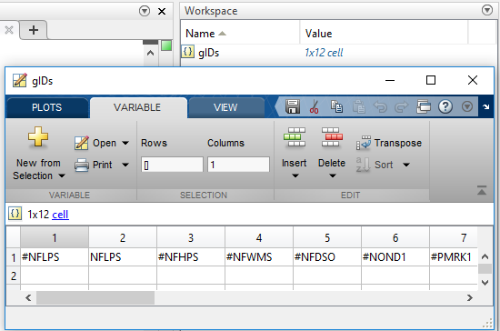 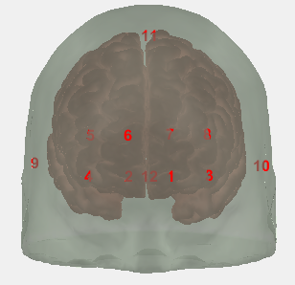

In the above example the .SD probe consists of 8 optodes (index 1-8) and 4 dummy optodes (index 9-12). Fill each corresponding cell array entry with the desired grommet identifier, and – if you do not want anything placed on the dummy optode positions - fill in #DUMMY in the corresponding elements (here 9-12)

Please note for Short Separation (SS) Measurements: Depending on the type of grommet you choose, short separation channels (holes for a SS fiber) are typically already included. In your SD probe layout, you might have added dedicated SS optodes. If you did, just give those a “#DUMMY” ID and no dedicated grommet will be placed at the SS optode location.

**Further cap generation information:**

STL files for these elements are placed under   
 …/ninjaCap/stl/elements/<identifier>/…

where <identifier> is the folder name identical to the defined string ID. Files within are always “grommet.stl” and “grommetComplement.stl”, where “grommet” is the element to be placed, and “grommetComplement” is the keep out geometry used to create corresponding holes/spaces in the panel grids. These “grommets” can have any geometry and can also be elements that are not “grommets” after all.