**ninjaCap: Keep-out regions for ear slit (10-5 choordinates/ anchors)**

see also keepOutEar.SD

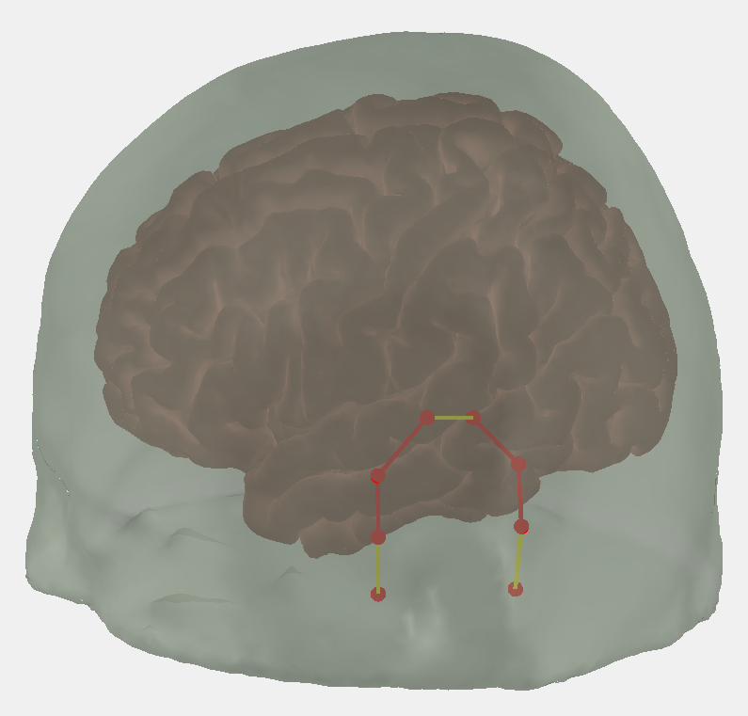 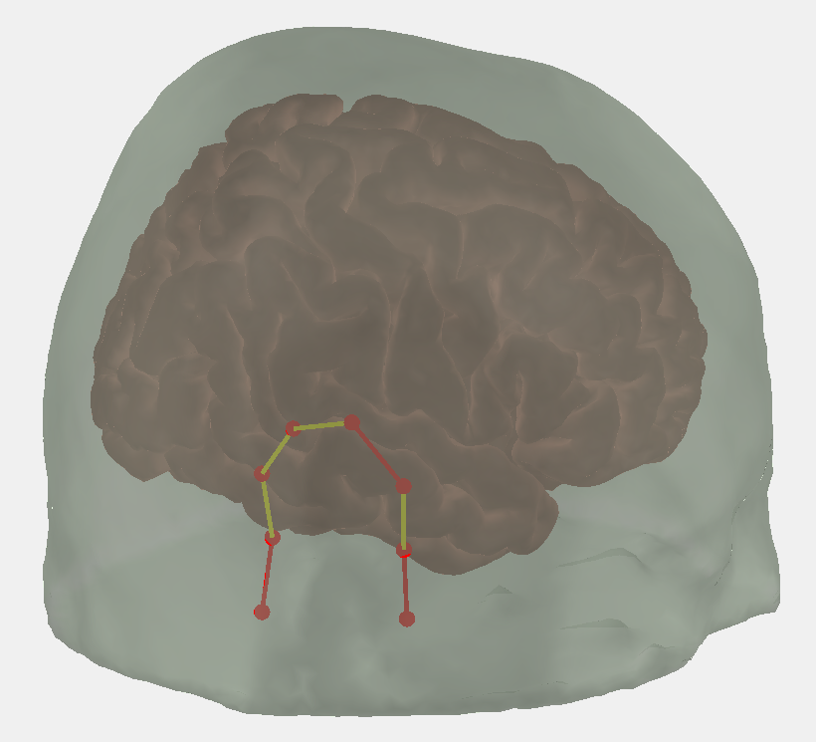

TPP8

TPP10

TPP10h

TTP8h

RPA

T10h

T8

TP8h

TPP9h

TPP7

TPP9

TP7h

TTP7h

T7

T9h

LPA

L

R

**LPA – T9h – T7 – TTP7h – TP7h – TPP7 – TPP9h – TPP9 | TPP10 – TPP10h – TPP8 – TP8h – TTP8h – T8 – T10h – RPA**



