Agile Product Portfolio
Software Engineering Group Coursework

<Project Title>

Group number: <#>

Student ID | Student Name
2944758 | Saidi Fan
3054534 | Xinyi Luan
3064401 | Chenghao Yuan
3033868 | Zhimian Zhao
3047552 | Zhijie Guo

Planning (20%)
Conceptual model
Personas Product Vision User Stories Features Prototype Tests

1.1 Personas
Persona Name | Role/User type | Goals | Pain Points | Related User Stories (IDs)
john | Primary User – Elderly living independently | - Receive reminders for daily physical activity and medication intake including type and dosage.  - Input daily health status easily.  - View weekly summaries of health conditions. 4.Use an emergency button to directly contact the caregiver. 5. Export health and medication records for personal or medical use | - Poor memory leads to forgetting medication dosage and timing. 2.Prefers independent living and does not want to rely on family daily. 3. Traditional interfaces are too complex to use. 4.Declining eyesight requires larger fonts and simple layouts. 5.Reduced hearing makes audio-only alerts unreliable. | S1, S2, S3, S4, S6
Lisa | Secondary User – Caregiver (Daughter) | - Receive daily updates on basic health status and medication adherence.  - View weekly or monthly health summaries.  - Make one-tap calls to the elderly user when needed. 4. Help input and manage medication information （type/dosage/time）remotely. | - Busy work schedule prevents real-time monitoring.  - Frequent checking causes unnecessary interruption to both parties.  - Fear of missing emergencies when not in contact. | S2, S3, S5, S7

Note: You need to have at least two personas. The personas should be used to justify the product vision and user stories.

1.2 Product Vision
FOR elderly individuals living independently and their family caregivers
WHO need a simple and reliable way to manage daily health monitoring and medication adherence without disrupting independent living
The (PRODUCT NAME) is a (product category)
The ElderCare is a user-friendly remote health monitoring web application
THAT enables daily health recording, medication reminders, emergency contact, and shared updates between elderly users and caregivers
UNLIKE complex clinical monitoring systems or general-purpose health apps
OUR PRODUCT prioritises accessibility, simplicity, and family-centred communication through large-interface design and integrated reminder functions.

Note: This product vision should be derived from the defined personas and guides backlog prioritisation and design decisions.

1.3 Meeting Logs (Appendix)

Story Writing (20%)

2.1 Product Backlog and User Stories
Story ID | Feature (epics) | Story Title | User Story | Acceptance Criteria | Priority (Must / Should / Could) | Justification of prioritisation /Trade-off | Story Owner
S1 | Medication & Activity Reminders | Medication & Activity Reminder | As an older adult, I want to receive reminders for medication and daily activity so that I do not forget important routines | Given I have set my medication or activity schedule When the scheduled time is reached Then I see a reminder with large text and clear icons  · | Must | This feature directly addresses memory-related issues and is essential for supporting independent living. Without reminders, older adults may forget medication or activities, which creates safety risks. Advanced personalisation options are deprioritised to keep the interaction simple.
S2 | Daily Health Input | Record Daily Health Status | As an older adult, I want to input my daily health condition so that my wellbeing can be tracked over time. | Given I am on the daily health input page  When I select a simple health option and submit it  Then my health status is saved and I see a confirmation message | Must | Daily health input provides the core data required for monitoring and summaries. The input is intentionally simplified, trading detailed medical information for ease of use and accessibility.
S3 | Health Summary | Weekly Health Summary | As an older adult, I want to view a weekly summary of my health so that I understand my overall condition. | Given I have recorded my daily health status for the past 7 days  When I open the weekly summary page  Then I see a simple visual summary with large text | Should | Weekly summaries improve user awareness and reflection but are not required for immediate safety or daily operation. This feature is prioritised after core monitoring and alert functions.
S4 | Emergency Support | Emergency Contact Button | As an older adult, I want a one-tap emergency button so that I can immediately contact my carer in urgent situations. | Given I have an emergency contact set  When I press the emergency button  Then my designated carer is notified immediately | Must | Emergency contact functionality is critical for user safety and risk management. It is prioritised over non-essential analytics features due to its immediate impact in urgent situations.
S5 | Data Management | Export Medication & Health Data | As an older adult, I want to export my medication and basic health data so that it can be shared when needed. | Given I have recorded my medication and health data  When I select a time range and tap export  Then my data is downloaded in a clear and readable format | Could | Data export is useful for sharing information externally but is not required for daily system use. It introduces additional technical complexity and is therefore deprioritised in early development stages.
S6 | Carer Monitoring | View Daily Health & Medication Status | As a carer, I want to receive daily updates on health and medication so that I feel reassured without frequent interruptions | Given my older family member has submitted daily health and medication information  When I open my dashboard  Then I see the latest daily status summary | Must | This feature directly reduces carer anxiety by providing timely updates without frequent manual checking. Notification frequency is limited to avoid over-alerting and disruption.
S7 | Health Summary | Weekly / Monthly Reports | As a carer, I want to view weekly or monthly summaries so that I can understand long-term trends. | Given health records exist for multiple weeks or months  When I select a weekly or monthly view  Then I see aggregated health trends without medical diagnosis | Should | Long-term summaries support understanding of trends but do not affect immediate response or safety. Real-time detail is intentionally reduced to prevent information overload.
S8 | Communication | One-Tap Call Function | As a carer, I want to call the older adult with one tap so that communication is quick and simple. | Given my older family member is registered as a contact  When I tap the call button  Then the call starts immediately | Could | One-tap calling improves convenience but does not directly contribute to monitoring or safety. It is deprioritised in favour of core communication and alert features.
S9 | Medication Management | Assist Medication Input | As a carer, I want to help input medication information so that records remain accurate. | Given I have permission to manage medication records  When I edit and save the medication information  Then the system confirms that the information has been updated | Must | This feature ensures medication data accuracy while reducing the cognitive burden on older adults. Allowing carers to edit information trades off full user independence for safety and reliability.

2.2 Sprint 1 Summary
Item | Sprint 1 (Weeks2-6)  Discovery, MVP design and partial implementation | Sprint 2(Weeks7-11)  Refinement, testing & evaluation
Planned stories (Plan - P) | S1, S2
Delivered stories (Done - D) | S1
Stories not completed (No - N) | S2
Key change planned for Sprint 2 | Simplify UI | N/A

Note: Stories marked “P” or “N” should be reflected upon in Sprint learning or retrospectives.

2.3 Group contribution and Individual contribution (Appendix)

3. Design (20%)

3.1 Design Models and Evidence
Diagram | Type (Class / Sequence) | Purpose | Related User Stories  (Story IDs) | Design decision rationale
D1 | Class | Domain Structure | S1, S2 | Clarifies data structure

Note: You are not penalised for modifying or discarding models if justified by learning.

3.2 Stories and Evidence
For each story marked as “Done” in Sprint 1 must be mapped to at least one test.

Story ID | Evidence Type (UML Diagram / Git Commit ID(s) / Test Evidence: testcases / their results) | Reference (file / commit / screenshot) | Acceptance Criteria Met (Yes / Partially / No) | Notes  (if partially completed)
S1 | Git commit | a3f9c2 | P | Task saving works, but keyboard navigation is not fully implemented.

Note: If a story is marked “Done” without evidence, it will not be treated as complete.

4. Working Prototype and Implemented Features (20%)
Submit a short video (3-5 minutes) that demonstrates the implementation of 2 core end-to-end features + refinement of Sprint 1 feature. Each demonstrated feature must be traceable to user stories and acceptance criteria. The video should be submitted under the “Product Video” assignment on Canvas.

5. Testing and Evaluation (20%)

Story ID | Acceptance Criteria | Test Performed | Outcome (Pass / Partial / Fail) | Accessibility Checked | Notes  (If partially tested)
S1 | Reminder is displayed at scheduled time with large text and clear icons | Manual test: create a reminder and wait until scheduled time | Pass | Large font, high contrast, clear icons, popup button accessible | Reminder popup triggered correctly
S2 | Health status can be selected, saved and confirmation shown | Manual test: select health status and submit form | Pass | Large buttons, clear icons, readable fonts | Data saved and visible in history page
S6 | Carers can remotely view linked elderly's health trends. | Registered a 'carer' account linked to 'elder1'; verified dashboard data filtering. | Pass | Simple layout, clear data grouping. | Data is presented in a clear, structured list to avoid information overload for busy caregivers.
S9 | Only 'Carer' role can edit medication info. | Switched between 'elder' and 'carer' roles to verify restricted access to edit functions. | Pass | Large confirmation text, high contrast. | Implemented role-based access control (RBAC) to ensure only authorized carers can modify sensitive medical data.

Note: You may have more than one test per story. At least one test per story is required.

Given / When / Then Test Scenarios
S1 – Medication & Activity Reminder Given the user has added a medication or activity reminder When the scheduled time is reached Then a reminder popup is displayed with large text and clear icons Test Result: Pass
S2 – Daily Health Input Given the user is on the daily health input page When the user selects a health status and clicks submit Then the health status is saved successfully and a confirmation message is displayed Test Result: Pass
S6 –Given an elderly user has submitted data. When the linked Carer logs in. Then they can view the summarized health trends of that specific elderly user: Pass
S9 –Given a user is logged in as a 'Carer'. When they update a medication dosage. Then the changes are instantly reflected on the elderly user's reminder list: Pass

APPENDIX
- Group Contribution

Story ID | Story Title | Predicted workload in hours | Actual workload in hours | Status  (TODO/In progress / DONE) | Owner name
S1
S2
S3
S4
S5

- Individual Contribution

Team member | Role (s) | Stories Owned | Evidence (Git / Diagram / Test) | What could have been improved with more time?
StudentName_1 | Backend | S1, S3 | commit a3f9c2, D1

Meeting Logs
You are required to schedule at least 2 meetings with your Customer (TA).

Meeting ID | Team attendees | Customer (TA’s name) | When | Agenda items | Actions and Owner
M1

Meeting Diary for Team meetings
Meeting ID | Team attendees | When | Agenda items | Actions and Owner
M1 | CHENHAO YUAN  SAIDI FAN  ZHIMIAN ZHAO  XINYI LUAN | 2026.2.2 | 1.Confirmation of the project topic--Challenge 2: Remote Health Monitoring - supporting Independent Living for Older  2.Agreement on weekly group meetings on Wednesdays。  3.Discussion and outline of the overall project framework | Action1: Draft the initial project proposal  Owner: Teams

Note: Meeting logs are not marked directly and are used only as supporting evidence.

Test Evidence

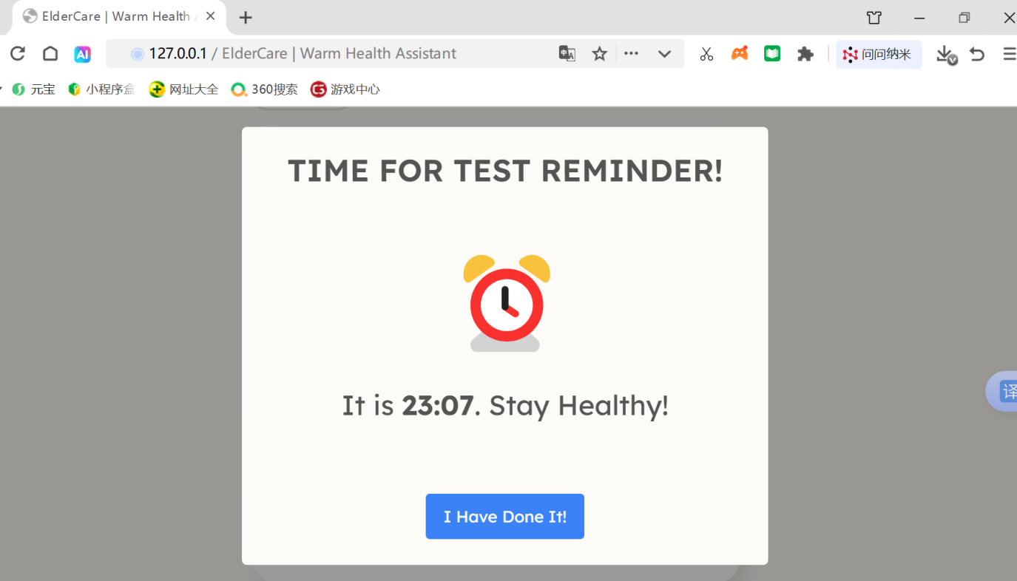
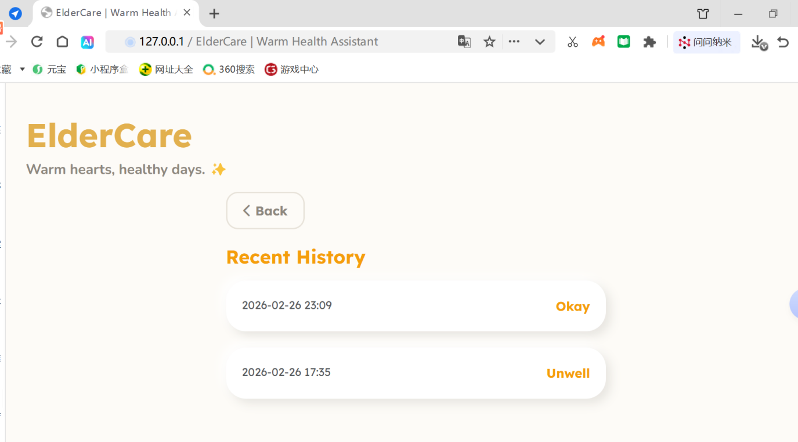
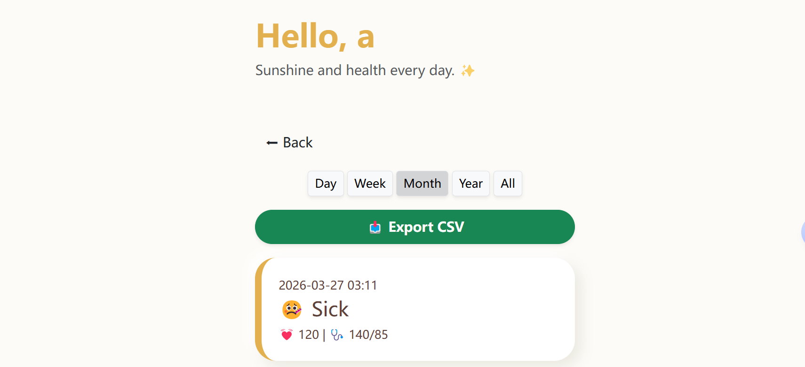

Sprint summary
During Sprint 1, the team mainly focused on implementing two core features: S1 – Medication & Activity Reminder and S2 – Daily Health Input. The reminder functionality (S1) was successfully completed, including backend logic, frontend interface, and automated popup notifications.
Through this sprint, the team gained a better understanding of agile development, task prioritisation, and cross-functional collaboration. In Sprint 2, the team plans to refine the user interface, improve accessibility design, and complete the remaining health input and summary features.
In Sprint 2, we focused on Carer Integration (S6/S9) and System Security. We implemented a linked-account logic that allows caregivers to remotely monitor health status and manage medications. To ensure safety, we added role-based permissions so only carers can modify medical data. Accessibility was further refined by adding larger touch targets and high-contrast themes to support users with declining dexterity and eyesight (Persona: John).

