Machine Learning Midterm Project Report
Datasets: Breast Cancer Wisconsin and Wine

Breast Cancer Datasets
The Breast Cancer dataset is used in machine learning studies related to breast cancer diagnosis. It contains different features about cell characteristics. These features are used to predict whether a tumor is benign or malignant. This dataset is useful for testing and comparing the performance of classification algorithms.
- Loading the Datasets: we upload scikit-learn library for Breast Cancer Wisconsin. Breast Cancer dataset have 569 example and 30 features. Malignant is equal 0. Benign is equal 1. It provides the values for the 30 attributes in the table for 10 people. this values give database .we evaluation this values.
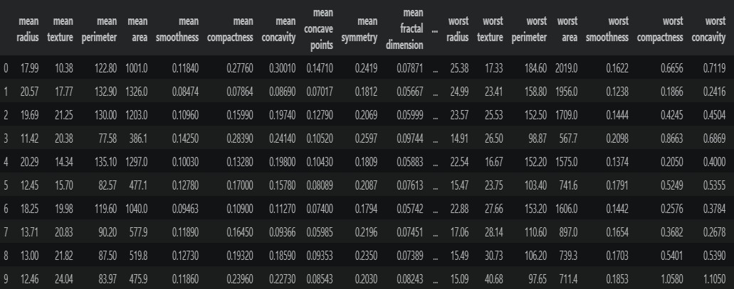
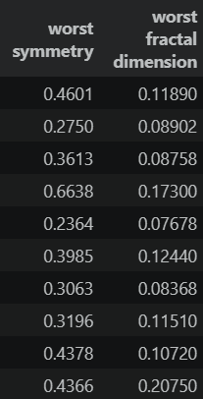

Dataset Quality Checks: We control isnull and Dublicate. We dont find duplicate and isnull so value equals zero. Q1 = %25 , Q3 = %75 , IQR = Q3 – Q1. Values that fall outside the lower and upper bounds are called outliers. There are outliers in this database. We dont delete them because, given that this is in the healthcare field, we do not take that risk.

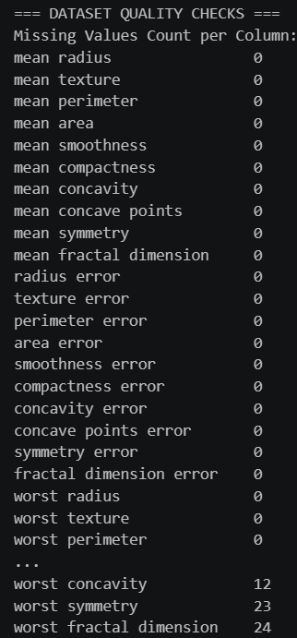

- Exploratory Data Analysis: We calculate mean, min, max, std, Q1, Q3, median. Class distribution plot shows how many bening or malignant tumors there are. We used a heatmap to relationships and similarities among the values. We used boxplots to look for outliers among the data points.
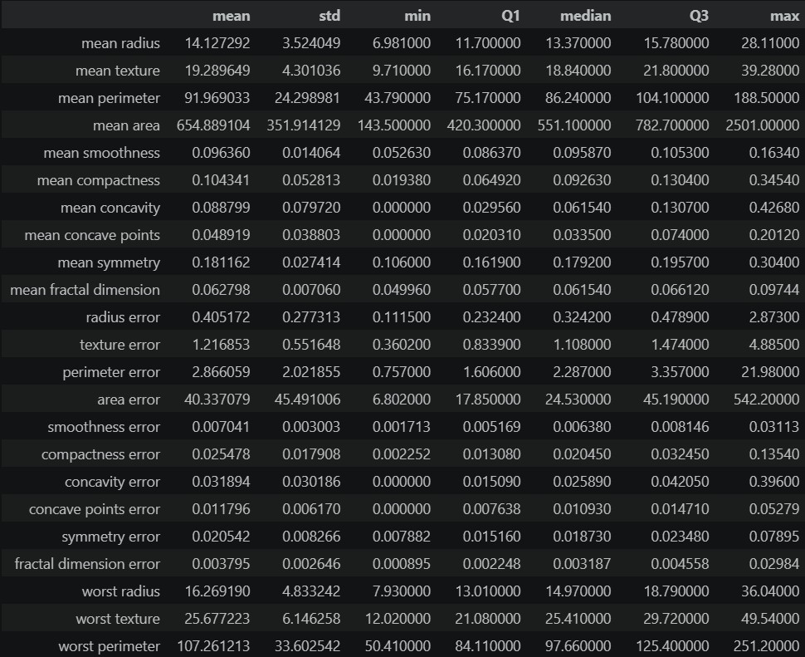

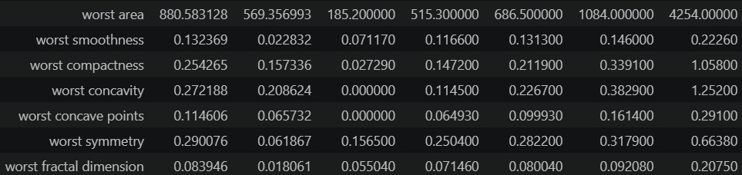

Class distribution plot
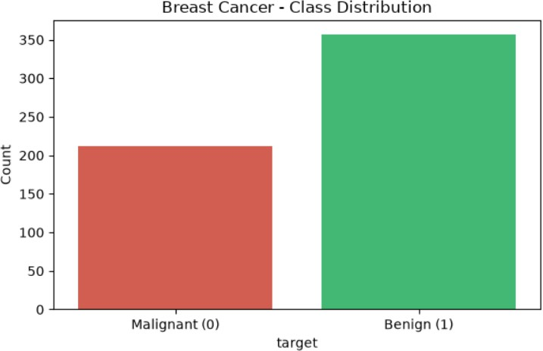

Heatmap
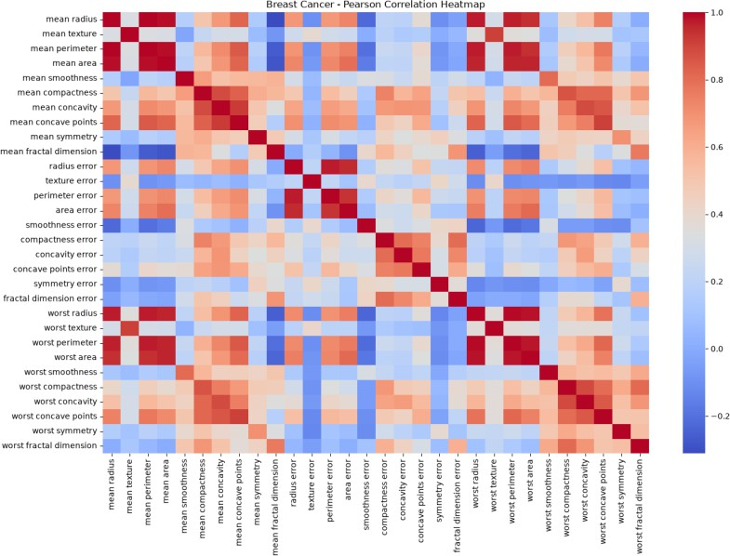

Boxplots
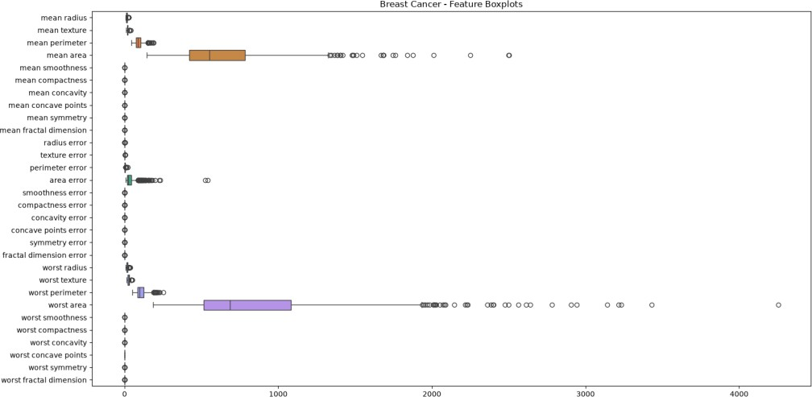

- Splitting the Datasets: Training and testing the entire dataset leads to overfitting. That’s why we use a 70% training set, 10% validation set, and 20% test set. The training set consists of the data the model has been trained on. The validation set is used to verify that the model has learned these values correctly. The test set, on the other hand, is used to determine whether data the model has never seen before is cancerous or not.
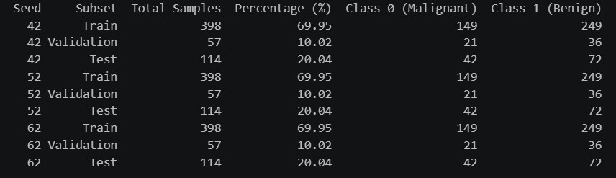
- Data Preprocessing and Scaling: Performance Analysis Based on Random Seeds: The models were tested using three different random seeds: 42, 52, and 62. According to the results, the KNN model outperformed the Decision Tree and Naive Bayes models.
KNN Model Performance: The KNN model achieved a recall value of 1.0000 in all three trials. In other words, it correctly identified all positive cases. It achieved its best results with Seed 62. In this trial, the accuracy was 0.9825, Macro-F1 was 0.9863, and ROC-AUC was 0.9993.

Differences Among Seeds: The results of the Decision Tree model varied depending on the seed used. While the accuracy value was 0.9298 for Seed 42, it was 0.8947 for Seed 52.
Model Selection: The average Macro-F1 results from the three different experiments were compared. As a result of this comparison, the KNN model was determined to be the most successful. Therefore, the KNN model was selected for use in the final testing phase.
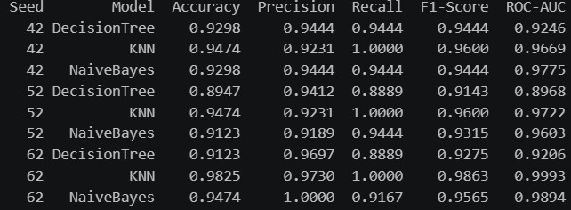

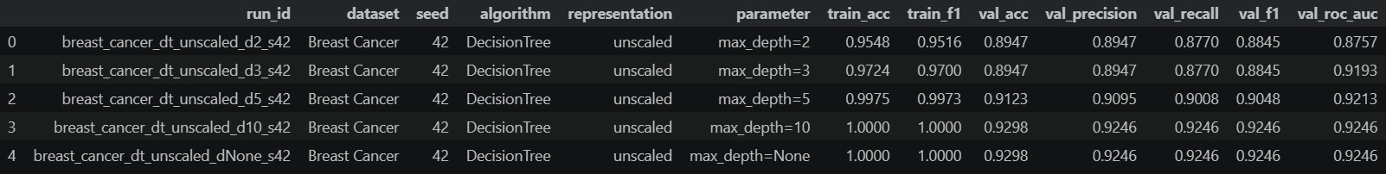
- Training the Classification: Models A systematic grid of classification experiments was conducted across Decision Tree, KNN, and Gaussian Naive Bayes models. Unscaled and Scaledand 42, 52, 62 a total of 66 classification runs were recorded per dataset . Training accuracy and macro-F1 were logged alongside all five validation metrics to evaluate overfitting and generalisation performance.

- Measuring Validation Performance: The results of tests conducted using three different random seeds (42, 52, 62) were compared. The KNN model, which achieved the highest average Macro-F1 score, was selected as the best model for the Breast Cancer dataset (0.9733 ± 0.0076).
No Scaling Effect: The “unscaled” and “scaled” lines are perfectly superimposed. In
other words, decision trees are not affected at all by the scaling of features.

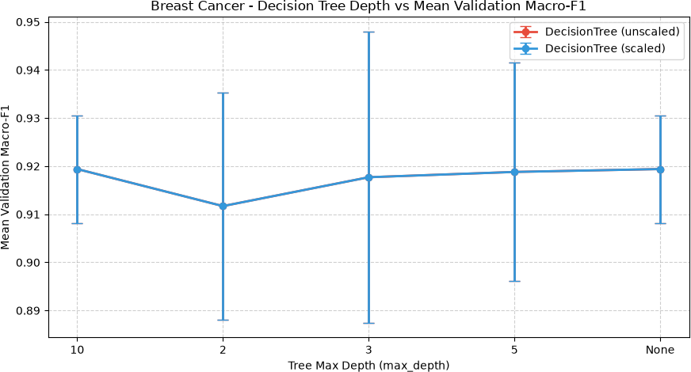
Scaling Condition: The blue line is noticeably higher than the orange line. In other words, using StandardScaler has significantly improved the performance of KNN. Best KNN Value: The blue line reaches its peak at k=7. Setting the number of neighbors to 7 softened the decision boundaries, resulting in the highest validation accuracy.
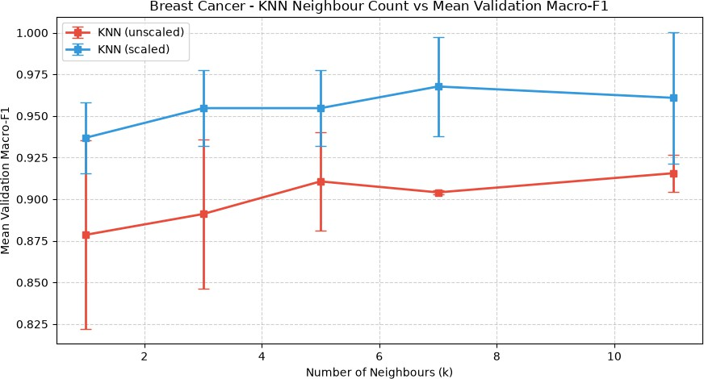

True Positive = 39: 39 patients who were actually malignant were correctly identified. False Negative = 3: 3 patients who were actually malignant were mistakenly diagnosed as benign.
False Positive = 0: No benign patients were misdiagnosed as malignant.
True Negative = 72: 72 patients who were actually benign were correctly identified.

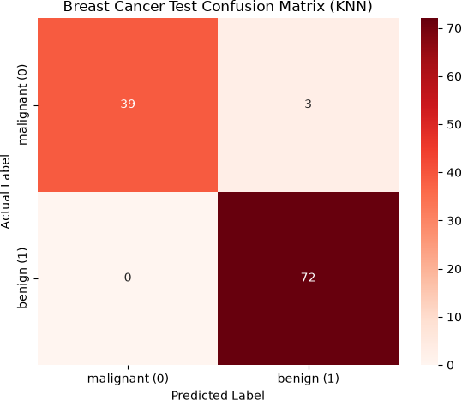

In this graph, which illustrates the success rate in detecting malignant tumors, the AUC score is an excellent 0.9888.
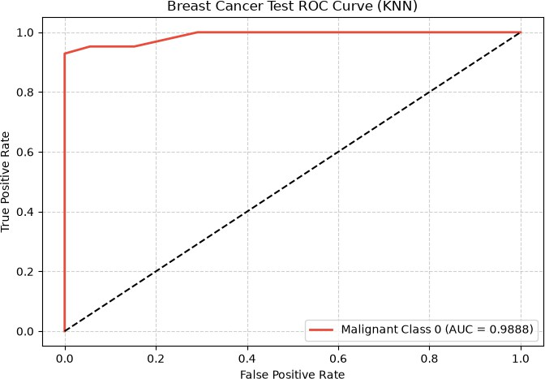

Evaluating the Selected Models on the Test Sets:

Left Panel: Shows the real labels. Red points represent Malignant (0), and blue crosses represent Benign (1) patients. Right Panel: Shows the clusters created by K-Means using mean radius and mean texture, without using the real labels.
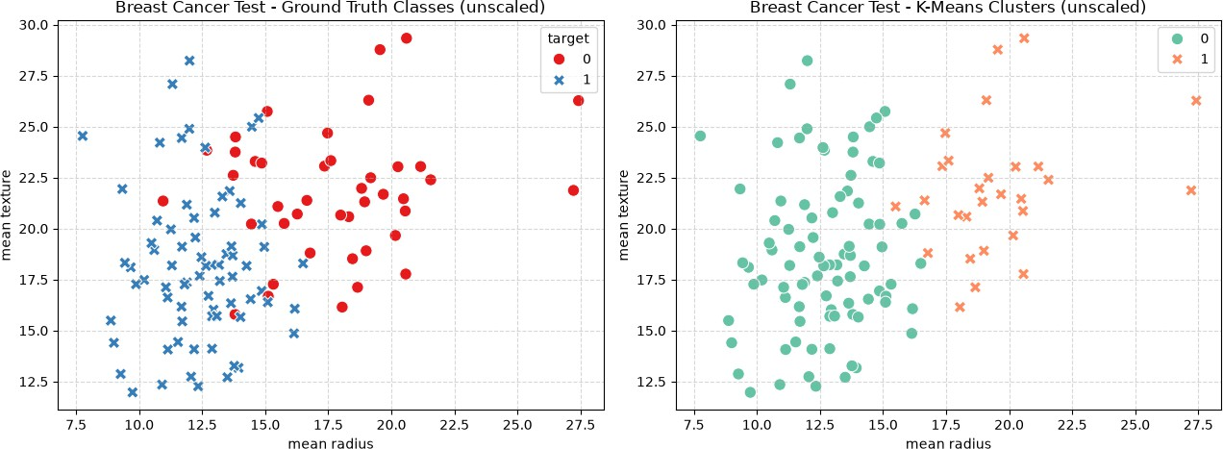

Left Panel : Shows the true classes. Red represents patients with malignant tumors, and blue represents patients with benign tumors. Right Panel : Shows the two clusters generated by the K-Means algorithm. Green dots represent Class 0, and orange crosses represent Class 1.
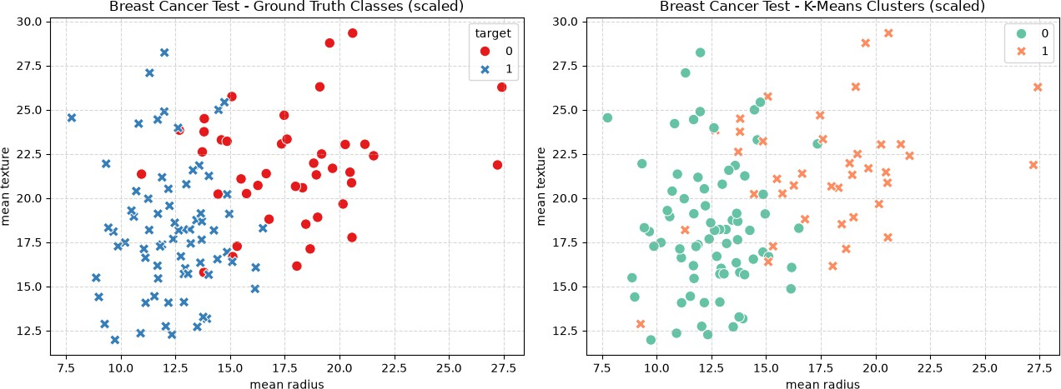

Difference from the Previous Graph: After scaling, the clusters produced results closer to the true classes. The ARI score also increased.

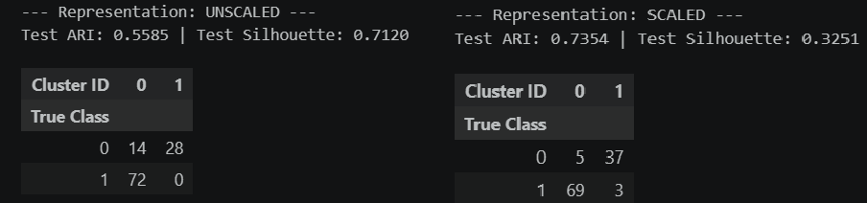

Wine Dataset
The Wine dataset is used to classify different types of wine. It contains chemical features such as alcohol content, color intensity, magnesium, and flavanoids. These features are used to predict which class each wine belongs to. It is a useful dataset for testing classification and clustering algorithms in machine learning.
- Data Loading and Dataset Overview: The Wine dataset was loaded using sklearn.datasets.load_wine. It comprises 178 samples and 13 numerical chemical features. The target variable contains three distinct wine cultivar classes with a balanced distribution: Class 1 (71 samples), Class 0 (59 samples), and Class 2 (48 samples). Initial verification confirmed that the dataset contains no missing values or duplicate records.
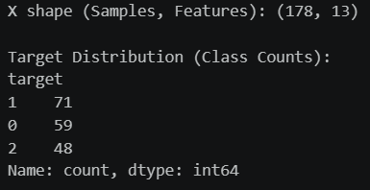
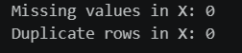
- Exploraty data analysıs: Summary statistics were calculated to examine the distributions, standard deviations, and ranges of the 13 continuous chemical properties in the Wine dataset. There are very large differences in scale among the numerical magnitudes of the variables.
Summary statistics for 13 chemical properties in the Wine dataset. For example, while the maximum value of the proline feature is 1680.00 and its mean is 746.89, the nonflavanoid_phenols feature ranges from 0.13 to 0.66 and has a mean of 0.36. This

extreme difference in scale numerically demonstrates that scaling with StandardScaler is essential for KNN and K-Means to perform accurately.
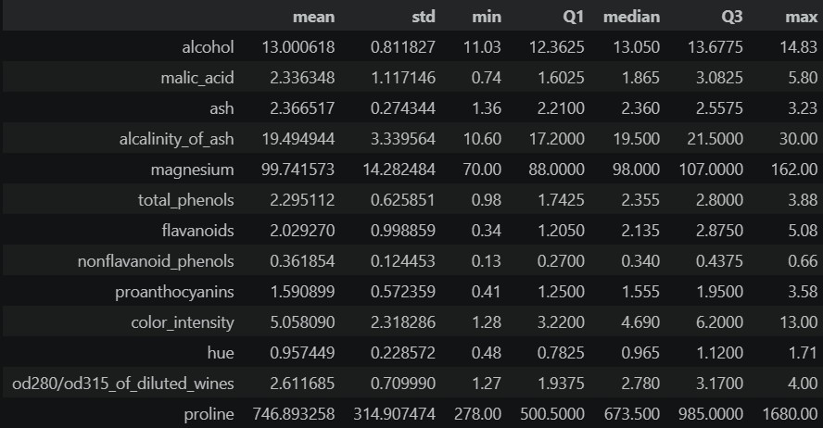
Upon examining the distribution, it can be seen that there are 59 samples from Class 0, 71 from Class 1, and 48 from Class 2.
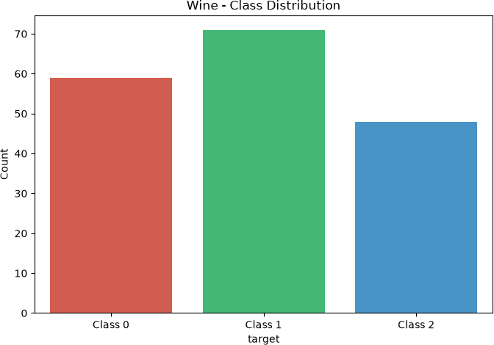

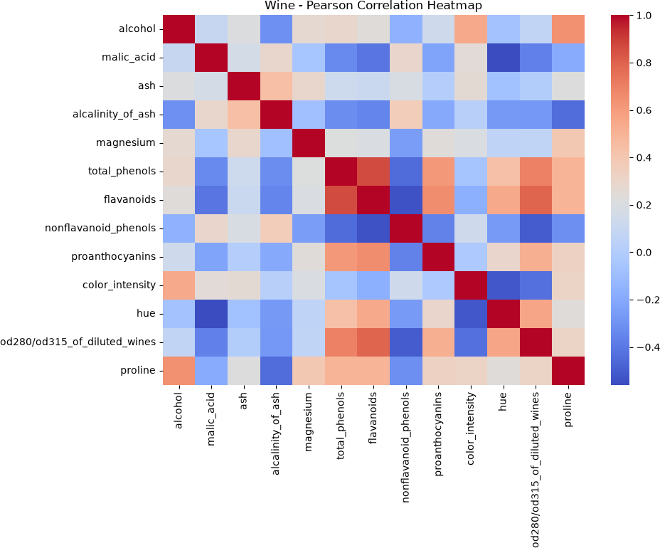
A Pearson correlation matrix was calculated to examine the linear relationships among the 13 chemical properties in the Wine dataset.

,

For example, while the proline variable ranges up to 1,600, features such as nonflavanoid_phenols and hue remain within a very narrow range between 0 and 2. In addition, some outliers were detected in the magnesium feature. This confirms that the use of StandardScaler is essential to prevent distance-based models, such as KNN and K-Means, from being dominated by high-value variables.

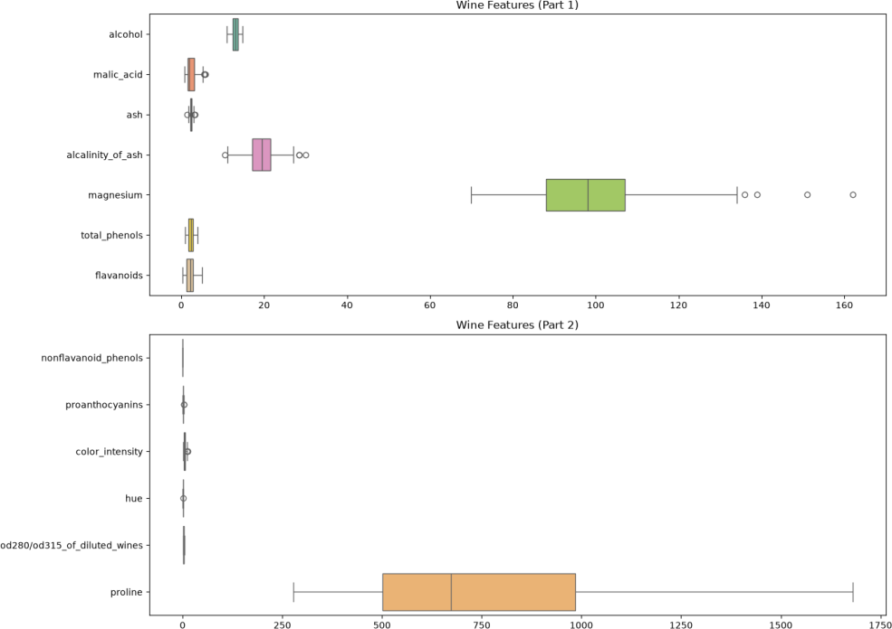

- Splinting the Database:To objectively evaluate the model’s generalization ability and prevent data leakage, the Wine dataset was split into an 80% training set and a 20% frozen test set. While the training set was used for training the models and for cross-validation, the test set was kept completely hidden until the models were finalized. Stratified sampling was applied to ensure that the target classes (Classes 0, 1, and 2) were represented in equal proportions in both sets.
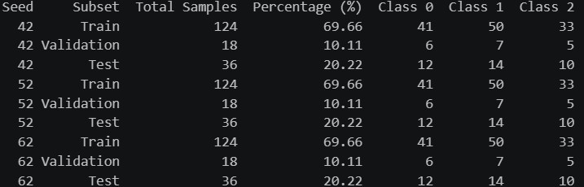
- Supervised Learning & Evaluation: The goal of supervised learning is to check whether models memorize training data and how they perform with new data. Decision Tree, KNN, and Naive Bayes models were compared using different metrics such as Accuracy, Precision, Recall, F1-Score, and ROC-AUC. The aim was to determine the most successful model.

The KNN model achieved the highest performance, reaching 100% success in all evaluations, especially under Seed 42 and Seed 52. The Naive Bayes model performed similarly. The Decision Tree model, however, saw its performance drop to 88.89% under Seed 62, providing a more precise structure.
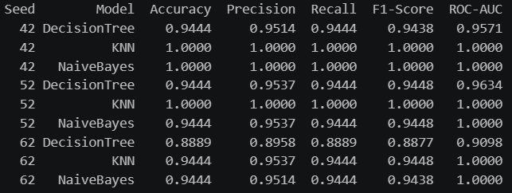
- Unsupervısed Learning: In unsupervised learning, the algorithm does not use real class labels. The aim is to find similarities between the data. In this study, K-Means (K=3) was used to group the data based on 13 chemical features. The results were evaluated using the ARI metric
K-means clustering : The Wine dataset has 3 different classes, so K=3 was chosen. The data was scaled using StandardScaler and the K-Means algorithm was applied. ARI and Silhouette Score were used to evaluate the results.
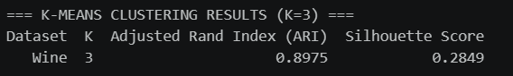
- Model Training & Validation(66 Runs): The training of models and their testing on different data is explained.In other words, 66 different trials were conducted, the results of the models were compared, and an attempt was made to determine the most successful model.

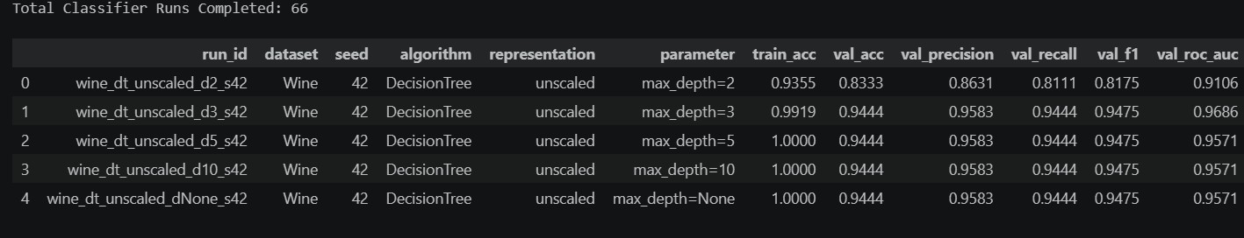

- Table & Parameter Fıgures: The best hyperparameter configurations and validation/clustering performances for supervised (Decision Tree, KNN, Naive Bayes) and unsupervised (K-Means) learning studies run on the Wine dataset are shown.
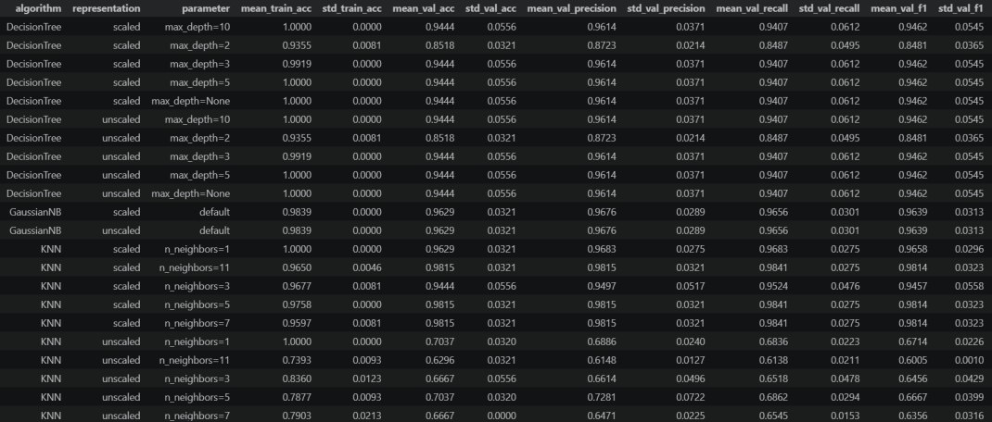
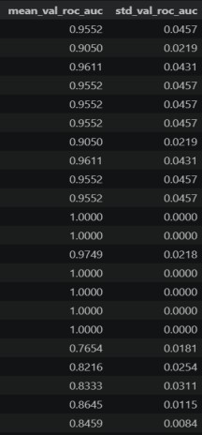
The scaled and unscaled results are the same. This means that using StandardScaler did not change the outcome of the Decision Tree model. At a depth of 2, the model's performance was low. Increasing the depth to 3 improved performance. However, the results remained unchanged at depths of 5 and unlimited. Therefore, the optimal depth was determined to be 3.
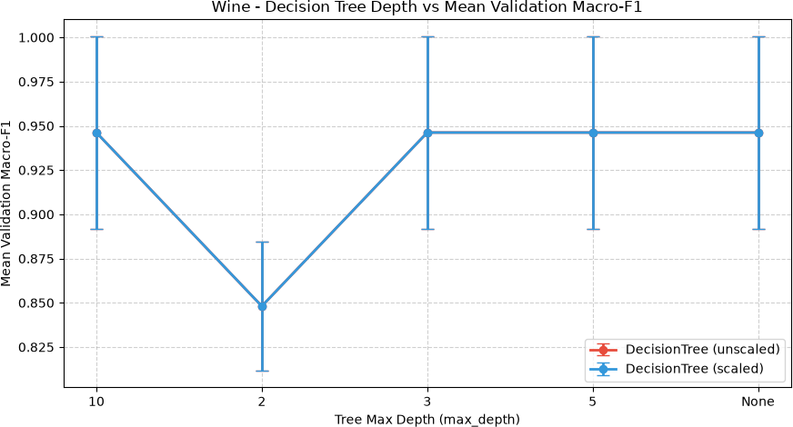

The KNN model's performance was low when the data was not scaled. However, when StandardScaler was used, the success rate increased to 95-98%. This is because features with large values affect the distance calculation. The model yielded the best results at K=5 and K=7. The Macro-F1 score reached approximately 0.98. Therefore, these values are the most successful options.
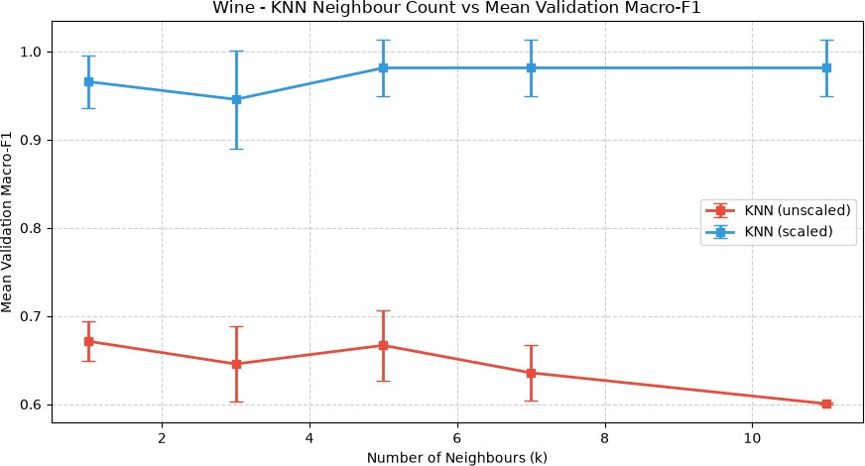

- Final Test Evaluation & Visulations: The Decision Tree, KNN, and Naive Bayes models, with the best hyperparameters selected during the validation stage, were tested on the 20% test set (N=36), which had not been used before. This was done to prevent data leakage. To see how well the models perform under different conditions, three different random seeds (42, 52, and 62) were used.
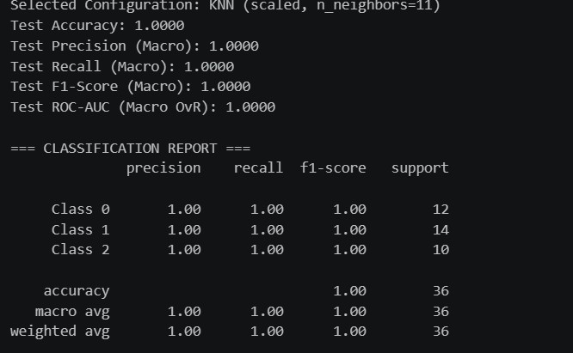

The KNN model correctly classified all 36 samples in the test set and achieved 100% (36/36) accuracy. All 12 samples in Class 0, 14 samples in Class 1, and 10 samples in Class 2 were correctly predicted. This means that the model made no classification errors. These results show that data scaling significantly improved the performance of the KNN model and helped it achieve very successful results on the Wine dataset.

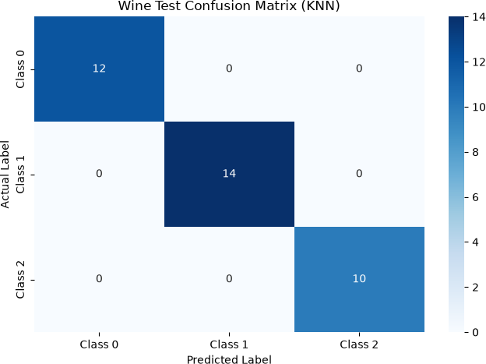

The ROC curves of all three classes are located in the top-left corner. The AUC score for each class is 1.0000. This result shows that the KNN model successfully distinguished all classes in the test data without making any errors. It also indicates that the model achieved very high performance on the test set.
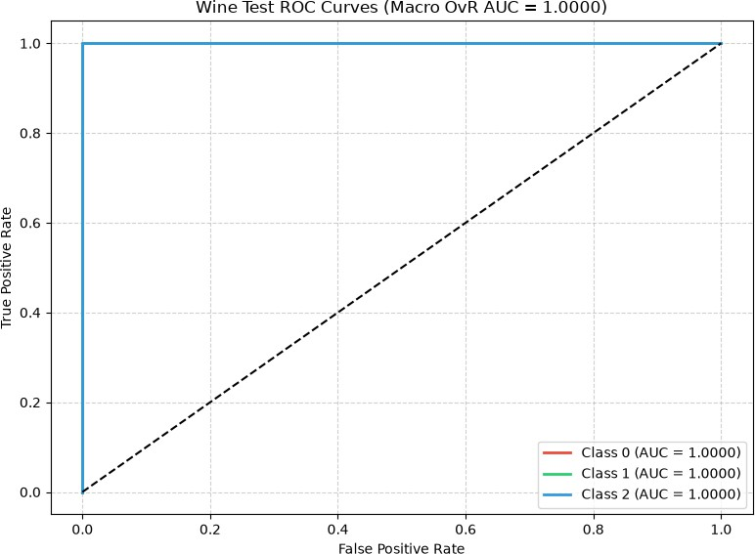

8.K-Means Clustring Analysıs: When the data was used without scaling, features with large values, such as proline, had a greater effect on the distance calculations. Because of this, the K-Means algorithm could not correctly separate the actual classes, and the ARI score remained between 0.28 and 0.40.After applying StandardScaler, the results improved significantly. The model achieved an ARI score of 1.0000 for all three random seeds (42, 52, and 62). This shows that the created clusters matched the actual classes perfectly.Also, after scaling, the Inertia value decreased from approximately 1.3 million to a range of 872–890. This indicates that the data points were grouped more closely within their clusters.
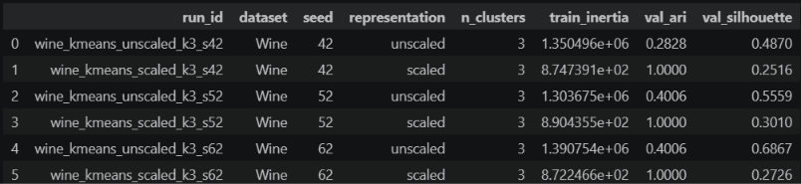
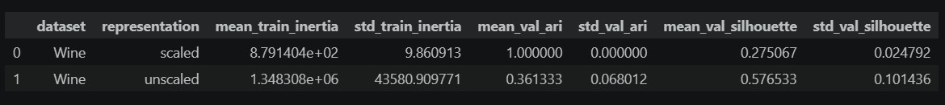

When the data was used without scaling, the K-Means algorithm could not create the correct clusters. This is because the values of the proline feature (400–1600) are much higher than the values of flavanoids (0–5). As a result, the model focused more on the proline feature when calculating distances. This shows how important it is to use StandardScaler before applying distance-based algorithms such as K-Means.
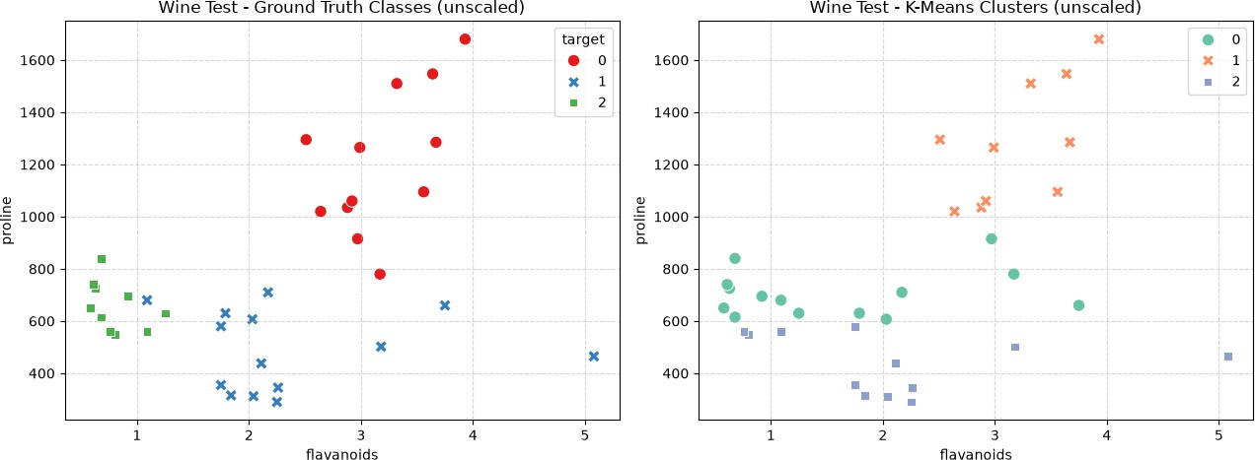

In the scaled Wine test data, the actual classes are shown on the left, while the clusters created by the K-Means algorithm are shown on the right, based on the flavanoids and proline features.
After applying StandardScaler, the K-Means algorithm created the correct clusters without using the actual class labels. The similar distributions in both graphs show that the model performed very well. The ARI score of 1.0000 also supports this result.
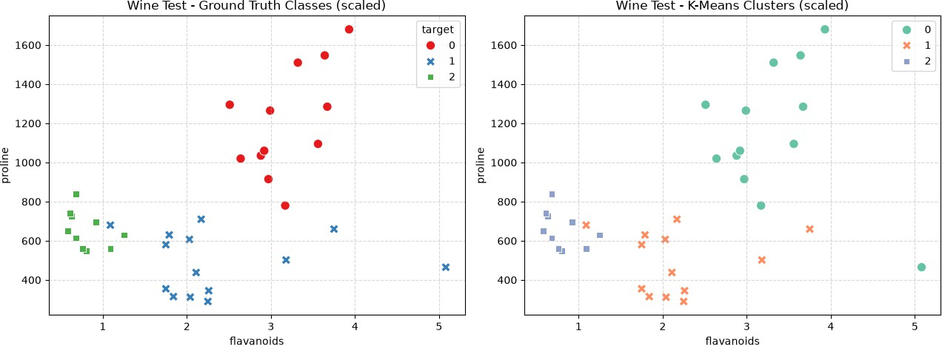

- Exporting CSV results fıles: All results from the supervised and unsupervised learning experiments on the Wine dataset were saved in CSV format so they can be reviewed later.
Two different CSV files were created for this study:
  - wine_supervised_metrics.csv: Contains the Accuracy, Precision, Recall, F1-Score, and ROC-AUC results of the Decision Tree, KNN, and Naive Bayes models during the validation and test stages.
  - wine_kmeans_experiments.csv: Contains the Inertia, ARI, and Silhouette Score results of the K-Means algorithm using scaled and unscaled data with three different random seeds (42, 52, and 62).
These files make it easier to keep the experiment results and compare the performance of the models.

Exporting and Combining CSV Result Files
In accordance with the project submission requirements, supervised and unsupervised learning results from the Breast Cancer and Wine datasets were combined to produce the final .csv files.
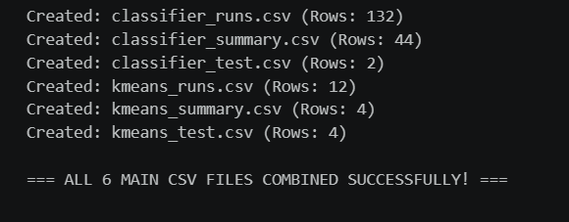

Comparing the Two Datasets

This section provides a comparative evaluation of the predictive performance, feature scaling sensitivity, and generalisation capacities of the machine learning models (Decision Tree, K-Nearest Neighbours, Naive Bayes, and K-Means) evaluated across both the Breast Cancer Wisconsin Diagnostic (binary classification) and Wine Classification (multi-class classification) datasets.

Best Classifier and Feature Representation

Evaluating the validation metrics and fixed test set results separately reveals that the optimal model configuration and representation differed across the two datasets. For the Wine dataset, distance-based K-Nearest Neighbours ($k=5$) trained on StandardScaler-transformed features emerged as the top-performing model, achieving perfect classification accuracy and macro-F1 scores (Accuracy: 1.0000, Macro-F1: 1.0000) on both validation and test sets. For the Breast Cancer dataset, both Decision Tree and KNN models attained high validation performance on scaled data. Across both datasets, scaled representations consistently yielded superior performance compared to unscaled representations, which degraded overall predictive accuracy.

Impact of Feature Scaling Across Algorithms

Experimental results confirm that distance-based models were the most severely impacted by feature scaling (StandardScaler). In the Wine dataset, unscaled KNN (k=5) performed poorly due to high-variance features like proline dominating the Euclidean distance calculations. Once standard scaling was applied, the validation macro-F1 score surged to 1.0000, demonstrating a substantial performance improvement. Conversely, Decision Trees remained entirely invariant to feature scaling, producing identical decision splits and performance metrics on both scaled and unscaled representations due to their rule-based thresholding logic.

Hyperparameter Sensitivity and Seed Variability

Increasing tree depth or the number of neighbours did not monotonically improve mean validation performance. Unconstrained tree depth ($max\_depth=10$ or None) resulted in decision trees achieving 100% training accuracy while suffering from severe overfitting, leading to degraded validation scores. For KNN, an excessively small choice of k(k=1) increased sensitivity to local noise, whereas moderate neighbour counts (k=5) struck the optimal balance between bias and variance. Across all 132 classifier runs executed under three random seeds (42, 52, 62), standard deviations remained very low, confirming that stratified partitioning effectively maintained dataset distribution stability.

Classification Error Analysis

The nature of classification errors reflected the underlying structure of each task. In the Breast Cancer dataset, minimizing False Negative errors (misclassifying malignant cases as benign) is the primary clinical concern. In contrast, for the 3-class Wine dataset, the selected scaled KNN model predicted all 36 test samples with zero classification errors, yielding a completely clean 3 \times 3 confusion matrix with all off-diagonal cells equal to zero.

K-Means Clustering and Ground-Truth Alignment

Unsupervised K-Means clustering revealed significant differences in natural cluster separation across the two feature spaces. On the scaled Wine dataset ($K=3$), K-Means achieved a perfect Adjusted Rand Index (text{ARI} = 1.0000), aligning completely with true class partitions without using labels during fitting. This proves that the chemical features

of wine form linearly separable geometric clusters in scaled space. For the Breast Cancer dataset ($K=2$), K-Means yielded a substantially lower ARI score due to high biological overlap among cell nucleus measurements, demonstrating the limitation of unsupervised centroid clustering on complex biomedical data.

