**QUESTION 1**

1. A variable whose meaning is confined to an object of a class is called

|  |  |  |
| --- | --- | --- |
|  |  | instance variable |
|  |  | local variable |
|  |  | global variable |
|  |  | static variable |

**5 points**

**QUESTION 2**

1. When you want the parameters in a method to be the same as the instance variables, you use the _____ keyword.

|  |  |  |
| --- | --- | --- |
|  |  | String |
|  |  | double |
|  |  | int |
|  |  | this |

**5 points**

**QUESTION 3**

1. The modifier private means that an instance variable can be accessed by name outside of the class definition

 True

 False

**5 points**

**QUESTION 4**

1. Analyze the following code:

class Test {

  public static void main(String[] args) {

    System.out.println(xMethod((double)5));

  }

  public static int xMethod(int n) {

    System.out.println("int");

    return n;

  }

  public static long xMethod(long n) {

    System.out.println("long");

    return n;

  }

}

|  |  |  |
| --- | --- | --- |
|  |  | The program displays int followed by 5 |
|  |  | The program displays long followed by 5 |
|  |  | The program runs and displays nothing. |
|  |  | The program does not compile. |

**10 points**

**QUESTION 5**

1. 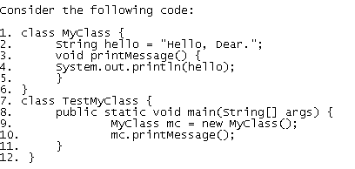

What is the output of this code?

|  |  |  |
| --- | --- | --- |
|  |  | A compiler error occurs at line 9 because no such method (constructor) for class MyClass has been declared. |
|  |  | A runtime exception occurs at line 4 |
|  |  | The code compiles and executes fine, and the output is "Hello, Dear." |
|  |  | The code compiles and executes fine, and there is no output |

**5 points**

**QUESTION 6**

1. Which of the following statements is true about the static modifier?

|  |  |  |
| --- | --- | --- |
|  |  | A static variable cannot change its value. |
|  |  | A static method is often written in a non-Java language and exists outside of JVM. |
|  |  | A static method can access instance variables |
|  |  | A static variable is shared by all the instances of the class |

**5 points**

**QUESTION 7**

1. Which of the following does not overload the method

public int myMethod (double a, int i)

|  |  |  |
| --- | --- | --- |
|  |  | public int myMethod(int i, double a) { } |
|  |  | public double myMethod(double b, int j){ } |
|  |  | public int myMethod(double a, double b, int i){ } |
|  |  | public int myMethod(int a, int i) { } |

**10 points**

**QUESTION 8**

1. Consider the following code:

class Test

{

  Test(){...}

  Test(int x){...}

  void method(){...}

}

which of the following code fragments, using the class defined above, would generate a compile error? The ellipses {...} are used here to indicate the presence of some code.

|  |  |  |
| --- | --- | --- |
|  |  |  |
|  |  |  |
|  |  |  |
|  |  |  |

**5 points (Extra Credit)**

**QUESTION 9**

1. What is the difference between static variable and instance variable?

|  |  |  |
| --- | --- | --- |
|  |  | static variable can not be changed while instance variable can |
|  |  | static variable is unique for each class instance, while an instance variable is shared by all instances |
|  |  | static variable is shared by all the instances of the class, while instance variable is not |
|  |  | static variable, once given a value, can no longer change |

**5 points**

**QUESTION 10**

1. Which of the following statements are correct about constructor? Three choices are applicable.

|  |  |  |
| --- | --- | --- |
|  |  | Constructor can ONLY be called when a new instance of the class has to be created. |
|  |  | Constructor can have multiple overloaded versions. |
|  |  | If you do not declare a constructor, then the class has no constructor; therefore can not be instantiated. |
|  |  | It always has the same name as the name of the class. |

**10 points**

**QUESTION 11**

1. A class can be defined by extending another class. It is called _______________ .

|  |  |  |
| --- | --- | --- |
|  |  | encapsulation |
|  |  | polymorphism |
|  |  | inheritance |
|  |  | attributes |

**5 points**

**QUESTION 12**

1. 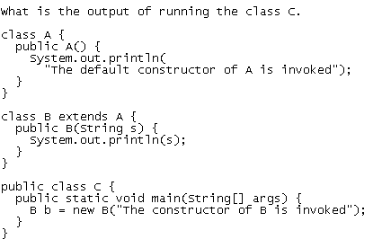

|  |  |  |
| --- | --- | --- |
|  |  | The constructor of B is invoked |
|  |  | The default constructor of A is invoked  The constructor of B is invoked |
|  |  | The default constructor of A is invoked |
|  |  | None of the given choices |

**10 points**

**QUESTION 13**

1. The Object class and the Integer class both have toString() methods. Note that the Object class is the root class of Java hierarchy.

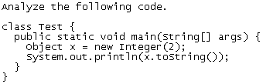

|  |  |  |
| --- | --- | --- |
|  |  | The program has syntax errors because an Integer object is assigned to x. |
|  |  | When x.toString() is invoked, the toString() method in the Object class is used |
|  |  | When x.toString() is invoked, the toString() method in the Integer class is used |
|  |  | None of the choices given here are valid |

**10 points**

**QUESTION 14**

1. 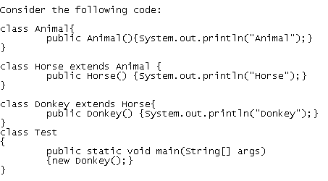   
   What output is generated when Test is run?

|  |  |  |
| --- | --- | --- |
|  |  | Donkey |
|  |  | Donkey  Horse  Animal |
|  |  | Animal  Horse  Donkey |
|  |  | None of the given choices |

**5 points (Extra Credit)**

**QUESTION 15**

1. A method that performs some actions but does not return a value can be declared a __________ method.

|  |  |  |
| --- | --- | --- |
|  | a. | null |
|  | b. | void |
|  | c. | public |
|  | d. | private |

**5 points**

**QUESTION 16**

1. Which of the following is NOT correct about declaring a class?

|  |  |  |
| --- | --- | --- |
|  |  | The body of the class is bracketed by {} |
|  |  | The name of the class must be after the "class" keyword |
|  |  | It can contain instance variables and instance methods |
|  |  | It must be declared with at least one instance variable |

**5 points**

**QUESTION 17**

1. A variable whose meaning is confined to a method definition is called an/a

|  |  |  |
| --- | --- | --- |
|  | a. | global variable |
|  | b. | none of the choices |
|  | c. | instance variable |
|  | d. | local variable |