# Homework3

* Problem 1
$$\left(\left(\left(2+3\right)-3\right)+\left(3*5\right)\right)+\left(\left(9-6\right)*\left(\frac{6}{3}\right)\right)=23$$

* Problem 2 arithmetic expression tree

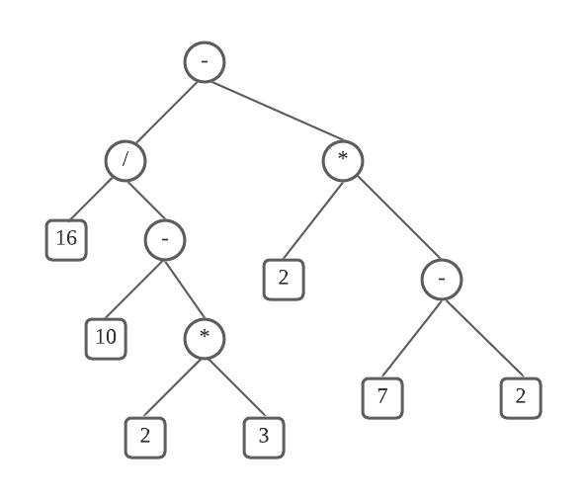

* Problem 3

Preorder tree traversal: A B D I E J L C F K G H

* Problem 4

Postorder tree traversal: I D L J E B K F G H C A

* Problem 5

Breadth-first tree traversal: A B C D E F G H I J K L

* Problem 6

Inorder tree traversal: H D B I E J A F K C G