This submission template is a convenient document for you to provide your work and your answers for Lab 5. This submission template is intended to be used in conjunction with the Lab 5 Instructions document. The instructions document illustrates how to correctly derive the answers, explains important theoretical and practical details, and contains the complete set of instructions for this lab.

Name:

Donghang He

Date:

2019.12.1

**Section One – Variable Length Subnet Masks**

2. Imagine that an organization is assigned the address block 169.222.0.0/18, and the organization needs one subnet with 220 hosts, one subnet with 128 hosts, and one subnet with 19 hosts.

Create the appropriate network identifiers for each subnet, using the process established for VLSMs in the overview section. Refer to step 1 for a similar example. Make sure to show your work.

First, we determine that the subnet with 220 hosts is the one with the most hosts. The closest number over 220 that is also a power of 2 is 256 which requires 8 bits. So we decide that the first subnet needs 8 bits for the host identifier. To determine the length of the subnet identifier, we simply subtract the length of the network prefix, 18 bits, and the length of the host identifier, 8 bits, from 32. 32 – 18 – 8 = 6. So we will use 6 bits for the subnet identifier.

First Subnet: 10101001 11011110 00000000

169.222.0.0/24

We repeat the process again for the next largest subnet, which requires 128 hosts. The closest number over 128 that is also a power of 2 is 256 which requires 8 bits. This subnet needs 128 hosts, but it also needs two addresses to give to the network address and broadcast address. So it requires 8 bits. 32 – 18 – 8 = 6

Second Subnet: 10101001 11011110 00000001

169.222.1.0/24

In a short word about the last subnet. 19 hosts require 5 bits. 32 – 18 – 5 = 9

Third Subnet: 101010001 11011110 00000010 000

169.222.2.0/27

3. Explain in your own words how the process of allocating subnets using VLSMs differs from the process of allocating subnets using a fixed length subnet mask.

Using the fixed length subnet mask, each subnet has the same length. But using VLSM each subnet has different length suit for themselves. VLSM saves a lot of spaces in the network addresses. In the FLSM, it just need to calculate the largest subnet requires bits, but in the VLSM it needs to calculate each subnet requires bits from the larger to the smaller.

5. Imagine that an organization is assigned the address block 45.0.0.0/8, and the organization has an existing subnet with 190 hosts, and another existing subnet with 53 hosts. Further imagine that after the network has been in used for some time, the organization must add another subnet that requires 105 hosts.

First, use the process established in the overview section to create the network identifiers for the two existing subnets. Second, use the same process to create the network identifier for the new subnet (illustrated in step 4). Last, identify the number of addresses that are left unallocated in the gap between the second and third subnet. Make sure to show your work.

From big subnet to small subnet. The first subnet requires 190 hosts, which means 8 bits.

32 – 8 – 8 = 16

First Subnet: 00101101 00000000 00000000

45.0.0.0/24

The second subnet requires 53 hosts, which means 6 bits.

32 – 8 – 6 = 18

Second Subnet: 00101101 00000000 00000001 00

45.0.1.0/26

The third subnet is bigger than the second one, so there might have a gap.

The third subnet requires 105 hosts, which means 7 bits.

32 – 8 – 7 = 17

Third Subnet: 00101101 00000000 00000001 1

45.0.1.128/25

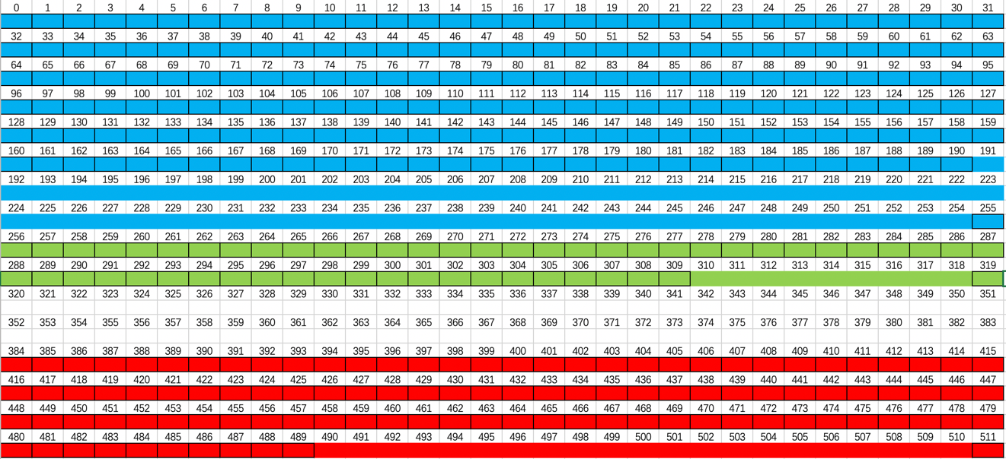

The table show the three subnets in visual. So there are 64 addresses that are left unallocated in the gap between the second and third subnet.

6. Explain in your own words why allocating a new subnet on an existing network results in an unavoidable gap of unallocated addresses.

Because the second subnet is 64 addresses, and the third subnet needs to be a subnet of 128 addresses, it exceeds the size of the second subnet. So you need to free up a space as large as the second subnet. And the bits require for the third subnet is one bit greater than the second, so there is a gap between them.

8. Now it is your turn to allocate a new subnet in-between existing subnets on a network. In the three parts below, keep in mind that there will be a gap of unallocated addresses in your subnet allocation, similar to the example given in step 7.

a) Imagine that an organization is assigned the address block 222.221.128.0/17, and the organization has an existing subnet with 107 hosts, and another existing subnet with 51 hosts. Using the process given in the overview section, allocate both subnets and identify the network identifier for both subnets. Make sure to show your work.

From big subnet to small subnet, the biggest one requires 107 hosts, which means 7 bits.

32 – 17 – 7 = 8

First Subnet: 11011110 11011101 00000000 0

222.221.0.0/25

And the second subnet requires 51 hosts, which means 6 bits.

32 – 17 – 6 = 9

Second Subnet: 11011110 11011101 00000000 10

222.221.0.128/26

b) Now the organization decides to add an additional subnet that supports 113 hosts. Allocate this subnet and identify its network identifier, making sure to show your work.

This subnet is greater than the second subnet, so there is a gap between these two subnets.

The subnet needs to support 113 hosts, which means 7 bits.

32 – 17 – 7 = 8

Third Subnet: 11011110 11011101 00000001 0

222.221.1.0/25

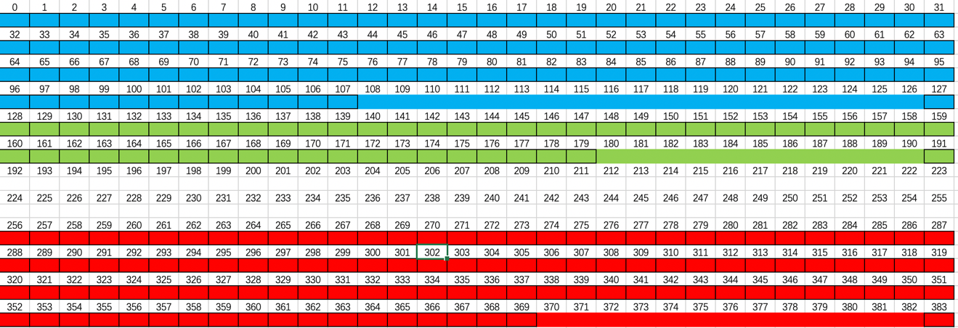

The table shows the three subnets in visual.

c) Last, the organization decides to add one additional subnet that supports 9 hosts. Allocate this subnet and identify its network identifier, making sure to show your work.

This subnet needs to support 9 hosts, which means 4 bits. And according to the table shows before. There is a gap between the second subnet and the third subnet. So we could put the fourth subnet between them.

32 – 17 – 4 = 11

Fourth Subnet: 11011110 11011101 00000000 1100

222.221.0.192/28

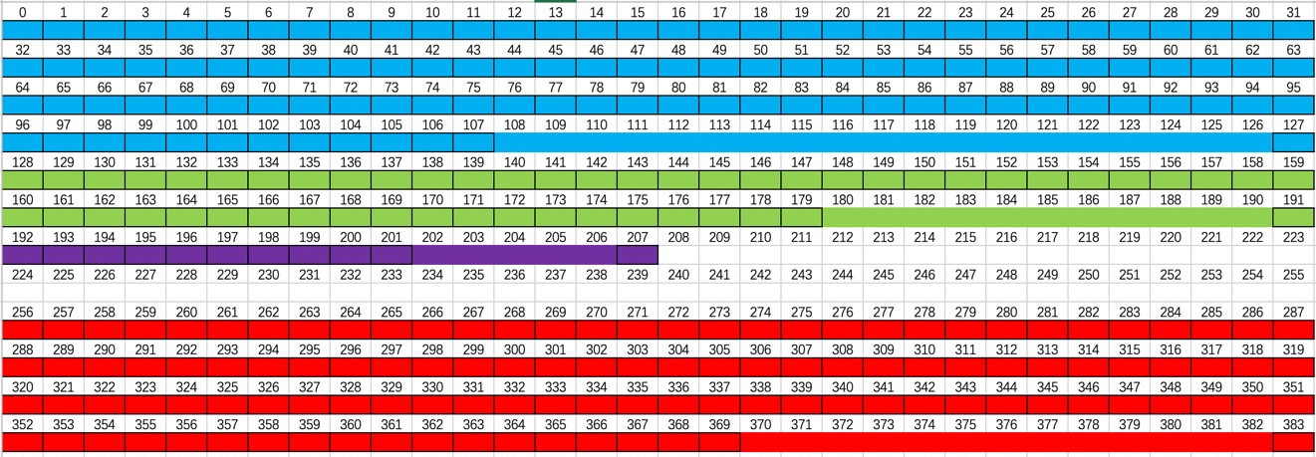

9. Explain in your own words how the process of allocating a new subnet in-between existing subnets works.

In my opinion, the best way to allocating a new subnet in-between existing subnets is drawing a table like that which I draw before. It shows the gap perfectly, and you can know how many addresses has been left. So, you can determine whether the new subnet could be located in the gap.

And in the calculating way, first you need to calculate the bits of the new subnet needs. Then, check whether it is smaller or equal than the subnet before the gap. If it does, it can be put in the gap.

Your lab submission will be evaluated according to the following rubric.

|  |  |  |  |
| --- | --- | --- | --- |
|  | **Letter Grade** | **Qualities Demonstrated by the Lab Submission** | **Grade Assigned** |
| **Answers and Methodology**  **Measures the correctness and completeness of the answers and methodology used for lab steps** | A+ 🡺 100 | The answers, and answer justifications where required, are entirely complete and correct for all steps. The methodologies used to derive the answers are entirely applicable to the given problems, and are implemented correctly, for all steps. There are absolutely no technical or other errors present. |  |
| A 🡺 96 | One insignificant technical or other error is present, but otherwise the answers, and answer justifications where required, are entirely complete and correct for all steps. Excluding the insignificant error, the methodologies used to derive the answers are entirely applicable to the given problems, and are implemented correctly, for all steps. |
| A- 🡺 92 | One or two technical or other errors are present, but otherwise the answers, and answer justifications where required, are entirely complete and correct for all steps. Excluding the one or two errors, the methodologies used to derive the answers are entirely applicable to the given problems, and are implemented correctly, for all steps. |
| B+ 🡺 88 | The answers, and answer justifications where required, are complete and correct for most steps. Likewise, the methodologies used to derive the answers are applicable to the given problems, and are implemented correctly, for most steps. |
| B 🡺 85 | The answers are correct or almost correct for most steps. Some answer justifications may be missing or incorrect, but most are present and correct where required. The methodologies used to derive the answers are applicable and implemented correctly for most steps. |
| B- 🡺 82 | The answers, and answer justifications where required, are complete and correct for about ¾ of the steps. Likewise, the methodologies used to derive the answers are applicable to the given problems, and are implemented correctly, for about ¾ of the steps. |
| C+ 🡺 78 | The answers are correct or almost correct for about ¾ of the steps. Some answer justifications may be missing or incorrect. The methodologies used to derive the answers are applicable to the given problems, and are implemented correctly, for about ¾ of the steps. |
| C 🡺 75 | The answers for about half of the steps are either missing or incorrect. Likewise, the methodologies used for about half of the steps are either inapplicable to the given problem, or are implemented incorrectly. Some answer justifications are missing or incorrect where required. |
| C- 🡺 72 | The answers for most of the steps are either missing or incorrect. Likewise, the methodologies used for most of the steps are either inapplicable to the given problem, or are implemented incorrectly. Some answer justifications are missing or incorrect where required. |
| D 🡺 67 | The answers for almost all of the steps are either missing or incorrect. Likewise, the methodologies used for almost all of the steps are either inapplicable to the given problem, or are implemented incorrectly. Some answer justifications are missing or incorrect where required. |
| F 🡺 0 | The answers for virtually all of the steps are either missing or incorrect. Likewise, the methodologies used for virtually all of the steps are either inapplicable to the given problem, or are implemented incorrectly. Some or all answer justifications are missing or incorrect where required. |

Use the **Ask the Facilitators Discussion Board** if you have any questions regarding how to approach this lab.

Save your assignment as ***lastnameFirstname_lab5.doc*** and submit it in the *Assignments* section of the course.

For help uploading files please refer to the *Technical Support* page in the syllabus.

* + Use ALTER TABLE statements to add the foreign key constraints to the tables after all of them have been created.