# MET CS669 Term Project

Name: Donghang He

目录

Area1: A Definition of an Organization 3

Organization type: 3

Description: 3

Physical Infrastructure 4

Area2: Application Requirements 10

Area3: Local Area Network Design 13

Area4: Local Backbone Network Design 16

Area 4-1: WAN Backbone Network Design 19

Area 5: Network Security and Management 20

Reference 24

# Area1: A Definition of an Organization

## Organization type:

International University with distributed campuses and online training capabilities, students and faculty expect highly reliable systems, and high-tech facilities.

## Description:

* Business or purpose: The main purpose of the organization is to establish an international teaching network that supports an international school with this network. Students and staff can use reliable systems and high-tech equipment in this school.
* Employee: front-end and back-end engineers, UI designers, manage team, programmer.
* Customers: students and teachers

## Physical Infrastructure

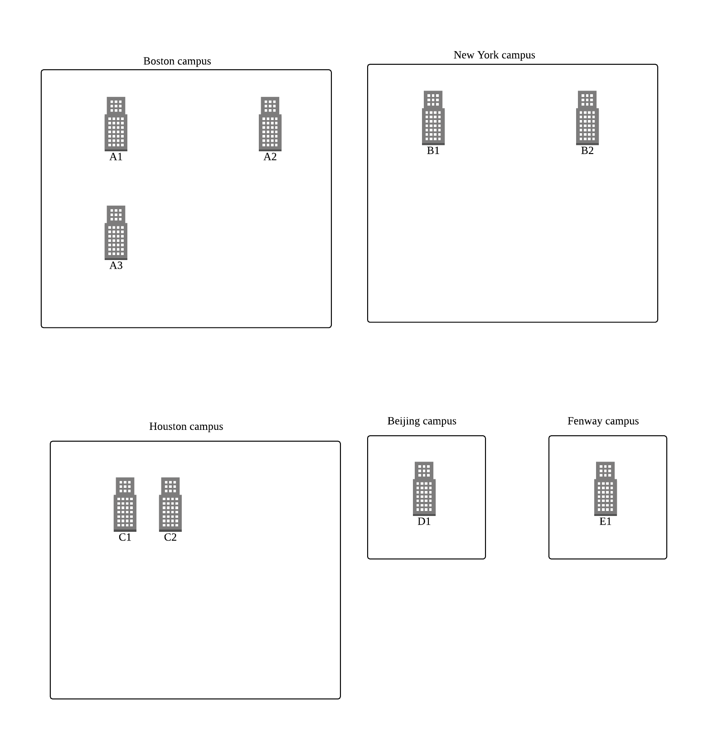

Figure 1.1 physical infrastructure

1. Boston campus:

|  |  |  |  |
| --- | --- | --- | --- |
| distance | A1 | A2 | A3 |
| A1 | - | 200m | 10m |
| A2 | 200m | - | 220m |
| A3 | 10m | 220m | - |

There are three buildings in Boston campus. A1 is close to A3 and A2 is far away from A1 and A3. The A1 building is used as a student research building, the A2 building serves as a library, and the A3 floor serves as a classroom building.

A1: width:20m, length:50m, floor:4

There are four floors of 8-10 labs or doctoral studios in each floor. Each room can accommodate 4-8 students. Each room has 4-8 desktops, 4-8 laptops, and several smartphones and tablets. The entire building is divided into four LANs connected to the backbone network of the entire building and connected to the wide-area backbone network of the entire campus. Each local area network has two switches, which respectively transmit network information to the left and right layers of each floor. Each room is connected to a wireless router, and the desktop computer is connected to the router through a network cable, and the wireless device receives information via Wi-Fi.

Functional Requirements:

* Doctoral studios:
  + 1. The studio supports fast internal communication
    2. There are many studio hosts, which have higher requirements on network load capacity.
    3. Support email service, you can communicate with the instructor via email
    4. Visit the intranet to download resources and materials related to your own learning project(e-study)
    5. Support text transfer service
* Labs:

1. Some laboratories involve experimental secrets and require high security for the network.
2. Support email service, you can communicate with the outside world via email
3. Visit the intranet to download resources and materials related to your own learning projects
4. Support text transfer service

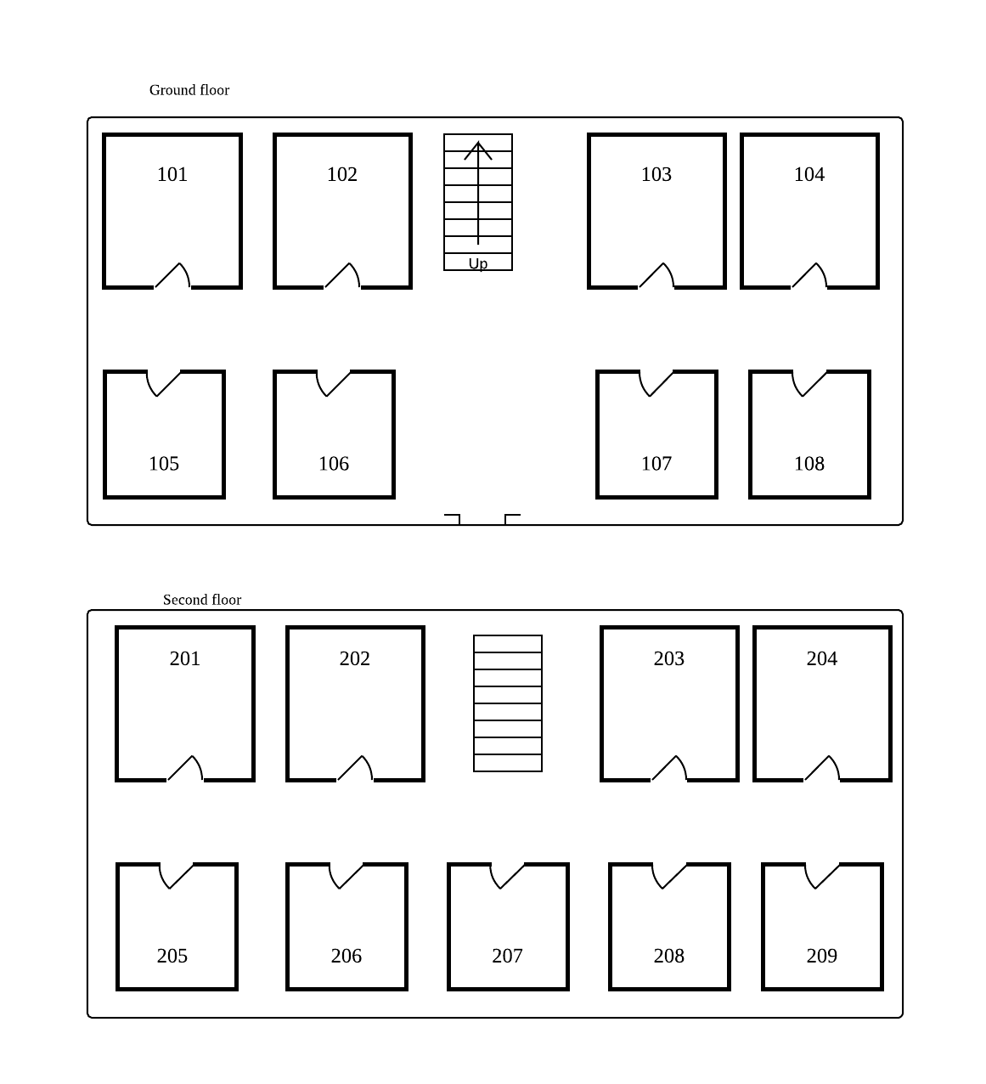

Figure 1.2 A1 building layout

1. New York campus:

|  |  |  |
| --- | --- | --- |
| distance | B1 | B2 |
| B1 | - | 230m |
| B2 | 230m | - |

There are two buildings at New York campus. B1 is office building, B2 is classroom building.

B1: width: 30m, length: 30m floor: 5

There are five floors of 4 office rooms or meeting rooms in each floor. Each room can accommodate 2 teachers. Each room has 2 desktops, 2 laptops, and several smartphones and tablets. The entire building is divided into five LANs connected to the backbone network of the entire building and connected to the wide-area backbone network of the entire campus. Each local area network has one switch, which respectively transmit network information to each floor. Each room is connected to a wireless router, and the desktop computer is connected to the router through a network cable, and the wireless device receives information via Wi-Fi.

Functional Requirements:

* + Office room

1. Support mail transmission service for communication with the outside world, can communicate with students through mail
2. Support file transfer to share files on your computer in the office with other hosts on your network
3. Support distance learning, multimedia teaching and video conferencing
4. Support access to the library, enabling staff and teachers to access and browse library resources in the office
5. Support external network access, the host in the office can communicate with the network outside the school
6. Fast internal communication between offices of the same type
7. To achieve office automation, provide access to communication with higher education departments, society, and families, and provide e-mail, bulletin board, and education and teaching information inquiry to improve work efficiency and management level.
   * Meeting room
8. Support for video conferencing
9. Support access to the library and external network access

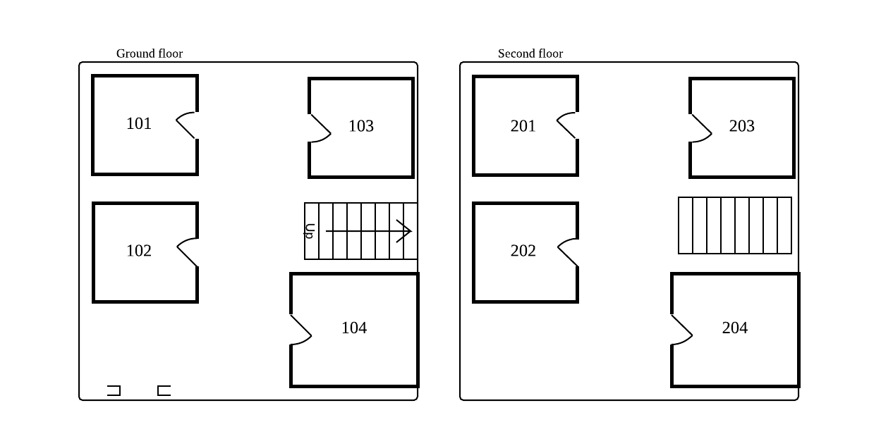

Figure 1.3 B1 building layout

1. Houston campus:

|  |  |  |
| --- | --- | --- |
| distance | C1 | C2 |
| C1 | - | 12m |
| C2 | 12m | - |

C1 is office building, C2 is classroom building

1. Beijing campus: Only have one building D1 is student researching building
2. Fenway campus: Only have one building E1 is student researching building

# Area2: Application Requirements

1. Application name: E-study
2. Application purpose: The main purpose of this application is to provide online learning for students at school. Students can get all the content related to the course (textbook, PPT, class video, homework, etc.) on the platform. The teacher posted the content on the platform for the students to browse. At the same time, the students submit their assignments on the platform, and the teacher can make corrections. At the same time, students can also communicate online with the teacher and leave a message. All questions raised by students are shared on the platform. The entire system is based on a web platform and can be used simultaneously by students from five campuses.
3. Application architecture: n-tier client-server architecture, n-tier architecture uses more than three sets of computers. In this case, the client is responsible for presentation logic, a database server is responsible for the data access logic and data storage, and the application logic is spread across two or more different sets of servers. The following picture shows an example of an n-tier architecture of a groupware product called TCB Works developed at the University of Georgia. TCB Works has four major components. The first is the Web browser on the client computer that a user uses to access the system and enter commands (presentation logic). The second component is a Web server that responds to the user’s requests, either by providing Hypertext Markup Language (HTML) pages and graphics (application logic) or by sending the

request to the third component, a set of 28 C programs that perform various functions such as adding comments or voting (application logic). The fourth component is a database server that stores all the data (data access logic and data storage). Each of these four components is separate, making it easy to spread the different components on different servers and to partition the application logic on two different servers.

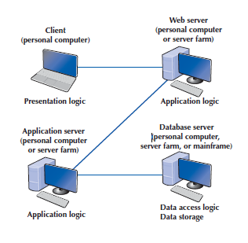

Figure 2.1 n-tier client-server architecture

In this platform there are some sub-system, uploading system, streaming system, email system, file sharing system. The bandwidth of these system shows below.

Bandwidth table:

|  |  |
| --- | --- |
| System | Estimate sharing bandwidth |
| Uploading system | 4Gbps |
| Streaming system | 4Gbps |
| Email system | 100Mbps |
| File sharing system | 2Gbps |

1. Typical user:

* Student: Every student at school will become a user of the system, mainly browsing resources, sharing resources, etc.
* Teacher: Every teacher in the school will use the system, mainly to publish the relevant content of the course, and correct the assignments and questions of the students.

1. Use case:

|  |  |  |
| --- | --- | --- |
| Use case Name | Browsing resources | |
| Actor: | Student user | |
| Description: | This use case describes the event of a student who want to check the content of his course. The use case will include steps for checking content and download it or upload some questions or assignments. | |
| Precondition: | Teacher has uploaded the content of this class.  Student has signed in to the platform. | |
| Step # | Actor | System |
| 1 | Student open the main page of the system. | System shows all courses which student has this semester. |
| 2 | Student clicks one course to enter the course page. | System shows a list of all available content of this course. |
| 3 | Student clicks one subtitle to view the content. | System show the content. |
| 4 | Student clicks the download button to download the file. |  |

# Area3: Local Area Network Design

Boston campus: A1 building

1. ground floor

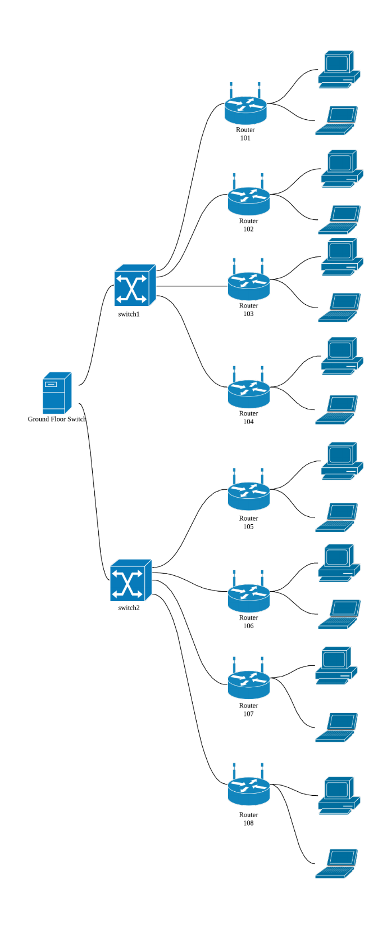

Figure 3.1 A1 building Ground Floor LAN

1. Second floor:

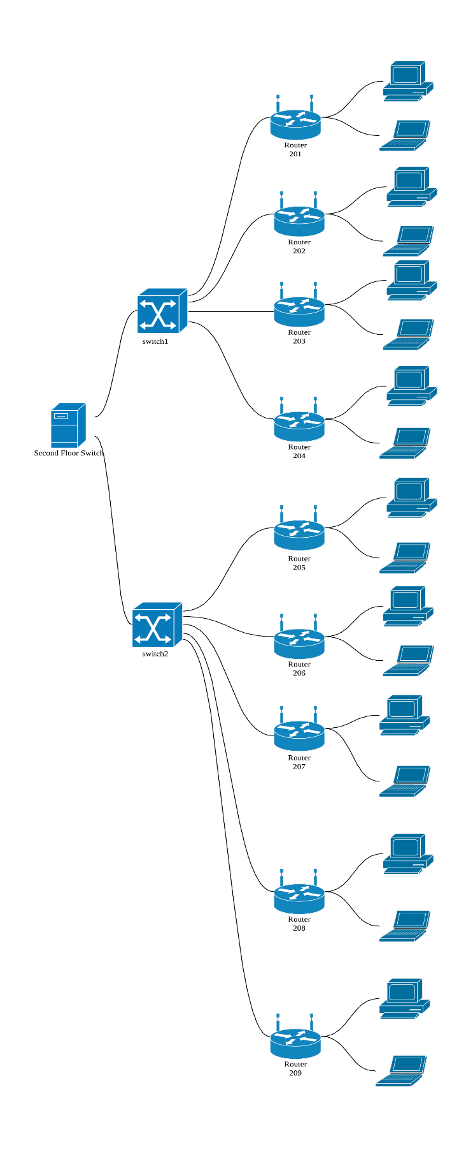

Figure 3.2 A1 building Second Floor LAN

New York Campus: B1 building

1. ground floor

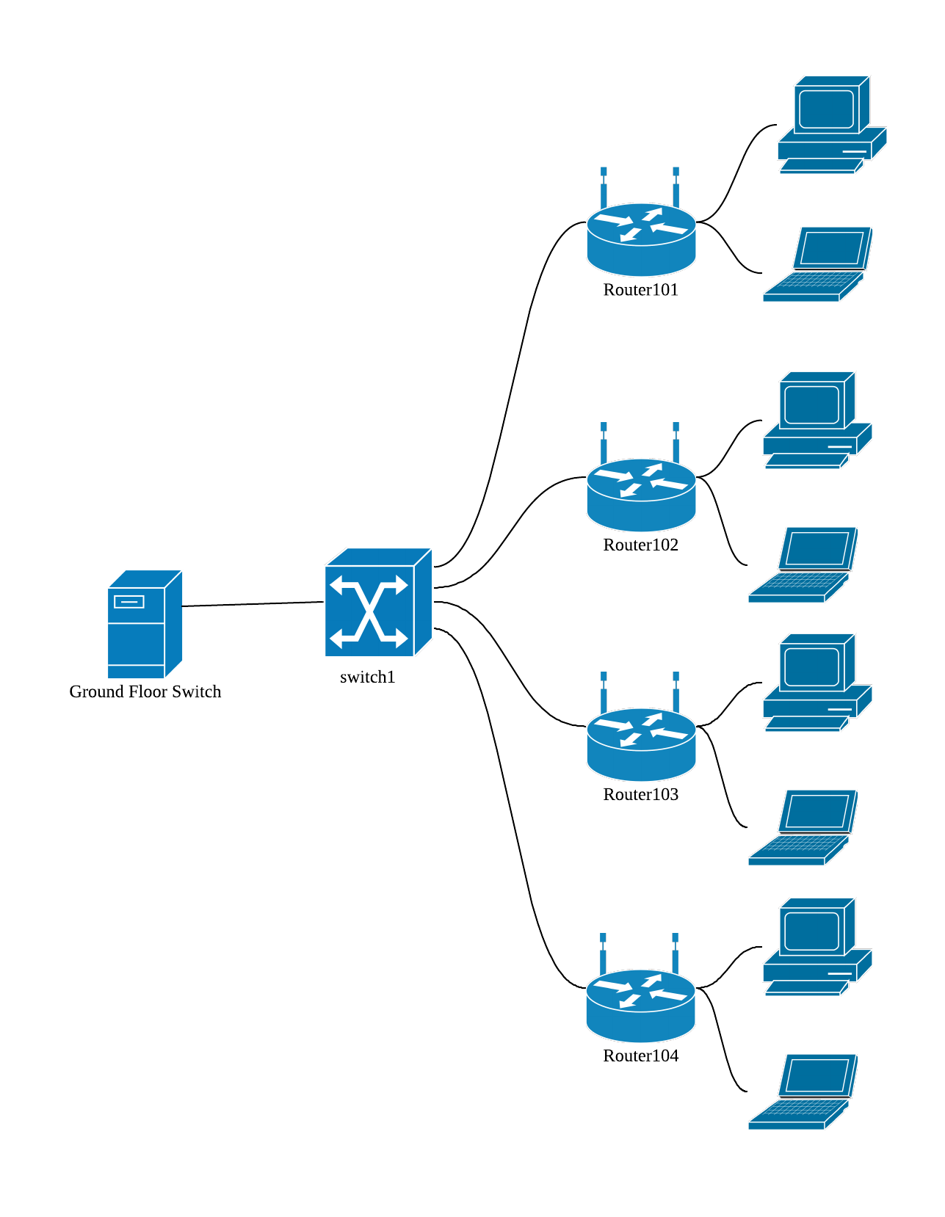

Figure 3.3 B1 building Ground Floor LAN

1. Second floor:

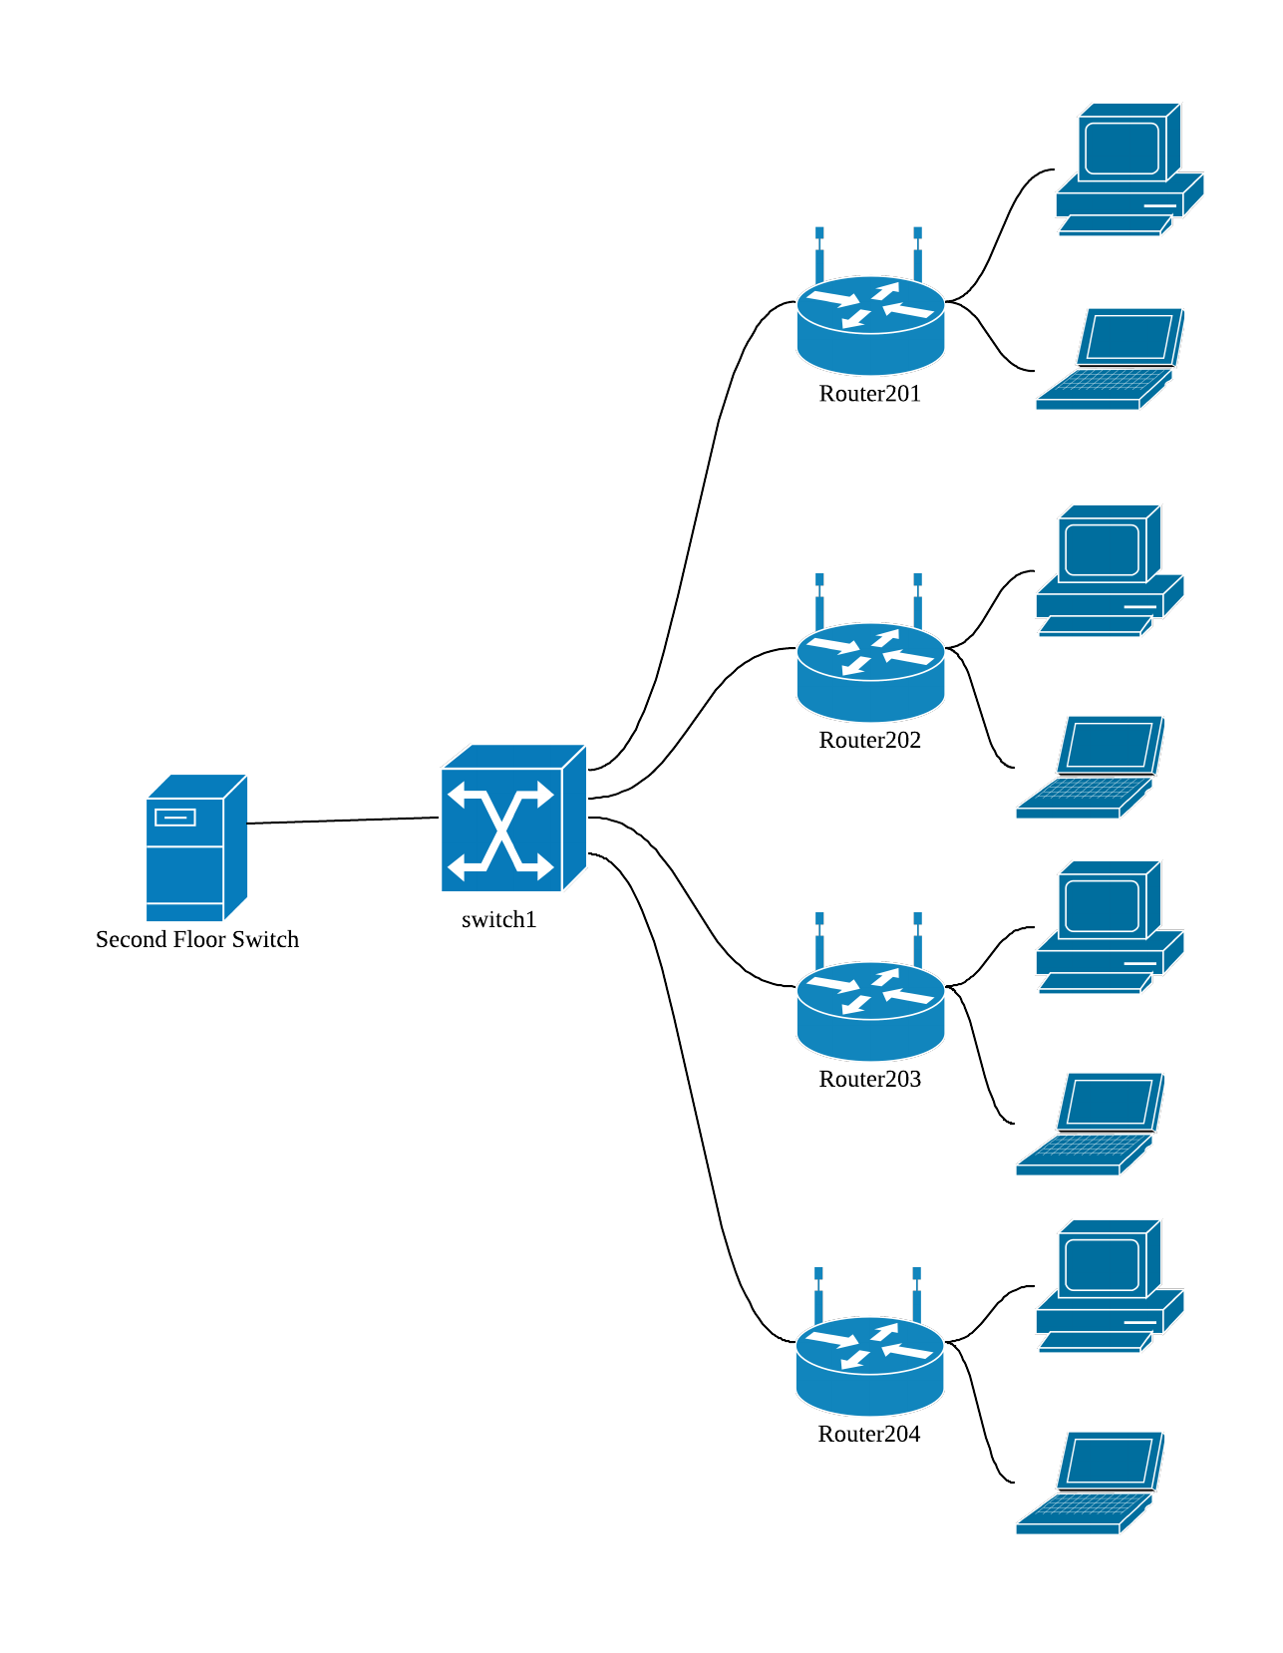

Figure 3.4 B1 building Second Floor LAN

# Area4: Local Backbone Network Design

Boston campus: A1 building

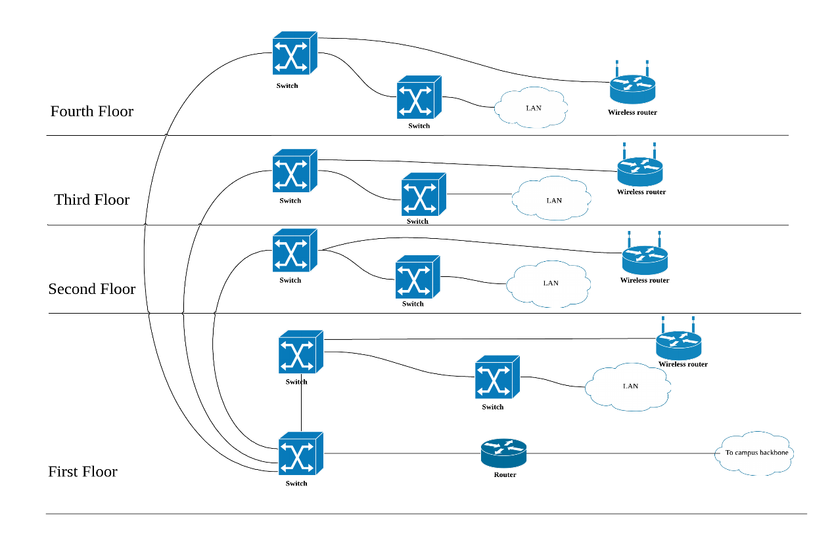

Figure 4.1 Boston Campus A1 building Local Backbone Network

New York campus: B1 building

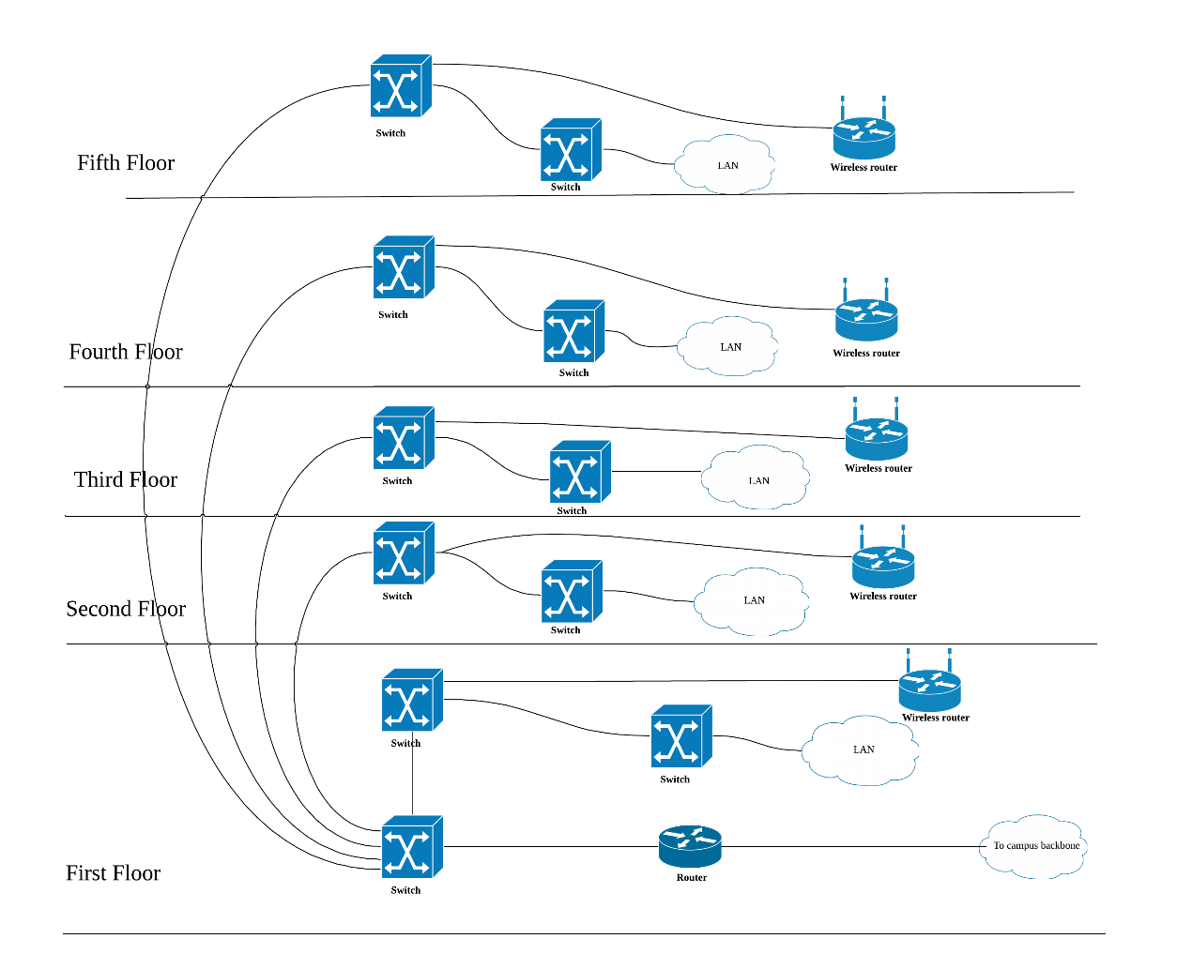

Figure 4.2 New York Campus B1 building Local Backbone Network

Switched backbones will be used in each building of the five campuses. Switched backbones are probably the most common type of BN used in the distribution layer (i.e., within a building); most new building BNs designed today use switched backbones. Switched BNs use a star topology with one switch at its center. There is a switch serving each LAN (access layer) that is connected to the backbone switch at the bottom of the figure (distribution layer). Most organizations now use switched backbones in which all network devices for one part of the building are physically located in the same room, often in a rack of equipment. This has the advantage of placing all network equipment in one place for easy maintenance and upgrade, but it does require more cable. In most cases, the cost of the cable is only a small part of the overall cost to install the network, so the cost is greatly outweighed by the simplicity of maintenance and the flexibility it provides for future upgrades.

# Area 4-1: WAN Backbone Network Design

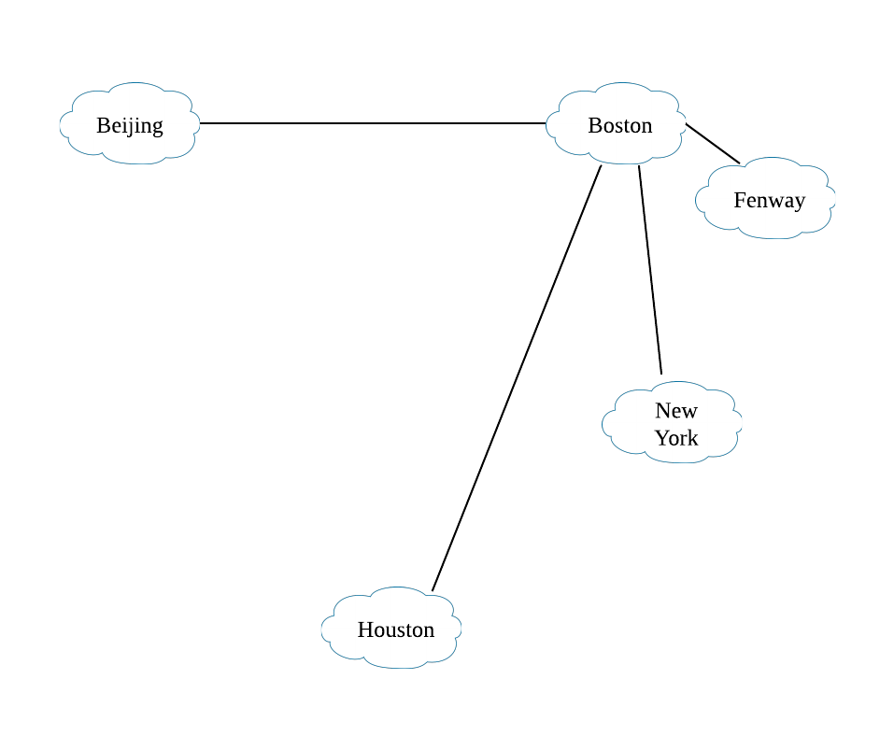

Figure 4.3 WAN Backbone Network

Wide-area network will use the star topology. Due to the distance between the campus is not very far in the USA and it is very far from the Beijing campus. So I think star topology is the most cheapest way. In each campus, the Wide-area network also use the star topology. The main point of the network is the A1 B1 C1 building. The diagram shows below:

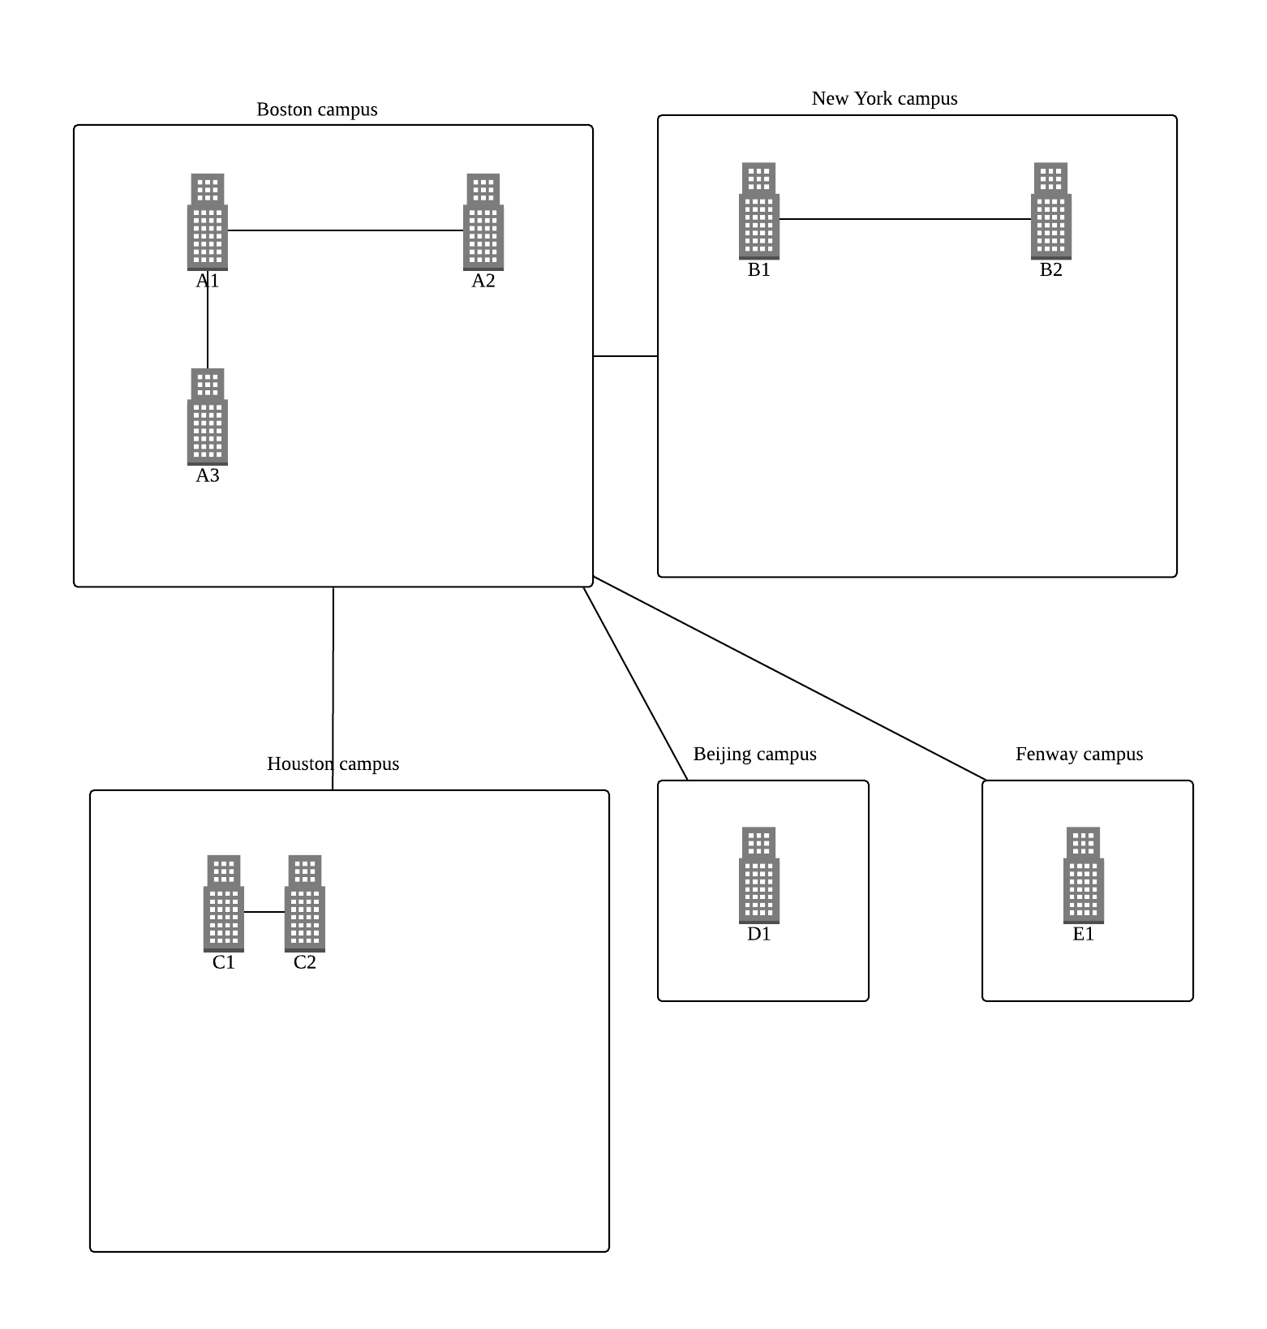

Figure 4.4 WAN backbone network

# Area 5: Network Security and Management

## Security

|  |  |  |  |  |
| --- | --- | --- | --- | --- |
| Asset | Importance | Most Important Security Requirement | Description | Owner(s) |
| Customer database | High | Confidentiality | This database contains all customers’ records, including address and information. | CIO |
| Web server | High | Integrity | This is used by our customers to place orders. It is very important that it would be available 24/7. | CIO |
| Mail server | Medium | Availability | This is used by employees for internal  communication. It is very important that no one intercepts this communication as sensitive information is shared via email. | CIO |

|  |  |  |  |
| --- | --- | --- | --- |
| Asset | Customer database | | |
| Asset Importance | High | | |
| Threat | Theft of information | | |
| Description | An external hacker or a disgruntled current or former employee can gain unauthorized access to the client data and distribute it to a third party. | | |
| Likelihood | Medium (2) | | |
| Impact on | Confidentiality | | |
| Impact Area | Priority | Impact | Score |
| Financial | High (3) | Medium (2) | 6 |
| Productivity | Medium (2) | High (3) | 6 |
| Reputation | High (3) | High (3) | 9 |
| Legal | Medium (2) | Medium (2) | 4 |
|  |  | Impact Score | 25 |
| Risk Score (Likelihood × Impact Score) | 50 | | |
| Adequacy of Existing Controls | Medium | | |
| Risk Control Strategy | Mitigate | | |
| Risk Mitigation Controls |  | | |
| Encryption | The database is encrypted. | | |
| Firewall | A firewall is installed on the router in front of the  database to prevent unauthorized access. | | |
| Personnel Policy | All employees have their log-in credentials removed  within 24 hours of their resignation or termination. | | |

|  |  |  |  |
| --- | --- | --- | --- |
| Asset | Web server | | |
| Asset Importance | High | | |
| Threat | Crash or overload | | |
| Description | Server may be flooded due to suddenly increased traffic or DDoS. | | |
| Likelihood | Medium (2) | | |
| Impact on | Confidentiality | | |
| Impact Area | Priority | Impact | Score |
| Financial | High (2) | Medium (2) | 4 |
| Productivity | Medium (3) | High (3) | 9 |
| Reputation | High (3) | High (3) | 9 |
| Legal | Medium (2) | Medium (2) | 4 |
|  |  | Impact Score | 25 |
| Risk Score (Likelihood × Impact Score) | 50 | | |
| Adequacy of Existing Controls | Medium | | |
| Risk Control Strategy | Mitigate | | |
| Risk Mitigation Controls |  | | |
| Encryption | The database is encrypted. | | |
| bandwidth | The bandwidth of server will be increased; scalable | | |
| Servers | More powerful servers will be added as well as datacenters to balance the traffic. There’s always backup servers for backup plan. | | |

## Management

1. Five common network issues

* **Managing Network Traffic**: A special device called a load balancer or virtual server acts as a traffic manager at the front. And With policy-based management, the network manager uses special software to set priority policies for network traffic that take effect when the network becomes busy.
* **Reducing Network Traffic:** Capacity management devices, sometimes called bandwidth limiter or bandwidth shapers, monitor traffic and can slow down traffic from users who consume a lot of network capacity.
* **Network virus**: The network should have the function of preventing and facilitating the killing of viruses. The campus network should be connected to the entire campus network with firewall filtering to prevent hackers.
* **Climate Control**: High temperature, humidity, even sunlight could damage the equipment. Keep an eye on the monitoring cooling equipment and other environmental values.
* **Unpatched Security Vulnerabilities**: The easiest fix for this problem is to maintain a strict schedule for keeping up with security patches. Also, gradually changing the programs and operating systems on your network to make them the same can simplify this process.

1. Personnel and positions

* Technical support: Mainly responsible for the technical selection of the entire system and system implementation. Change system functions according to user needs. Use the agile development model to develop a prototype of the system that can be used in a short time.
* Network engineer: Find problems in the network and solve problems.
* Network Analyst: Analyze data in the network
* System designer: upgrade the structure of the entire system, interface design, system logic design, network planning, etc.

1. Managed devices

* Managed Switches

Managed switches give more control over LAN traffic and offer advanced features to control that traffic. The managed switches at the campus are using Simple Network Management Protocol, for monitoring the devices on the network. Since SNMP queries can determine the health of the status of a particular device, IT managers can monitor the performance of the network and quickly detect and repair network problems without having to physically interact with the switch.

* Load Balancer or Virtual Server

To reduce the server pressure, this system uses google cloud load balancing. It distributes client requests or network load efficiently across multiple servers across the World.

# Reference

Business Data Communications and Networking (13th Edition) [Fitzgerald, Dennis, Durcikova]

**5 Common Network Security Problems and Solutions**

https://www.compuquip.com/blog/5-common-network-security-problems-and-solutions