# Assignment 11

## k-means

* Question 1: by visual check the plot below, optimal k is 2

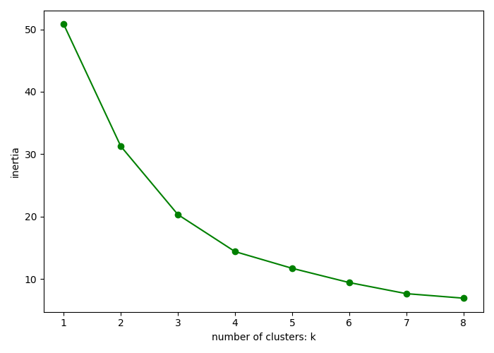

* Question 2:
  1. Cluster 0: percentage of “green”0%, percentage of “red”100%
  2. Cluster 1: percentage of “green”100%, percentage of “red”0%
* Question 3:

Cluster 1 is a pure cluster, all points in cluster 1 are labeled as green.