# Assignment 6

### Linear model

* Question1:

D=1 plot

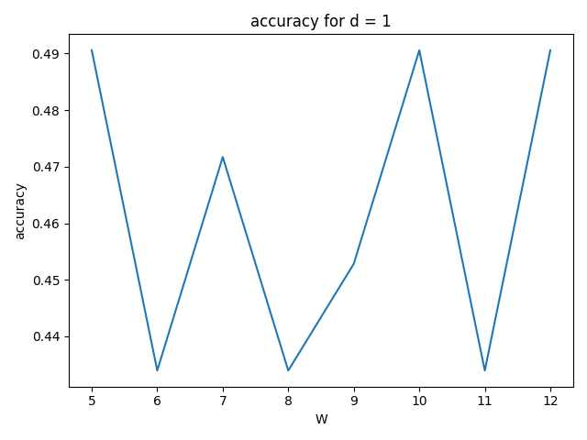

D=2 plot

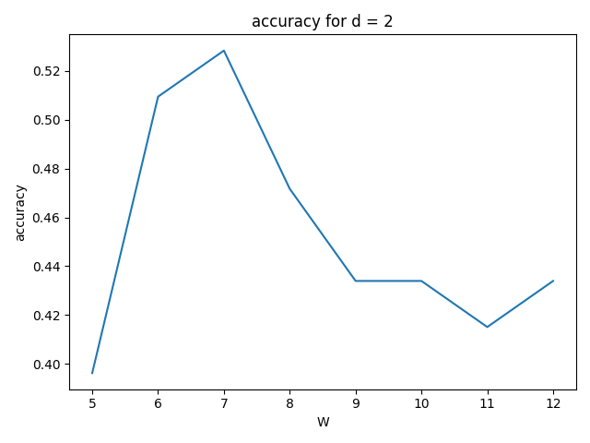

D=3 plot

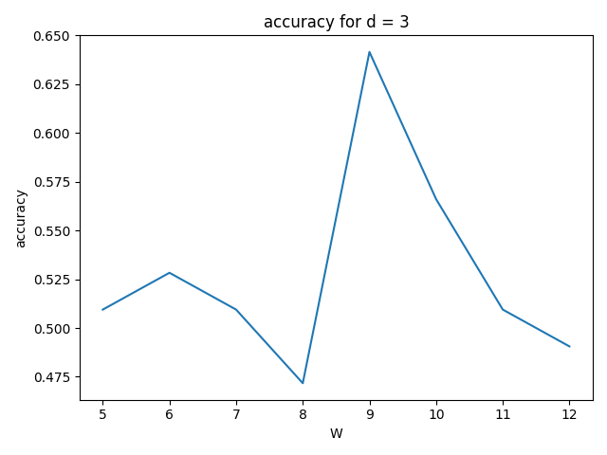

* Question2:

Best W (5, 10, 12), 7, 9, and I use 3 W for d=1 then the best is W =10. So, the accuracy is d=1 W=10; d=2 W=7; d=3 W=9

Accuracy: d=1 56.60%, d=2 54.72% d=3 58.49%

* Question3: confusion matrices

Line, d=1

[[17 12]

[11 13]]

Quadratic, d=2

[[17 12]

[12 12]]

Cubic, d=3

[[18 11]

[11 13]]

* Question4:

D=1 plot

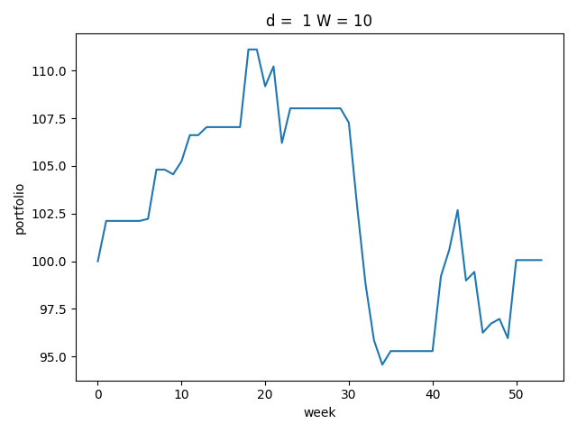

D=2 plot

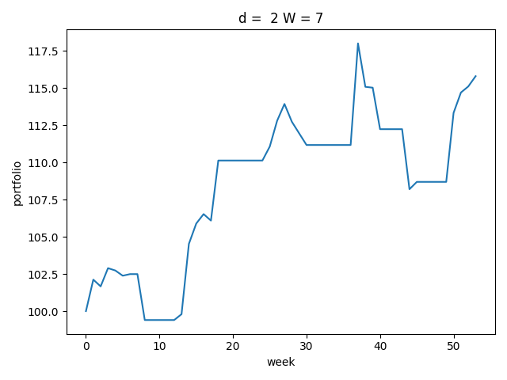

D=3 plot

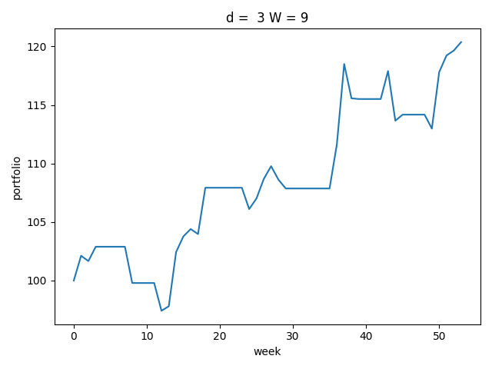

### Bakery Dataset

* Question1:
  1. Hour: 11
  2. Day of the week: Saturday
  3. Period: afternoon
* Question2:
  1. Hour: 11
  2. Day of the week: Saturday
  3. Period: afternoon
* Question3: most popular item: coffee, least popular item: Adjustment, chicken sand, olum & polenta, polenta, bacon, gift voucher, the BART, baw bars,
* Question4: in this question I check the most coffee selling in each day of the week and calculate the least baristas the shop need.

1. Monday: 2
2. Tuesday: 1
3. Wednesday: 1
4. Thursday: 1
5. Friday: 2
6. Saturday: 2
7. Sunday: 2

* Question5:

In this question I only select the item which transaction more than 200. Because there isn’t a category column in the dataset. So, I just divide it by myself.

Food: bread, cake, sandwich, cookies, brownie, muffin

Average price: 3.88

Drink: coffee, tea, hot chocolate, juice

Average price: 8.61

* Question6: coffee shop makes more money from selling drinks
* Question7:

|  |  |  |  |  |  |  |  |
| --- | --- | --- | --- | --- | --- | --- | --- |
| Top | Monday | Tuesday | Wednesday | Thursday | Friday | Saturday | Sunday |
| 1 | coffee | coffee | coffee | coffee | coffee | coffee | coffee |
| 2 | bread | bread | bread | bread | bread | bread | bread |
| 3 | tea | tea | tea | tea | tea | tea | tea |
| 4 | pastry | cake | cake | cake | sandwich | cake | cake |
| 5 | sandwich | pastry | none | pastry | cake | none | none |

Not exactly the same, the top1 to top3 is same

* Question8:

|  |  |  |  |
| --- | --- | --- | --- |
| Bottom | Monday | Tuesday | Wednesday |
| 1 | Dulce de leche | Honey | Adjustment |
| 2 | Crisps | Nomad bag | Vegan feast |
| 3 | Pick and mix bowls | Kids biscuit | Raw bars |
| 4 | Mighty protein | Half slice monster | Polenta |
| 5 | Drinking chocolate spoons | Granola | Olum & polenta |

|  |  |  |  |
| --- | --- | --- | --- |
| Bottom | Thursday | Friday | Saturday |
| 1 | Lemon and coconut | Honey | Victorian sponge |
| 2 | Argentina night | Mighty protein | Lemon and coconut |
| 3 | Duck egg | Panatone | Mortimer |
| 4 | Spread | Coffee granules | Fairy doors |
| 5 | Drinking chocolate spoons | Fairy doors | Ella’s kichen pouches |

|  |  |
| --- | --- |
| Bottom | Sunday |
| 1 | Coffee granules |
| 2 | Christmas common |
| 3 | Argentina night |
| 4 | Chocolates |
| 5 | Bacon |

Actually, not same from Monday to Sunday, only a few is same, and there are about 10 to 15 item has the least number for only 1 transaction.

* Question9: 0.83 drinks per transaction