# Assignment7

## Linear models

* Question 1:

1. Done in code
2. Plot

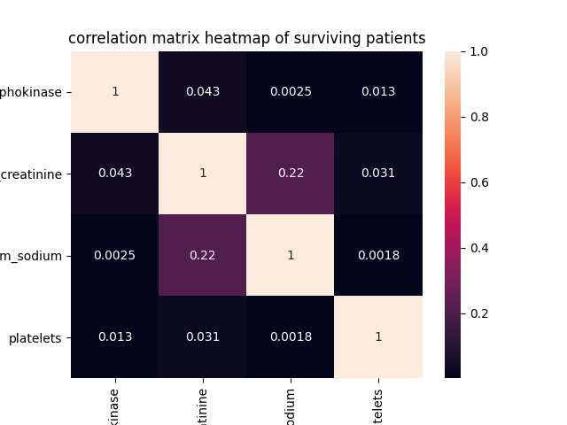

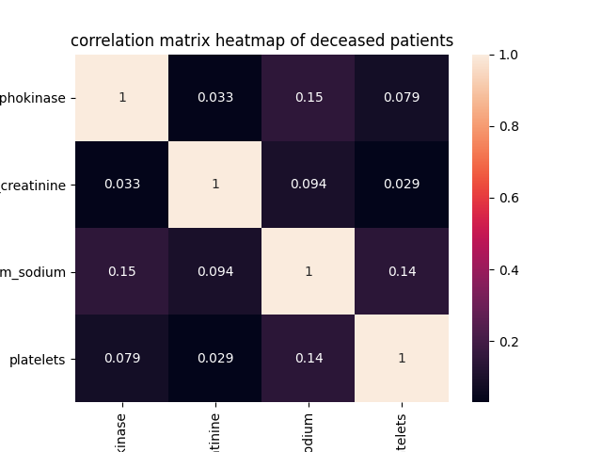

1. Answer
   1. Highest correlation features for surviving: serum sodium and serum creatinine
   2. Lowest correlation features for surviving: platelets and serum sodium
   3. Highest correlation features for deceased: serum sodium and creatinine phosphokinase
   4. Lowest correlation features for deceased: plates and serum creatinine

* Question 2: group 2
* Question 3: table

|  |  |  |
| --- | --- | --- |
| Model | SSE (death_event = 0) | (death_event = 1) |
| $$y=ax+b$$ | 1806.43 | 1659.56 |
| $$y=ax^{2}+bx+c$$ | 1785.69 | 1707.62 |
| $$y=ax^{3}+bx^{2}+cx+d$$ | 1800.99 | 1681.96 |
| $$y=a\log{x}+b$$ | 1793.2 | 1625.72 |
| $$\log{y}=a\log{x}+b$$ | 1790.43 | 1621.52 |

1. Best: surviving patients: quadratic, deceased patients: second GLM
2. Worst: surviving patients: simple linear regression, deceased patients: cubic spline

## Change of trend detection