## Assignment 8

## Tips

* Question 1:

average tip:

1. lunch 16.41%
2. dinner 15.95%

* Question 2:

average tip

1. Friday 16.99%
2. Saturday 15.32%
3. Sunday 16.69%
4. Thursday 16.13%

* Question 3: the highest tips is Friday lunch
* Question 4: correlation between is 0.68
* Question 5: correlation between is 0.49, so there is a positive relationship between tips and group size.
* Question 6: percentage of people are smoking is 38.11%
* Question 7: plot

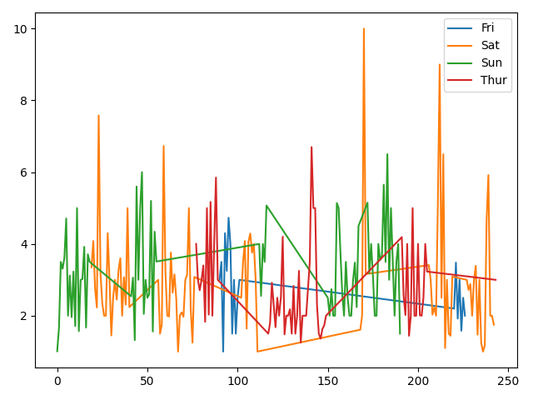

The tips are not increasing with time in each day.

* Question 8:

## Naïve Bayesian

* Question 1: accuracy for year 2 is 94.34%
* Question 2: confusion matrix

[[29 0]

[3 21]]

* Question 3: true positive rate: 100% true negative rate 87.5%
* Question 4: plot

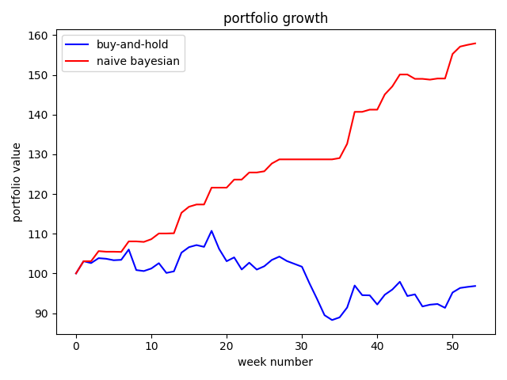

## Shapley feature explanations