# Assignment 9

## Discriminant Analysis

* Question 1:

LDA equation: $y=-3.72x_{1}+0.12x_{2}+0.46$

QDA equation:

* Question 2: LDA: 96.23%, QDA: 98.11%
* Question 3: confusion matrix
  1. LDA

[[27 2]

[ 0 24]]

* 1. QDA

[[28 1]

[ 0 24]]

* Question 4:

1. LDA

TPR: 93.1%, TNR: 100%

1. QDA

TPR: 96.55%, TNR: 100%

* Question 5: form the plot below, we can find that QDA is more accurate than other two strategy.

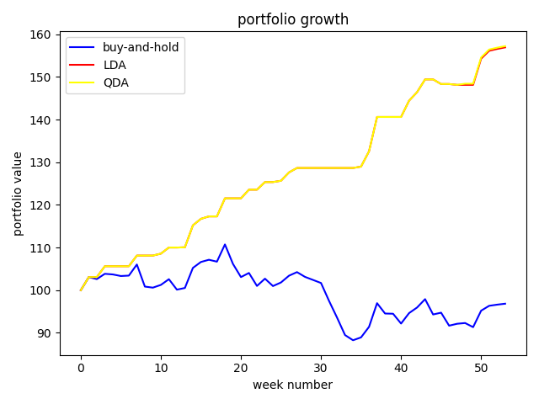

## Decision Trees

* Question 1: accuracy for year 2 is 92.45%
* Question 2: confusion matrix

[[25 4]

[ 0 24]]

* Question 3: true positive rate: 86.21% true negative rate: 100%
* Question 4: from the plot below, we can find that Decision Trees model give us a large amount.

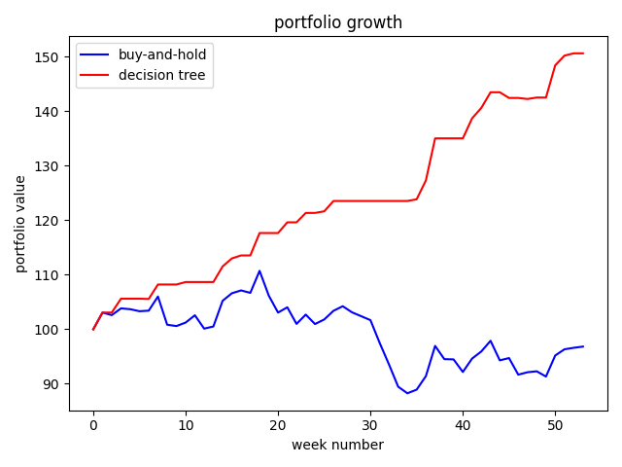

## Random Forest

* Question 1:

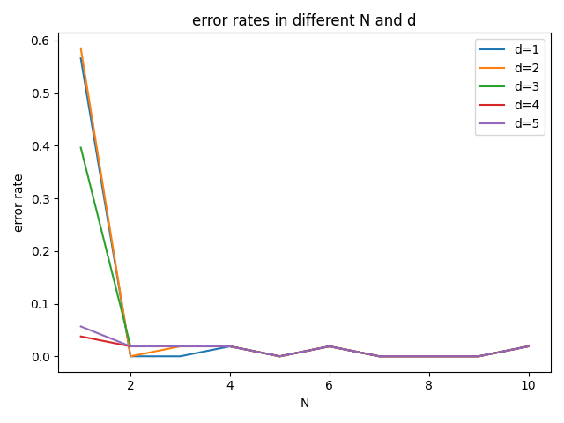

* Question 2: confusion matrix

[[29 0]

[ 0 24]]

* Question 3: TPR: 100%, TNR: 100%
* Question 4:

