Lecture 7:

Quiz #3 (Fri – Sun)

Assignment 7

Part 1:

* linear models (for heart prediction)

Part 2:

* change of trend in linear regression

Question:

you look for W and d ------🡪 the best

P(n) = a_0 + a_1P(n-1) + a_2**2 * P(n-2) …

suppose you look for different linear models

y = a0 + a1 Sin(pi *x/15) + a2* cos(pi * x/20)

y = ax**2 + bx + c

The way you answer this is by looking at the autocorrelation function (ACF)

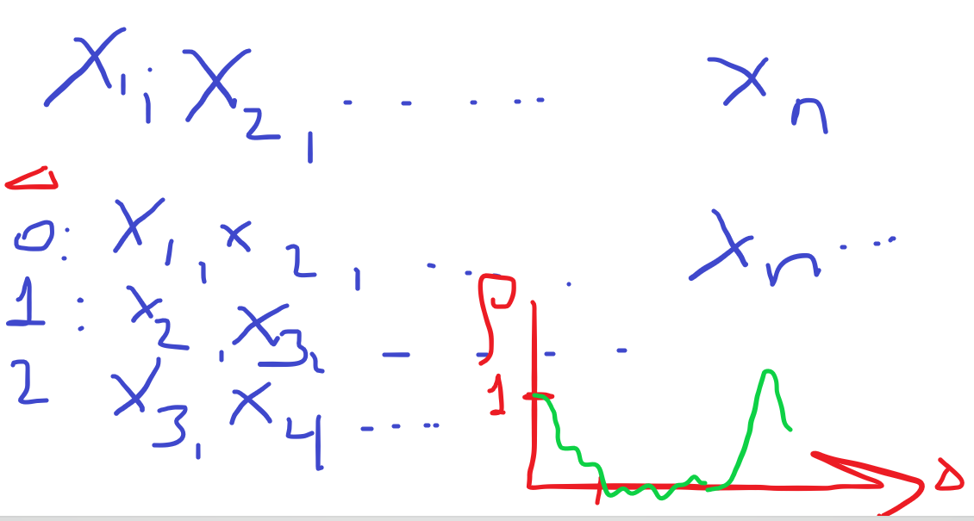

if ACF drops fast and stays near zero, it means that there is no linear relationship to explain your data

Linear regression

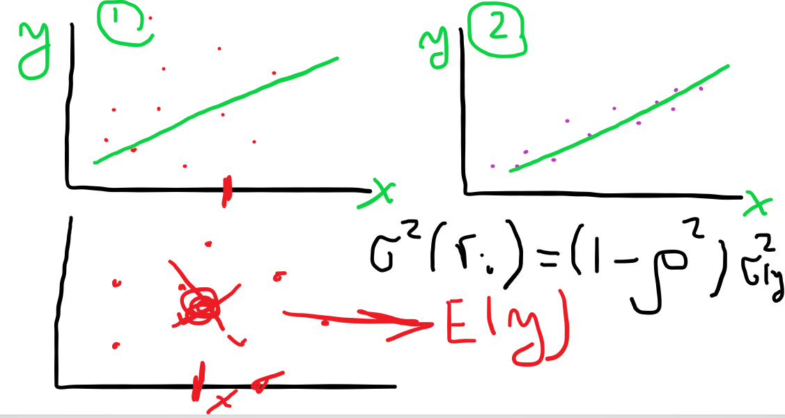

linear regression works “well” when we have significant correlation between y and x

var(X) = E((x-mu)**2) = EX**2 – mu**2

y = ax + b + e

E(e) = 0

E(xe) = 0 (x and e are not correlated)

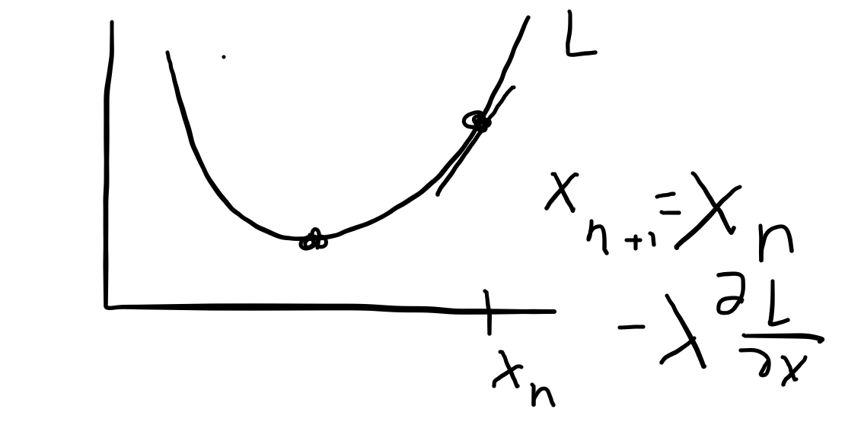

For the assignment on heart dataset, choose one independent feature X and 1 dependent feature Y as follows:

1. look at the last digit of your BUID
2. 0-2 ------------🡪 Group 1
3. 3,4 or 5 -----🡪 Group 2
4. 6,7 --------🡪 Group 3
5. 8, 9 ----------🡪 Group 4

Trend assignment

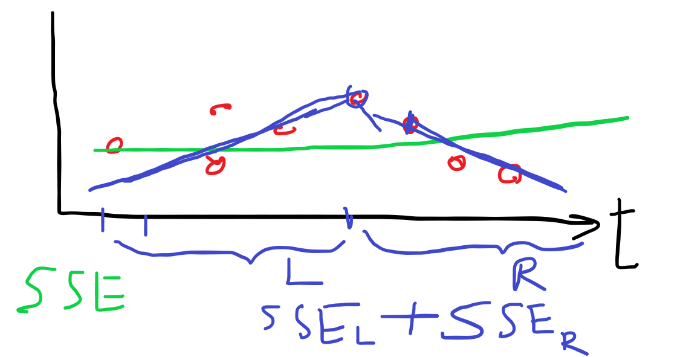

For every month, we split into two parts and compute L1 + L2. We look for day d so that this sum is minimal. This day “d” is our “breakpoint” day

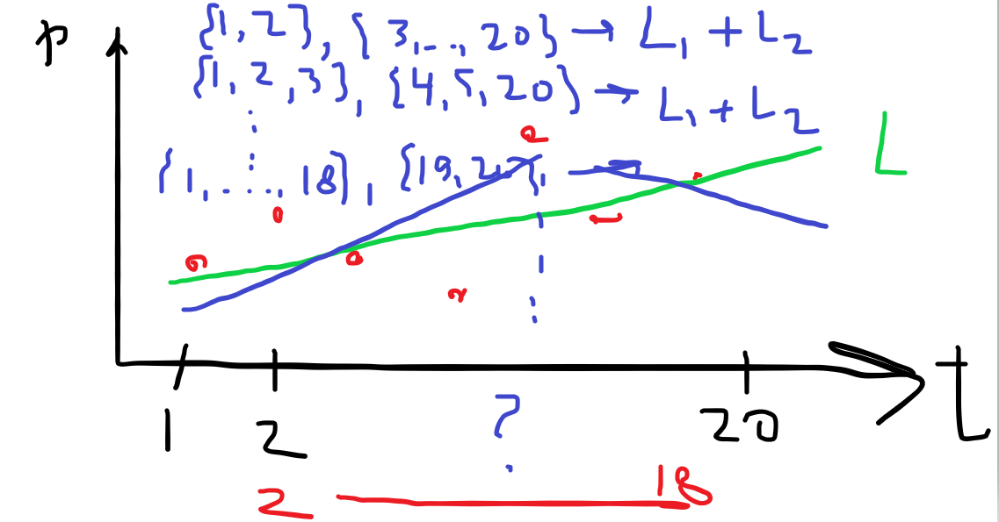

STAY HEALTHY and well

See you all next week !!!!

