CONNECT4 GAME REPORT

CS333-Project1

Buse Küçükbükücü

Connect4 game must be played by two users. In our scenario, user1 is person who is going to run the code and user2 is the computer which is going to work by written code.

So person will play against to computer.

Functions that in our code:

-createGame()

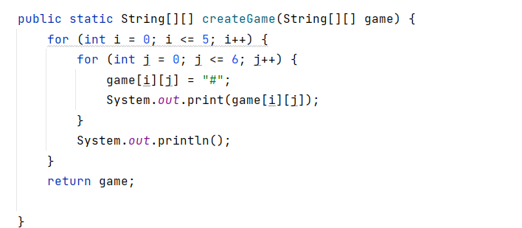

-check()

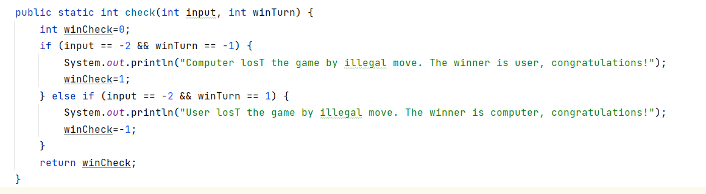

-printGame()

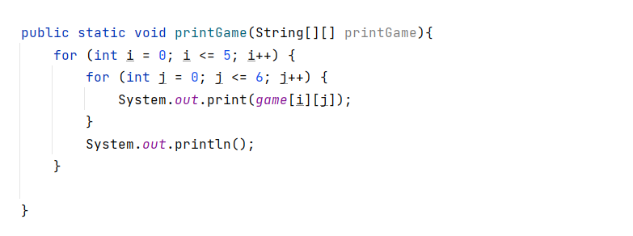

-takeMove():

In takeMove function, we are getting the column number that user1-person want to play. And we are checking the boundaries to catch if there is a illegal move.

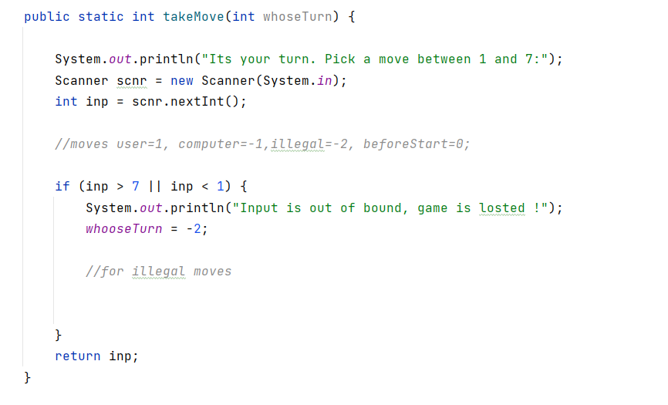

-playGame():

We are playing game in this function.

metin içeren bir resim

Açıklama otomatik olarak oluşturuldu