Lingyu Zhao
MET CS 669 A1
Professor Wolfe
03/23/2018

For the last iteration you started on your term project by providing your initial list of structural business rules. This is a solid start! You have since received feedback from your facilitator, learned from more material in the course, and had some additional time to think over the term project. While this is still fresh in your mind, make any enhancements and corrections to your business rules. Then provide a conceptual entity-relationship diagram (ERD) that reflects the business rules. Recall that a conceptual ERD is independent of the relational model, and therefore does not contain primary and foreign key constraints.

Make sure that all business rules are represented in the ERD, and that all entities and relationships present in the ERD are described by the business rules.

This work is summarized in the two steps below.

- Make any enhancements and corrections to your business rules you submitted last week, and provide the updated list below.

My updated business rules are based the feedback from Professor Wolfe. I appreciate his time to help me point out my ambiguous entities. Thank you again!

Before I state my business rules, I need to rearrange my entities. In my database design, it totally consists of nine entities. There are:

- Delivery_Option
- Customer
- Shipping_Address
- Order
- Package
- Seller_Inventory
- Package_Identifier
- Product
- Seller_Inventory

Updated Business Rules:
The Customer at least has one or more Delivery_Options; the Delivery_Option can be applied to one or many Customers.

The Customer can have one or more Shipping_Addresses; The Shipping_Address is associated to one or more Customers.

The Shipping_Address can receive zero or many Packages; the Package is only associated to one Shipping_Address.
The Customer can have zero or many Orders; The order is owned only by one Customer.

Each Order only has one Package; One Package must be associated to one Order.

The Customer can have zero or many Package_Identifiers; the Package_Identifier only belongs to one Customer.

Each Package_Identifier is only associated to one Package; One Package is only associate to one Package_Identifier.

One Package_Identifier at least have one Product; Each Product must be tracked by only one Package_Identifier.

The Product belongs to only one Seller_Inventory; the Seller_Inventory can have zero or many Products.

2. Create a conceptual ERD that reflects the business rules and provide it below.

This Term Project iteration is not a final submission of what you develop. You have the opportunity to make modifications before the final Term Project submission at the end of the course.
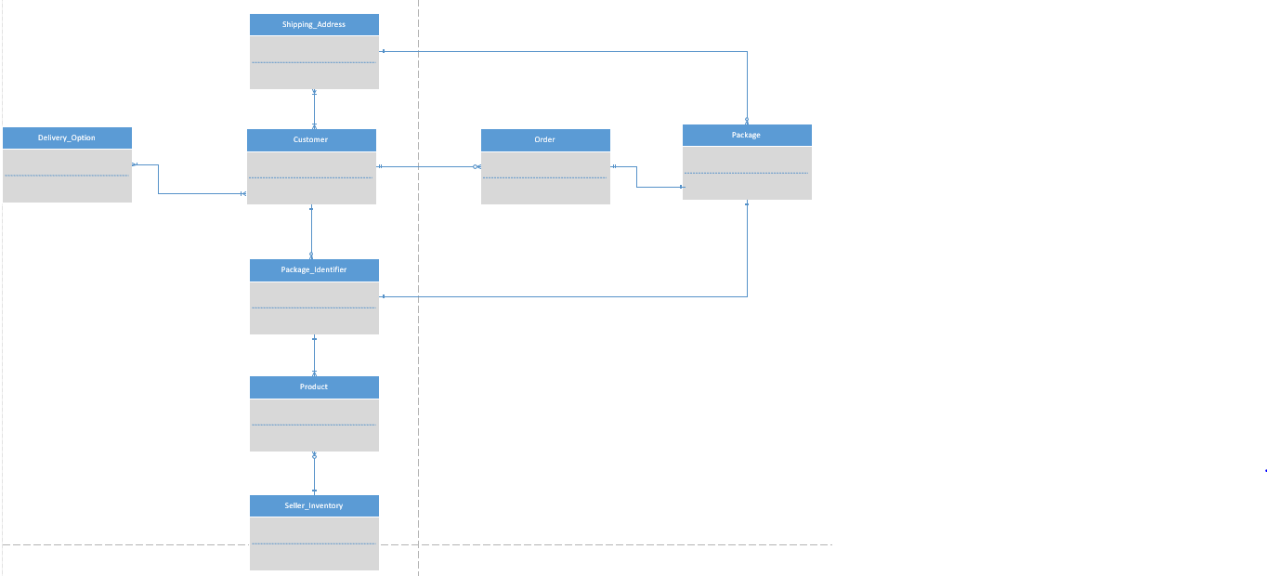

Use the Ask the Facilitators Discussion Forum if you have any questions regarding the how to approach this assignment.

Save your assignment as lastnameFirstname_iteration3.doc and submit it in the Assignments section of the course.

For help uploading files please refer to the Technical Support page in the syllabus.

